**Terraform and Ansible Tasks**

Terraform Task

Code Repo Url:

<https://github.com/kiranpe/AzureTasks/tree/master/Task4/Terraform_Task>

Starting an Azure Cloud Shell

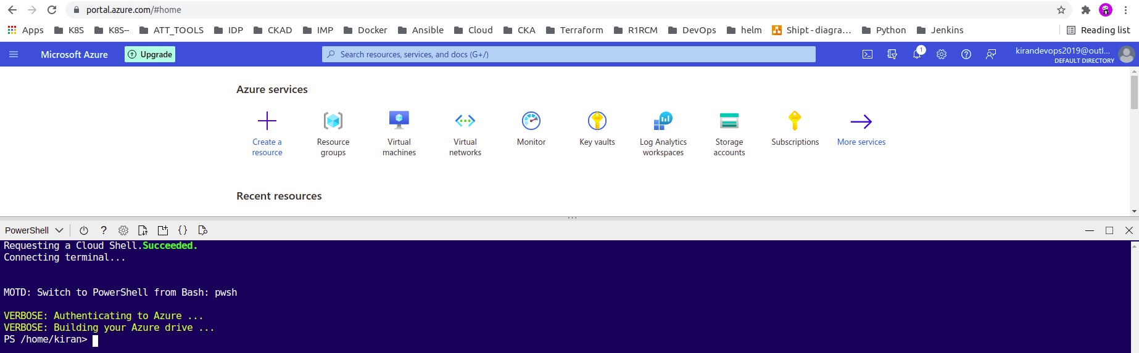

Initializing Terraform with the Azure Provider

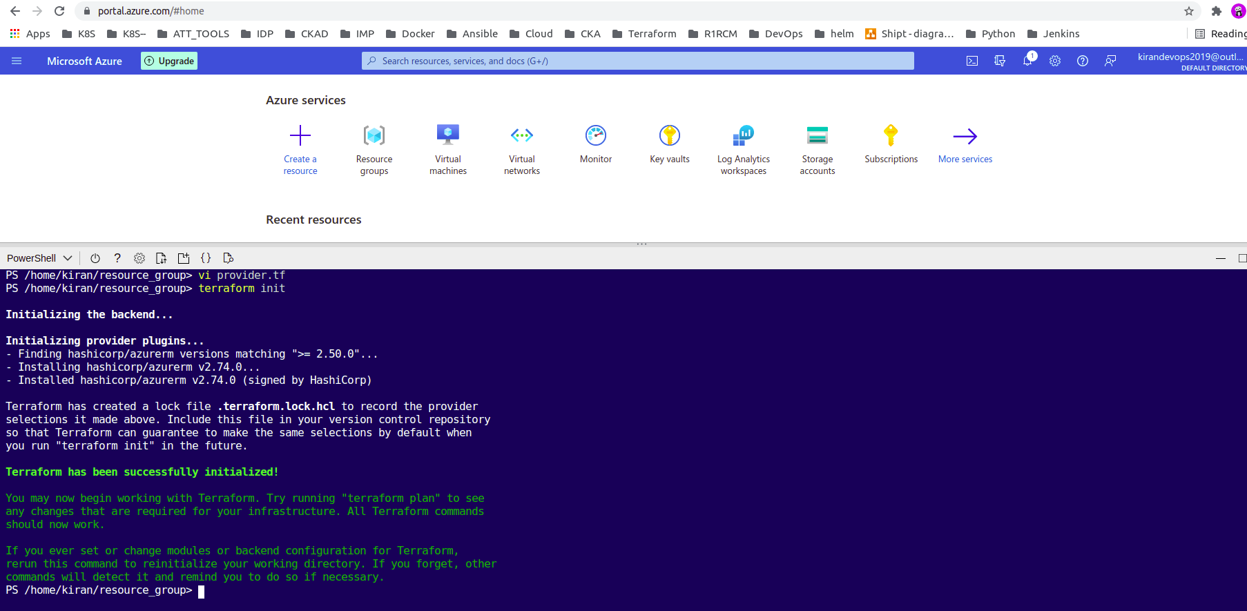

Setting Up a Data Source to Reference the Resource Group

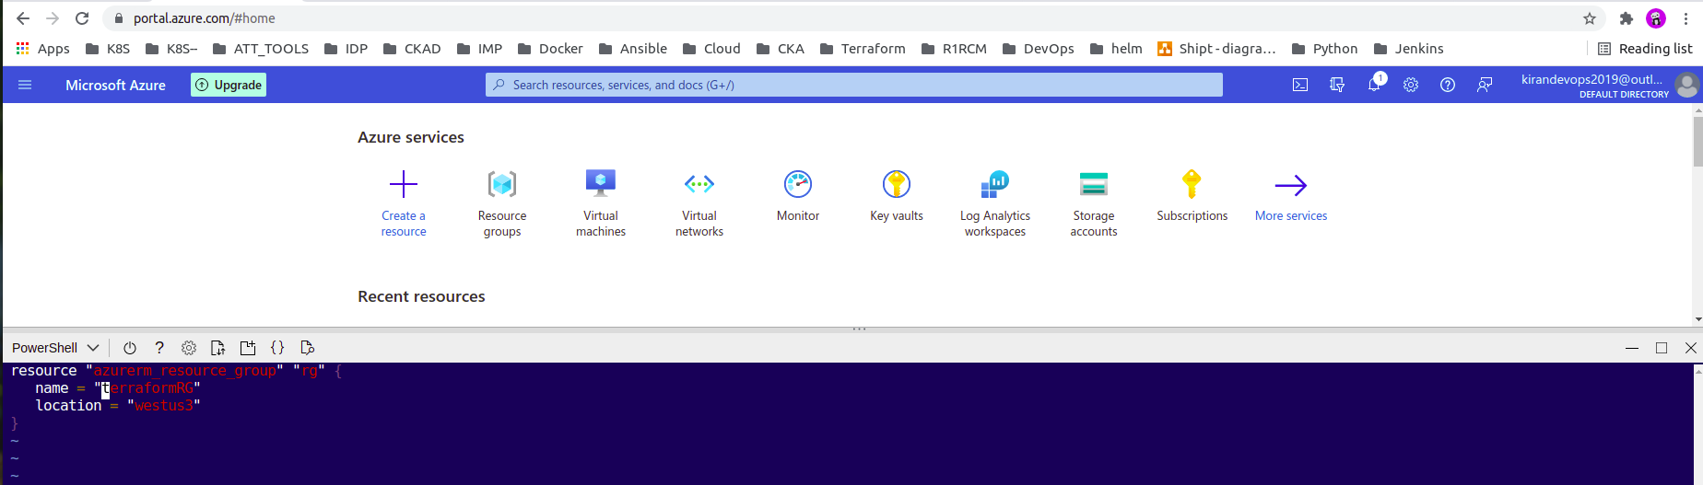

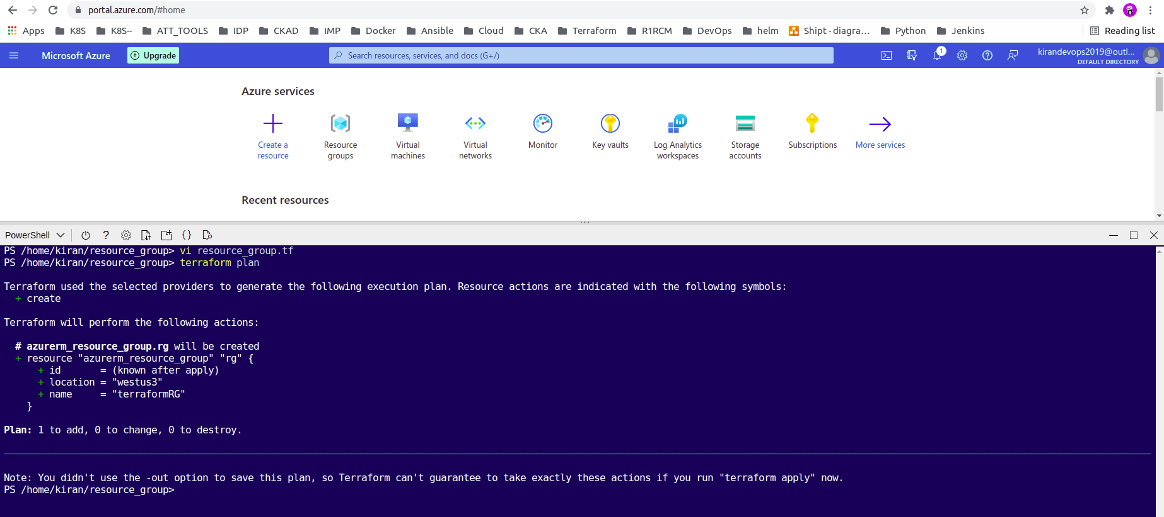

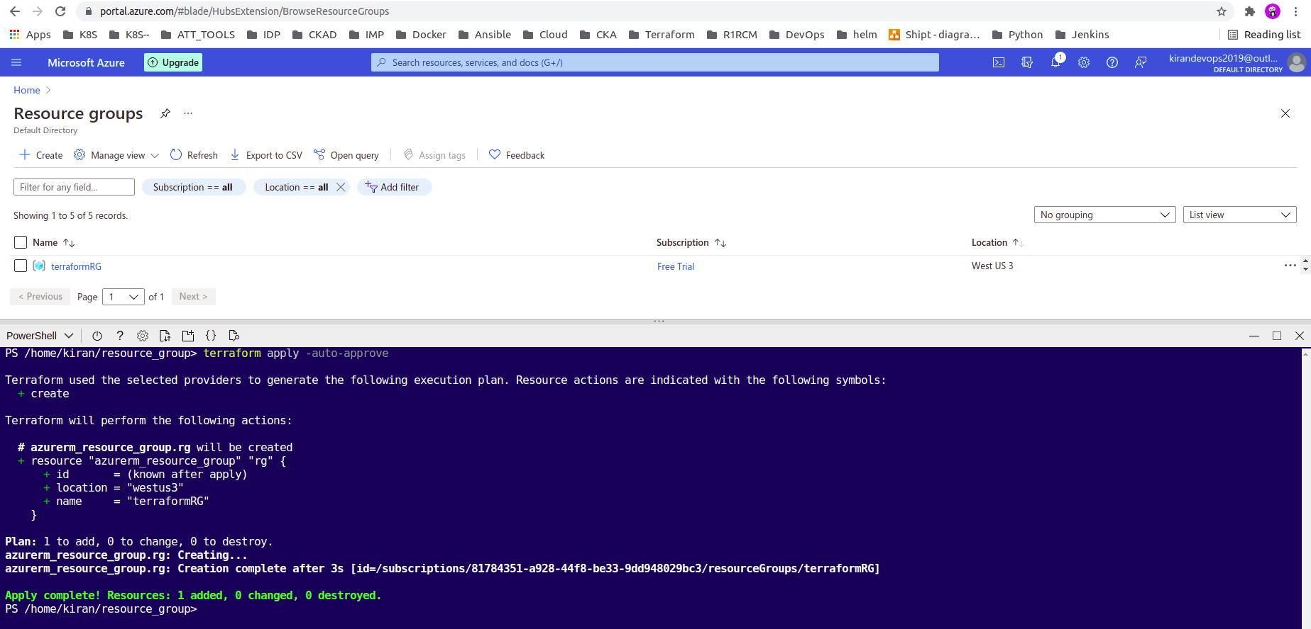

Using a VNet Module from the Terraform Registry

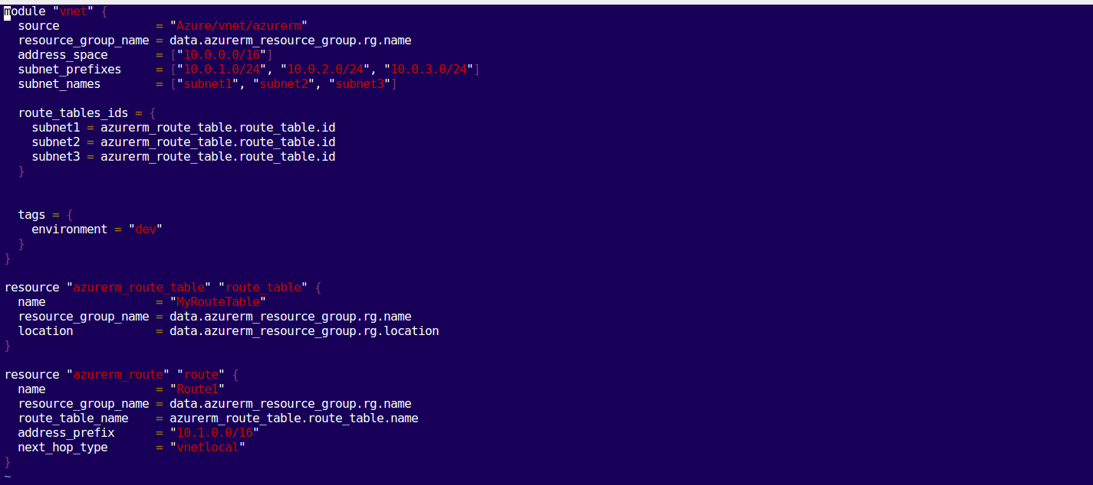

Using a Security Group Module from the Terraform Registry

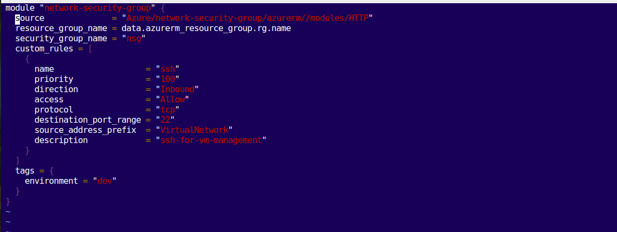

Created VNet and NSG

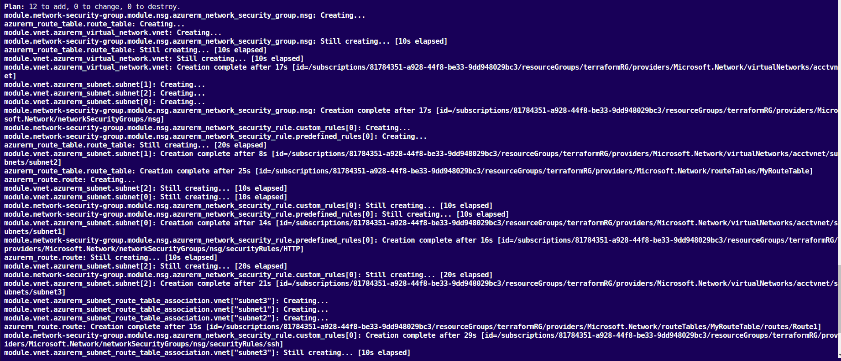

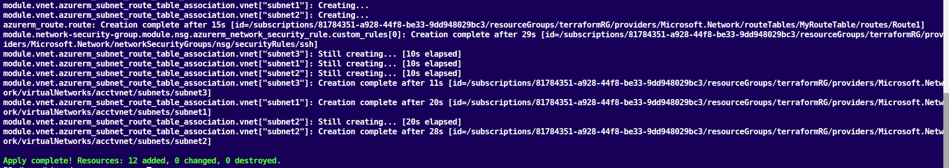

Created Local Module using Terraform DataSource for RG, NSG and VNet Values and Launched VM

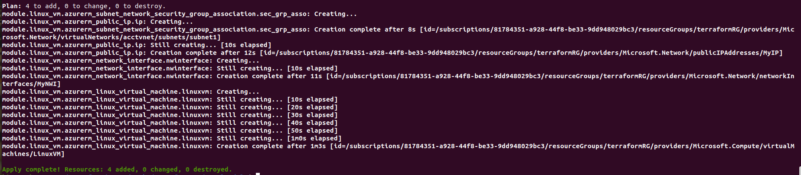

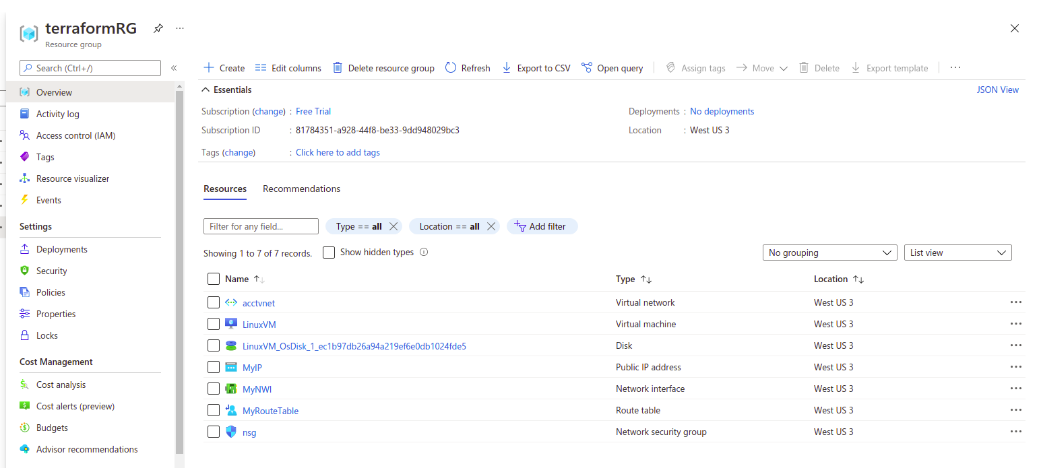

Ansible Tasks

Task1: Create 5 users called user1, user2,..,user5 and /bin/csh as their default shell

Yml file:

<https://github.com/kiranpe/AzureTasks/blob/master/Task4/Ansible_Tasks/task1.yml>

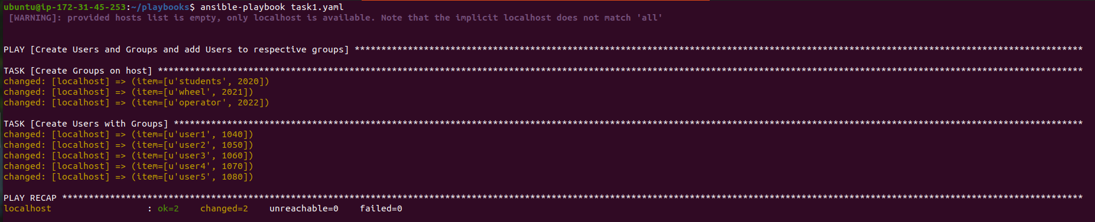

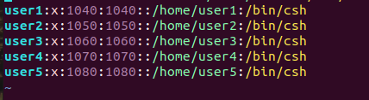

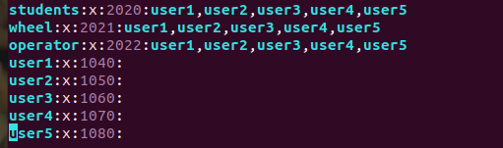

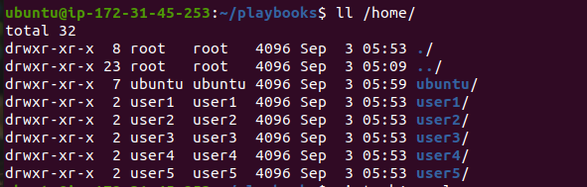

Task2: Create Folders inside users and copy pdf files into respective folder

Yml file:

<https://github.com/kiranpe/AzureTasks/blob/master/Task4/Ansible_Tasks/task2.yml>

Folders have been created inside each user folder

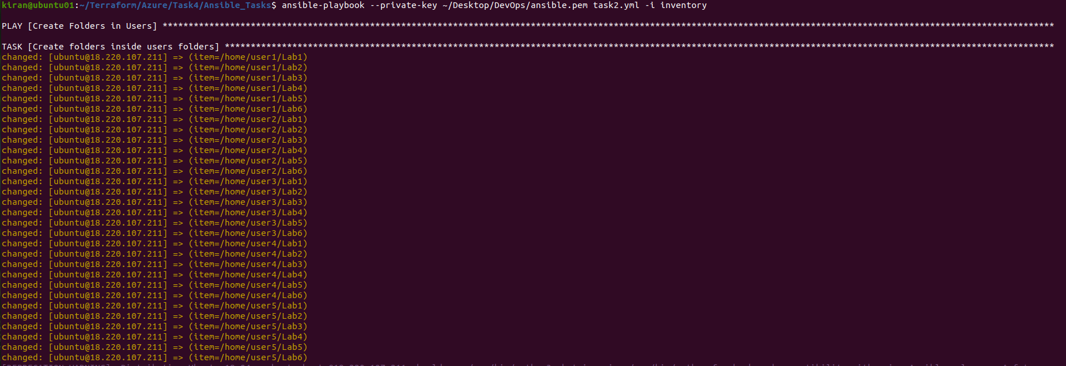

Files have been Created in respective folder successfully

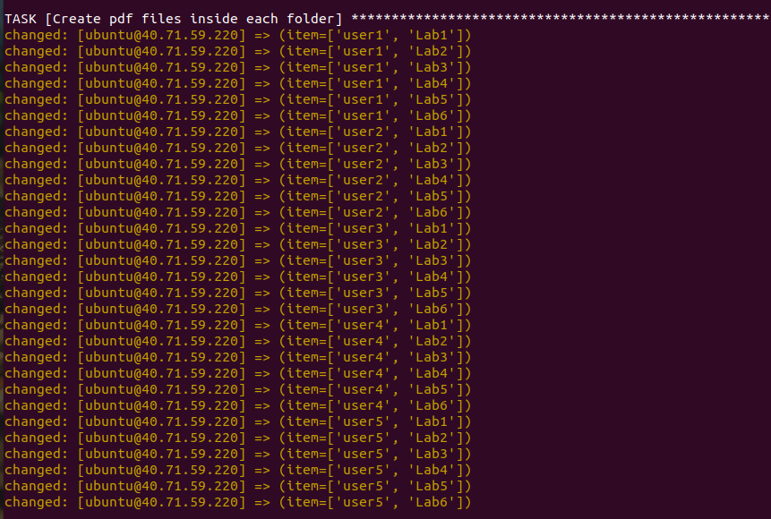

Files are on remote host.

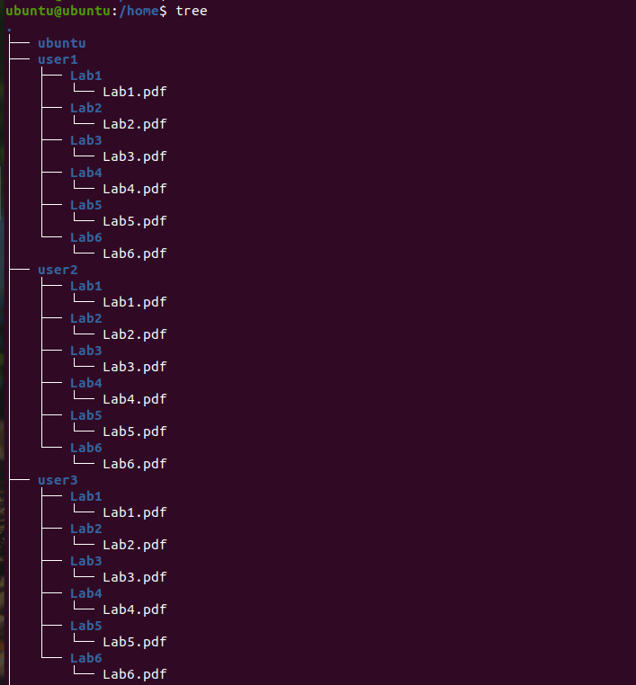

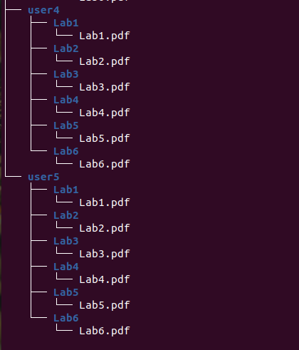

Task3: User should be able to SSH into the Jail

Code Url:

<https://github.com/kiranpe/AzureTasks/tree/master/Task4/Ansible_Tasks/jail_task>

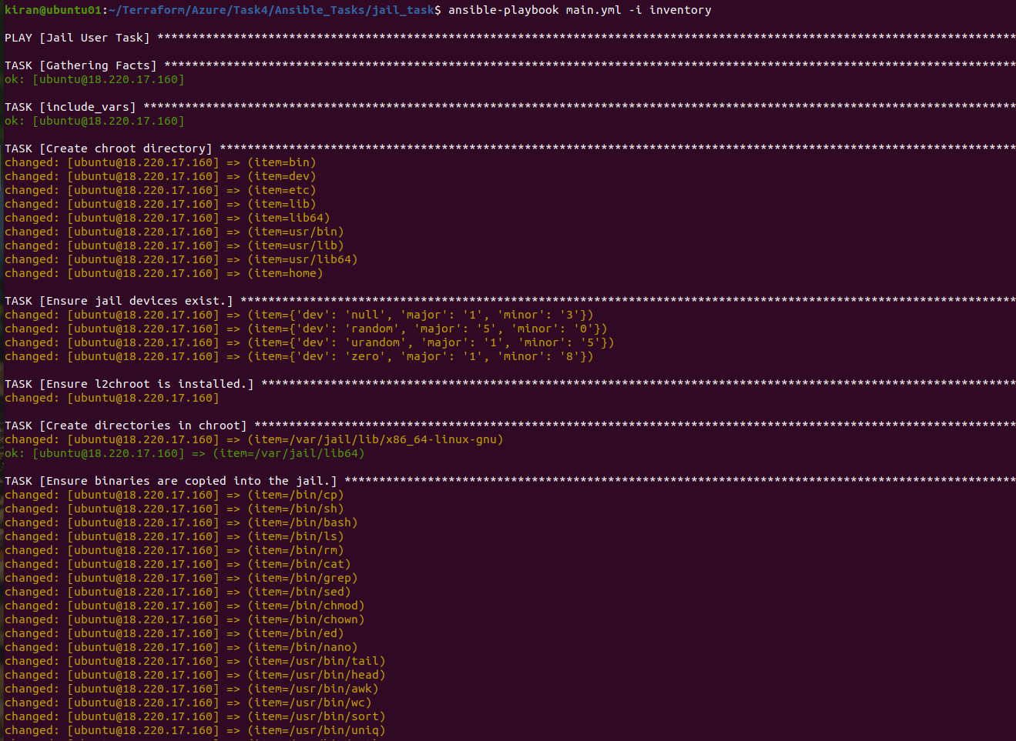

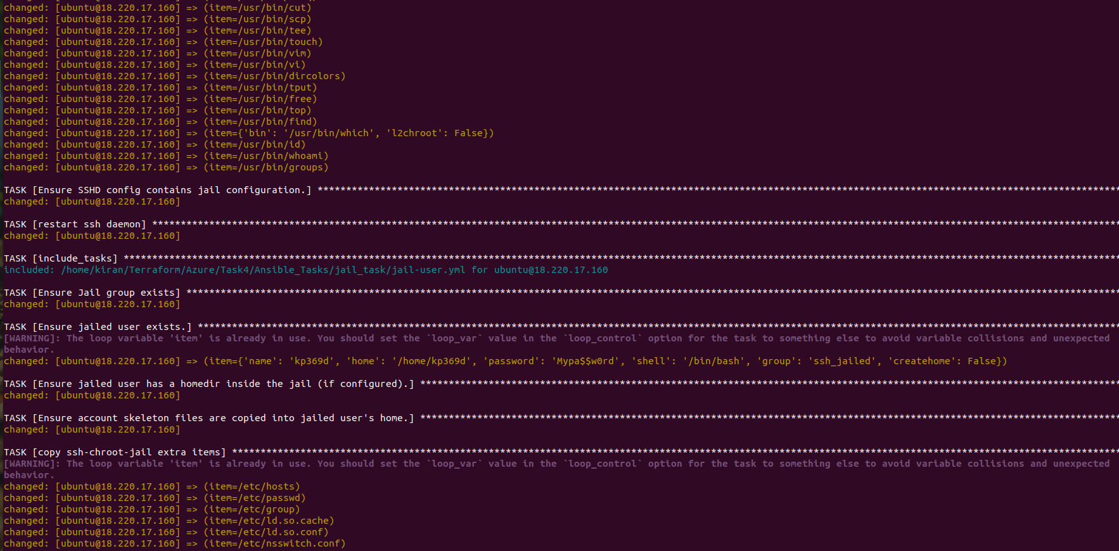

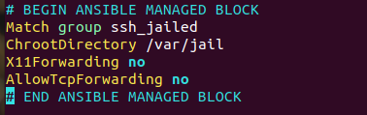

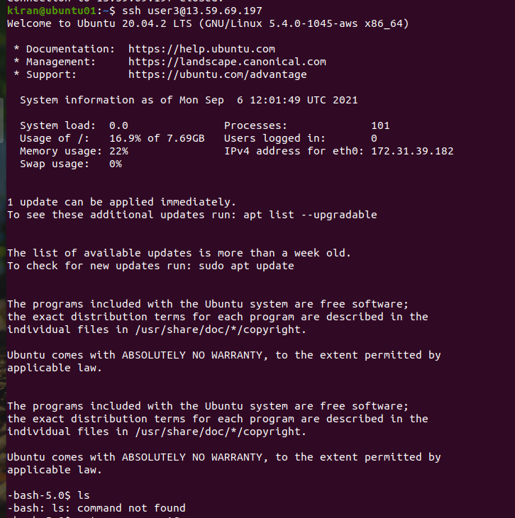

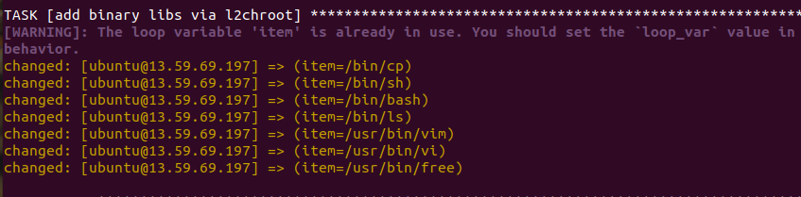

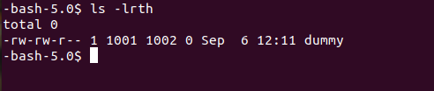

Task4: Modify Welcome message

Yml file: <https://github.com/kiranpe/AzureTasks/blob/master/Task4/Ansible_Tasks/task5.yml>

Jinja2 file: <https://github.com/kiranpe/AzureTasks/blob/master/Task4/Ansible_Tasks/motd-facts.j2>

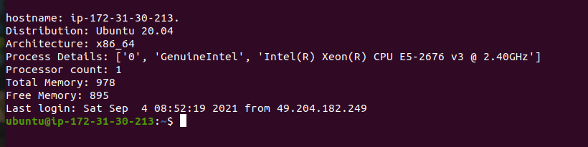

Task5: Create www directory under /srv on a debian system

Yml file:

<https://github.com/kiranpe/AzureTasks/blob/master/Task4/Ansible_Tasks/task5.yml>

Created www under /srv

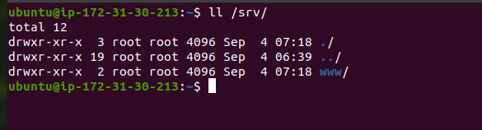

Task6: Checkout from git and push tarball to Prod and Run deployment script.

Yml file:

<https://github.com/kiranpe/AzureTasks/blob/master/Task4/Ansible_Tasks/task6.yml>

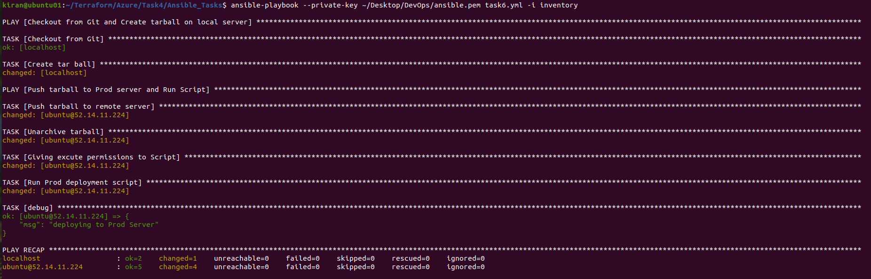

On Remote Server

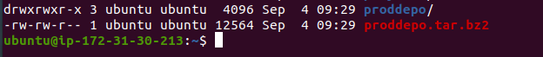

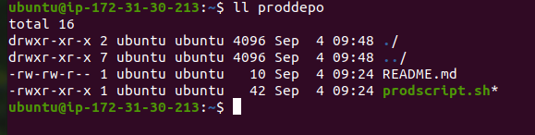

Task7: Ansible Module to move/rename a File/Folder

Yml file:

<https://github.com/kiranpe/AzureTasks/blob/master/Task4/Ansible_Tasks/task7.yml>

Before:

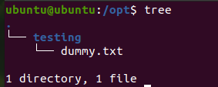

After:

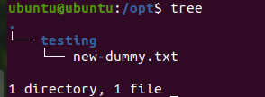

Using ad-hoc command: How to file:

<https://github.com/kiranpe/AzureTasks/blob/master/Task4/Ansible_Tasks/task7.txt>

**Folder:**



Before:



After:



**File:**



Before: 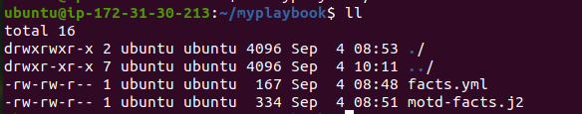

After:

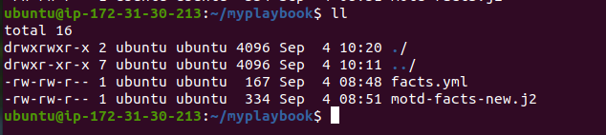

Task8: Get list of Ansible pre-defined variables

Yml file: <https://github.com/kiranpe/AzureTasks/blob/master/Task4/Ansible_Tasks/task8.yml>

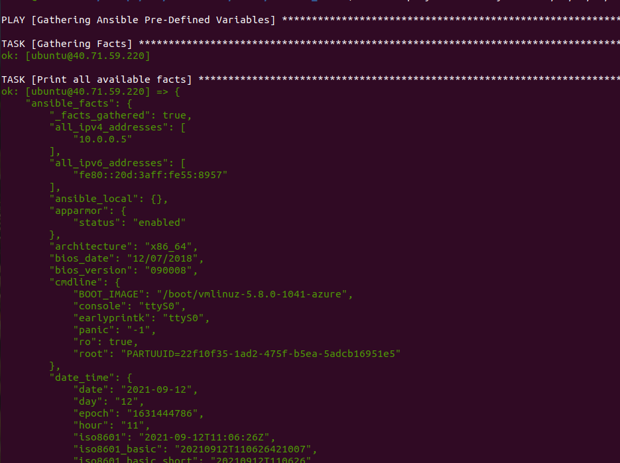

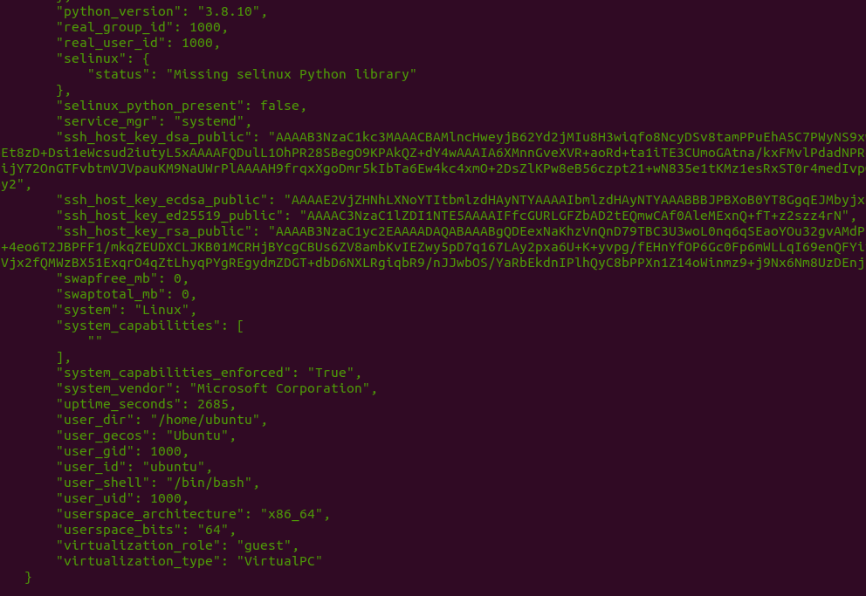

Task9: Run only one Task in playbook using tags

Yml file: <https://github.com/kiranpe/AzureTasks/blob/master/Task4/Ansible_Tasks/task9.yml>

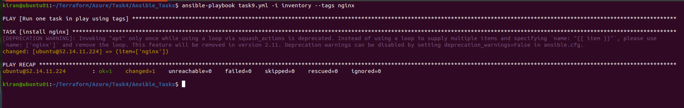

Task10: Playbook to create new user and password

Yml file: <https://github.com/kiranpe/AzureTasks/blob/master/Task4/Ansible_Tasks/task10.yml>

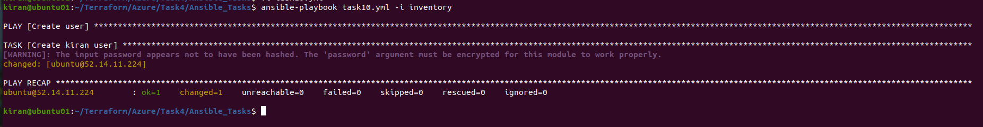

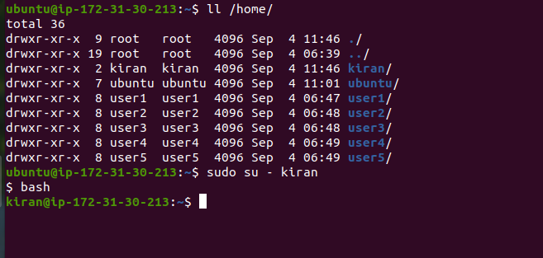

Task11: Pass Variable to Ansible Playbook

Yml file:

<https://github.com/kiranpe/AzureTasks/blob/master/Task4/Ansible_Tasks/task11.yml>

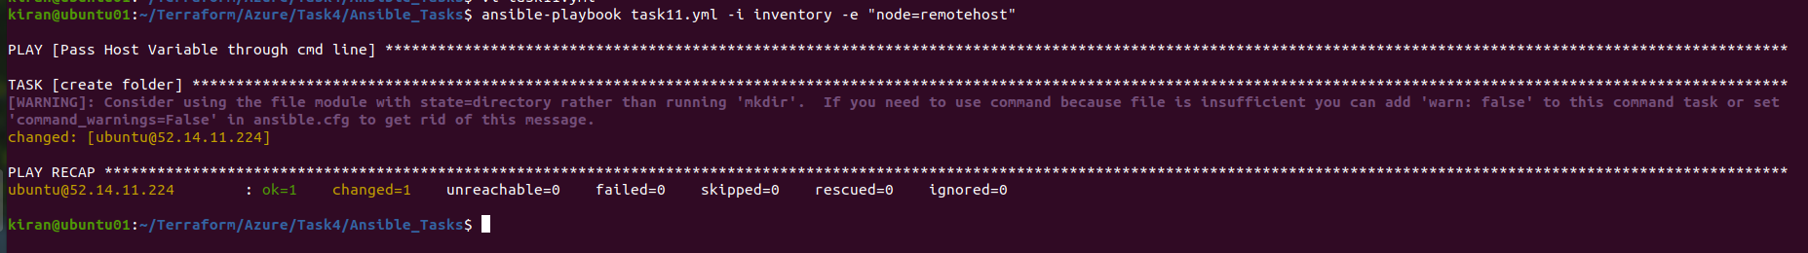

Task12: Playbook to delete files and folders inside a directory

Yml file:

<https://github.com/kiranpe/AzureTasks/blob/master/Task4/Ansible_Tasks/task12.yml>

