Docker && Kubernetes

Docker Task:

1.create a docker container with customized homepage of NGINX

Created Image

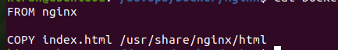





Index.html file



Successfully verified

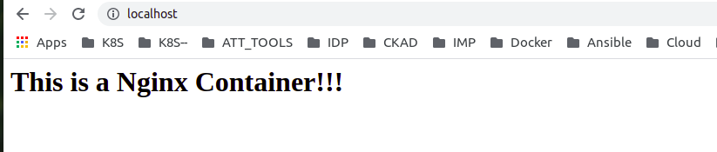

2.save image upload to hub.docker.com

Created Tag



Pushed Image to docker hub

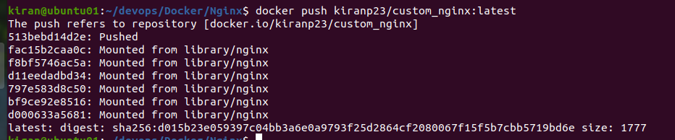

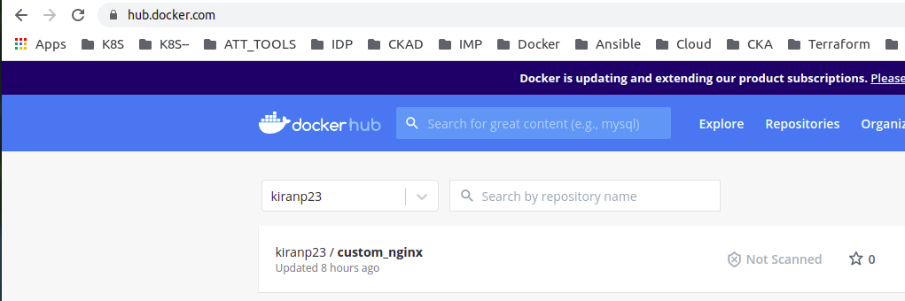

3. upload the image to azure CRegistry

Pushed to azure Container Registry

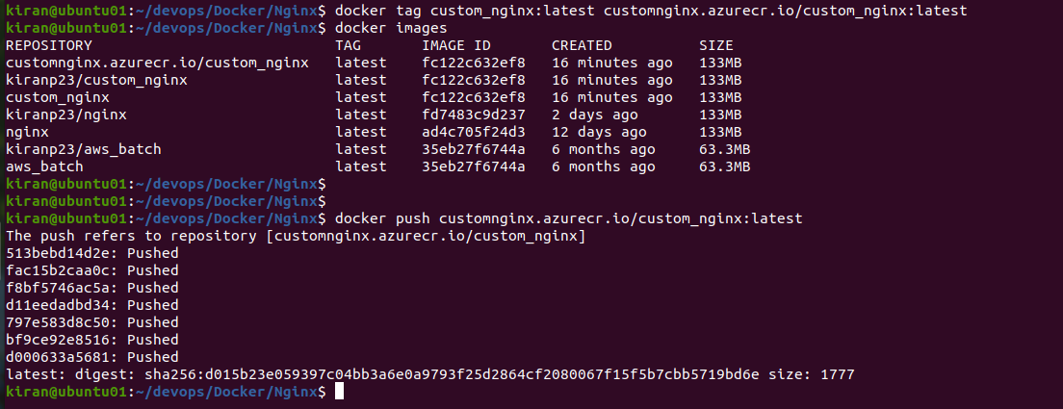

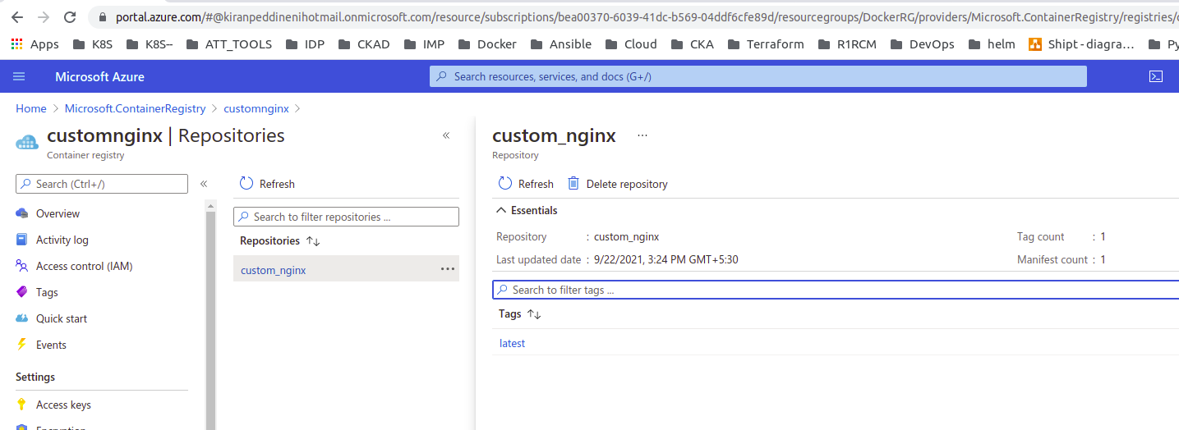

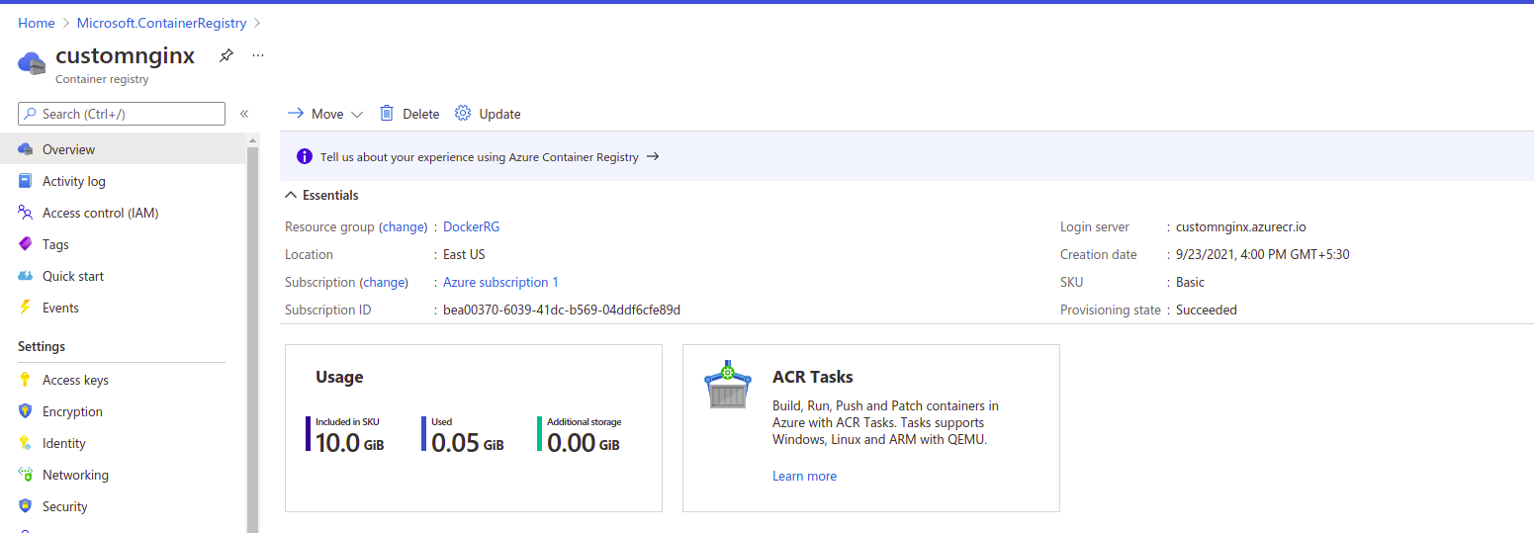

4. run created image in ACInstance

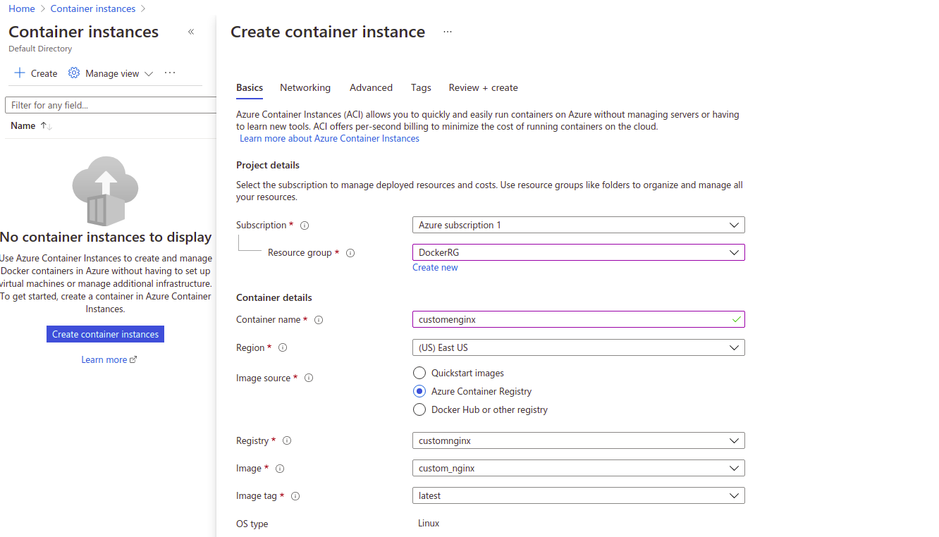

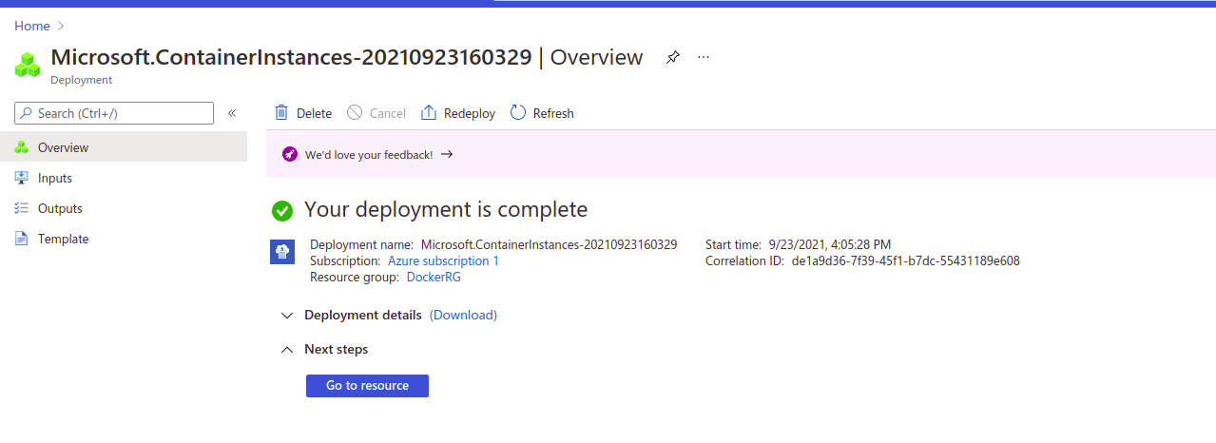

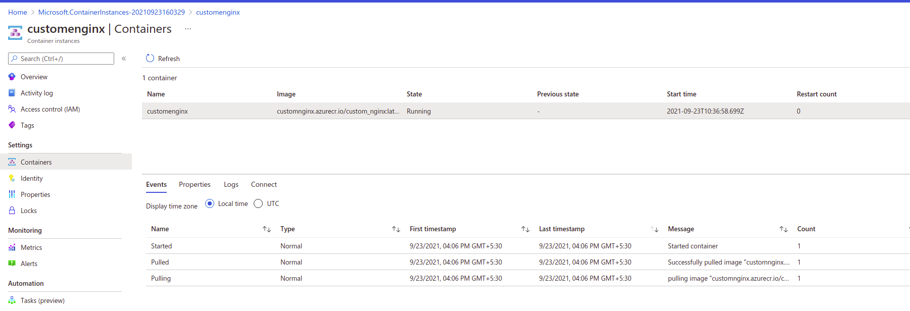

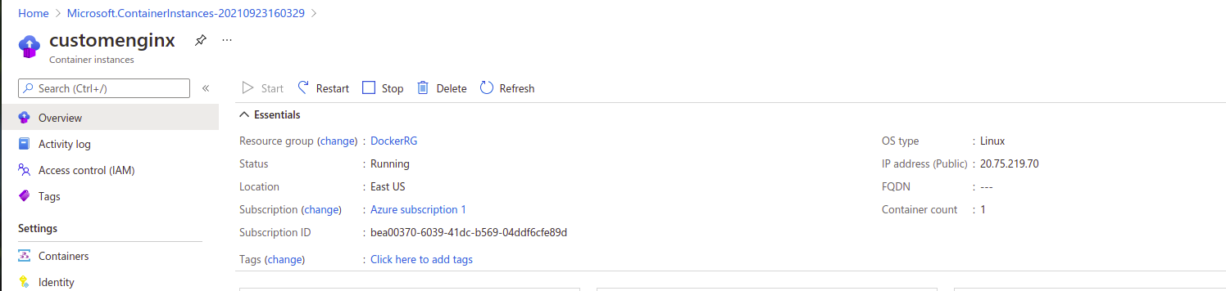

Tested Successfully

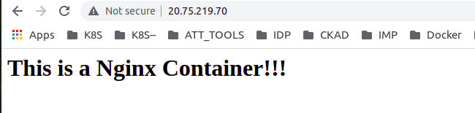

Kubernetes Task:

1) Create AKS Cluster

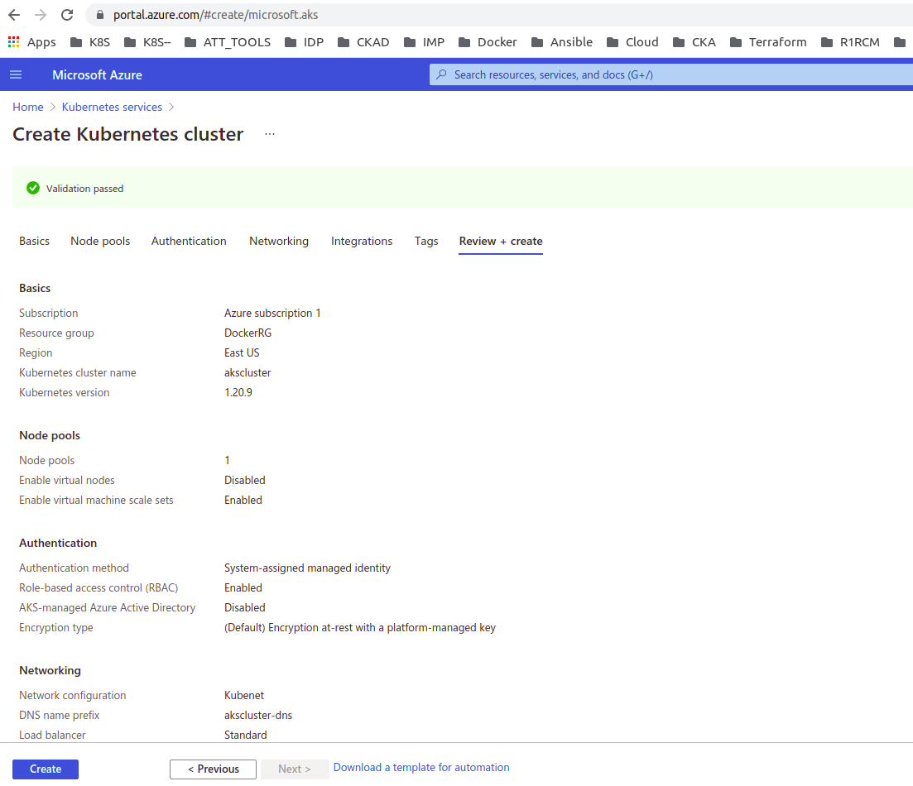

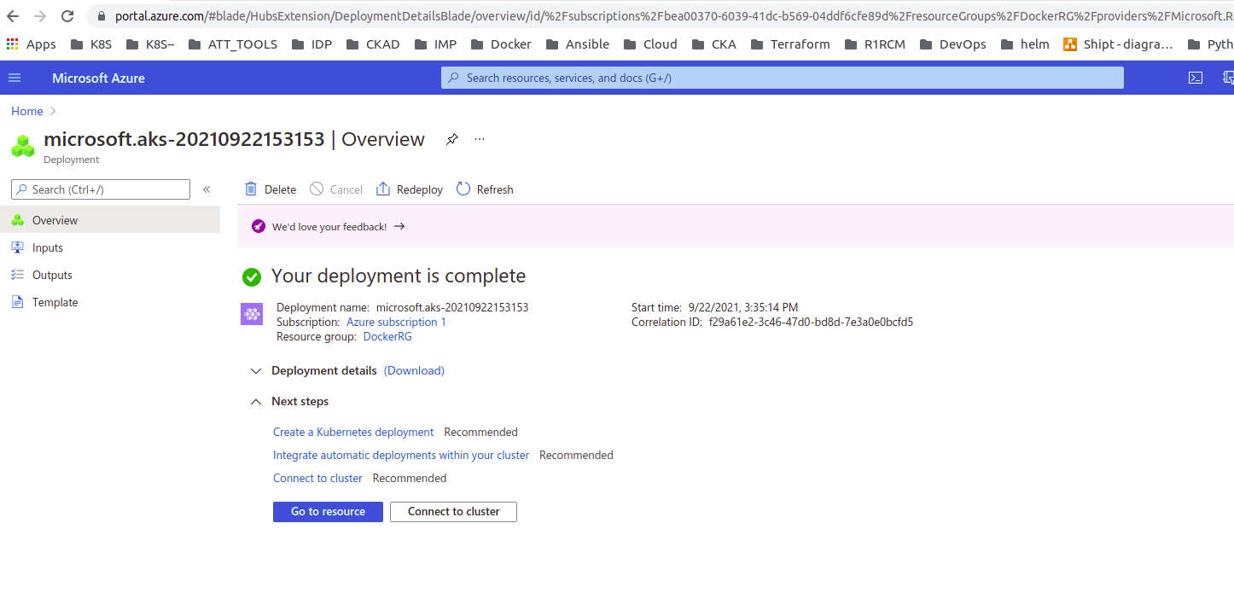

Setting up kubectl

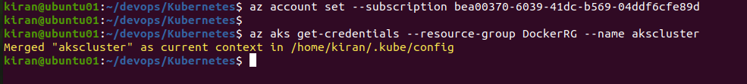

Successfully Connected

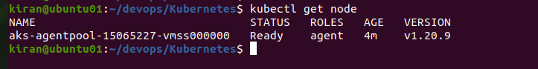

Deploying Your First Nginx Pod && Viewing Your Pod

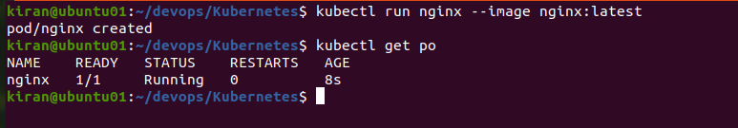

Where is your Pod running on?



Pod Output in JSON

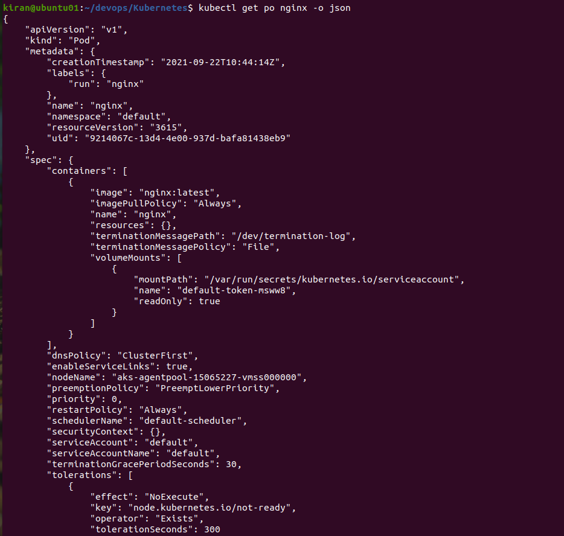

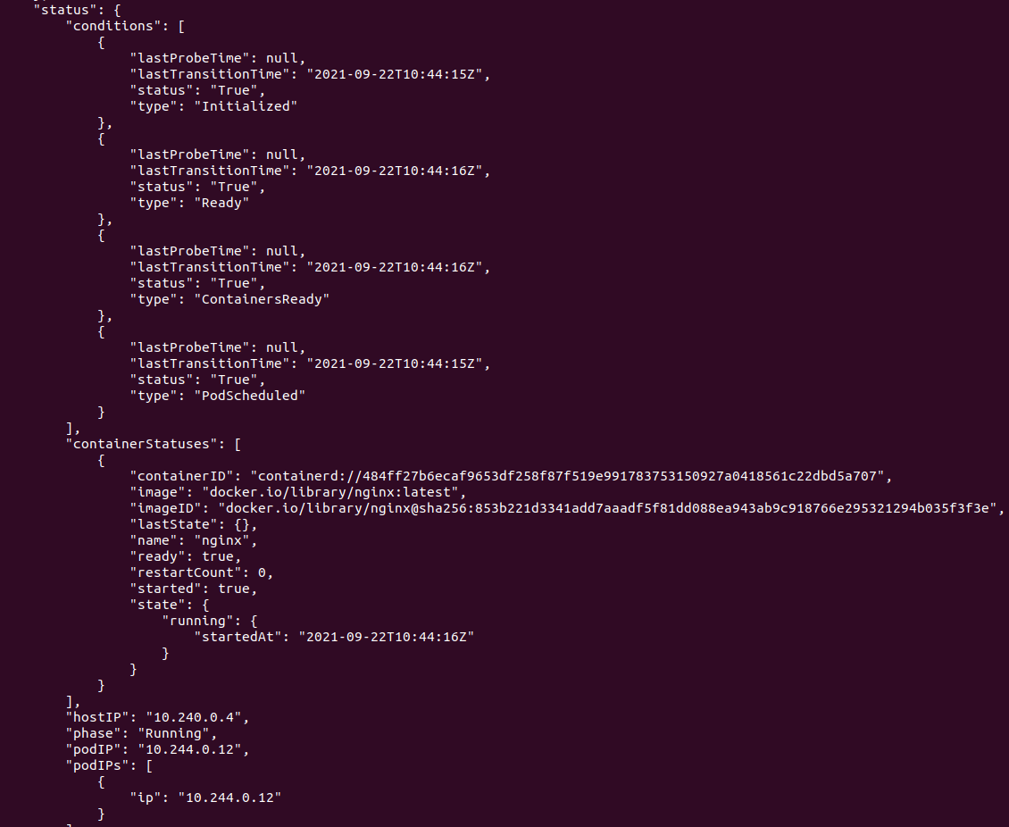

Executing Commands against Pod

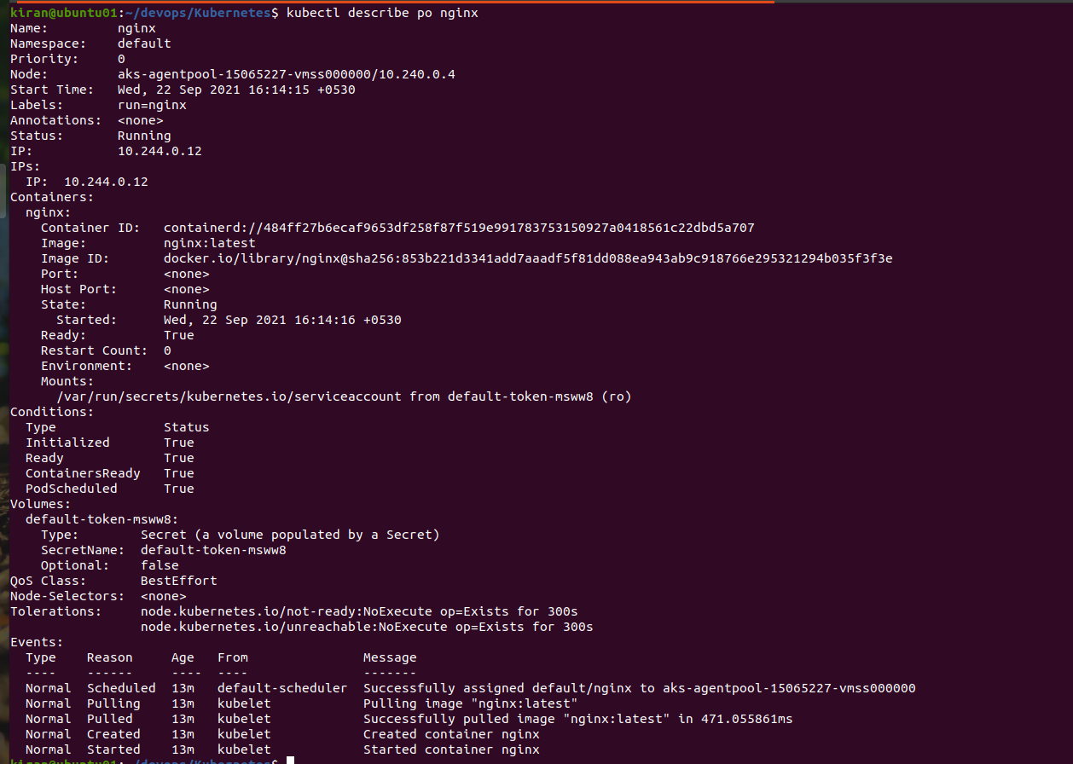

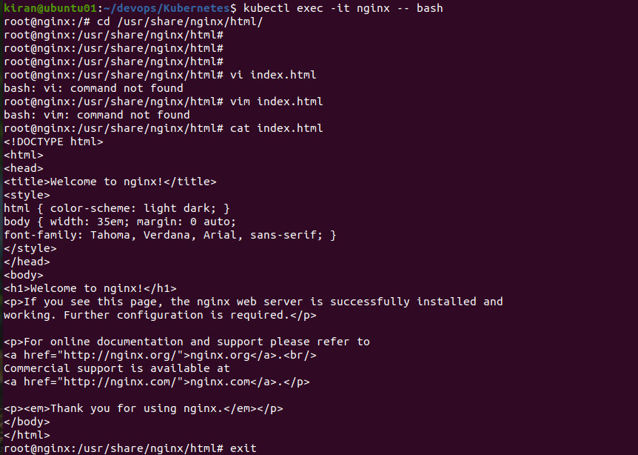

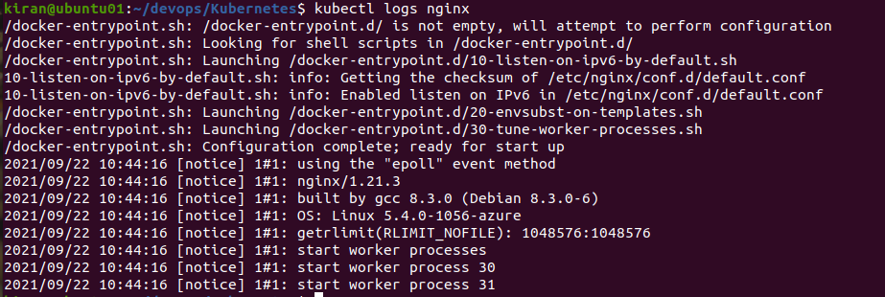

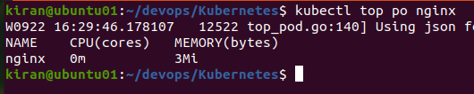

Terminating a Pod

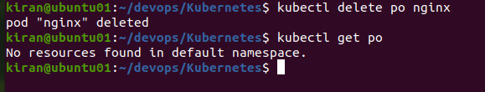

Adding a 2nd container to a Pod

Multi Containers:

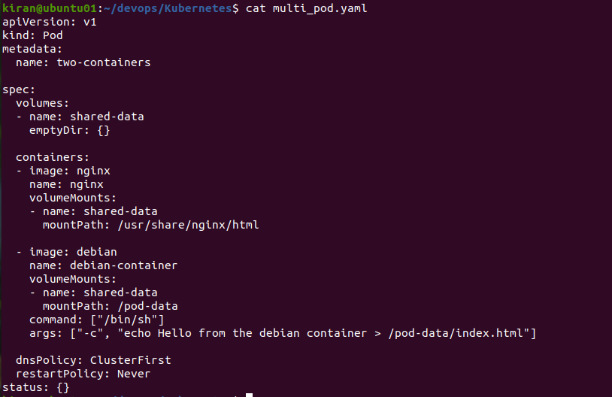



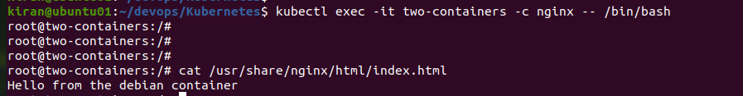



Init Containers:

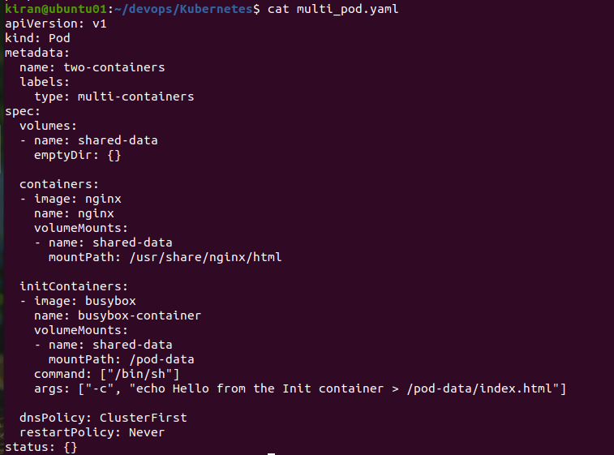



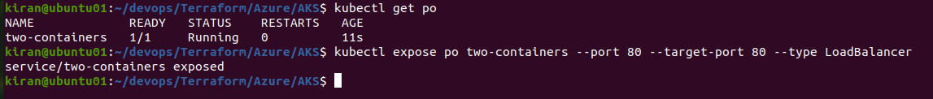

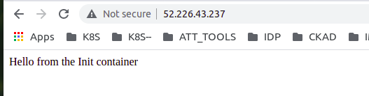

Creating Your First ReplicaSet - 4 Pods serving Nginx

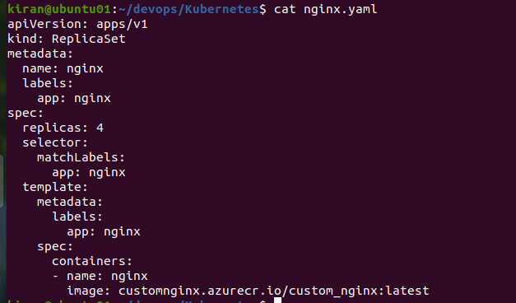

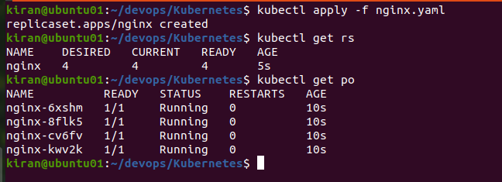

Removing a Pod from ReplicaSet

Deleted a pod but ReplicaSet always maintains desired No of pods

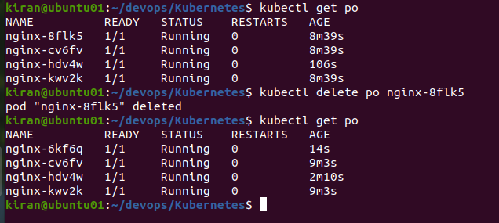

Scaling & Autoscaling a ReplicaSet

