



alaviiva

First name Last name – First name Last name

Title of project work

Subtitle

Metropolia University of Applied Sciences

Information and communication technologies

Software Engineering

Software project

Date

**Table of contents**

1 Introduction 1

2 Visio 1

3 Concepts, definitions 2

4 Conceptual model 2

4.1 Objective 2

4.2 Feeds 2

4.3 Printouts 2

4.4 Content 2

4.5 Assumptions and simplications 3

4.6 Description of the model 3

4.6.1 List of components 3

4.6.2 Process diagram 4

5 Programming implementation of the model 5

5.1 Programming languages and libraries used (exernal APIs) 5

5.2 Architecture 5

5.3 Structural description of the user interface 5

5.4 Description of internal logic 5

5.5 Descriptions of external data repositories (files, databases) 5

5.6 Testing 5

6 Simulator user manual 5

7 Simulation tests carried out 5

8 Summary 5

**Appendices**

Appendix 1. Javadoc-document

Appendix 2. Liitteen nimi

# Introduction

Here we explain the content and purpose of this document.

Throughout the document, use the Word predefined styles: *Title 1*, *Title 2* and *Title 3* for headings, and *plaint text* for the text content. Each paragraph of text ends with a single press of the Enter key. When you use the styles, the headings are automatically numbered and the table of contents is automatically generated.

Replace the template palint text with your own. Add chapters, subchapters and appendices as necessary. Do not leave unnecessary guiding texts in your document.

To update the automatically generated table of contents: (1) Highlight the list (select it with the mouse), it will turn grey. (2) Press F9.

# Visio

This is a brief description of the objective that the project is aiming to achieve. The vision answers the question “what wil be the end product of the project”. The vision can be presented as text and/or a picture.

Figure 1 shows an example of a vision picture (Note! and explanation of the picture is required).:

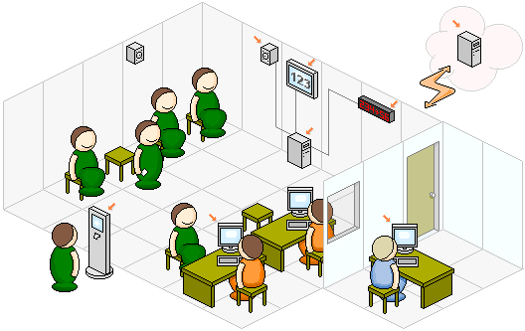

**Kuva 1.** Health centre simulation

# Concepts, definitions

This describes the concepts used in the document, which are then used systematically. An example of a concept definition:

*A client* is a person visiting a health centre.

*Service time* refers to the time it takes to visit a service point, e.g. a doctor.

*The list of events* is …

# Conceptual model

The conceptual model is a non-software-spesific description of the simulation model to be developed, which describes the model’s objectives, inputs, outputs, content, assumptions and simplifications.

## Objective

*What is the purpose of simulation? What is the aim, what do you want to find out? Who is expected to benefit from the results? What can the results be used for?*

## Feeds

*What output data cant he user provide to the simulation run? This could be, for example, the number of service points, the distributions and their parameters used for arrival intervals and service times, simulation time, etc.*

## Printouts

*Performance metrics! Describe what you get out of the simulation runs: utilization rates, throughput, queue lenghts, etc. Describe these in terms of your model, i.e., real-world concepts, e.g., bank teller utilization..*

## Content

*The limits of the model: what real-world issues are included in the model?*

*Model detail: how accurately are real-world components described in the model?*

## Assumptions and simplications

*Assumptions are beliefs that cannot be completely certain about the real world but are assumed to hold.*

*These simplifications will speed up the development and use of the model.*

*While assumptions relate to imperfect knowledge of the nature of the real world, simplifications relate to simplifying understandable real-world phenomena.*

## Description of the model

### List of components

*The component list serves as a checklist of things to consider.*

*Note that these are components of the model world. They do not include, e.g., clock, event, event list.*

Example:

|  |  |
| --- | --- |
| **Component** | **Features** |
| Customer | distribution of arrival delays |
| Registration hall | queue at the registration desk If the number of chairs is finite, the queue has finite capacity. |
| Registration desk | distribution of service time |
| Doctor’s queue | infinite capacity |
| Doctor | distribution of service time |

In general, all queues are allowed to be infinite in simulations (there is no capacity limit). In some situations, you may want to specify a capacity for queues, e.g., as above, to model the adequacy of chairs (only seated customers can fit the lobby). In this case, you need to model how to deal with customers who cannot fir in the lobby.

### Process diagram

A process diagram can visualise the structure of the system and, like a list of components, it shows the things to consider.

Figure 2 shows an example of a one-stop shop system.

Customers Queue (capacity) Registration desk (service time distribution)

(arrival interval-time)

**Kuva 2.** Description of a single point of service in the process diagram

# Programming implementation of the model

## Programming languages and libraries used (exernal APIs)

## Architecture

High-level components and the connections between them in a graph (e.g., MVC).

## Structural description of the user interface

It is worth presenting with screenshots.

## Description of internal logic

(Event list, Events, Clock, etc.)

## Descriptions of external data repositories (files, databases)

## Testing

Testing in general + Junit tests

# Simulator user manual

Tells the user what to do (inputs).

The results data, and how to read/interpret them are also explained.

This part of the document can be detached and will work as such.

Make sufficient use of the user interface images.

# Simulation tests carried out

What was tried and what was found out.

It is worthwhile to contribute to this section by presenting different simulation runs.

# Summary