**Slide3:**

Salesforce:

**Salesforce, Inc.** is an [American](https://en.wikipedia.org/wiki/United_States) [cloud](https://en.wikipedia.org/wiki/Cloud_computing)-based software company headquartered in [San Francisco, California](https://en.wikipedia.org/wiki/San_Francisco,_California). It provides [customer relationship management](https://en.wikipedia.org/wiki/Customer_relationship_management) (CRM)

software and applications focused on [sales](https://en.wikipedia.org/wiki/Sales), [customer service](https://en.wikipedia.org/wiki/Customer_service), [marketing automation](https://en.wikipedia.org/wiki/Marketing_automation), [e-commerce](https://en.wikipedia.org/wiki/E-commerce), [analytics](https://en.wikipedia.org/wiki/Analytics), and application development.

Salesforce Testing:

Salesforce testing is the Process of Verifying a salesforce Customization & configuration with the Purpose of Identifying any Errors, gaps, or Missing requirements versus the Actual requirement.

Testing helps to identify and fixe any possible bugs in the application before it goes live.

**Slide4:**

**Sales cloud**: 🡪sales cloud is a specific product offers by the Salesforce that is designed to help the Companies manage their sales processes and Customer relationships

Key feature:

**a.Lead Management**: Track your Leads from click to close, while continually optimising your campaigns across Every channel.

Lead: is used to store the info of a potential customer who wants to buy your product. He is not yet customer.

**b.Account & contact Management**:

If he is already a previous customer, then you can store his info on account.

Account: we store the info of our customers basically prospects to whom we are working to do deal to close something. An object we can store the info of prospects.

**c.Opportunity management:**

where you can store the info of deals that are about to happen or already happened even, we have lost it or won the opportunity. Deal will be with amount or on different stages.

d. **sales forecasting and Analytics:**

sales cloud offers sales forecasting tools to help you predict future sales and revenue. you can also analyze your sales data to identify trends, track performance and gain insights into your Business.

2. Service cloud: Service cloud is customer service and support application from the salesforce. Service cloud can help you deliver personalized support form to your customer by email (email to case), phone, social media, chat.

3.**Commerce Cloud**: is cloud based-SaaS e commerce Platform developed by salesforce. It provides a comprehensive set of tools for businesses to create and manage their online storefronts

**a. Order Management:** commerce cloud provides business with tools to manage order across all the channels, including online, mobile and in-stores to fulfill order Quickly & efficient.

b. Me**rchandising**: commerce cloud allows business to manage their product catalog, pricing, and Promotions across all channels. It easier to merchandising and promote their products

c. **AI-powered personalization:** it uses Ai to provide personalized recommendations, search results and product suggestions based on the customer data behavior.

4. **Experience cloud:** that is designed to help businesses create engaging experience for their customers

1. Content Management: it provides Business with tools to Manage and Publish their content across all the digital channels, including websites, mobile apps, and social media.
2. Personalization: uses the customer data and AI to provide personalized content recommendations, offers to each individual customer.

5.**Analytics Cloud**: its Integrates with various data sources, including salesforce data, external databases and third-party applications allowing businesses to analyze date.

a. **Data integration:** allows businesses to integrate the data from various sources, including salesforce data and third-party applications.

b. visu**alization**: Analytics cloud provides a suite of tools for creating dashboards & reports. User can choose the range of visualization types, including charts & tables.

C. **Mobile access:** it’s optimized for mobile devices, allowing users to access their data and reports from anywhere & anytime.

6.**Marketing Cloud**: **Salesforce Marketing Cloud**is a cloud marketing platform that empowers users to deliver relevant and personalized journeys across different platforms and devices.

a. **Email Marketing:** MC provides email marketing tools that enables business to create and delivery personalized, targeted emails campaigns to customers

b.**Social Media Marketing:** marketing cloud allows business to manage social media campaigns and Engage with customers across the all social media platforms, including Facebook, twitter, Instagram.

1. **Data Management:** Businesses to collect, store and manage customer data, including behaviour and engagement data in single location.
2. **Analytics:** Mc provides the real time analytics and reporting tools that enable business the to measure the Success of their campaigns.

Slide 5:

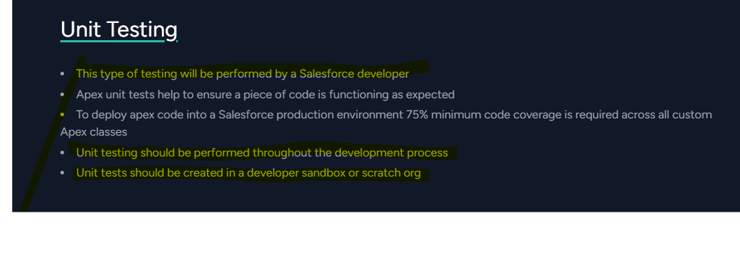

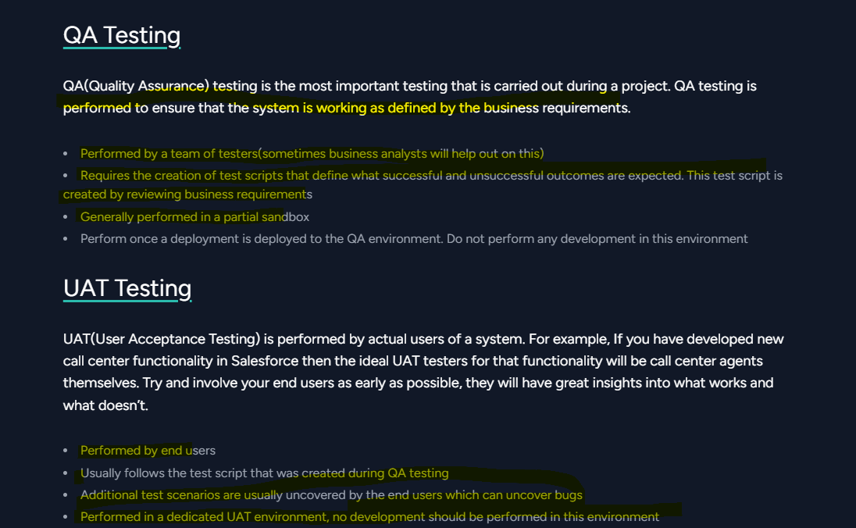

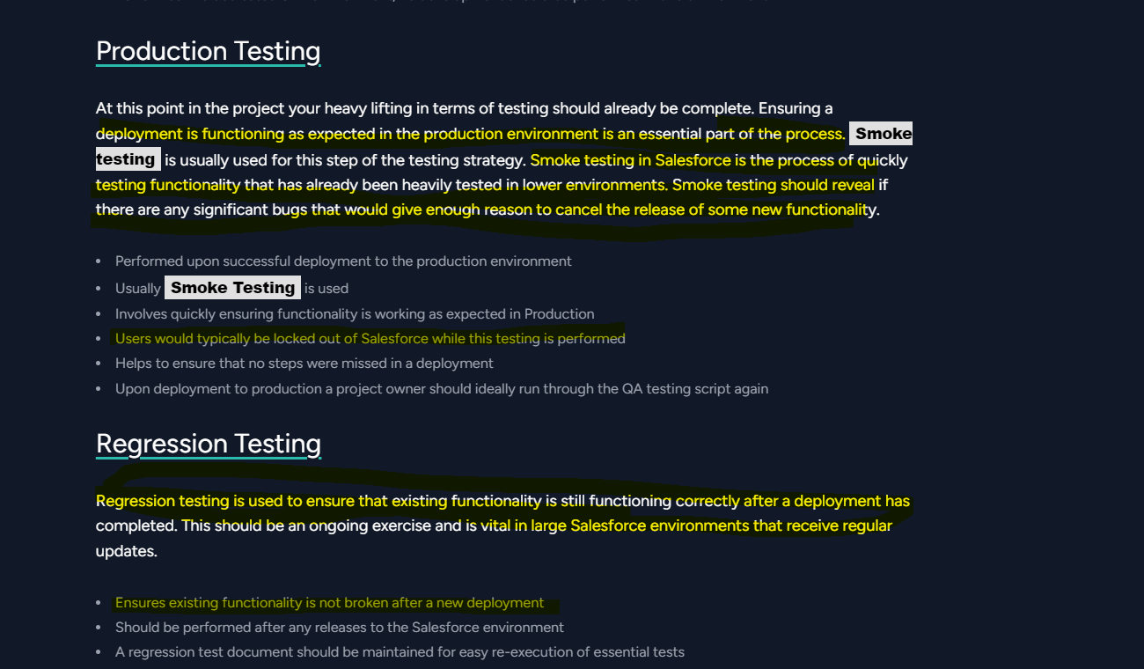

Regression testing is a software testing practice that ensures an application still functions as expected after any code changes, updates, or improvements. Regression testing is responsible for the overall stability and functionality of the existing features.

Slide 6:

Types of Objects in salesforce:

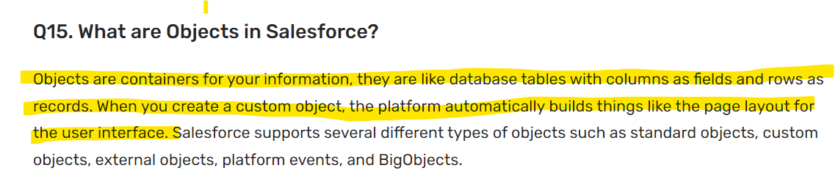

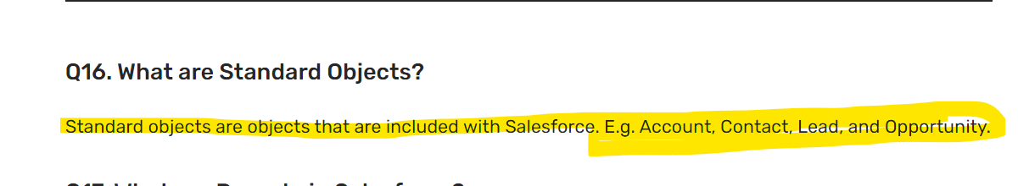

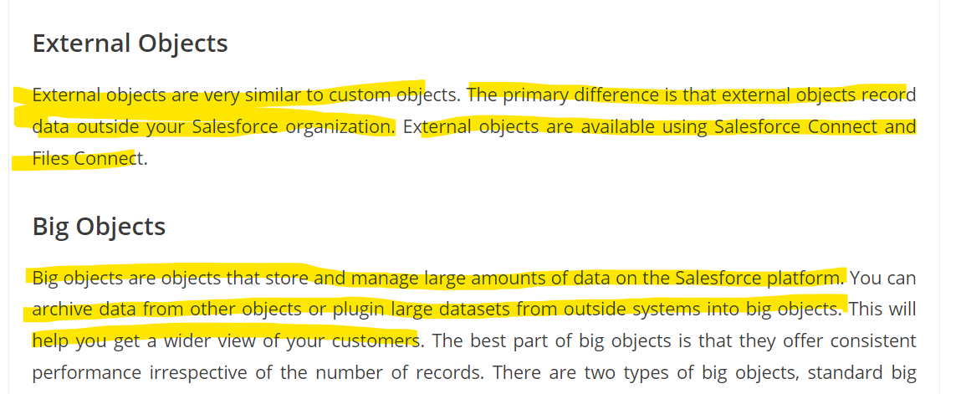

Roles & Profiles

