NAME: kiran Rajput ROLL NO:32
REG: 11607472

Case1: Ecommerce company wants to check the sales seasonality for products and wants to emphasis accordingly on such category.
TASK: Analyze sales according to various seasons [Summers and Winters] and give names of 2 products those fluctuate their sales due to seasonal change.
ANS1:PRODUCTS WHOSE SALE FLACTUATES ARE
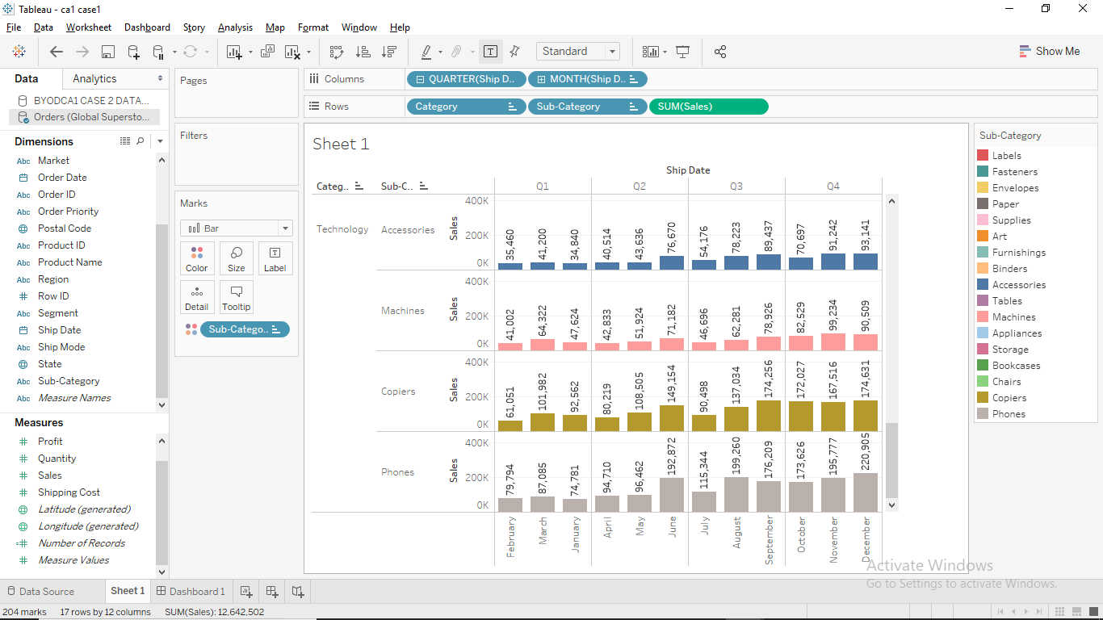

Case2: You have been the dataset of Titanic Ship and needs to find some insights from that dataset.
TASK1: Which gender is given more preference for survival.
TASK2: Which age group of people are mostly not survived.
TASK3: Passengers paying more fare given priority for survival?
TASK4: Inequalities between various class also leads to low survival rate for which class?
ANS2:
TASK1:
FEMALES ARE GIVEN MORE PREFERENCE FOR SURVIVAL
TASK2:
AGE GROUP MOSLY NOT SURVIVED : 45-71
TASK3:
PASSANGERS PAYING MORE WERE GIVEN PRIORITY FOR SURVIVAL
TASK4:
INEQUALITIES BETWEEN CLASS ALSO LEADS TO LOW SURVIVAL RATE OF CLASS 3
