SIMATS ENGINEERING
CSA6303- Threat Intelligence and Network Security
A1-Malware Analysis Assignment
Assessment Questions
Subject | Threat Intelligence | Total Marks | 30
Questions | 3 (all compulsory) | Marks per Question | 10
REg.No | 192312353 | Name | VELUGU KIRAN BOJA RAJU
Faculty | Dr.V.Parthipan | Slot | A
Instructions: Answer all questions. Each question carries 5 marks. Support answers with examples and diagrams where appropriate.
CO3: Perform threat analysis using intelligence models and utilize industry tools for monitoring and detection.

Code of Conduct:

I VELUGU KIRAN BOJA RAJU/192312353 (Name / Reg No) certify that this submission is my original work and that I have adhered to the guidelines specified for this assessment. I understand that any violation of academic integrity rules will result in disciplinary action.

Signature of Student :V.Kiran

Questions :

Exercise 1: Threat Intelligence Platform Investigation
Objective: To investigate suspicious IP addresses, domains, and file hashes using a threat intelligence platform.
Practical Tasks:
- Examine sample IoCs using VirusTotal or another authorized threat intelligence platform.
- Review available reputation scores and threat classifications.
- Record the findings and recommend appropriate security actions.
Expected Output: A threat intelligence investigation report.

Exercise 2: Security Log Collection and Correlation
Objective: To collect and correlate security events from different sources.
Practical Tasks:
- Collect sample authentication, firewall, and web server logs.
- Identify common IP addresses, timestamps, and user activities.
- Correlate events to identify suspicious patterns.
Expected Output: A correlated security event summary.

Exercise 3: Threat Hunting Using Network Logs
Objective: To identify suspicious network activities through proactive threat hunting.
Practical Tasks:
- Examine sample network traffic logs.
- Identify unusual outbound connections and repeated connection attempts.
- Investigate suspicious communication patterns and document relevant IoCs.
Expected Output: A threat-hunting report with findings and recommendations.

ANSWERS

1.
import urllib.request
import urllib.error
import json
import csv
# VirusTotal API Key
API_KEY = "YOUR_VIRUSTOTAL_API_KEY"
BASE_URL = "https://www.virustotal.com/api/v3"
# Sample Indicators of Compromise
sample_iocs = {
"ip_addresses": [
"8.8.8.8",
"1.1.1.1",
"185.199.110.153"
],
"domains": [
"google.com",
"example.com",
"github.com"
],
"file_hashes": [
"44d88612fea8a8f36de82e1278abb02f"
]
}
results = []
# Investigate IP, Domain and File Hash
def investigate_ioc(ioc, ioc_type):
print("\nInvestigating:", ioc)
url = f"{BASE_URL}/{ioc_type}/{ioc}"
headers = {
"x-apikey": API_KEY
}
request = urllib.request.Request(
url, headers=headers
)

try:
with urllib.request.urlopen(
request, timeout=20
) as response:
data = json.loads(response.read())
attributes = data["data"]["attributes"]
stats = attributes.get(
"last_analysis_stats", {}
)
malicious = stats.get("malicious", 0)
suspicious = stats.get("suspicious", 0)
harmless = stats.get("harmless", 0)
undetected = stats.get("undetected", 0)
reputation = attributes.get(
"reputation", "Not Available"
)
if malicious > 0:
classification = "Malicious"

elif suspicious > 0:
classification = "Suspicious"
else:
classification = "No Malicious Detection"
result = {
"Indicator": ioc,
"Type": ioc_type,
"Reputation": reputation,
"Malicious": malicious,
"Suspicious": suspicious,
"Harmless": harmless,
"Undetected": undetected,
"Classification": classification
}

results.append(result)

print("Reputation:", reputation)
print("Malicious:", malicious)
print("Suspicious:", suspicious)
print("Harmless:", harmless)
print("Undetected:", undetected)
print("Classification:", classification)
except urllib.error.HTTPError as e:
if e.code == 401:
print("Invalid API key!")
elif e.code == 404:
print("Indicator not found!")
elif e.code == 429:
print("API rate limit exceeded!")
else:
print("HTTP Error:", e.code)
except Exception as e:
print("Error:", e)
# Main Program
print("====================================")
print(" THREAT INTELLIGENCE INVESTIGATION")
print("====================================")
for ip in sample_iocs["ip_addresses"]:
investigate_ioc(ip, "ip_addresses")
for domain in sample_iocs["domains"]:
investigate_ioc(domain, "domains")
for file_hash in sample_iocs["file_hashes"]:
investigate_ioc(file_hash, "files")
# Generate CSV Report
if results:
with open(
"threat_intelligence_report.csv",
"w",
newline=""
) as file:
writer = csv.DictWriter(
file,
fieldnames=results[0].keys()
)
writer.writeheader()
writer.writerows(results)
print("\n====================================")
print(" INVESTIGATION REPORT GENERATED")
print("====================================")
print("Total IoCs investigated:", len(results))
for item in results:
print(
item["Indicator"],
"=>",
item["Classification"]
)
print("\nReport saved as:")
print("threat_intelligence_report.csv")
else:
print("\nNo results available.")

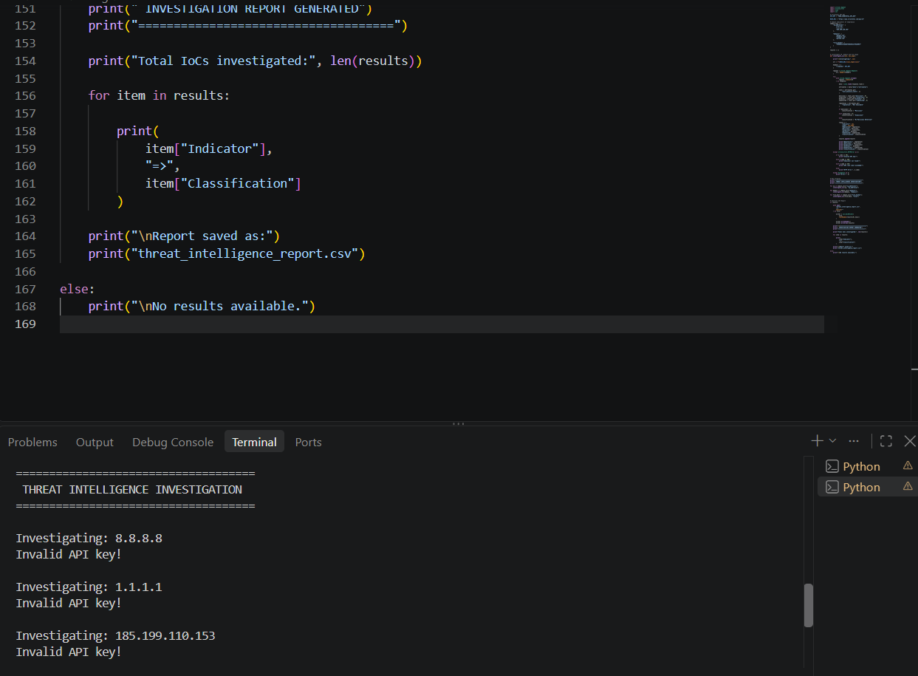
2.
import pandas as pd
# Authentication logs
auth_logs = [
["09:10:12", "192.168.1.15", "admin", "Failed"],
["09:10:18", "192.168.1.15", "admin", "Failed"],
["09:10:25", "192.168.1.15", "admin", "Success"],
["09:15:30", "192.168.1.20", "user1", "Success"]
]
# Firewall logs
firewall_logs = [
["09:10:10", "192.168.1.15", 22, "Allowed"],
["09:10:15", "192.168.1.15", 22, "Allowed"],
["09:10:20", "192.168.1.15", 443, "Allowed"],
["09:16:10", "192.168.1.25", 3389, "Blocked"]
]

# Web server logs
web_logs = [
["09:10:30", "192.168.1.15", "/admin", 401],
["09:10:35", "192.168.1.15", "/admin", 401],
["09:10:40", "192.168.1.15", "/dashboard", 200],
["09:15:45", "192.168.1.20", "/home", 200]
]

auth = pd.DataFrame(
auth_logs,
columns=["Time", "IP", "Username", "Event"]
)

firewall = pd.DataFrame(
firewall_logs,
columns=["Time", "IP", "Port", "Action"]
)
web = pd.DataFrame(
web_logs,
columns=["Time", "IP", "URL", "Status"]
)
print("\nAUTHENTICATION LOGS")
print(auth.to_string(index=False))
print("\nFIREWALL LOGS")
print(firewall.to_string(index=False))
print("\nWEB SERVER LOGS")
print(web.to_string(index=False))
# Find common IP addresses
common_ips = set(auth["IP"]) & set(firewall["IP"]) & set(web["IP"])
print("\nCORRELATED SECURITY EVENTS")
for ip in sorted(common_ips):
failed = len(auth[
(auth["IP"] == ip) &
(auth["Event"] == "Failed")
])

successful = len(auth[
(auth["IP"] == ip) &
(auth["Event"] == "Success")
])
web_errors = len(web[
(web["IP"] == ip) &
(web["Status"] == 401)
])
print("\nIP Address:", ip)
print("Failed Logins:", failed)
print("Successful Logins:", successful)
print("Unauthorized Web Requests:", web_errors)
if failed >= 2 and successful >= 1:
print("Alert: Suspicious login pattern detected!")
if web_errors >= 2:
print("Alert: Repeated unauthorized web requests!")

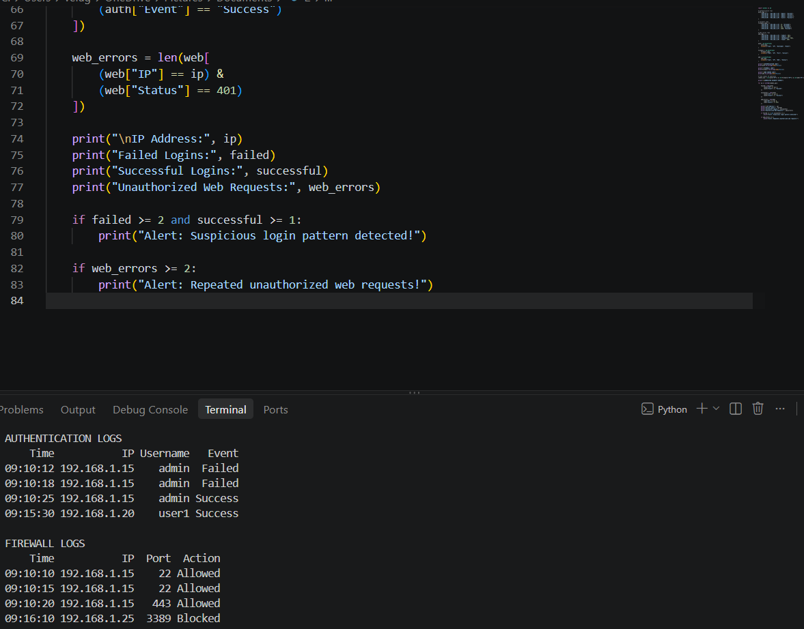
3.
import pandas as pd

# Sample network traffic
network_logs = [
["10:00:10", "192.168.1.10", "8.8.8.8", 53, "Allowed"],
["10:01:15", "192.168.1.10", "185.199.110.153", 443, "Allowed"],
["10:01:20", "192.168.1.10", "185.199.110.153", 443, "Allowed"],
["10:01:25", "192.168.1.10", "185.199.110.153", 443, "Allowed"],
["10:02:10", "192.168.1.12", "203.0.113.50", 4444, "Blocked"],
["10:02:15", "192.168.1.12", "203.0.113.50", 4444, "Blocked"],
["10:03:30", "192.168.1.15", "8.8.8.8", 53, "Allowed"]
]

df = pd.DataFrame(
network_logs,
columns=[
"Time", "Source_IP",
"Destination_IP", "Port", "Status"
]
)

print("NETWORK TRAFFIC LOGS")
print(df.to_string(index=False))

print("\nTHREAT HUNTING ANALYSIS")

# Identify repeated connections
connections = df.groupby(
["Source_IP", "Destination_IP", "Port"]
).size().reset_index(name="Attempts")

for _, row in connections.iterrows():

print("\nSource IP:", row["Source_IP"])
print("Destination IP:", row["Destination_IP"])
print("Port:", row["Port"])
print("Attempts:", row["Attempts"])

if row["Attempts"] >= 2:
print("Alert: Repeated connection detected!")

if row["Port"] == 4444:
print("Alert: Unusual port requires investigation!")

# Identify blocked connections
blocked = df[df["Status"] == "Blocked"]

print("\nBLOCKED CONNECTIONS")

if not blocked.empty:
print(blocked.to_string(index=False))
print("Warning: Blocked outbound connection attempts detected.")

print("\nTHREAT HUNTING COMPLETED")


