**ASSESSMENT - 2**

**NAME: KIRAN R**

**REG NO.: 21MICO167**

**SUBJECT TITLE: ADVANCED SERVER SIDE PROGRAMMING**

**COURSE CODE: CSI3023**

**LAB SLOT: L21+L22**

Q) You are asked to carry out the registration process of an expert talk on "Web Services". First, you need to provide the form, which includes the participant personal details (Name, Id, Designation, Affiliation, Fee). Expected participants are students, researchers and software engineer. The registration fee is fixed depends on their designation that means students (500/-), researchers (1000/-) and software engineer (2000/-). The event is organized for the fixed number of participations to 15 each category with 5 participation. You need to display the message as "Registration Full" while it reaches the maximum registration. Once the registration is completed, generate the participation report. The report should contain the list of participant details on each category.

**Code:**

import java.io.IOException;

import java.io.PrintWriter;

import java.util.ArrayList;

import java.util.List;

import javax.servlet.ServletException;

import javax.servlet.annotation.WebServlet;

import javax.servlet.http.HttpServlet;

import javax.servlet.http.HttpServletRequest;

import javax.servlet.http.HttpServletResponse;

@WebServlet("/RegistrationServlet")

public class NewServlet extends HttpServlet {

private static final long serialVersionUID = 1L;

private int studentCount = 0;

private int researcherCount = 0;

private int engineerCount = 0;

private final int MAX_PARTICIPANTS_PER_CATEGORY = 5;

private final List<Participant> participants = new ArrayList<>();

@Override

protected void doGet(HttpServletRequest request, HttpServletResponse response) throws ServletException, IOException {

response.setContentType("text/html");

PrintWriter out = response.getWriter();

// Displaying the registration form

out.println("<html><head><title>Web Services</title></head><body>");

out.println("<h1>Web Services</h1>");

out.println("<form method='post'>");

out.println("Name: <input type='text' name='name'><br>");

out.println("ID: <input type='text' name='id'><br>");

out.println("Designation: <select name='designation'>");

out.println("<option value='Student'>Student</option>");

out.println("<option value='Researcher'>Researcher</option>");

out.println("<option value='Software Engineer'>Software Engineer</option>");

out.println("</select><br>");

out.println("Affiliation: <input type='text' name='affiliation'><br>");

out.println("Fees: <input type='text' name='fees'><br>");

out.println("<input type='submit' value='Register'>");

out.println("</form>");

out.println("</body></html>");

}

@Override

protected void doPost(HttpServletRequest request, HttpServletResponse

response) throws ServletException, IOException {

String name = request.getParameter("name");

String id = request.getParameter("id");

String designation = request.getParameter("designation");

int fee = 0;

switch(designation) {

case "Student":

if (studentCount < MAX_PARTICIPANTS_PER_CATEGORY) {

fee = 500;

studentCount++;

} else {

response.setContentType("text/html");

PrintWriter out = response.getWriter();

out.println("<html><head><title>Registration is Full</title></head><body>");

out.println("<h2>Registration Full</h2>");

out.println("<p>Maximum number of registrations for Students has been reached!</p>");

out.println("</body></html>");

return;

}

break;

case "Researcher":

if (researcherCount < MAX_PARTICIPANTS_PER_CATEGORY) {

fee = 1000;

researcherCount++;

}

else

{

response.setContentType("text/html");

PrintWriter out = response.getWriter();

out.println("<html><head><title>Registration is Full</title></head><body>");

out.println("<h2>Registration Full</h2>");

out.println("<p>Maximum number of registrations for Researchers has been reached!</p>");

out.println("</body></html>");

return;

}

break;

case "Software Engineer":

if (engineerCount < MAX_PARTICIPANTS_PER_CATEGORY) {

fee = 2000;

engineerCount++;

} else {

response.setContentType("text/html");

PrintWriter out = response.getWriter();

out.println("<html><head><title>Registration is Full</title></head><body>");

out.println("<h2>Registration Full</h2>");

out.println("<p>Maximum number of registrations for software engineers has been reached!</p>");

out.println("</body></html>");

return;

}

break;

default:

break;

}

participants.add(new Participant(name, id, designation, fee));

response.setContentType("text/html");

PrintWriter out = response.getWriter();

out.println("<html><head><title>RegistrationConfirmation</title></head><body>");

out.println("<h2>Registration Confirmation</h2>");

out.println("<p>Name: " + name + "</p>");

out.println("<p>ID: " + id + "</p>");

out.println("<p>Designation: " + designation + "</p>");

out.println("<p>Registration Fee: " + fee + "</p>");

out.println("</body></html>");

if (participants.size() == 15) {

generateParticipationReport(response);

}

}

private void generateParticipationReport(HttpServletResponse response)

throws IOException {

response.setContentType("text/html");

PrintWriter out = response.getWriter();

out.println("<html><head><title>ParticipationReport</title></head><body>");

out.println("<h2>Participation Report</h2>");

out.println("<h3>Students:</h3>");

for (Participant participant : participants) {

if (participant.getDesignation().equals("Student")) {

out.println("<p>Name: " + participant.getName() + ", ID: " +

participant.getId() + "</p>");

}

}

out.println("<h3>Researchers:</h3>");

for (Participant participant : participants) {

if (participant.getDesignation().equals("Researcher")) {

out.println("<p>Name: " + participant.getName() + ", ID: " +

participant.getId() + "</p>");

}

}

out.println("<h3>Software Engineers:</h3>");

for (Participant participant : participants) {

if (participant.getDesignation().equals("Software Engineer")) {

out.println("<p>Name: " + participant.getName() + ", ID: " +

participant.getId() + "</p>");

}

}

out.println("</body></html>");

}

}

class Participant {

private final String name;

private final String id;

private final String designation;

public Participant(String name, String id, String designation, int fee) {

this.name = name;

this.id = id;

this.designation = designation;

}

public String getName() {

return name;

}

public String getId() {

return id;

}

public String getDesignation() {

return designation;

}

}

**OUTPUT:**

**Entering details for Student:**

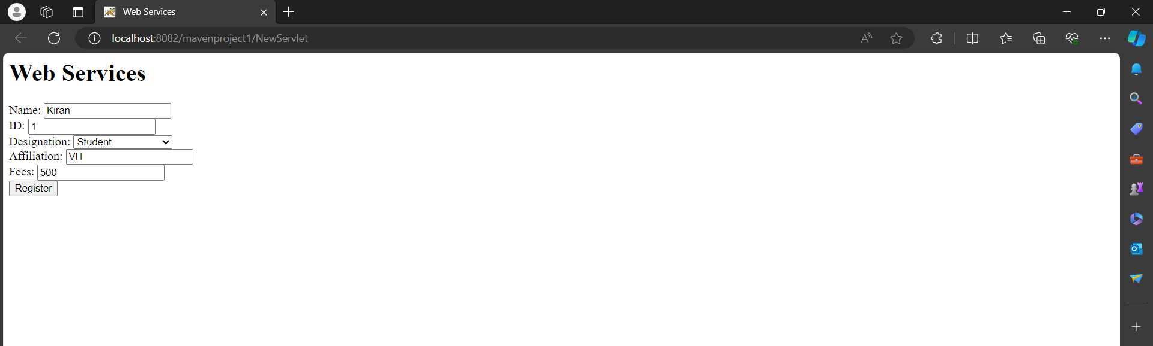

**Entering 6th details for Student:**

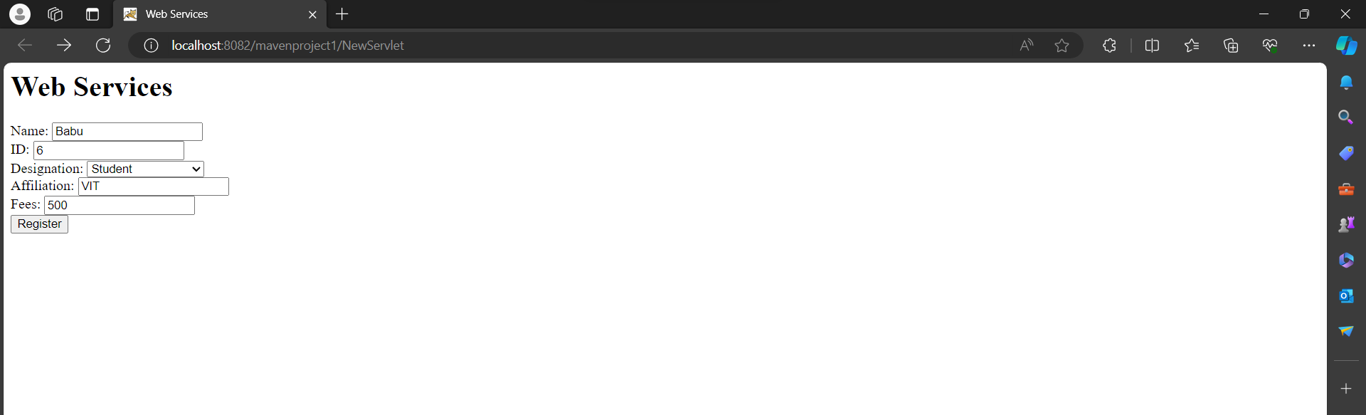

**Registration Full Error for Student Designation after 5th registration:**

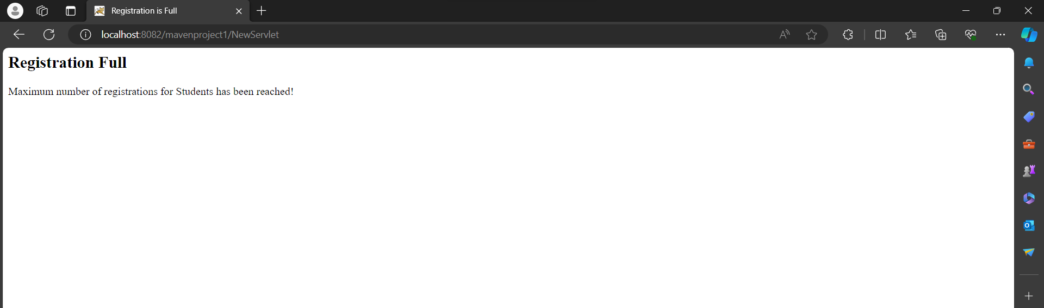

**Entering details for Researcher:**

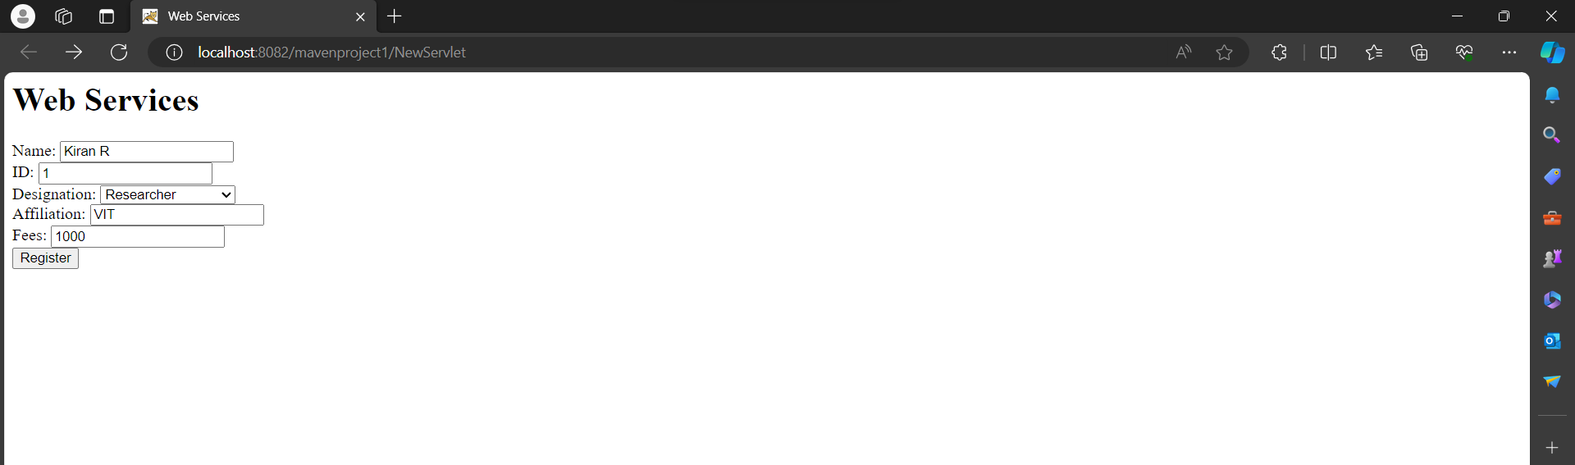

**Entering 6th details for Researcher:**

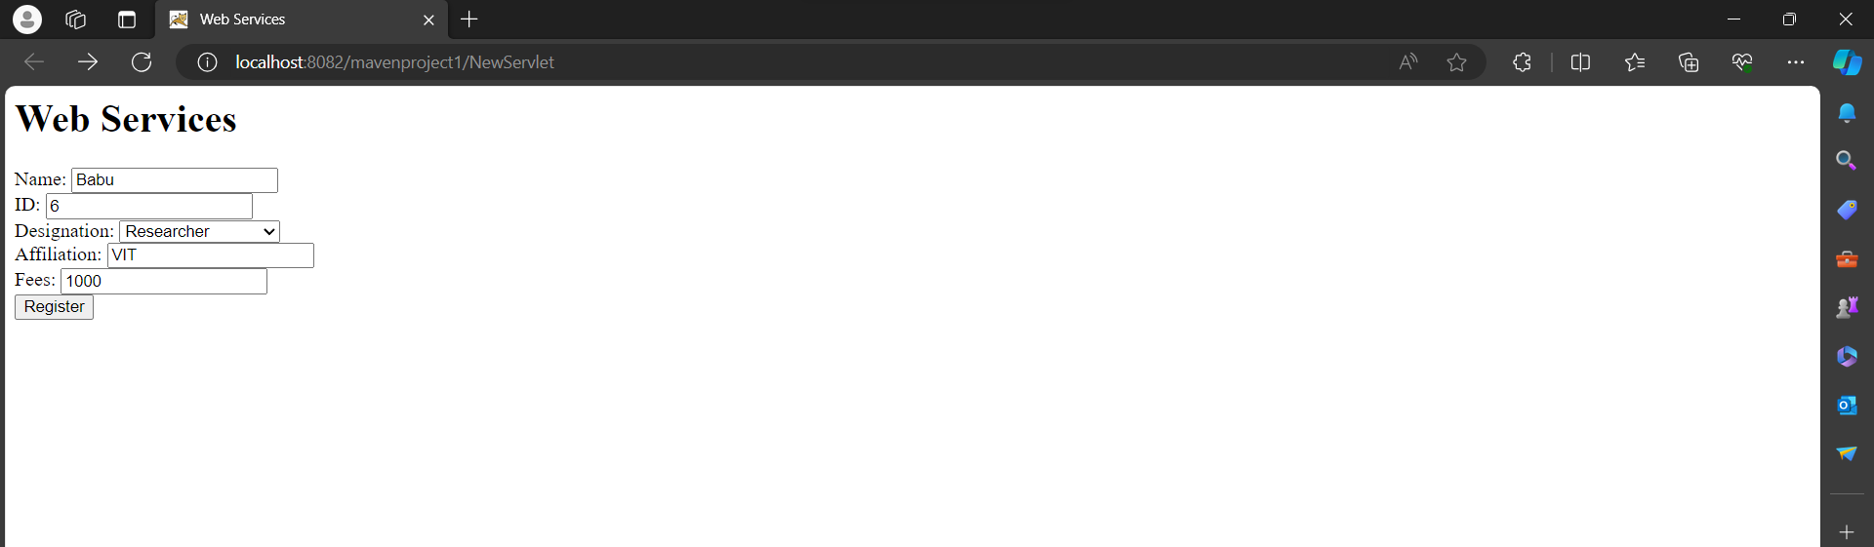

**Registration Full Error for Researcher Designation after 5th registration:**

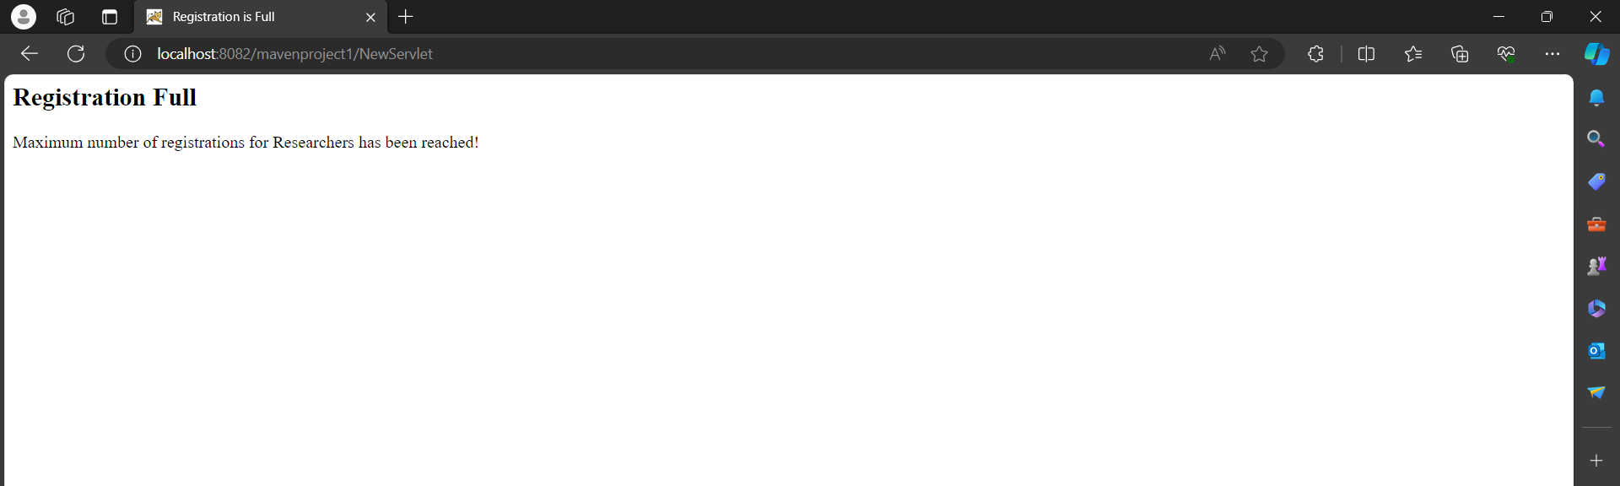

**Entering details for Engineer:**

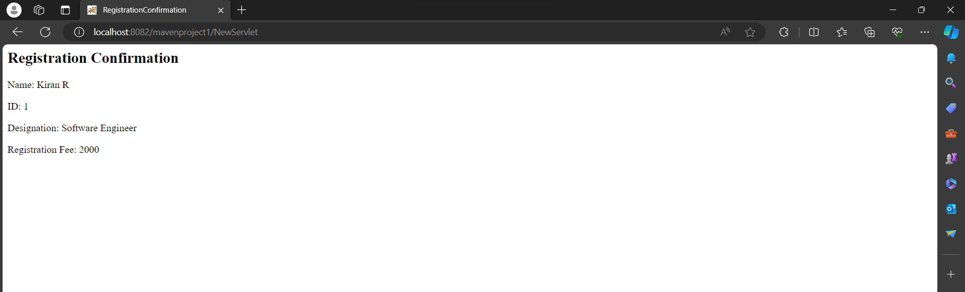

**Registration Full Error for Engineer Designation after 5th registration:**

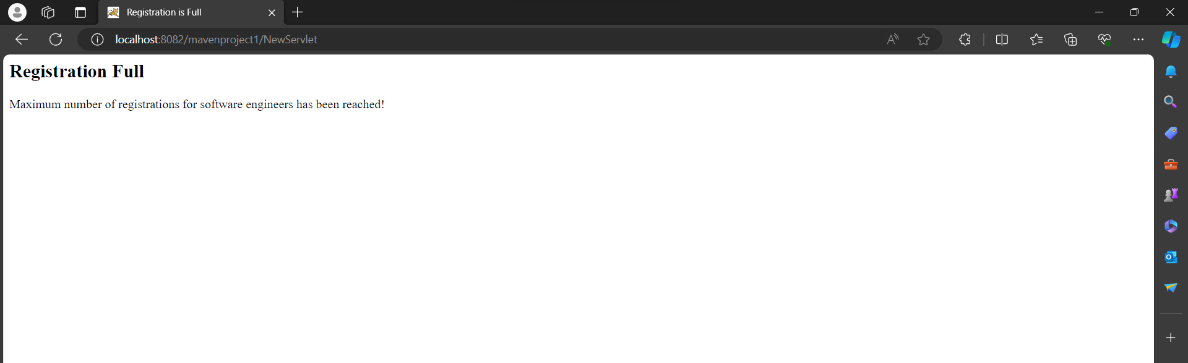

**Final Output:**

