num_steps = 500

learning_rate = 0.5

valid_window = 200

vocabulary_size = 1000

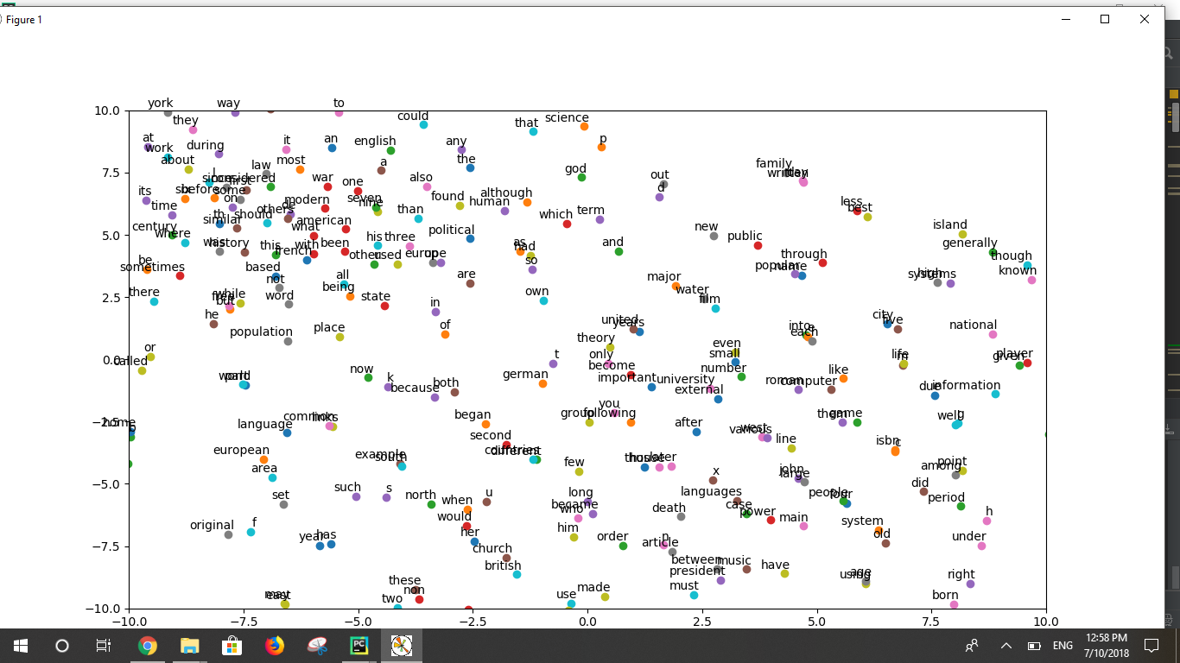

num_steps = 200

learning_rate = 1.5

valid_window = 150

vocabulary_size = 2000

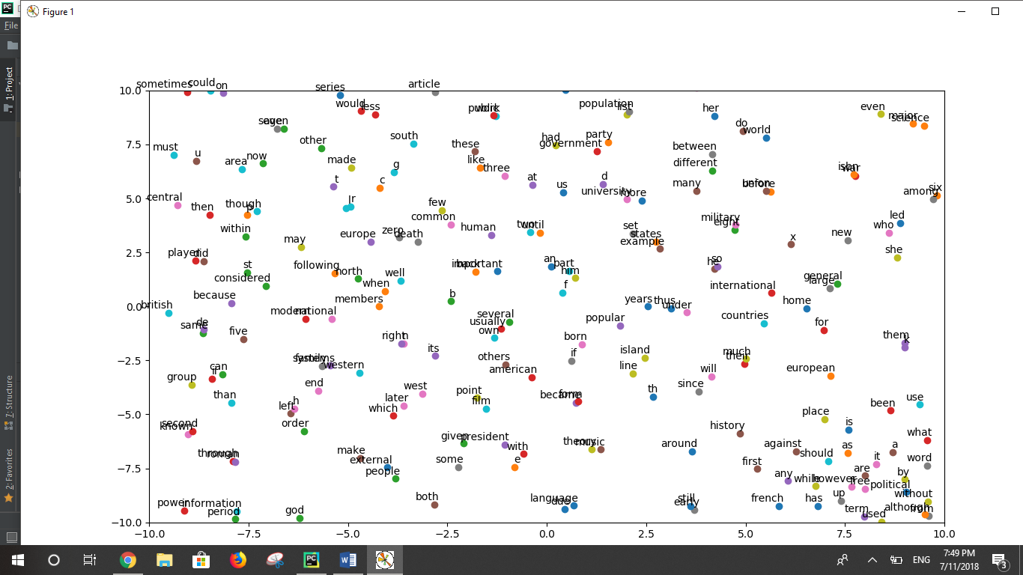

num_steps = 1000

learning_rate = 0.25

valid_window = 250

vocabulary_size = 5000

