PROJECT REPORT
Loan Approval Prediction
Data Analytics with AI: a machine learning system and web interface for loan officers

Abstract
Lending decisions depend on judging quickly and consistently whether an applicant is likely to repay. This project builds a machine learning system that estimates the probability that a loan application will be approved from nine applicant and loan attributes, and delivers the estimate through a professional web interface. A dataset of 1,200 applications in the schema of the widely used Loan Approval Prediction dataset was cleaned, enriched with engineered affordability features (total income, repayment-to-income ratio and loan-to-income multiple) and used to train four classifiers: Logistic Regression, Decision Tree, Random Forest and Gradient Boosting. Hyper-parameters were tuned with five-fold cross-validated grid search, and models were compared on a held-out test set of 240 applications.
The selected model, Random Forest, reached an accuracy of 85.8%, an F1 score of 0.911 and a ROC-AUC of 0.814. Credit history was by far the most influential input. The model is served through a Flask application that shows an approval-probability gauge, plain-language risk factors and suggestions for what could improve the outcome. Gender and marital status are deliberately excluded from the model and Gender is used only for a fairness audit. The dataset supplied with this project is synthetic, so the reported figures demonstrate the method rather than real-world lending performance.
Keywords: loan approval, credit risk, classification, Random Forest, feature engineering, Flask, explainability.

Contents
1. Introduction
2. Requirements Analysis
3. Dataset
4. Methodology
5. Exploratory Data Analysis
6. Results and Discussion
7. System Design and Implementation
8. User Interface
9. Testing
10. Limitations and Ethical Considerations
11. Conclusion and Future Scope
12. References

1. Introduction

1.1 Background
Banks and housing finance companies receive large numbers of loan applications. Assessing each one manually is slow and can be inconsistent between officers. Data analytics and machine learning let an institution learn, from past decisions, which combinations of applicant characteristics tend to lead to approval, and apply that learning consistently to new applications.

1.2 Problem statement
Given an applicant’s profile (education, employment type, dependents, income, co-applicant income, loan amount, repayment term, credit history and property area), predict whether the loan will be approved, and present the result in a form a loan officer can understand and act on.

1.3 Objectives
- Clean and explore the loan application data and identify the factors that influence approval.
- Engineer affordability features that reflect how lenders reason about repayment capacity.
- Train and compare several classification models using cross-validation and a held-out test set.
- Build a responsive, professional web interface that returns an approval probability with explanations.
- Exclude protected attributes from the model and audit the outcome for fairness.

1.4 Scope
The project covers the complete analytics workflow: data preparation, exploratory analysis, modelling, evaluation, deployment as a web application and documentation. It is a decision-support tool. It is not intended to make automated lending decisions.

2. Requirements Analysis

2.1 Functional requirements
- The user can enter applicant, income, loan and credit details in a single form.
- The system returns an approval probability and a decision at a 50% threshold.
- The system explains the result with the main risk factors and shows what changes would improve it.
- The system rejects invalid input with a clear message and warns when a request lies outside the range of the training data.
- The user can view model performance and dataset insights inside the application.

2.2 Non-functional requirements
- Usability: clear labels in plain language, keyboard-accessible controls, responsive layout down to mobile width.
- Performance: a prediction returns in well under one second on a laptop.
- Reproducibility: fixed random seeds; one command trains the model and regenerates every chart.
- Fairness: protected attributes are not used as model inputs.

2.3 Software and hardware requirements
Table 1: Software requirements (requirements.txt)
Package | Version | Purpose
Python | 3.10 or later | Programming language
pandas | 2.0 or later | Data loading and manipulation
numpy | 1.24 or later | Numerical computing
scikit-learn | 1.3 or later | Preprocessing, models, cross-validation, metrics
matplotlib, seaborn | 3.7 / 0.12 or later | Charts
flask | 3.0 or later | Web application and JSON API
joblib | 1.3 or later | Saving the trained model
playwright (optional) | 1.40 or later | Regenerating UI screenshots

Hardware: any modern computer with at least 4 GB of RAM. No GPU is required. Training all four models with grid search takes well under a minute on a laptop.

3. Dataset

3.1 Source
The project uses a dataset of 1,200 loan applications with 13 columns, following the schema of the public Loan Approval Prediction (Dream Housing Finance) dataset. The file supplied with this project is synthetic. It was generated by a seeded script (generate_dataset.py) because the project was built without internet access. It reproduces the real dataset’s columns, category proportions, missing-value pattern and an approval rate of 73.7%, but it is not real customer data. To use the real dataset, replace data/loan_data.csv with the downloaded file and re-run train_model.py; no other change is needed.

3.2 Attributes
Table 2: Dataset attributes
Column | Type | Description
Loan_ID | Identifier | Unique application number (not used)
Gender | Categorical | Male / Female (excluded from model; fairness audit only)
Married | Categorical | Yes / No (excluded from model)
Dependents | Categorical | 0, 1, 2 or 3+ (converted to a number)
Education | Categorical | Graduate / Not Graduate
Self_Employed | Categorical | Yes / No
ApplicantIncome | Numeric | Applicant monthly income (INR)
CoapplicantIncome | Numeric | Co-applicant monthly income (INR)
LoanAmount | Numeric | Loan amount in INR thousands
Loan_Amount_Term | Numeric | Repayment term in months
Credit_History | Binary | 1 = meets guidelines, 0 = does not
Property_Area | Categorical | Urban / Semiurban / Rural
Loan_Status | Target | Y = approved, N = rejected

3.3 Data quality
The data contains 311 missing cells, concentrated in Credit_History, Self_Employed, LoanAmount and Dependents (Figure 6). The dataset is moderately imbalanced: 73.7% of applications were approved. The data was split 80/20 into 960 training and 240 test applications, stratified by outcome.

4. Methodology

4.1 Workflow
The pipeline follows six stages: (1) load and inspect the data, (2) explore it visually, (3) impute missing values and engineer features, (4) train and tune four models with cross-validation, (5) evaluate them on the held-out test set and select the best, and (6) refit the chosen model on all data and deploy it in the web application. All preprocessing lives inside a single scikit-learn Pipeline, so exactly the same transformations are applied to training data and to new applications, and information from the test set never leaks into training.

4.2 Preprocessing
- Numeric columns: missing values replaced by the median, then standardised.
- Credit history: missing values replaced by the most frequent value.
- Categorical columns: missing values replaced by the most frequent category, then one-hot encoded; unseen categories are ignored safely at prediction time.
- Dependents: the label ‘3+’ is converted to the number 3.

4.3 Feature engineering
Table 3: Engineered features
Feature | Definition and rationale
TotalIncome | Applicant income + co-applicant income; household repayment capacity
LogTotalIncome, LogLoanAmount | Log transforms that reduce the skew of income and loan amount
EMI | Loan amount × 1000 ÷ term; monthly repayment (principal only)
EMI_to_Income | EMI ÷ total income; share of monthly income committed to repayment
Loan_to_Income | Loan amount ÷ annual income; how many years of income are borrowed

4.4 Models
Four classifiers of increasing flexibility were compared. Logistic Regression is a transparent linear baseline. A Decision Tree gives human-readable rules but overfits easily. A Random Forest (Breiman, 2001) averages many decorrelated trees and is robust to noisy features. Gradient Boosting builds trees sequentially, each correcting the errors of the previous ones. Each model’s hyper-parameters were tuned with grid search using five-fold stratified cross-validation and ROC-AUC as the objective. The final model was chosen by cross-validated ROC-AUC on the training data, not by test performance, to avoid selecting on the test set.

4.5 Evaluation metrics
- Accuracy: share of all decisions that were correct.
- Precision: of the applications predicted approved, the share that really were approved.
- Recall: of the applications that were really approved, the share the model found.
- F1 score: harmonic mean of precision and recall.
- ROC-AUC: how well the model ranks approved applications above rejected ones, independent of the threshold.

4.6 Fairness by design
Gender and marital status are recorded in the data but are not inputs to the model or the web form. After training, predicted and actual approval rates are compared across gender groups on the test set (Section 6.4) as a basic audit. Removing a protected attribute does not by itself guarantee fairness, because other variables can act as proxies, so this audit should be repeated on any real dataset.

5. Exploratory Data Analysis
Exploratory analysis was carried out before modelling to understand the data and to guide feature engineering.
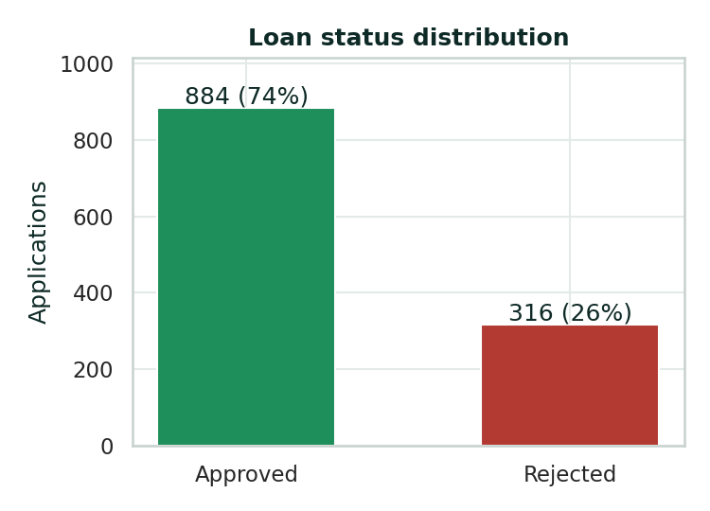
Figure 1: Distribution of loan outcomes
About 73.7% of applications were approved, so the classes are imbalanced; a model that approved everything would already be right about three times in four. Recall and ROC-AUC are therefore reported alongside accuracy.
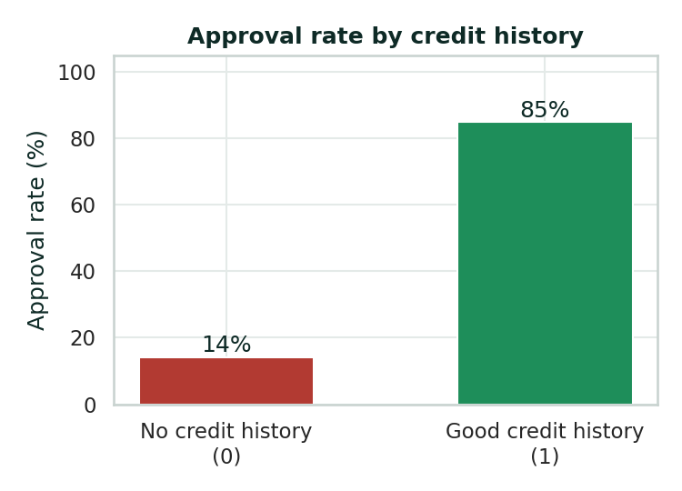
Figure 2: Approval rate by credit history
Credit history is the strongest single signal. Applicants who meet the credit guidelines are approved far more often than those who do not, and the correlation matrix (Figure 5) confirms that Credit_History has by far the highest correlation with the outcome.
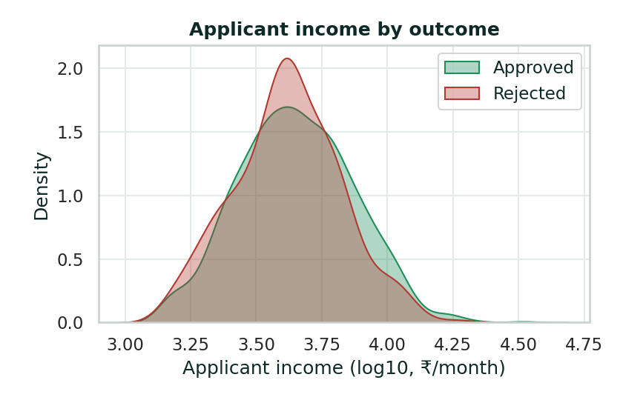
Figure 3: Applicant income for approved and rejected applications
Income alone separates the two groups only weakly: the distributions overlap heavily. Income matters mainly through its relation to the size of the loan, which is why ratio features were engineered.
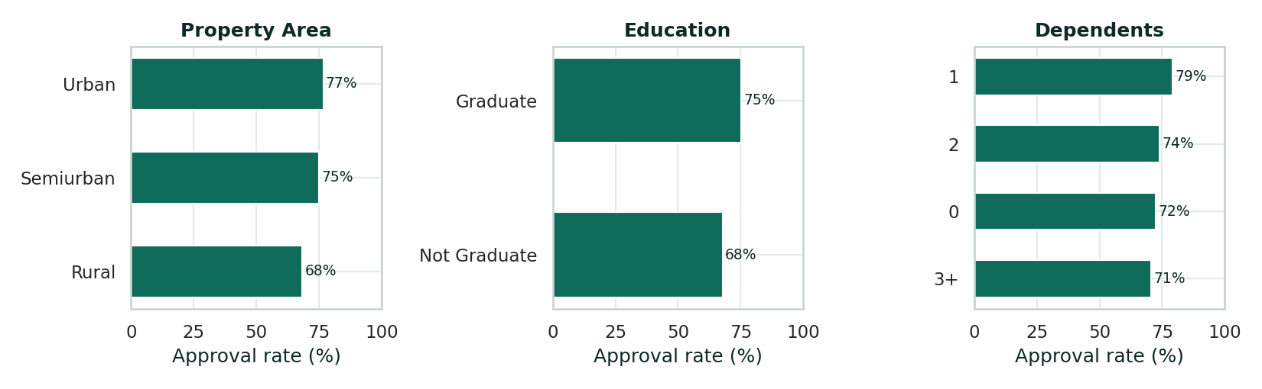
Figure 4: Approval rate by property area, education and dependents
Approval rates are somewhat higher in urban and semi-urban areas and for graduates, with smaller differences by number of dependents.
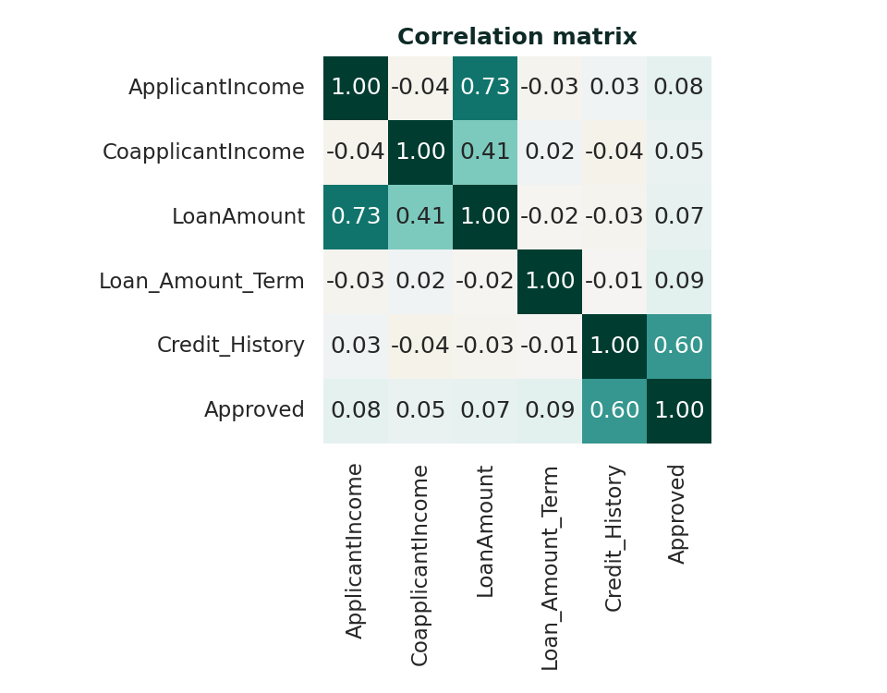
Figure 5: Correlation matrix of numeric columns
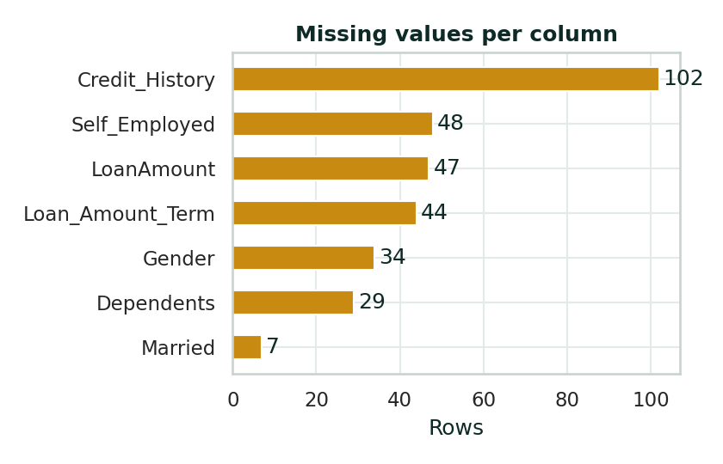
Figure 6: Missing values per column

6. Results and Discussion

6.1 Model comparison
Table 4: Performance on the held-out test set (240 applications)
Model | CV AUC | Accuracy | Precision | Recall | F1 | Test AUC
Logistic Regression | 0.787 | 0.858 | 0.849 | 0.983 | 0.911 | 0.826
Decision Tree | 0.767 | 0.833 | 0.855 | 0.932 | 0.892 | 0.791
Random Forest (selected) | 0.792 | 0.858 | 0.849 | 0.983 | 0.911 | 0.814
Gradient Boosting | 0.779 | 0.858 | 0.856 | 0.972 | 0.910 | 0.772

The four models perform similarly, which is typical for a small tabular dataset where a single feature dominates. Random Forest was selected because it achieved the highest cross-validated ROC-AUC (0.792). On the test set it reached 85.8% accuracy, 84.9% precision, 98.3% recall and an F1 score of 0.911. Differences of one or two points between models are within the noise expected from a test set of 240 applications and should not be over-interpreted.
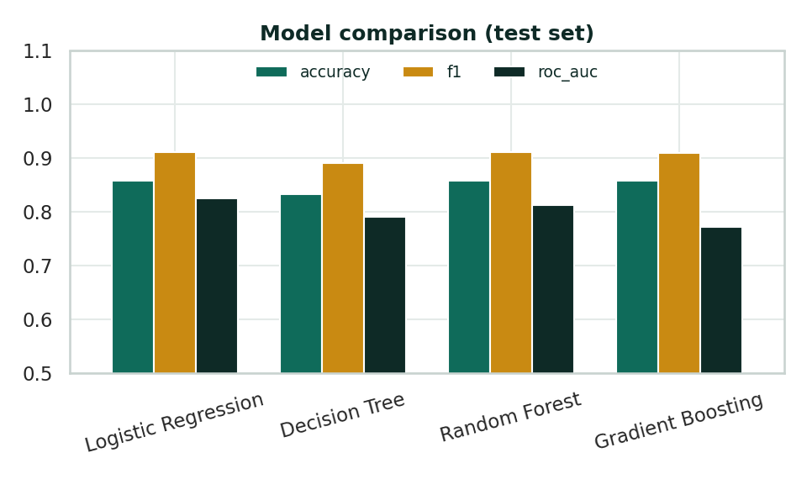
Figure 7: Accuracy, F1 and ROC-AUC of the four models
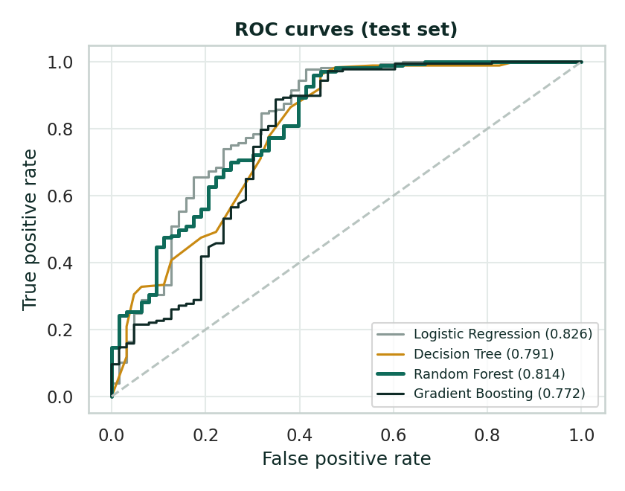
Figure 8: ROC curves on the test set

6.2 Confusion matrix
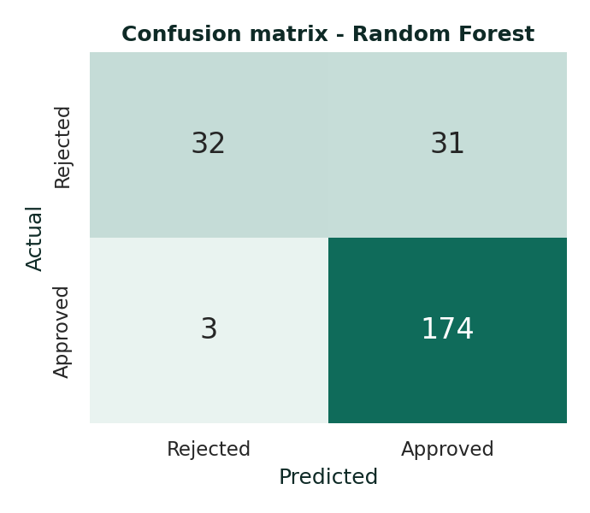
Figure 9: Confusion matrix of Random Forest
Of 177 genuinely approved applications the model correctly identified 174 and missed only 3. However, of 63 genuinely rejected applications it correctly flagged 32 (a specificity of 50.8%) and wrongly approved 31. The model is therefore good at recognising strong applications but is more lenient than a cautious lender would be. A lender who is more worried about bad loans than about lost customers can raise the decision threshold in app.py; this trades recall for specificity.

6.3 Feature importance
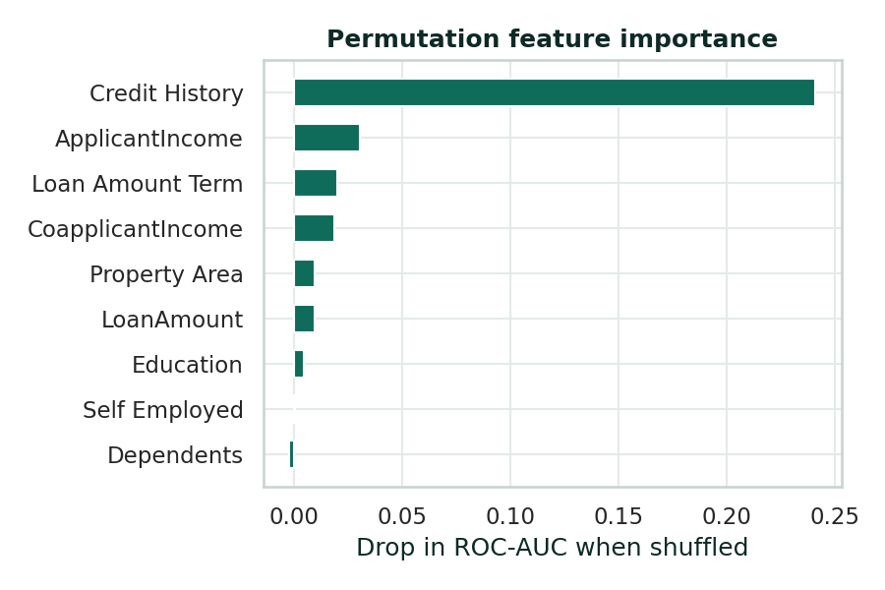
Figure 10: Permutation feature importance (drop in ROC-AUC)
Permutation importance measures how much the test ROC-AUC falls when one input is randomly shuffled. Credit History dominates (a drop of 0.241), followed by ApplicantIncome, Loan_Amount_Term and CoapplicantIncome. This agrees with the exploratory analysis and with lending practice: repayment history matters most, then the applicant’s capacity to repay the requested amount over the chosen term.

6.4 Fairness audit
Table 5: Actual and predicted approval rate by gender (test set)
Group | Applications | Actual approval rate | Predicted approval rate
Female | 58 | 79.3% | 81.0%
Male | 177 | 71.2% | 86.4%

Because gender was not given to the model, differences between actual and predicted rates arise only through other variables. The group sizes are small, so this table is an illustration of the audit procedure rather than evidence of fairness; on real data it should be repeated with larger samples and additional groups.

7. System Design and Implementation

7.1 Architecture
The system has three layers. The modelling layer (loan_utils.py and train_model.py) builds the preprocessing pipeline, trains and evaluates the models and saves the best pipeline with joblib together with a metrics file. The service layer (app.py) is a Flask application that loads the saved pipeline once at start-up, validates each request, calls the model and computes explanations. The presentation layer (templates/index.html) is a single responsive page that calls the JSON API and renders the results.

7.2 API
Table 6: API endpoints
Endpoint | Method | Description
/ | GET | Web interface
/api/predict | POST | Accepts the nine applicant fields as JSON; returns probability, decision, risk factors, what-if scenarios and repayment ratios
/api/metrics | GET | Returns model comparison, test metrics, confusion matrix and dataset summary as JSON

7.3 Explanations shown to the user
- Risk factors: credit history, repayment load (monthly repayment as a share of household income), loan size (loan as a multiple of annual income) and household income, each labelled Strong, Watch or Risk.
- What could improve the chance: the model is re-run with a good credit history, a 360-month term or a 20% smaller loan, and scenarios that raise the probability by at least three points are shown.
- Out-of-range caution: if the repayment load or loan multiple exceeds the 99th percentile of the training data, a warning advises manual review.

7.4 Project structure
Table 7: Files in the project
File | Role
README.md | Overview, setup and usage
requirements.txt | Python dependencies
data/loan_data.csv | Dataset
generate_dataset.py | Creates the dataset
loan_utils.py | Feature engineering and preprocessing pipeline
train_model.py | EDA, training, evaluation, model and figure export
app.py | Flask application and API
templates/index.html | Web interface
models/ | Saved model and metrics.json
static/figures/ | Generated charts
capture_screenshots.py | Regenerates the UI screenshots

8. User Interface
The interface, named LoanLens, is designed for a loan officer working through applications. A dark side rail provides navigation between three views. The assessment view groups the form into Applicant, Income, Loan request and Credit sections, with the result beside it so that the form and the answer are visible together.

8.1 Assess applicant
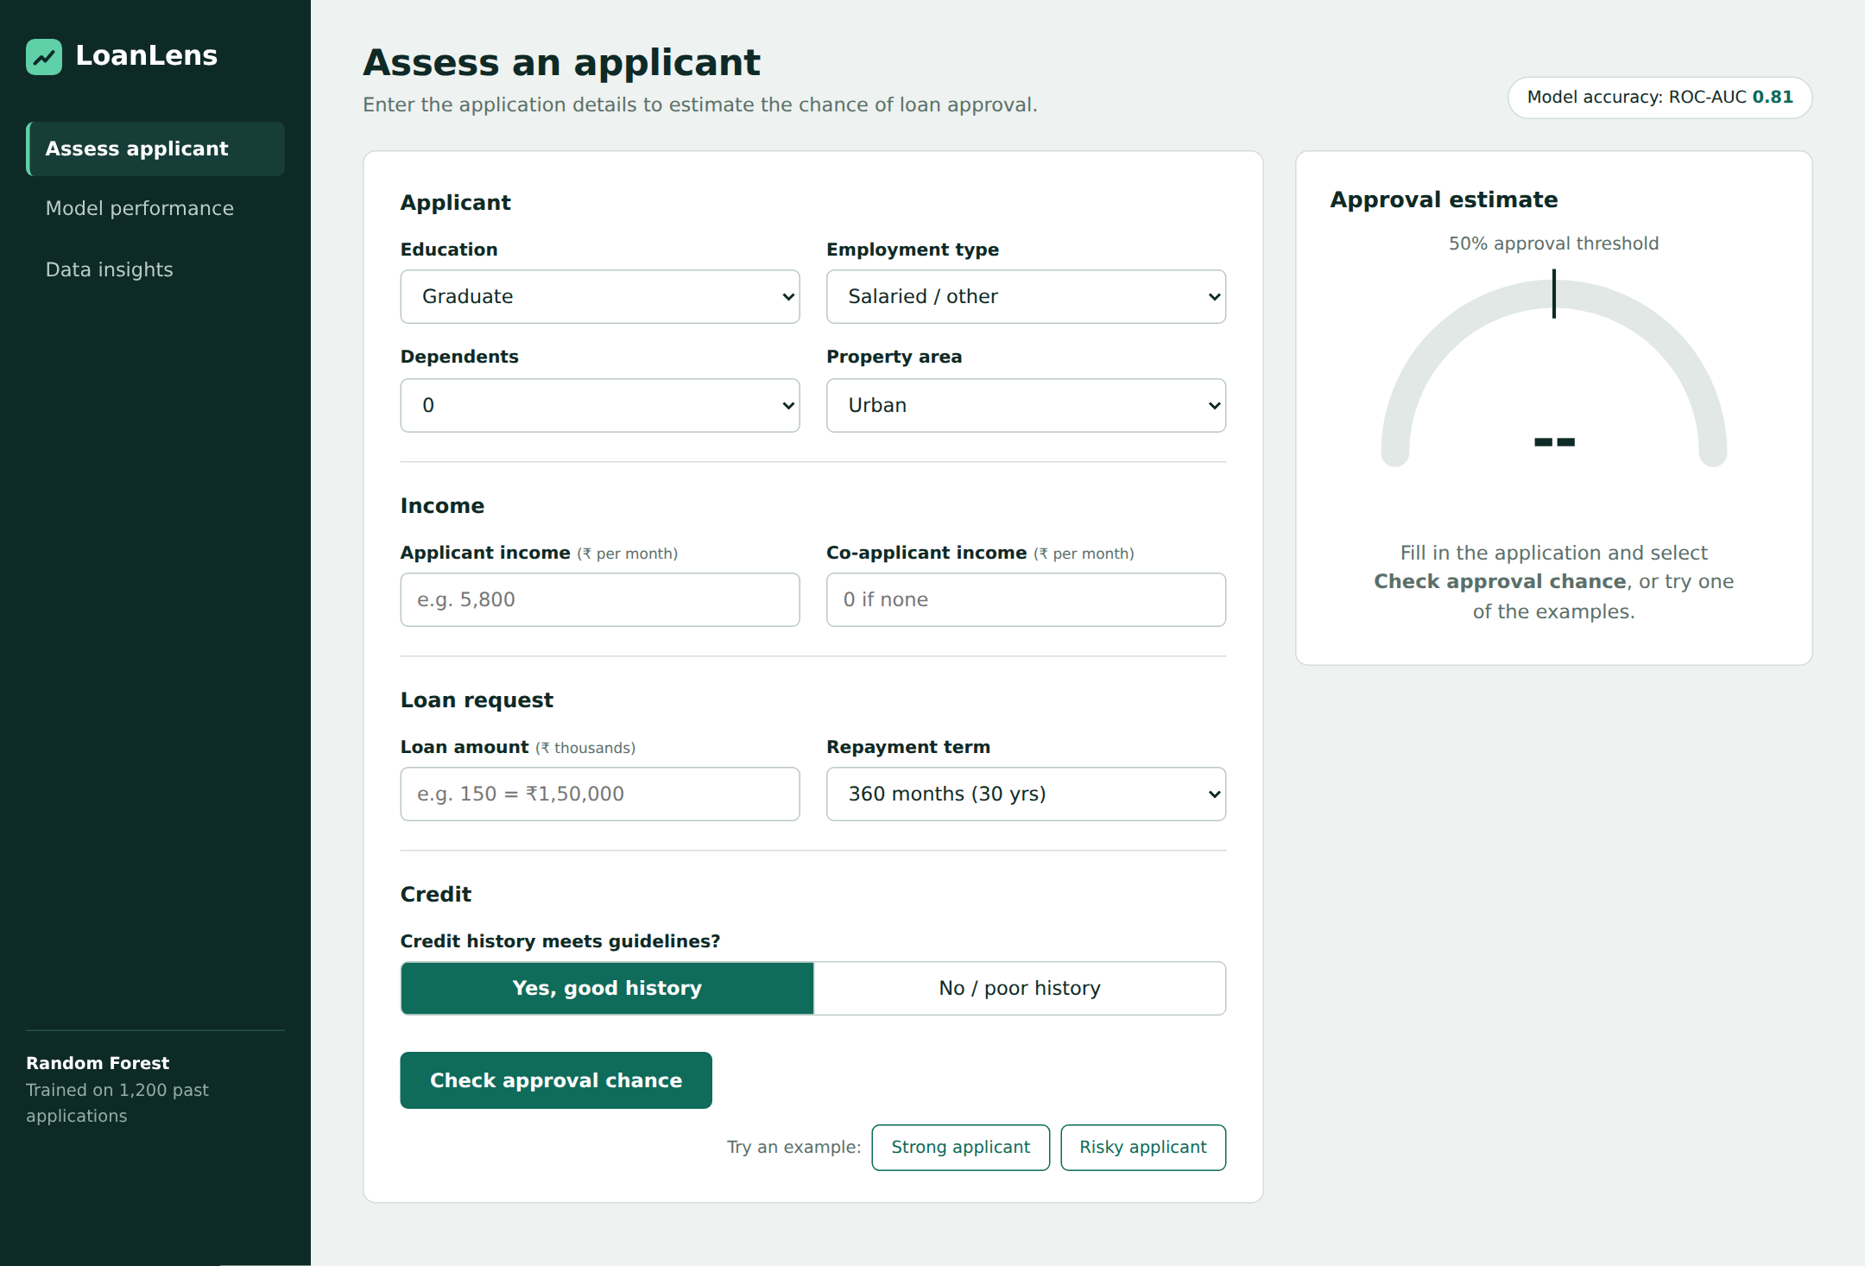
Figure 11: Assessment screen before any input
Before any input the result panel shows an empty gauge and an instruction. Two example buttons load a strong and a risky applicant for quick demonstration.
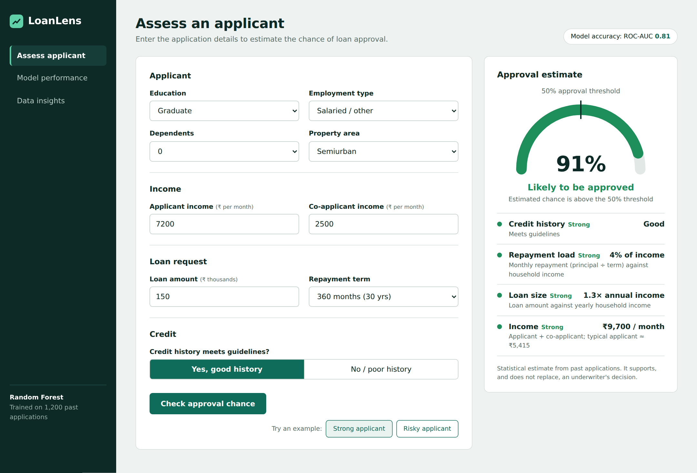
Figure 12: Approved example: 91% estimated approval chance
The gauge shows the estimated probability against the 50% threshold. Below it, each factor is marked Strong, Watch or Risk using both a colour and a text label, so the meaning does not rely on colour alone.
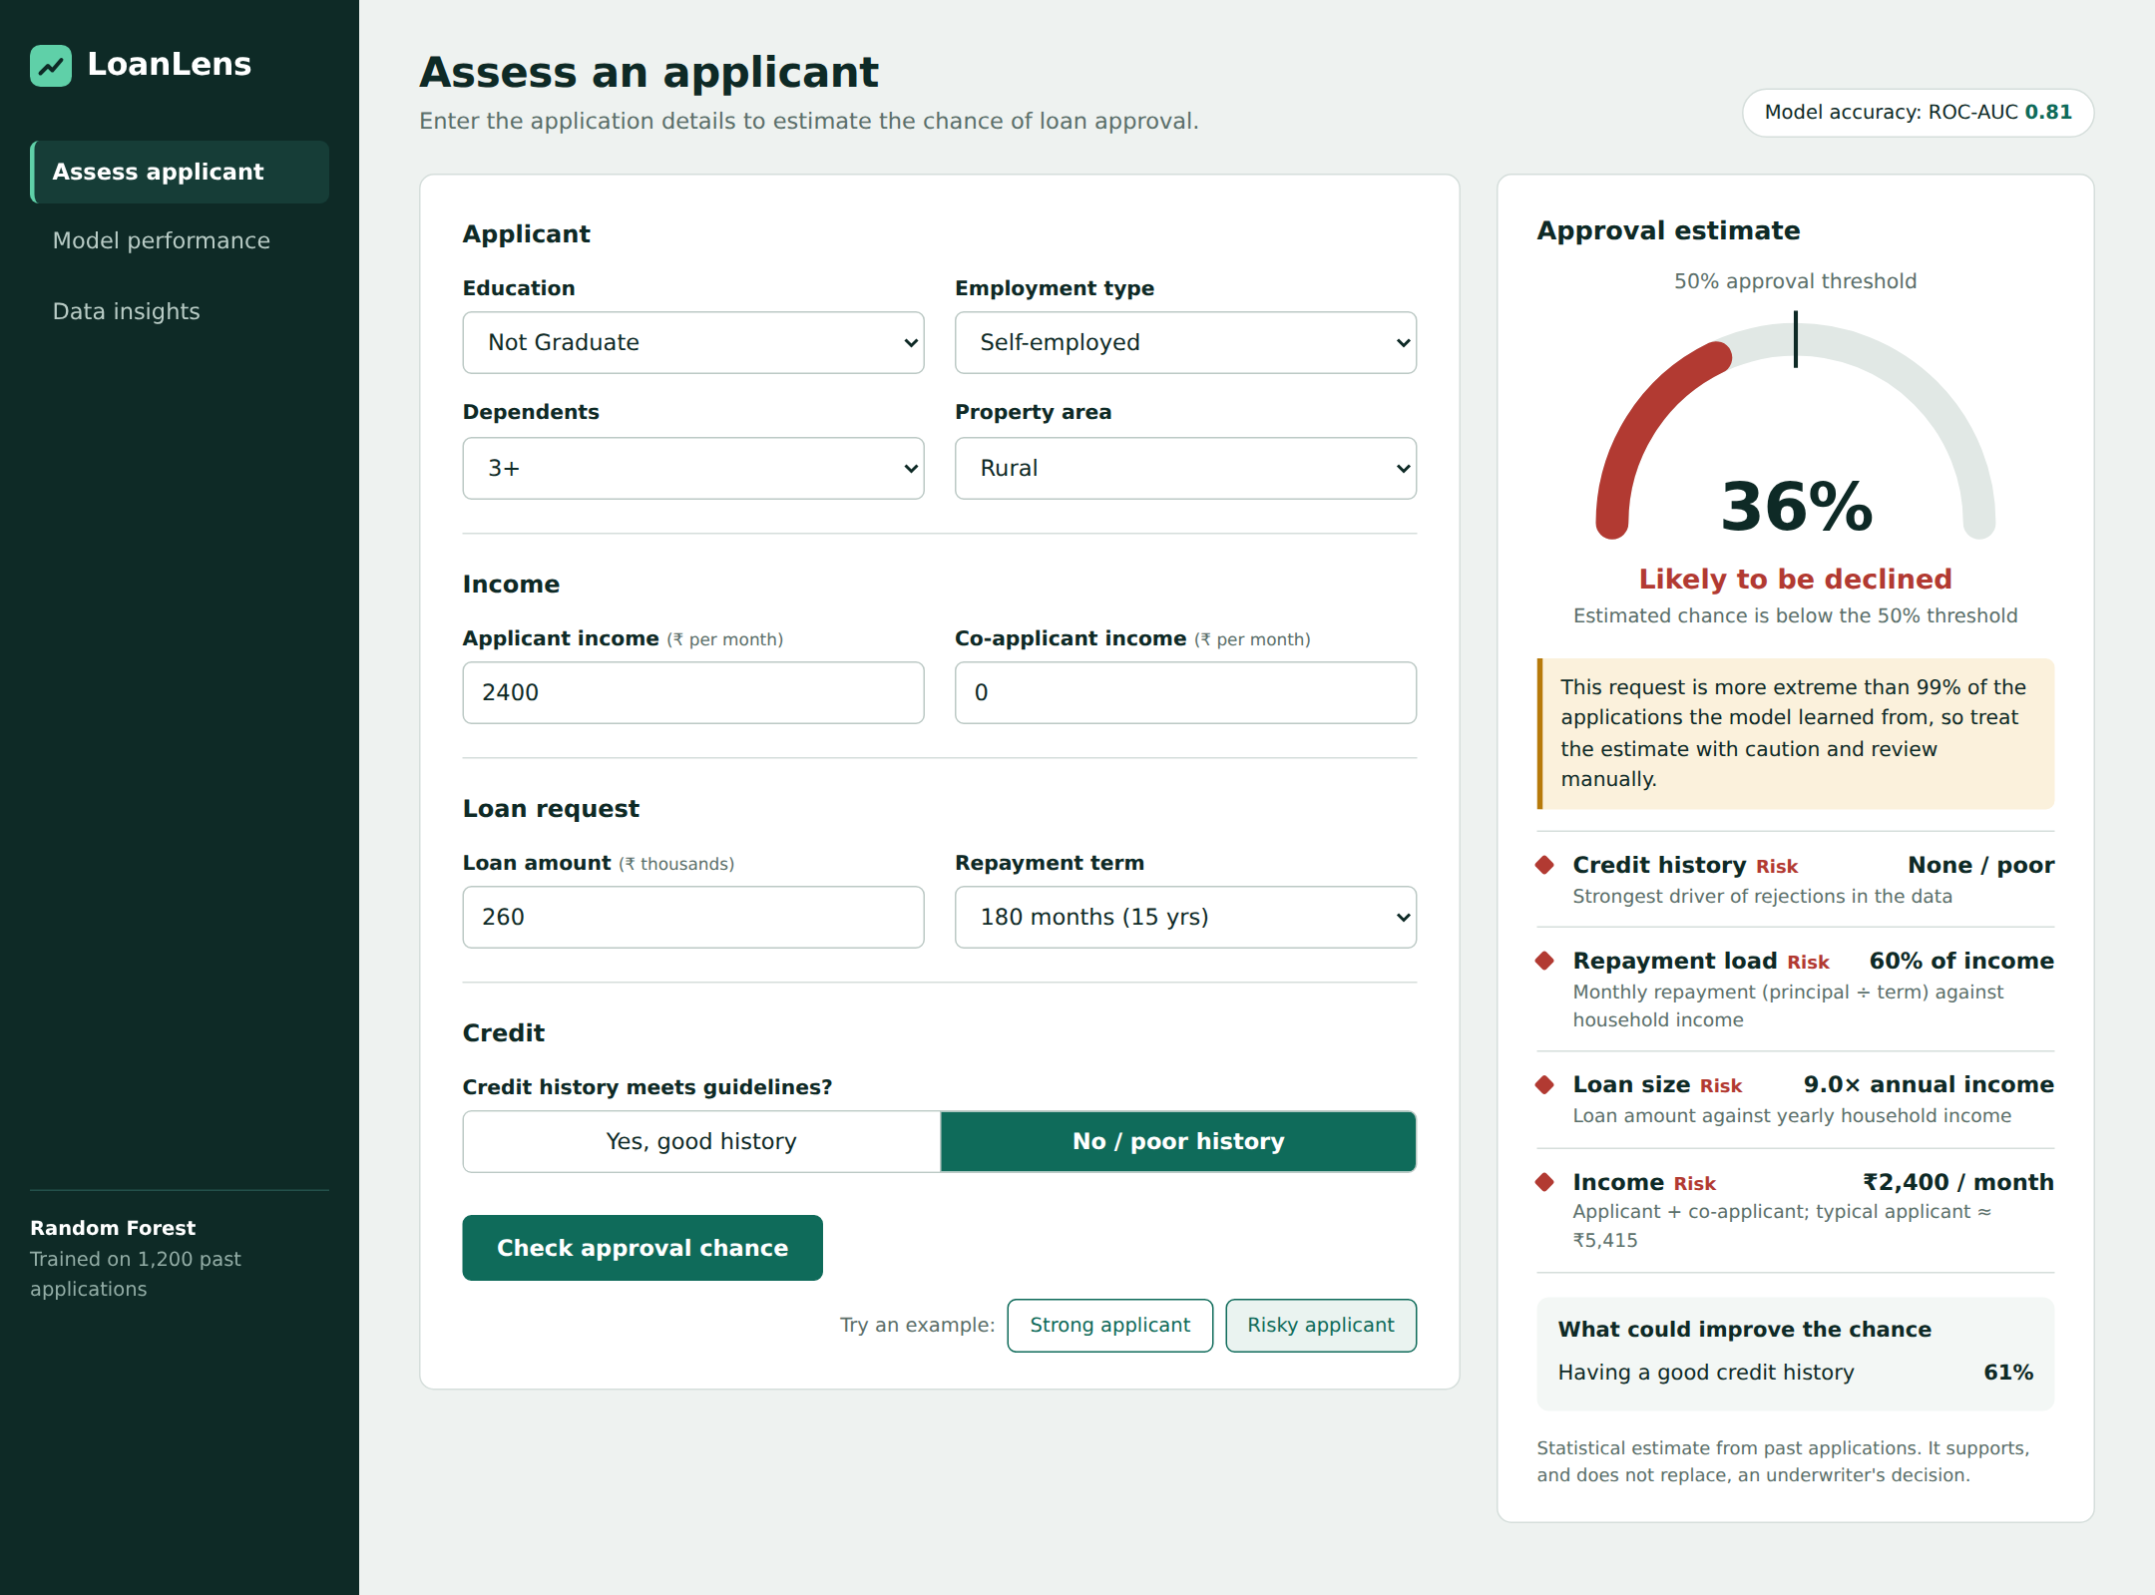
Figure 13: Declined example with out-of-range caution and what-if suggestion
For a declined application the panel adds a caution when the request is unusual and lists what could improve the chance; here, a good credit history would raise the estimate from 36% to 61%.
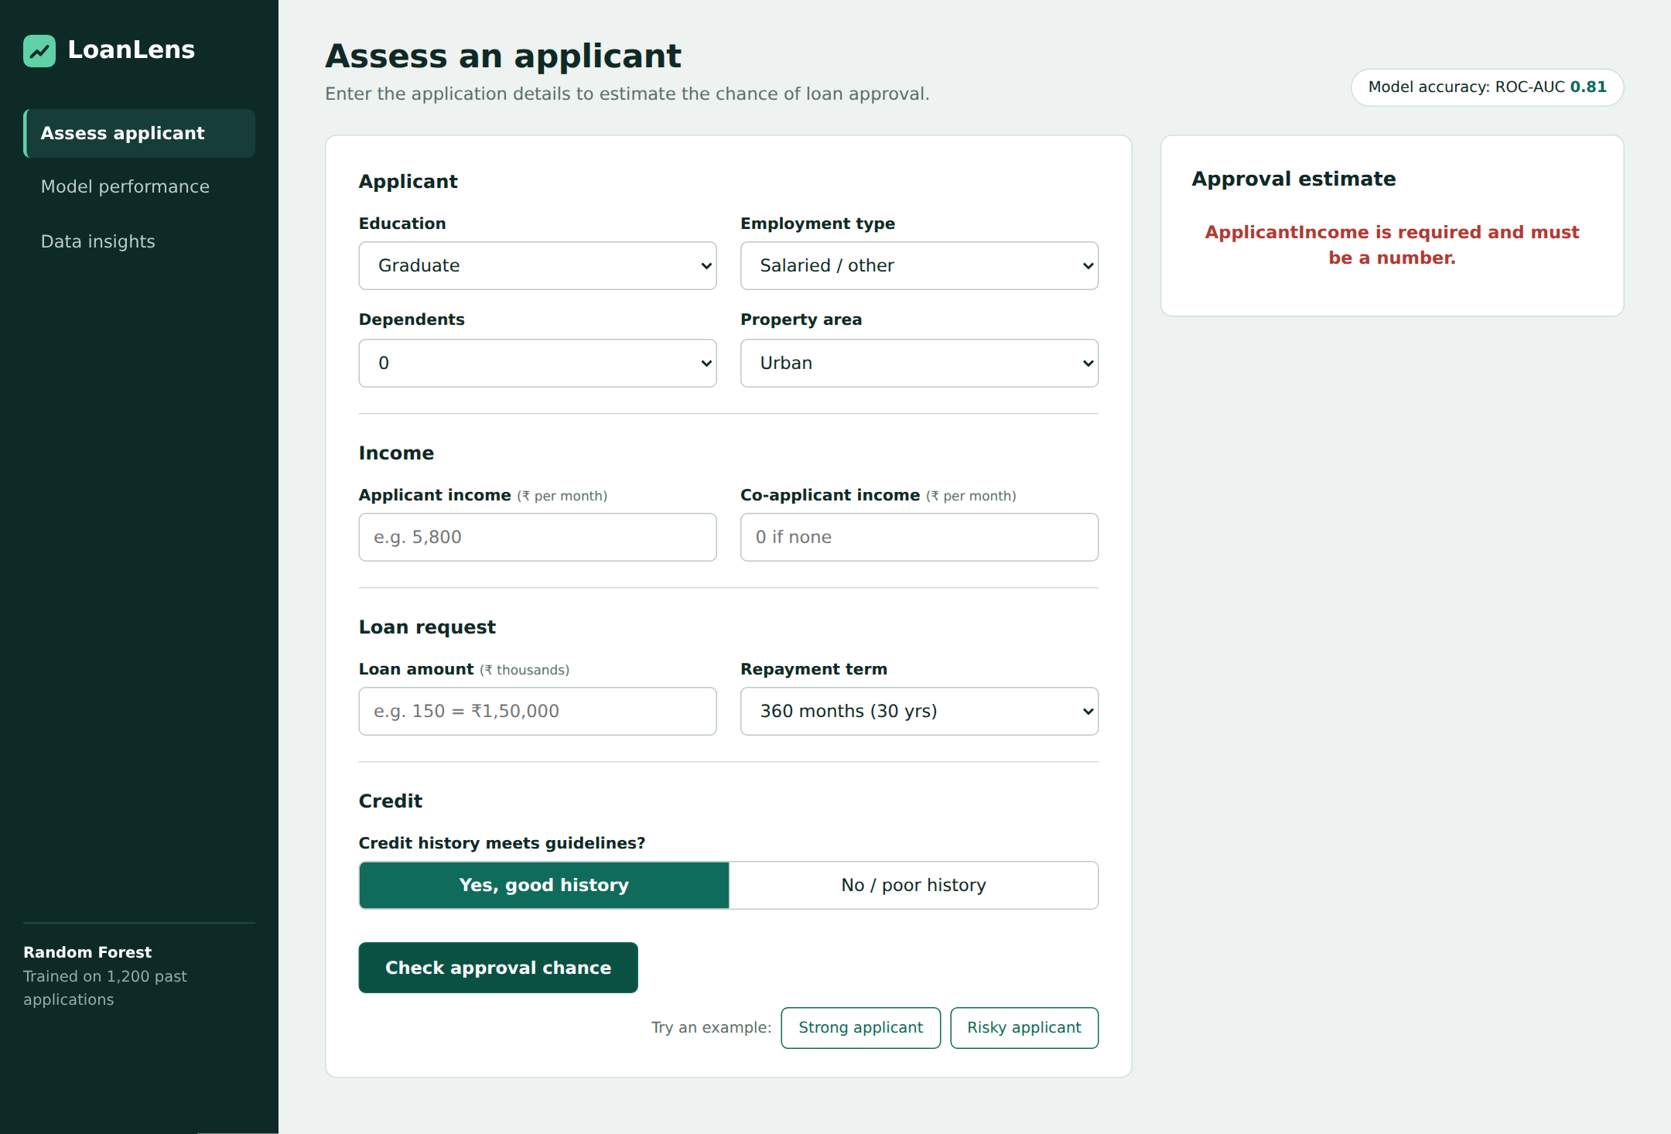
Figure 14: Validation message when required fields are empty

8.2 Model performance and data insights
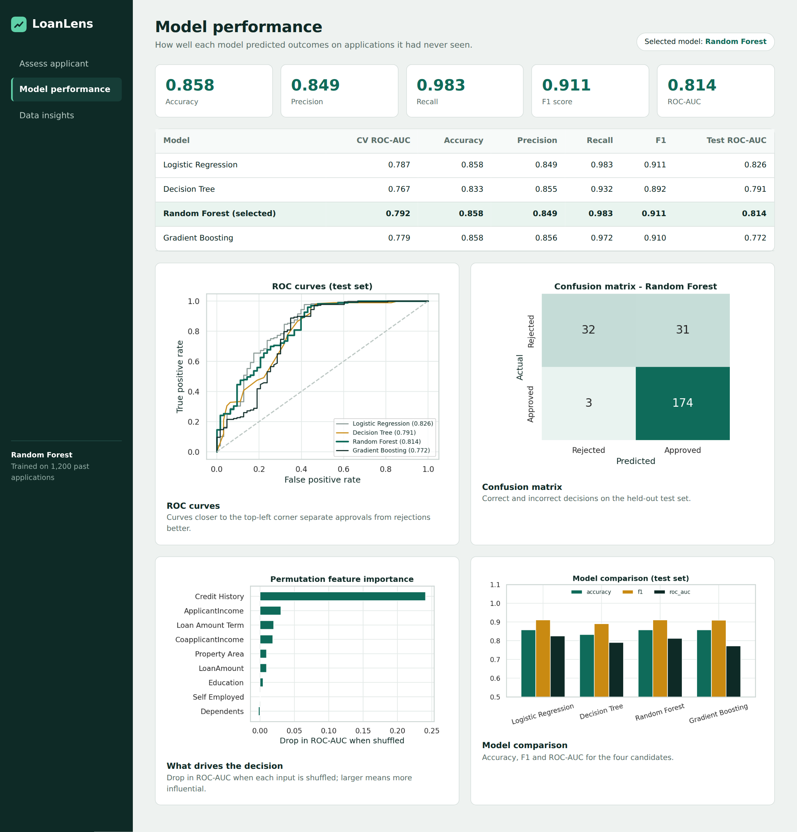
Figure 15: Model performance view
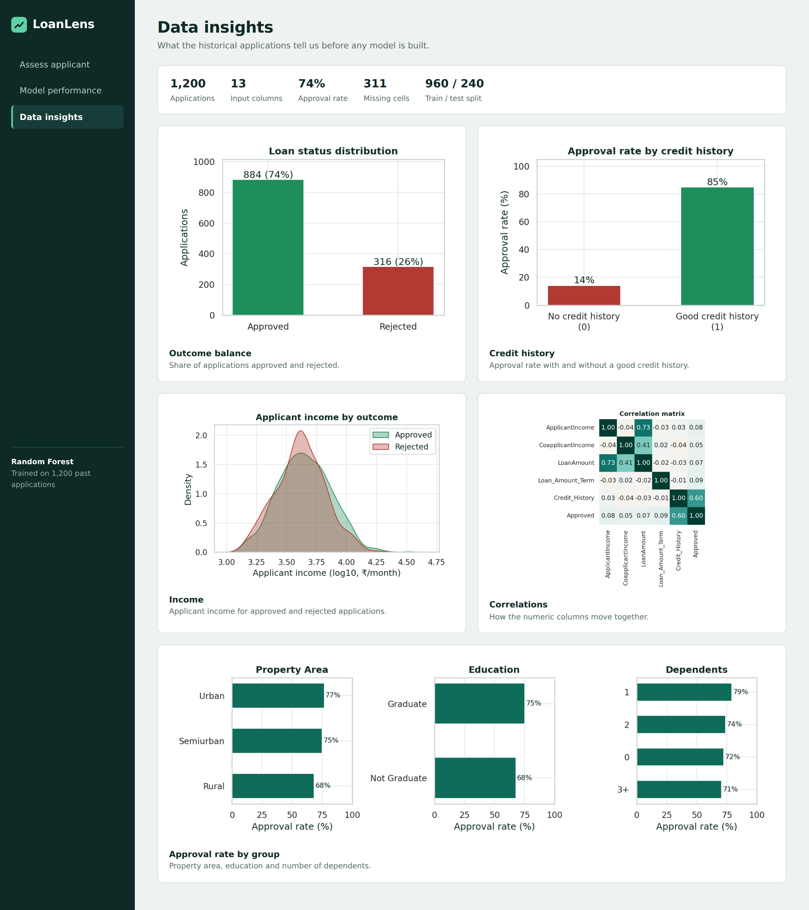
Figure 16: Data insights view

8.3 Mobile layout
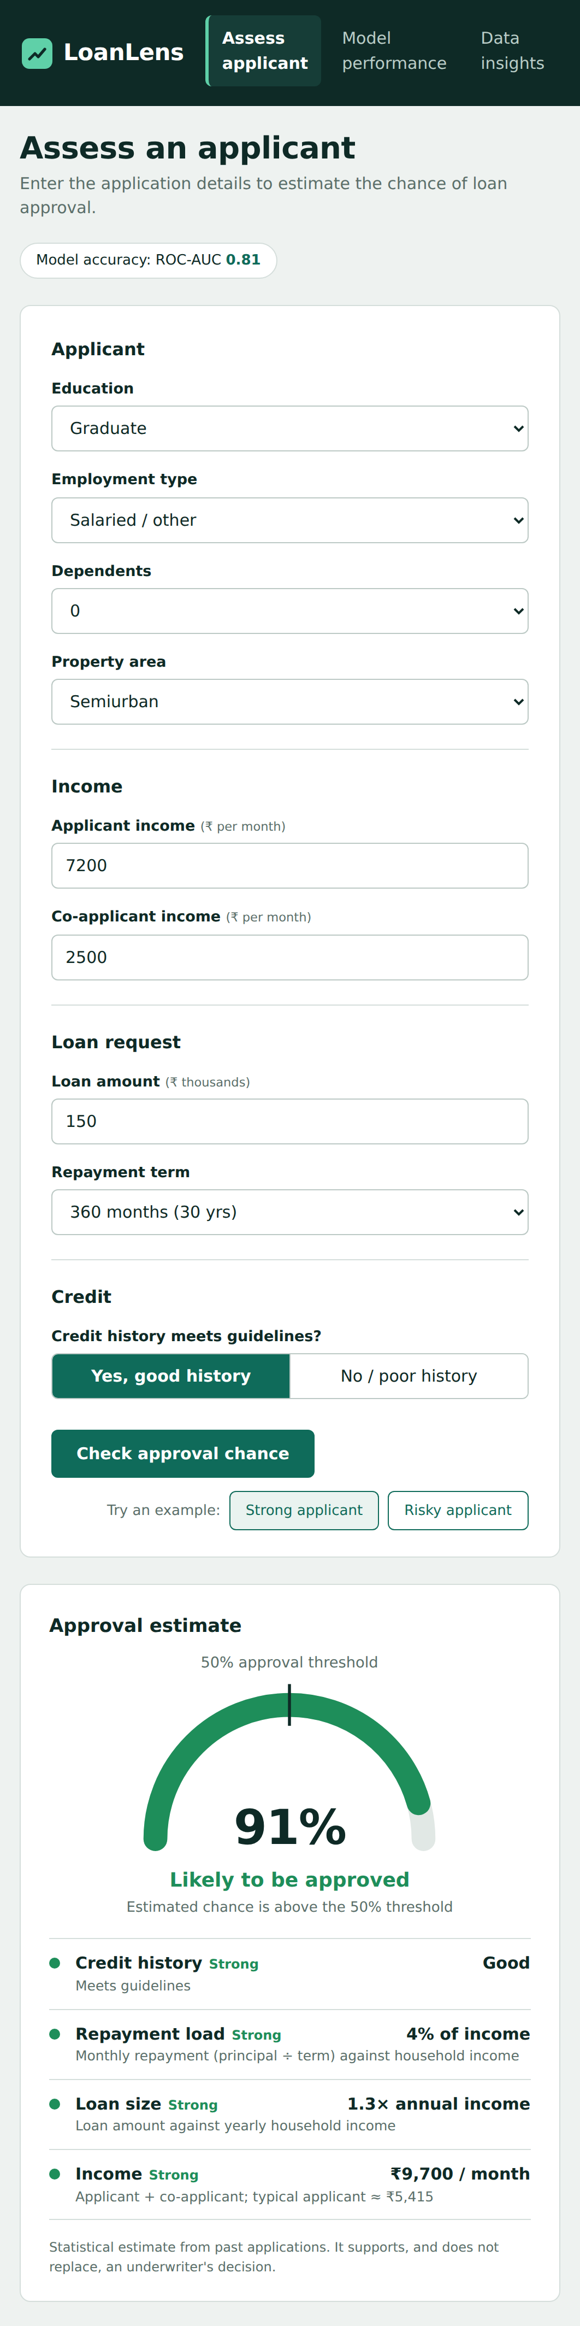
Figure 17: Layout at a 390 px phone width
Below about 1000 px the navigation moves to the top and the form and result stack in a single column.

9. Testing
The prediction API and the interface were tested with valid and invalid input. Valid inputs were checked against expected outcomes, and invalid inputs were checked for a clear error message and an HTTP 400 response.
Table 8: Test cases and results
ID | Scenario | Expected | Actual | Result
T1 | Strong applicant example | Approved, high probability | Approved, 91% | Pass
T2 | Risky applicant example | Declined with risk factors | Declined, 36%; caution shown | Pass
T3 | Average applicant, good credit | Approved | Approved, 84% | Pass
T4 | Same applicant, no credit history | Probability drops sharply | Declined, 19% | Pass
T5 | Applicant income of ₹10 | Rejected with message | HTTP 400, income must be 500–500000 | Pass
T6 | Education set to an invalid value | Rejected with message | HTTP 400, select an education level | Pass
T7 | Repayment term of 9,999 months | Rejected with message | HTTP 400, term must be 12–480 | Pass
T8 | Empty form submitted | Readable message on screen | Message shown (Figure 14) | Pass
T9 | Phone-width viewport (390 px) | Single-column layout, no overflow | Layout as in Figure 17 | Pass
T10 | ₹25 lakh loan on ₹3,000 income, good credit | Flagged as unusual | Caution shown, but estimate 65% | Limitation

Test T10 exposes a real limitation, discussed in the next section: with a good credit history the model still gives a fairly high estimate for an extremely unaffordable request, because such requests are almost absent from the training data. The caution banner is a mitigation, not a cure.

10. Limitations and Ethical Considerations
- Synthetic data. The supplied dataset is generated, so the metrics show that the pipeline works but do not describe real lending performance. The project should be re-run on real historical data before any conclusion is drawn.
- Small dataset. With about one thousand examples, small differences between models are not statistically meaningful.
- Dominance of credit history. The model leans heavily on one feature and can be over-optimistic on unusual requests (test T10).
- Lenient towards weak applications. Specificity is only 50.8%, so the model approves many applications that were rejected in the data.
- Simplified affordability. Repayment is principal divided by term and ignores interest, existing debts and expenses because the public dataset does not contain them.
- Fairness. Removing gender and marital status reduces direct bias but does not remove proxy effects. Historical decisions may themselves encode bias that a model can learn.
- Human oversight. The tool is decision support. Final decisions on real loans need a qualified underwriter and must follow applicable regulation and explanation rights.

11. Conclusion and Future Scope
This project delivered an end-to-end loan approval prediction system: a reproducible training pipeline, a comparison of four models, an evaluation with the metrics that matter for imbalanced lending data, and a professional web interface that explains its output. Random Forest was selected and reached 85.8% accuracy and a ROC-AUC of 0.814 on the test set, with credit history emerging as the dominant driver.
Possible extensions:
- Train on a real, larger dataset and calibrate the predicted probabilities.
- Add interest rates, existing liabilities and credit scores to obtain a realistic affordability measure.
- Use SHAP values for per-application explanations.
- Add a configurable decision threshold and a cost-sensitive objective so the lender can express its risk appetite.
- Monitor model drift and add user authentication and an audit log before any real deployment.
- Containerise the application with Docker and deploy it to a cloud platform.

12. References
[1] Pedregosa, F. et al. (2011). Scikit-learn: Machine Learning in Python. Journal of Machine Learning Research, 12, 2825–2830.
[2] Breiman, L. (2001). Random Forests. Machine Learning, 45(1), 5–32.
[3] Fawcett, T. (2006). An introduction to ROC analysis. Pattern Recognition Letters, 27(8), 861–874.
[4] McKinney, W. (2010). Data Structures for Statistical Computing in Python. Proceedings of the 9th Python in Science Conference, 56–61.
[5] Hunter, J. D. (2007). Matplotlib: A 2D Graphics Environment. Computing in Science & Engineering, 9(3), 90–95.
[6] Waskom, M. L. (2021). seaborn: statistical data visualization. Journal of Open Source Software, 6(60), 3021.
[7] Pallets Projects. Flask documentation. https://flask.palletsprojects.com
[8] Analytics Vidhya. Loan Prediction Practice Problem (Dream Housing Finance dataset), the public dataset whose schema this project follows.

