**Program:1**

**import** java.util.*;

**import** java.lang.*;

**import** java.io.*;

**class** Student

{

**int** grades;

String fname, lname;

**public** Student(**int** grades, String fname,

String lname)

{

**this**.grades = grades;

**this**.fname = fname;

**this**.lname = lname;

}

**public** String toString()

{

**return** **this**.grades + " " + **this**.fname +

" " + **this**.lname;

}

}

**class** Grades **implements** Comparator<Student>

{

**public** **int** compare(Student a, Student b)

{

**return** a.grades - b.grades;

}

}

**class** Program1

{

**public** **static** **void** main (String[] args)

{

Student [] arr = {**new** Student(02, "chaitu", "krishna"),

**new** Student(01, "sai", "kiran"),

**new** Student(03, "aj", "jogi")};

System.***out***.println("Unsorted");

**for** (**int** i=0; i<arr.length; i++)

System.***out***.println(arr[i]);

Arrays.*sort*(arr, **new** Grades());

System.***out***.println("\nSorted by grades");

**for** (**int** i=0; i<arr.length; i++)

System.***out***.println(arr[i]);

}

}

**Output:1**

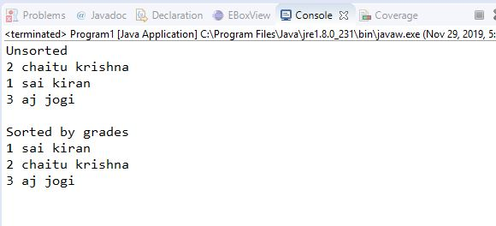

**Program:2**

**abstract** **class** Shape

{

**abstract** **void** getPerimeter();

**abstract** **void** getArea();

}

**public** **class** Shapedemo

{

**public** **static** **void** main(String[] args)

{

Square sq=**new** Square(2);

sq.getPerimeter();

sq.getArea();

Pentagon pg=**new** Pentagon(4);

pg.getPerimeter();

pg.getArea();

Circle cr=**new** Circle(3);

cr.getPerimeter();

cr.getArea();

}

}

**class** Square **extends** Shape

{

**int** a;

**double** perimeter,area;

Square(**int** a)

{

**this**.a=a;

}

@Override

**void** getPerimeter()

{

perimeter=4*a;

System.***out***.println("perimeter of square:"+perimeter);

}

@Override

**void** getArea()

{

area=a*a;

System.***out***.println("area of square:"+area);

}

}

**class** Pentagon **extends** Shape

{

**double** s,perimeter,area;

Pentagon(**double** s)

{

**this**.s=s;

}

@Override

**void** getPerimeter()

{

perimeter=5*s;

System.***out***.println("perimeter of pentagon:"+perimeter);

}

@Override

**void** getArea()

{

area=(Math.*sqrt*(5*(5 + 2*(Math.*sqrt*(5))))* s*s)/4;

System.***out***.println("area of pentagon:"+area);

}

}

**class** Circle **extends** Shape

{

**double** r,perimeter,area;

Circle(**double** r)

{

**this**.r=r;

}

@Override

**void** getPerimeter()

{

perimeter=2*3.14*r;

System.***out***.println("perimeter of circle:"+perimeter);

}

@Override

**void** getArea()

{

area=3.14*r*r;

System.***out***.println("area of circle:"+area);

}

}

**Output:2**

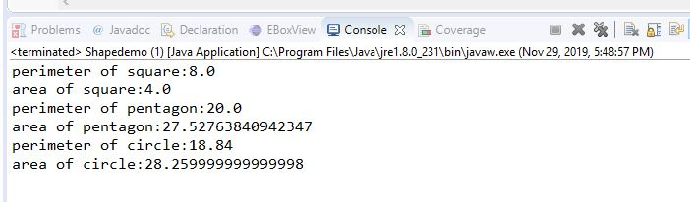

**Program:3**

**import** java.util.List;

**import** java.util.ArrayList;

**public** **class** Program3 {

**public** **static** **void** main(String args[]) {

**int** key;

List<Integer> a1=**new** ArrayList<Integer>();

a1.add(23);

a1.add(35);

a1.add(123);

a1.add(273);

a1.add(1223);

key=273;

a1.contains(key);

**if**(a1.contains(key)==**true**) {

System.***out***.println(key+" found in array list");

}

**else**

System.***out***.println(key+" Not found in array list");

}

**boolean** contains(**int** key) {

**return** **true**;

}

}

**Output:3**

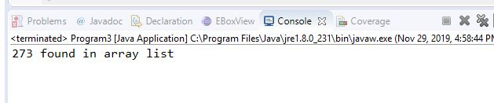

**Program:4**

**import** java.util.Scanner;

**public** **class** Program4 {

**static** Scanner *sc*=**new** Scanner(System.***in***);

**public** **static** **void** main(String args[]) {

**int** empId[]=**new** **int**[20];

empId=*input*();

*sort*(empId);

}

**static** **int**[] input() {

**int**[] empId=**new** **int**[20];

**for**(**int** i=0;i<20;i++) {

empId[i]=*sc*.nextInt();

}

**return** empId;

}

**static** **void** sort(**int**[] empId) {

**int** temp;

**for**(**int** i=0;i<empId.length;i++) {

**for**(**int** j=i+1;j<empId.length;j++) {

**if**(empId[i]<=empId[j]){

temp=empId[i];

empId[i]=empId[j];

empId[j]=temp;

}

}

System.***out***.println(empId[i]);

}

}

}

**Output:4**

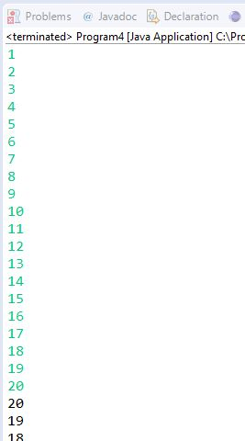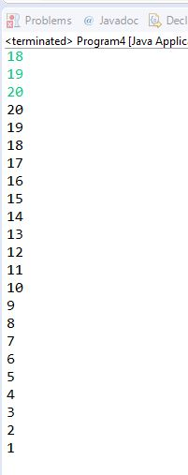

**Program:5**

**class** BinarySearch{

**public** **static** **void** binarySearch(**int** arr[], **int** first, **int** last, **int** key){

**int** mid = (first + last)/2;

**while**( first <= last ){

**if** ( arr[mid] < key ){

first = mid + 1;

}**else** **if** ( arr[mid] == key ){

System.***out***.println("Element is found at index: " + mid);

**break**;

}

**else**

{

last = mid - 1;

}

mid = (first + last)/2;

}

**if** ( first > last ){

System.***out***.println("Element is not found!");

}

}

**public** **static** **void** main(String args[]){

**int** arr[] = {1,2,3,4,5};

**int** key = 2;

**int** last=arr.length-1;

*binarySearch*(arr,0,last,key);

}

}

**Output:5**

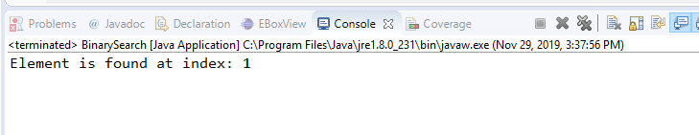

**Program:6**

**import** java.io.IOException;

**import** java.util.Scanner;

**public** **class** Car {

**public** **static** **void** main(String args[]) **throws** IOException{

**int** n=0,m=0;

Scanner sc=**new** Scanner(System.***in***);

**int**[] evenNumber=**new** **int**[10];

**int**[] oddNumber=**new** **int**[10];

**int**[] carNumber=**new** **int**[10];

System.***out***.println("Enter car numbers");

**for**(**int** i=0;i<10;i++) {

carNumber[i]=sc.nextInt();

}

**for**(**int** i=0;i<10;i++) {

**int** temp=carNumber[i];

**if**(temp%2==0){

evenNumber[n]=carNumber[i];

System.***out***.println("Even car numbers: "+evenNumber[n]);

n++;

}

**else** {

oddNumber[m]=carNumber[i];

System.***out***.println("Odd car number: "+oddNumber[m]);

m++;

}

}

}

}

**Output:6**

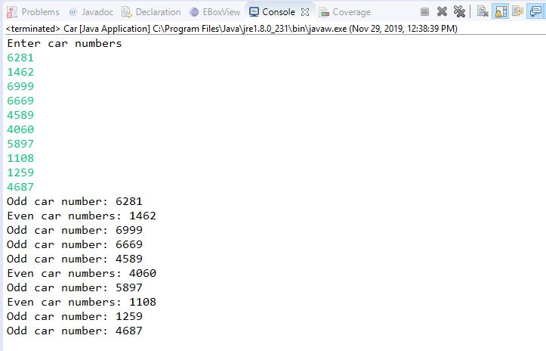

**Program:7**

**Algorithm:**

.*Start the program*

. *Initialize the required variable*

**.** *Enter the First matrix elements*

**.** *Enter the second matrix elements*

**.** *Save the program*

**.** *Multiply the program*

**.** *Run the output*

**package** CodeCamp;

**import** java.util.Scanner;

**public** **class** Programmatrix {

**public** **static** **void** main(String args[])

{

**int** i,j,k;

**int** arr[][] = **new** **int**[3][3];

**int** arr1[][]=**new** **int**[3][3];

**int** arrm[][]=**new** **int**[3][3];

Scanner sc = **new** Scanner(System.***in***);

System.***out***.print("Enter 3*3 Array1 Elements : ");

**for**(i=0; i<3; i++)

{

**for**(j=0; j<3; j++)

{

arr[i][j] = sc.nextInt();

}

}

System.***out***.print("Enter 3*3 Array2 Elements : ");

**for**(i=0; i<3; i++)

{

**for**(j=0; j<3; j++)

{

arr1[i][j] = sc.nextInt();

}

}

System.***out***.println("Matrix multiplication is");

**for** (i = 0; i < 3; i++) {

**for** (j = 0; j < 3; j++) {

**for** (k = 0; k < 3; k++) {

arrm[i][j] += arr[i][k] * arr1[k][j];

}

}

}

**for** (i = 0; i < 3; i++) {

**for** (j = 0; j < 3; j++) {

System.***out***.print(arrm[i][j] + " ");

}

System.***out***.print("\n");

}

}

}

**Output:7**

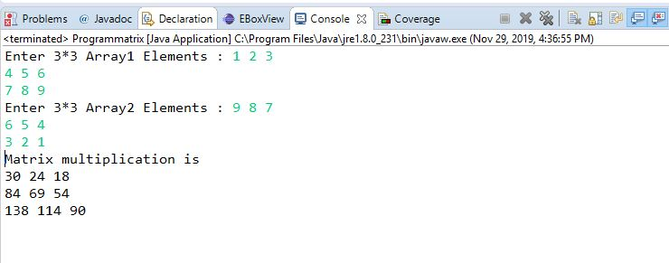

**Program:8**

**long** methodA(byte x, double y)

{

return x / y * 2;

}

**Program:9**

 public void add(int index, int element)

• public void add(int element)

• public int remove(int index)

• public int size()

• public String toString()

**Program:10**

**public** **class** Program10 {

**public** **static** **void** main(String[] args) {

**int** a=12, b=21;

**int** sum=a+b;

System.***out***.println("Enter two numbers to add: ");

System.***out***.println(a);

System.***out***.println(b);

System.***out***.println("The sum is:"+sum);

}

}

**Output:10**

1.It is not a valid declaration because the values are not specified to the variables

2.After validation the output is below

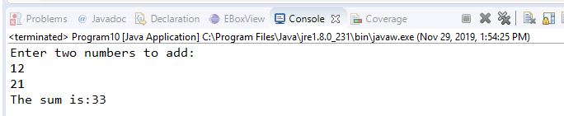

**Program:11**

**public** **class** Program11 {

**public** **static** **void** main(String[] args)

{

**char** c = 0x000A;

System.***out***.println(c);

}

}

**Output:11**

1.No the syntax not work.

2.It doesn’t print output.

3.The behavior of this program is platform independent: It won’t compile on any platform.

**Program:12**

**public** **class** Program12 {

**public** **static** **void** main(String[] args) {

**int** i = 0;

**while** (-1 << i != 0)

i++;

System.***out***.println(i);

}

}

**Output:12**

1.The program doesn’t show any output.

2.If the ‘i==0’in while, then it showing ‘0’ as an output.

**Program:13**

**public** **class** HelloWorld

{

**public** **static** **void** main(String args[])

{

**try**

{

System.***out***.println("Hello world");

System.*exit*(0);

}

**finally**

{ System.***out***.println("Goodbye world");

}

}

}

**Output:13**

1.No the syntax doesn’t work.

2.I renamed Finally to finally.

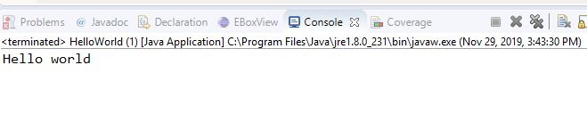

**Program:14**

**import** java.io.IOException;

**public** **class** San

{

San()**throws** IOException

{

}

}

**class** Foundry **extends** San

{

Foundry() **throws** IOException{

**super**();

}

{

}

**public** **static** **void** main(String[] args)

{

System.***out***.println("hello");

}

}

**Output:14**

**Program:15**

**public** **class** Program

{

**private** **static** **final** String ***Program*** = **null**;

**public** **static** **void** main(String[] args)

{

Program t = **new** Program();

*x* = 22;

*y* = 44;

System.***out***.println("Program : " + ***Program***);

System.***out***.println("t.x: " + t.*x*);

System.***out***.println("t.y: " + t.*y*);

System.***out***.println("y: " + *y*);

}

**static** **int** *x* = 11;

**private** **static** **int** *y* = 33;

}

**Output:15**

