Program:10

**package** codecamp1;

**import** java.util.Scanner;

**public** **class** Addition {

**public** **static** **void** main(String[] args) {

**int** a,b;

Scanner sc =**new** Scanner(System.***in***);

System.***out***.println("Enter values of a and b: ");

a=sc.nextInt();

b=sc.nextInt();

**int** sum=a+b;

System.***out***.println("Enter two numbers to add: ");

System.***out***.println (a);

System.***out***.println (b);

System.***out***.println ("The sum is: " +sum);

}

}

Output:

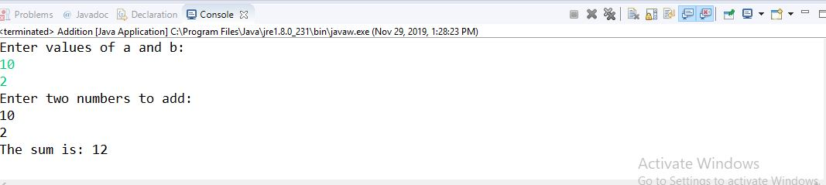

**Program:7**

**package** codecamp1;

**public** **class** Matrixmultiplication{

**public** **static** **void** main(String args[]){

**int** a[][]={{1,2,3},{4,5,6},{7,8,9}};

**int** b[][]={{4,5,6},{7,8,9},{1,2,3}};

**int** c[][]=**new** **int**[3][3];

**for**(**int** i=0;i<3;i++){

**for**(**int** j=0;j<3;j++){

c[i][j]=0;

**for**(**int** k=0;k<3;k++)

{

c[i][j]+=a[i][k]*b[k][j];

}

System.***out***.print(c[i][j]+" ");

}

System.***out***.println();

}

}

}

Output:

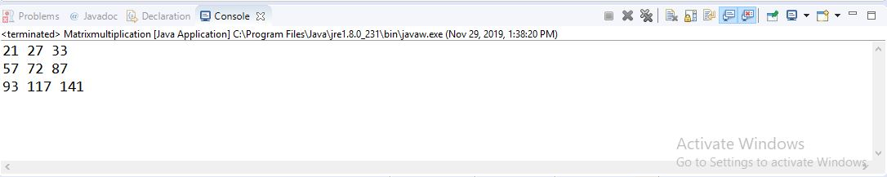

Program:11

**package** codecamp1;

**public** **class** LinePrinter {

**public** **static** **void** main(String[] args)

{

**char** c = 0x000A; System.***out***.println(c); } }

Output:

1.yes

2.It shows logical error, while run it doesn’t show anything

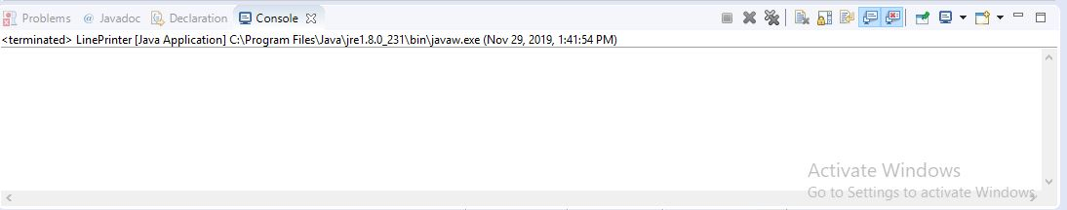

3. It is platform independent

Program:3

**package** codecamp1;

**public** **class** Sequentialtest {

**public** **static** **int** sequentialSearch(**int**[] values, **int** target)

{

**for** (**int** i = 0; i < values.length; i++)

{

**if** (values[i] == target)

{

**return** i;

}

}

**return** -1;

}

**public** **static** **void** main(String[] args)

{

**int**[] arr1 = {1, 11, -18, 17, 210};

**int** index = *sequentialSearch*(arr1,11);

System.***out***.println(index);

index = *sequentialSearch*(arr1,22);

System.***out***.println(index);

}

}

Output:

