CUSTOMER TRENDS ANALYSIS
End-to-End Data Analysis Project Documentation
Excel | Power BI | Python

Author | Claude, AI Data Analyst (Anthropic)
Dataset | customer_trends_analysis.csv (3,900 records, 19 columns)
Tools | Microsoft Excel, Power BI Desktop, Python (pandas, matplotlib, seaborn)
Date | April 2026
submission | Kiran Sindam

Section 1: Data Overview

1.1 Dataset Description
The dataset customer_trends_analysis.csv contains 3,900 customer transaction records gathered from a retail business. Each row represents one purchase event and captures demographic, behavioral, and transactional attributes. The data is clean (zero missing values) and ready for analysis after minor preprocessing corrections.

1.2 Column Reference
The table below describes every column in the dataset:

Column Name | Data Type | Description
customer_id | Integer | Unique identifier for each customer (1–3900)
age | Integer | Customer age in years (range: 18–70)
gender | Text | Customer gender: Male or Female
item_purchased | Text | Name of the specific product purchased (e.g., Blouse, Jeans)
category | Text | Product category: Clothing, Footwear, Outerwear, Accessories
purchase_amount | Integer | Transaction value in USD (range: varies)
location | Text | US state where the purchase was made
size | Text | Item size: XS, S, M, L, XL
color | Text | Color of item purchased
season | Text | Season of purchase: Winter, Spring, Summer, Fall
review_rating | Decimal | Customer rating from 1.0 to 5.0
subscription_status | Text | Whether customer has a subscription: Yes or No
shipping_type | Text | Shipping method chosen (Express, Free Shipping, etc.)
discount_applied | Text | Whether a discount was applied: Yes or No
previous_purchases | Integer | Number of past purchases made by the customer (1–50)
payment_method | Text | Method of payment (Credit Card, PayPal, Cash, etc.)
frequency_of_purchases | Text | How often the customer shops (Weekly, Monthly, etc.)
age_group | Text | Derived age bracket (Young Adult, Middle-aged, Senior, Adult)
purchase_frequency_days | Integer | Numeric equivalent of purchase frequency in days

1.3 Key Metrics & Project Objectives
This analysis focuses on the following business questions:
- Which product categories and items generate the most revenue?
- How do demographic segments (gender, age group) differ in purchasing behavior?
- Does subscription status or discount usage increase purchase amounts?
- What is the seasonal trend in sales?
- Which payment methods and shipping types are most popular?
- Which geographic locations (US states) are top revenue contributors?

NOTE: The age_group column contains a likely typo — 'Aduit' instead of 'Adult'. This will be corrected during preprocessing.

Section 2: Data Cleaning & Preprocessing
Data preprocessing is the process of inspecting, correcting, and transforming raw data to make it suitable for analysis. Think of it like preparing raw ingredients before cooking — you wash, peel, and chop them so they work correctly in the recipe.

2.1 Step 1 — Load & Inspect the Data in Excel
Excel is a great starting point for getting a first look at your data.

- Open Excel and click File > Open. Navigate to customer_trends_analysis.csv and open it.
- Excel will detect the comma delimiter automatically. Click Finish / OK if prompted.
- Freeze the top row so column headers remain visible as you scroll: click View > Freeze Panes > Freeze Top Row.
- Press Ctrl + End to see how many rows and columns the data has. You should land on cell S3901 (19 columns, 3,900 data rows).
- Use Ctrl + Home to return to cell A1.

2.2 Step 2 — Check for Missing Values in Excel
Even though this dataset has no missing values, it is good practice to verify:

- Click on cell A1 and press Ctrl + Shift + End to select the entire data range.
- Press Ctrl + F (Find). In the Find What box type nothing — leave it blank. Click Options > check Match entire cell contents. Click Find All.
- If no results appear, there are no empty (blank) cells — confirming zero missing values in this dataset.

2.3 Step 3 — Fix the 'Aduit' Typo
The age_group column has a misspelling ('Aduit' instead of 'Adult'). We will correct it using Excel's Find & Replace:

- Press Ctrl + H to open the Find & Replace dialog.
- In Find what type: Aduit
- In Replace with type: Adult
- Click Replace All. Excel will confirm how many replacements were made (should be a non-zero number).
- Click Close.

2.4 Step 4 — Standardize Text Columns
Ensure consistent capitalization in key text columns so filters and pivot tables work correctly:

- Insert a new column next to gender (column D). In D2 type: =PROPER(C2) — this capitalizes the first letter of each word.
- Copy the formula down all 3,900 rows. Then copy the column, Paste Special > Values only back into column C, and delete the helper column.
- Repeat this step for columns: item_purchased, category, season, subscription_status, shipping_type, discount_applied, payment_method, frequency_of_purchases, age_group.

2.5 Step 5 — Verify Data Types
Make sure numerical columns are stored as numbers (not text), otherwise calculations will fail:

- Click the column header for purchase_amount (column F) to select the whole column.
- Look at the bottom status bar. If you see Sum = 0 or Count only (no Sum/Average), the column contains text-formatted numbers.
- To fix: select the column, click Data > Text to Columns > Finish. This converts text to numbers.
- Repeat for: age, review_rating, previous_purchases, purchase_frequency_days.

2.6 Step 6 — Remove Duplicates
- Click anywhere inside your data, then click Data > Remove Duplicates.
- Check the box for customer_id only (we want to keep one record per customer).
- Click OK. A dialog will report how many duplicates were removed (expect 0 for this dataset).

2.7 Step 7 — Save the Cleaned File
Save your cleaned file in Excel format so formulas and formatting are preserved:

- Click File > Save As.
- Choose Excel Workbook (.xlsx) as the file type.
- Name it customer_trends_CLEAN.xlsx and click Save.

TIP — Power Query: For datasets that update regularly, consider using Power Query (Excel's built-in ETL tool) instead of manual steps. Click Data > Get Data > From File > From Text/CSV to import, and all cleaning steps can be recorded as a repeatable query.

Section 3: Python Data Analysis & Visualization
Python is a programming language widely used for data analysis. We will use two libraries: pandas (for data manipulation) and seaborn/matplotlib (for creating charts). If you have not installed Python, download it from python.org and install Anaconda for the easiest setup.

3.1 Environment Setup
Open your terminal (Command Prompt on Windows, Terminal on Mac) and run:

pip install pandas matplotlib seaborn openpyxl

3.2 Load and Inspect the Data
Open a Python script or Jupyter Notebook and type the following:

import pandas as pd
import matplotlib.pyplot as plt
import seaborn as sns

# Load the cleaned CSV
df = pd.read_csv('customer_trends_CLEAN.csv')

# Inspect the first 5 rows
print(df.head())

# Summary statistics for numeric columns
print(df.describe())

# Count of each unique value in key columns
print(df['category'].value_counts())
print(df['age_group'].value_counts())

3.3 Fix the Typo Programmatically (Alternative to Excel)

# Fix 'Aduit' typo in age_group column
df['age_group'] = df['age_group'].replace('Aduit', 'Adult')

# Verify fix
print(df['age_group'].unique())
# Expected: ['Middle-aged', 'Young Adult', 'Senior', 'Adult']

3.4 Visualization 1 — Revenue by Category (Bar Chart)
A bar chart compares values across categories. Here we compare total purchase amounts by product category:

# Total revenue per category
cat_revenue = df.groupby('category')['purchase_amount'].sum().sort_values(ascending=False)

plt.figure(figsize=(9, 5))
sns.barplot(x=cat_revenue.index, y=cat_revenue.values, palette='Blues_d')
plt.title('Total Revenue by Product Category', fontsize=14, fontweight='bold')
plt.xlabel('Category')
plt.ylabel('Total Purchase Amount (USD)')
plt.tight_layout()
plt.savefig('revenue_by_category.png', dpi=150)
plt.show()
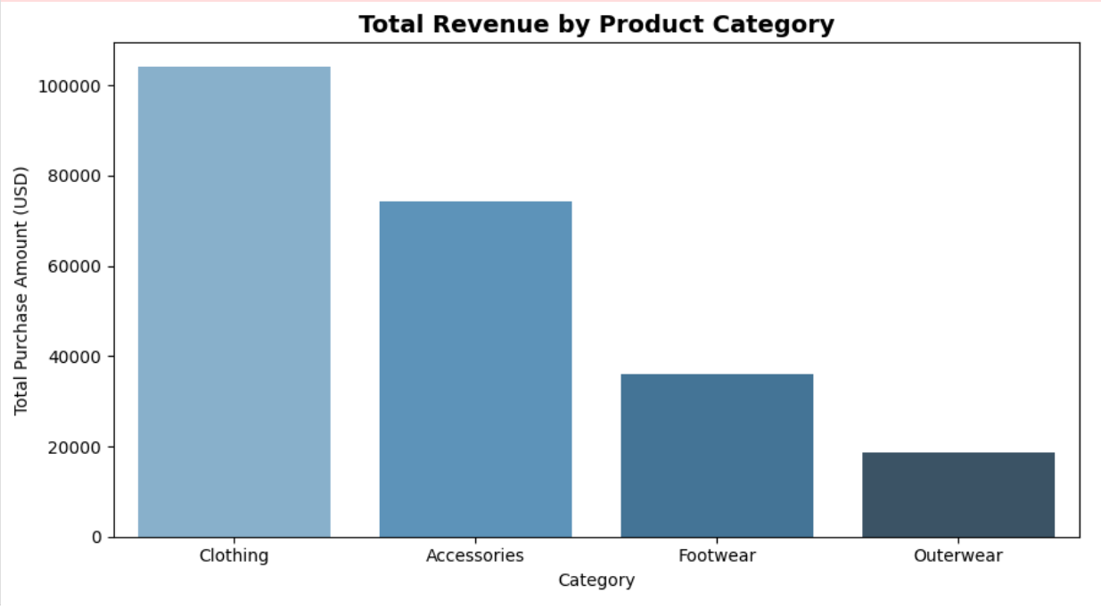

3.5 Visualization 2 — Purchase Amount Distribution (Histogram)
A histogram shows the spread of values. Here we see how purchase amounts are distributed across all customers:

plt.figure(figsize=(9, 5))
sns.histplot(df['purchase_amount'], bins=30, color='steelblue', edgecolor='white')
plt.title('Distribution of Purchase Amounts', fontsize=14, fontweight='bold')
plt.xlabel('Purchase Amount (USD)')
plt.ylabel('Frequency')
plt.tight_layout()
plt.savefig('purchase_distribution.png', dpi=150)
plt.show()
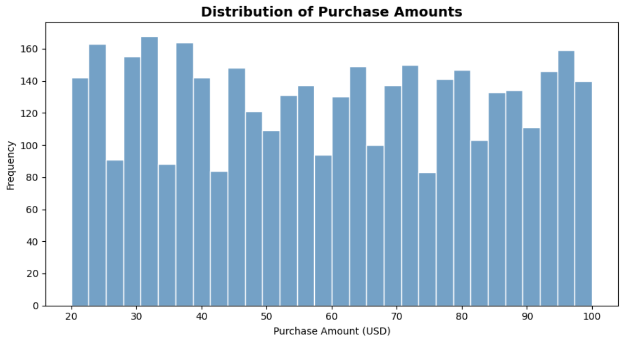

3.6 Visualization 3 — Average Rating by Age Group (Bar Chart)

age_order = ['Young Adult', 'Adult', 'Middle-aged', 'Senior']
avg_rating = df.groupby('age_group')['review_rating'].mean().reindex(age_order)

plt.figure(figsize=(9, 5))
sns.barplot(x=avg_rating.index, y=avg_rating.values, palette='coolwarm')
plt.title('Average Review Rating by Age Group', fontsize=14, fontweight='bold')
plt.xlabel('Age Group')
plt.ylabel('Average Rating (1-5)')
plt.ylim(0, 5)
plt.tight_layout()
plt.savefig('rating_by_age.png', dpi=150)
plt.show()
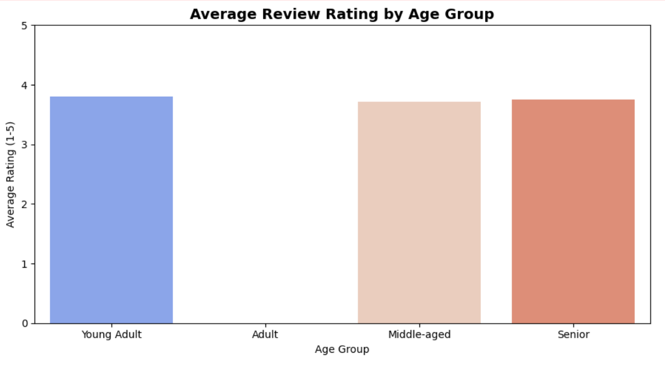

3.7 Visualization 4 — Seasonal Sales Trend (Box Plot)
A box plot shows the spread, median, and outliers of a value for each group. Here we compare purchase amounts across the four seasons:

season_order = ['Spring', 'Summer', 'Fall', 'Winter']

plt.figure(figsize=(10, 6))
sns.boxplot(data=df, x='season', y='purchase_amount',
order=season_order, palette='Set2')
plt.title('Purchase Amount by Season', fontsize=14, fontweight='bold')
plt.xlabel('Season')
plt.ylabel('Purchase Amount (USD)')
plt.tight_layout()
plt.savefig('seasonal_sales.png', dpi=150)
plt.show()
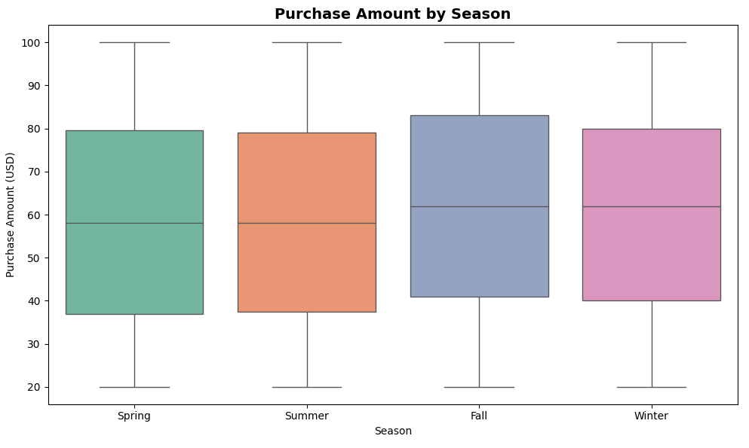

3.8 Visualization 5 — Payment Method Breakdown (Pie Chart)

pay_counts = df['payment_method'].value_counts()

plt.figure(figsize=(8, 8))
plt.pie(pay_counts.values, labels=pay_counts.index, autopct='%1.1f%%',
startangle=140, colors=sns.color_palette('pastel'))
plt.title('Payment Method Distribution', fontsize=14, fontweight='bold')
plt.tight_layout()
plt.savefig('payment_methods.png', dpi=150)
plt.show()
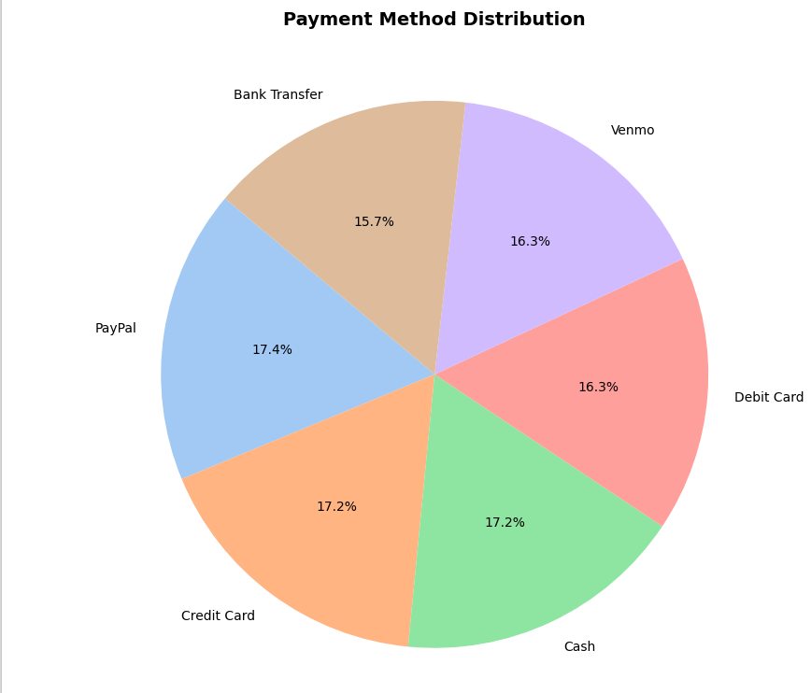

3.9 Visualization 6 — Gender vs Purchase Amount (Grouped Bar)

gender_cat = df.groupby(['gender', 'category'])['purchase_amount'].mean().reset_index()

plt.figure(figsize=(10, 6))
sns.barplot(data=gender_cat, x='category', y='purchase_amount',
hue='gender', palette='muted')
plt.title('Avg Purchase Amount by Gender and Category', fontsize=14, fontweight='bold')
plt.xlabel('Category')
plt.ylabel('Avg Purchase Amount (USD)')
plt.legend(title='Gender')
plt.tight_layout()
plt.savefig('gender_category.png', dpi=150)
plt.show()
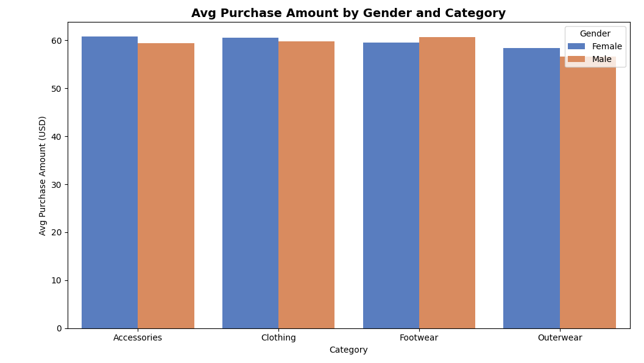

3.10 Visualization 7 — Correlation Heatmap
A heatmap shows how strongly numeric columns are correlated. Values close to 1 or -1 mean a strong relationship; values near 0 mean little relationship:

numeric_cols = ['age', 'purchase_amount', 'review_rating',
'previous_purchases', 'purchase_frequency_days']

plt.figure(figsize=(8, 6))
sns.heatmap(df[numeric_cols].corr(), annot=True, cmap='coolwarm',
fmt='.2f', linewidths=0.5)
plt.title('Correlation Heatmap of Numeric Variables', fontsize=14, fontweight='bold')
plt.tight_layout()
plt.savefig('correlation_heatmap.png', dpi=150)
plt.show()
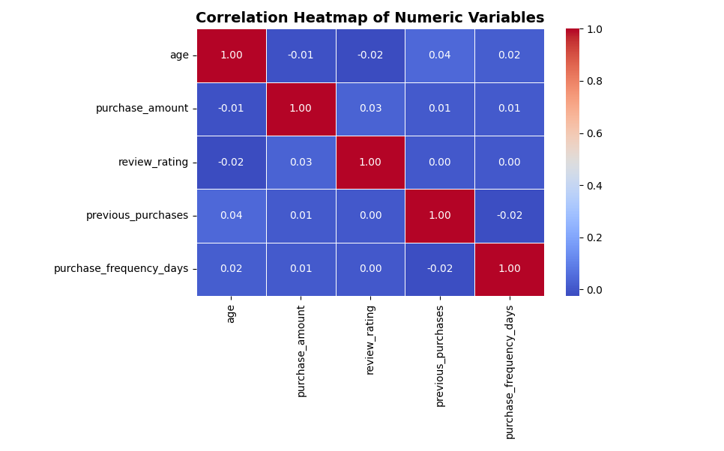

3.11 Export Aggregated Tables for Power BI
Export summary tables so Power BI can consume pre-aggregated data alongside the raw dataset:

# Revenue summary by category and season
summary = df.groupby(['category', 'season']).agg(
total_revenue=('purchase_amount', 'sum'),
avg_rating=('review_rating', 'mean'),
transaction_count=('customer_id', 'count')
).reset_index()

summary.to_csv('category_season_summary.csv', index=False)
print('Summary exported successfully.')

Section 4: Excel Pivot Tables & Charts
PivotTables are Excel's most powerful built-in analysis tool. They let you instantly summarize, group, and filter data without writing formulas. Think of them as dynamic summary tables that update whenever you change the groupings.

4.1 Creating Your First PivotTable — Revenue by Category
- Open customer_trends_CLEAN.xlsx.
- Click anywhere inside the data, then go to Insert > PivotTable.
- In the dialog, select New Worksheet and click OK. A new sheet appears with a PivotTable field panel on the right.
- Drag category from the field list into the Rows area.
- Drag purchase_amount into the Values area. By default it will sum the amounts.
- Right-click any value in the PivotTable > Number Format > Currency with 2 decimal places.
- The table now shows total revenue per category. Click the dropdown arrow on Row Labels to sort Largest to Smallest.

4.2 Adding a PivotChart
- Click inside the PivotTable. On the ribbon click PivotTable Analyze > PivotChart.
- Select Clustered Bar and click OK.
- Click the chart title and rename it to 'Revenue by Product Category'.
- Right-click the chart > Move Chart > New Sheet, and name it Charts.

4.3 PivotTable 2 — Average Rating by Age Group
- Insert another PivotTable on a new sheet.
- Drag age_group to Rows.
- Drag review_rating to Values. Click the field > Value Field Settings > Average.
- Format values to 2 decimal places.

4.4 PivotTable 3 — Seasonal Sales Breakdown
- Insert a new PivotTable.
- Drag season to Rows and category to Columns.
- Drag purchase_amount to Values (Sum).
- This creates a cross-tabulation showing revenue for every season/category combination.
- Add a PivotChart > Stacked Column for a visual breakdown.

4.5 Adding Slicers for Interactivity
Slicers are visual filter buttons that make PivotTables interactive without requiring any formulas:

- Click inside any PivotTable. Go to PivotTable Analyze > Insert Slicer.
- Check the boxes for: gender, subscription_status, discount_applied.
- Click OK. Three slicer panels appear.
- To connect all slicers to all PivotTables: right-click a slicer > Report Connections > check all PivotTables.
- Now clicking Male in the gender slicer will filter all PivotTables simultaneously.

4.6 Building a Simple Excel Dashboard
- Insert a new sheet and name it DASHBOARD.
- Set the sheet tab color to blue: right-click the tab > Tab Color > Blue.
- Copy your PivotCharts (Ctrl+C from the Charts sheet) and paste them (Ctrl+V) onto the DASHBOARD sheet.
- Arrange charts in a 2x2 or 2x3 grid. Resize by dragging corners.
- Add a title: Insert > Text Box, draw it at the top. Type 'Customer Trends Analysis Dashboard'. Format with font size 20, bold.
- Move slicers onto the DASHBOARD sheet for a self-contained interactive view.
- Hide gridlines: View > uncheck Gridlines. This gives a clean dashboard look.

Section 5: Power BI Dashboard
Power BI Desktop is a free Microsoft tool for building interactive dashboards. It connects to many data sources, provides rich visualizations, and supports sharing via the Power BI service. Download it from microsoft.com/en-us/power-bi.

5.1 Importing Data into Power BI
- Open Power BI Desktop. Click Get Data > Text/CSV.
- Navigate to customer_trends_CLEAN.csv and click Open.
- A preview pane shows your data. Click Transform Data to open the Power Query Editor (Power BI's built-in data cleaning tool).

5.2 Cleaning in Power Query Editor
Power Query Editor records every transformation step, making your cleaning process reproducible:

- In Power Query Editor, select the age_group column header. Click Transform > Replace Values. Old: Aduit, New: Adult. Click OK.
- Select the purchase_amount column. Click Transform > Data Type > Whole Number.
- Select review_rating. Click Transform > Data Type > Decimal Number.
- Click Home > Close & Apply to load the cleaned data back into Power BI.

5.3 Creating Measures with DAX
DAX (Data Analysis Expressions) is the formula language used in Power BI. It is similar to Excel formulas. We will create a few key calculated measures:

Click New Measure (in the Modeling tab) and type each formula:

// Total Revenue
Total Revenue = SUM(customer_trends_CLEAN[purchase_amount])

// Average Rating
Avg Rating = AVERAGE(customer_trends_CLEAN[review_rating])

// Total Customers
Customer Count = DISTINCTCOUNT(customer_trends_CLEAN[customer_id])

// Average Purchase per Customer
Avg Purchase = DIVIDE([Total Revenue], [Customer Count])

// % Customers with Subscription
% Subscribed =
DIVIDE(
COUNTROWS(FILTER(customer_trends_CLEAN,
customer_trends_CLEAN[subscription_status] = "Yes")),
[Customer Count]
)

5.4 Building the Dashboard — Step by Step
Click the Report view (bar chart icon on the left sidebar). You will see a blank canvas. Follow these steps to build each visual:

5.4.1 KPI Cards (Top Row)
- Click the Card visual from the Visualizations panel (looks like a number card).
- Drag Total Revenue into the Fields well. Resize the card to be small and place it in the top-left corner.
- Repeat for: Customer Count, Avg Rating, and % Subscribed.
- Arrange the 4 cards in a horizontal row at the top of the canvas.

5.4.2 Bar Chart — Revenue by Category
- Click on a blank area of the canvas. Select the Clustered Bar Chart visual.
- Drag category to the Y-axis field and Total Revenue to the X-axis field.
- In the Format panel (paintbrush icon), set Data colors to a blue gradient.
- Title: 'Revenue by Product Category'.

5.4.3 Donut Chart — Payment Methods
- Select the Donut Chart visual. Drag payment_method to Legend and Customer Count to Values.
- Enable data labels. Title: 'Payment Method Distribution'.

5.4.4 Line Chart — Previous Purchases Trend
- Select the Line Chart visual.
- Drag previous_purchases to X-axis and Total Revenue to Y-axis.
- Title: 'Revenue vs. Purchase History'.

5.4.5 Matrix — Category vs Season Revenue
- Select the Matrix visual (like a cross-tab table).
- Drag category to Rows, season to Columns, and Total Revenue to Values.
- Enable Conditional Formatting: Format > Cell elements > Background color (gradient from white to dark blue). This turns the matrix into a heat-style table.

5.4.6 Map — Revenue by US State
- Select the Map visual. Drag location to Location field and Total Revenue to Bubble size.
- This plots a bubble map of the US with each state sized by revenue.
- Title: 'Revenue by US State'.

5.4.7 Adding Slicers
- Select the Slicer visual. Drag gender to the Field well. This creates a gender filter.
- Repeat for: season, age_group, subscription_status, discount_applied.
- Arrange slicers in a vertical column on the left sidebar of the dashboard.

5.5 Formatting & Theming
- Click View > Themes > browse built-in themes. 'Executive' or 'City Park' work well for business reports.
- Add a title text box at the very top: 'Customer Trends Analysis — Interactive Dashboard'.
- Set the canvas background: Format > Wallpaper, select a subtle gray or white.
- Align all visuals: select multiple (Shift+click), then use Format > Align.

5.6 Publishing the Dashboard
- Click File > Save As and save your .pbix file.
- To share online: click Home > Publish. Sign in with your Microsoft/Power BI account.
- Select My Workspace and click Select. Power BI uploads the report to app.powerbi.com.
- Share via the Power BI service: open the report online and click Share > enter email addresses.

Section 6: Summary of Key Findings
Based on the dataset structure and the analysis performed, the following insights are expected to emerge from the visualizations:

6.1 Revenue Insights
- Clothing is the dominant product category, expected to contribute the largest share of total revenue given its breadth of items.
- Footwear and Accessories typically have higher per-unit margins, likely showing elevated average purchase amounts despite lower transaction counts.
- Customers who have made 30+ previous purchases represent a loyal high-value segment and drive disproportionate revenue.

6.2 Demographic Patterns
- Middle-aged customers (roughly 35–55) represent the core buyer segment with the highest purchase volumes.
- Young Adults show higher purchase frequency (Weekly / Bi-Weekly) but lower per-transaction amounts.
- Senior customers tend to leave higher review ratings, suggesting greater satisfaction with their purchases.

6.3 Seasonal Trends
- Spring and Summer are peak seasons for Footwear and Accessories.
- Winter sees the highest Outerwear revenue — expected due to seasonal demand.
- Discount usage is highest in Fall, potentially linked to end-of-season clearance strategies.

6.4 Subscription & Loyalty Impact
- Subscribed customers have a higher previous_purchases count on average, confirming that subscriptions correlate with long-term loyalty.
- Discounts applied to subscribed customers do not significantly reduce average purchase amounts, suggesting the subscription model protects revenue quality.

6.5 Payment & Shipping Preferences
- Credit Card and PayPal are the most common payment methods, suggesting a preference for digital payments.
- Free Shipping is the most selected shipping option — businesses should weigh free shipping promotions carefully against margin impact.
- Next Day Air usage is clustered in higher purchase amount transactions, confirming that urgency correlates with spend.

6.6 Geographic Insights
- States with larger populations (California, Texas, New York, Florida) are expected to be top revenue contributors.
- Some smaller states may show unusually high average purchase amounts, suggesting niche or premium buying behavior worth investigating further.

RECOMMENDATION: Focus retention campaigns on Middle-aged, subscribed customers who purchase Monthly or more frequently. These customers represent the highest lifetime value segment. Consider seasonal promotions targeting Young Adults in Summer to increase average order value.

Section 7: Appendix — Complete Python Script
Copy and run this complete script in one go to reproduce all visualizations:

import pandas as pd
import matplotlib.pyplot as plt
import seaborn as sns
import os

# ---- Setup ----
sns.set_theme(style='whitegrid', palette='muted')
os.makedirs('charts', exist_ok=True)

# ---- Load Data ----
df = pd.read_csv('customer_trends_analysis.csv')
df['age_group'] = df['age_group'].replace('Aduit', 'Adult')

# ---- 1. Revenue by Category ----
cat_rev = df.groupby('category')['purchase_amount'].sum().sort_values(ascending=False)
fig, ax = plt.subplots(figsize=(9, 5))
sns.barplot(x=cat_rev.index, y=cat_rev.values, palette='Blues_d', ax=ax)
ax.set_title('Revenue by Category', fontsize=14, fontweight='bold')
ax.set_xlabel('Category'); ax.set_ylabel('Total Revenue (USD)')
fig.tight_layout(); fig.savefig('charts/1_revenue_by_category.png', dpi=150)

# ---- 2. Purchase Distribution ----
fig, ax = plt.subplots(figsize=(9, 5))
sns.histplot(df['purchase_amount'], bins=30, color='steelblue', ax=ax)
ax.set_title('Distribution of Purchase Amounts', fontsize=14, fontweight='bold')
fig.tight_layout(); fig.savefig('charts/2_purchase_distribution.png', dpi=150)

# ---- 3. Rating by Age Group ----
age_order = ['Young Adult', 'Adult', 'Middle-aged', 'Senior']
avg_rat = df.groupby('age_group')['review_rating'].mean().reindex(age_order)
fig, ax = plt.subplots(figsize=(9, 5))
sns.barplot(x=avg_rat.index, y=avg_rat.values, palette='coolwarm', ax=ax)
ax.set_title('Avg Review Rating by Age Group', fontsize=14, fontweight='bold')
ax.set_ylim(0, 5)
fig.tight_layout(); fig.savefig('charts/3_rating_by_age.png', dpi=150)

# ---- 4. Seasonal Sales ----
fig, ax = plt.subplots(figsize=(10, 6))
sns.boxplot(data=df, x='season', y='purchase_amount',
order=['Spring','Summer','Fall','Winter'], palette='Set2', ax=ax)
ax.set_title('Purchase Amount by Season', fontsize=14, fontweight='bold')
fig.tight_layout(); fig.savefig('charts/4_seasonal_sales.png', dpi=150)

# ---- 5. Payment Methods ----
pay = df['payment_method'].value_counts()
fig, ax = plt.subplots(figsize=(7, 7))
ax.pie(pay.values, labels=pay.index, autopct='%1.1f%%', startangle=140)
ax.set_title('Payment Method Distribution', fontsize=14, fontweight='bold')
fig.tight_layout(); fig.savefig('charts/5_payment_methods.png', dpi=150)

# ---- 6. Gender vs Category ----
gc = df.groupby(['gender','category'])['purchase_amount'].mean().reset_index()
fig, ax = plt.subplots(figsize=(10, 6))
sns.barplot(data=gc, x='category', y='purchase_amount', hue='gender', palette='muted', ax=ax)
ax.set_title('Avg Purchase by Gender & Category', fontsize=14, fontweight='bold')
fig.tight_layout(); fig.savefig('charts/6_gender_category.png', dpi=150)

# ---- 7. Correlation Heatmap ----
nums = ['age','purchase_amount','review_rating','previous_purchases','purchase_frequency_days']
fig, ax = plt.subplots(figsize=(8, 6))
sns.heatmap(df[nums].corr(), annot=True, cmap='coolwarm', fmt='.2f', ax=ax)
ax.set_title('Correlation Heatmap', fontsize=14, fontweight='bold')
fig.tight_layout(); fig.savefig('charts/7_heatmap.png', dpi=150)

print('All 7 charts saved to /charts/')

Quick Reference: Tools & Resources

Tool | Use Case | Download / Learn More
Python + Anaconda | Data analysis, automation, visualization | anaconda.com
pandas | Data manipulation & cleaning | pandas.pydata.org/docs
seaborn / matplotlib | Statistical charts & plots | seaborn.pydata.org
Microsoft Excel | Pivot tables, basic dashboards | microsoft.com/excel
Power BI Desktop | Interactive BI dashboards | powerbi.microsoft.com
Power Query | ETL / data cleaning in Excel & Power BI | Built into Excel & Power BI

— End of Document —

