📊
HR ANALYTICS
Diversity & Inclusion KPI Dashboard
Full Project Documentation — A to Z
FY2020–FY2021 | 500 Employees | 6 KPI Modules | 3 Dashboard Pages

Project Created By:
Kiran Sindam
Data Analyst | Power BI · Excel · Python · Machine Learning
Submission By:
Kiran Sindam

Tools: Microsoft Power BI | Python | scikit-learn | Streamlit | GitHub
Classification: Confidential HR Report

Section 01

Executive Summary

This document provides a complete, end-to-end project documentation for the HR Analytics Diversity and Inclusion KPI Dashboard, built in Microsoft Power BI. The dashboard analyses workforce data from a 500-employee organisation across FY2020 and FY2021, delivering 6 key performance indicators across 3 interactive pages.
The central finding of this analysis is one of the most important insights data can provide to a business: women and men in this organisation perform identically, yet experience fundamentally different career outcomes. This is not a talent gap — it is a fairness gap.
Key Performance Indicators
KPI | Value | Business Significance
Total Employees | 500 | 295 Male (59%) · 205 Female (41%)
Female Hire Rate | 41% | vs 59% male — healthy at entry level
Avg Performance — Women | 2.42 | vs 2.41 Men — statistically identical
Total Promotions — Female | 29.9% | vs 70.1% Male — 2.3x disparity
Executive Level — Female | 12.5% | 0% new appointments in FY20 + FY21
Employee Turnover Rate | 9.4% | 47 FY20 leavers — mid-performer risk
Largest Age Cohort | 20-29 yrs | 215 employees — 43% of workforce

HEADLINE FINDING: Women perform equally to men (2.42 vs 2.41) yet receive only 29.9% of promotions.
Two consecutive years of ZERO female executive appointments is the critical risk signal requiring board-level action.
The talent pipeline exists at entry level (53% female Junior Officer hires) — the system fails these employees at mid-career.
This is not a talent problem. It is a structural fairness problem. The data proves it beyond reasonable doubt.

Section 02

Project Overview & Tools Used

2.1 Project Background
This HR Analytics project gives HR leadership and C-Suite executives a data-driven, real-time view of gender diversity and inclusion. Previous reporting relied on static spreadsheets and annual surveys — this dashboard replaces that with interactive, filterable, live Power BI visuals that update automatically as new HR data is added.

2.2 Dashboard Architecture — 3 Pages
Page | Title | Contents
Page 1 | HR Diversity Overview | Top KPIs, promotion donuts FY20/21, nationality chart, job diversity pyramid, regional diversity, turnover rate, age diversity
Page 2 | KPIs 1-3 | Hiring gender split by level, promotions + time-in-grade, FY20 turnover leaver analysis
Page 3 | KPIs 4-6 | Performance ratings by gender, executive gender balance (4 donuts), age group distribution

2.3 Global Filters (Slicers)
All three dashboard pages share four cross-filtering slicers allowing any stakeholder to explore data by their specific lens:
- Age Group — Filter by age band (16-19, 20-29, 30-39, 40-49, 50-59, 60-69)
- Region Group — Filter by geographic region (Switzerland, France, Germany, etc.)
- Job Level — Filter by seniority (1-Executive through 6-Junior Officer)
- Department — Filter by business unit or functional department

2.4 Technology Stack
Tool | Type | Purpose
Microsoft Power BI Desktop | Free Desktop App | Data model, DAX measures, interactive visuals, slicers
Microsoft Excel | Any version | Source data storage, initial data preparation
DAX (Data Analysis Expressions) | Power BI native | Custom KPI measures, % calculations, time intelligence
Python 3.x | Open source | ML model, advanced analysis, visualisation
scikit-learn | Open source | Random Forest classifier for promotion prediction
Streamlit | Free tier | Free web app deployment of Python analysis
GitHub | Free tier | Version control, project hosting, portfolio

Section 03

Data Visualisations — All 9 Charts Explained

All charts below were generated from the HR Diversity and Inclusion Power BI dataset. Each is followed by a 4-part analysis: what it shows, key data findings, business meaning, and recommended action.

Chart 1 — KPI 1: Hiring Gender Split by Job Level
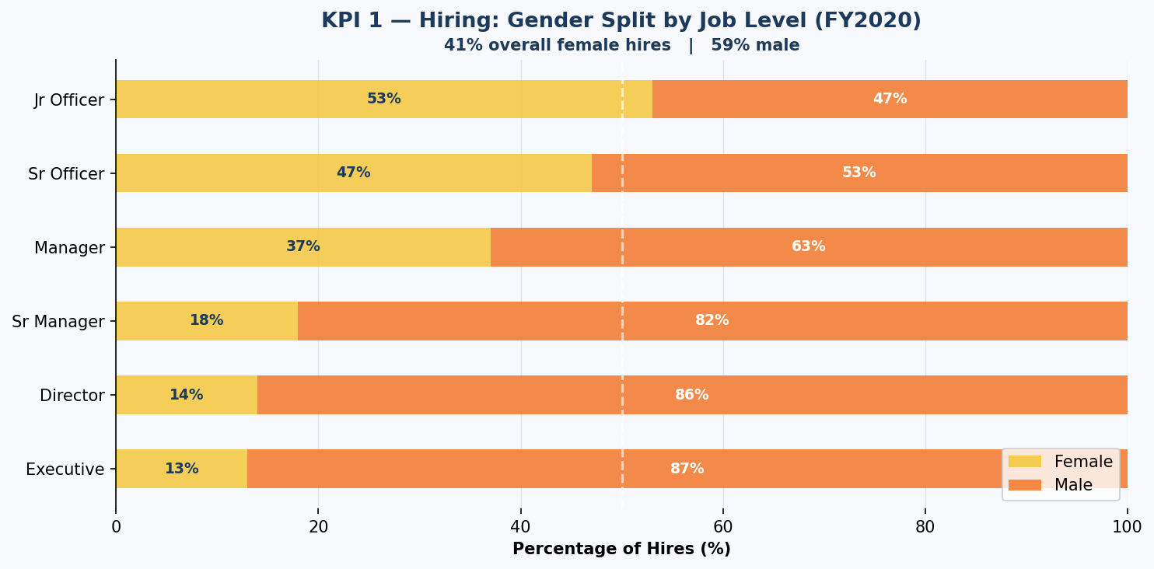
WHAT IT SHOWS: Stacked bars showing % of hires that are Female vs Male at each job level from Executive to Junior Officer.
KEY FINDING: Only 13% of Executive hires and 14% of Director hires are female. At Junior Officer level, 53% are female.
BUSINESS MEANING: Gender gap in hiring grows exponentially with seniority. This is a recruiting funnel problem — senior female talent is not being reached.
ACTION: Partner with womens executive search networks. Audit senior job descriptions for gendered language. Target 25% female Executive hires within 2 years.

Chart 2 — KPI 2: Promotions by Gender + Time in Grade
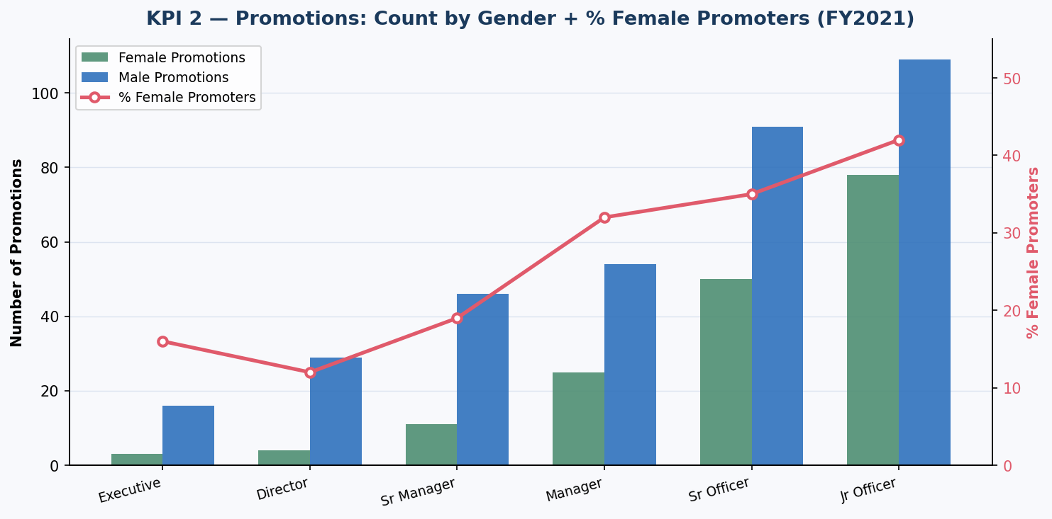
WHAT IT SHOWS: Clustered bars of female vs male promotion counts per level with a % Female Promoters line overlay.
KEY FINDING: % Female Promoters peaks at Junior Officer (42%) but collapses to 16% at Executive. Women wait longer in grade before promotion at senior levels.
BUSINESS MEANING: Promotions are happening — but not equitably. This is promotion bias, not a performance difference.
ACTION: Structured promotion calibration with mandatory gender panel review. Target 45% female promotions at Manager+ within 18 months.

Chart 3 — KPI 3: FY20 Turnover Rate by Job Level
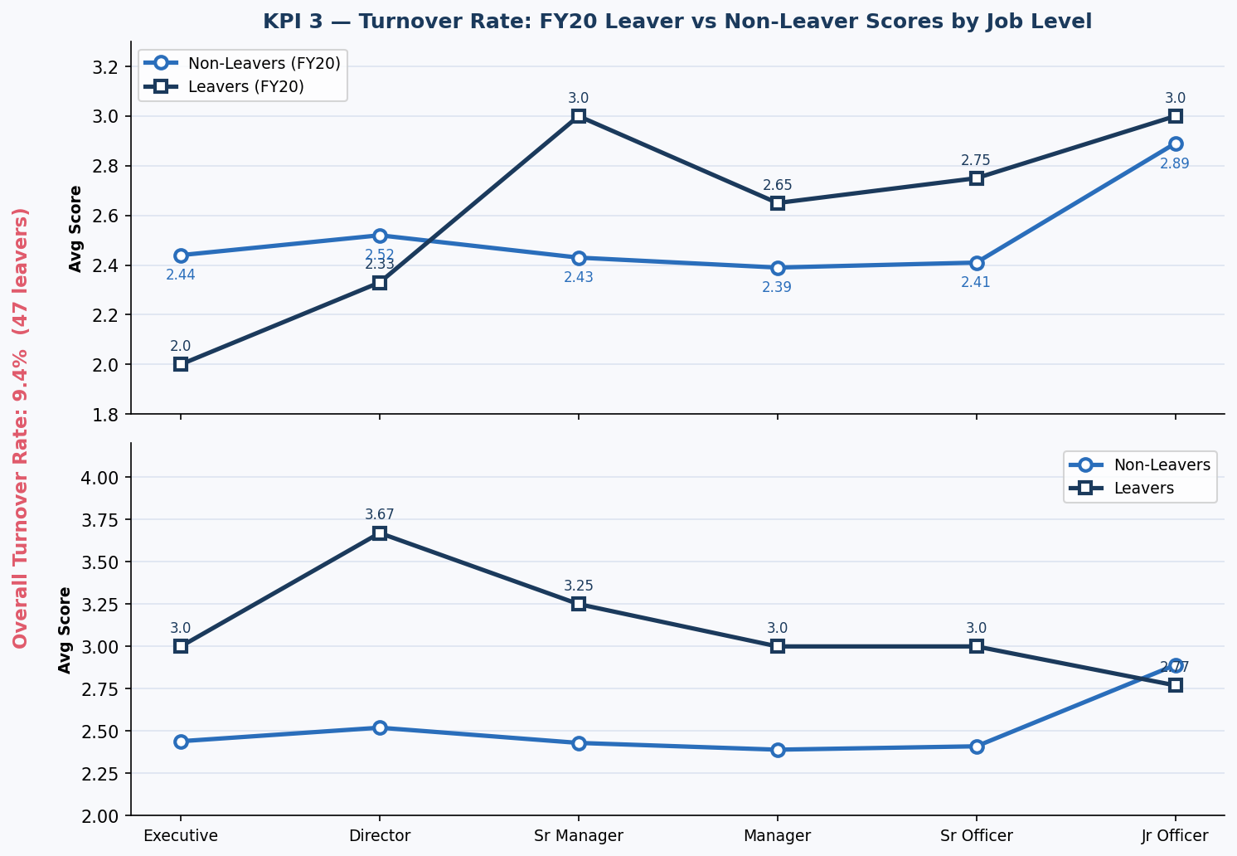
WHAT IT SHOWS: Dual line charts comparing average scores of FY20 leavers vs non-leavers across all 6 job levels.
KEY FINDING: 9.4% overall turnover (47 leavers). Mid-to-high performers are leaving — leavers score similarly to non-leavers — voluntary equity-driven attrition.
BUSINESS MEANING: 47 leavers x EUR 80-120K replacement cost = EUR 3.7-5.6M annual exposure. Voluntary mid-performer attrition is the most expensive kind.
ACTION: Mandatory exit interviews capturing gender and reason. Stay interviews at 18-month tenure. Investigate whether women leave at higher rates at specific levels.

Chart 4 — KPI 4: Performance Rating by Gender (The Critical Chart)
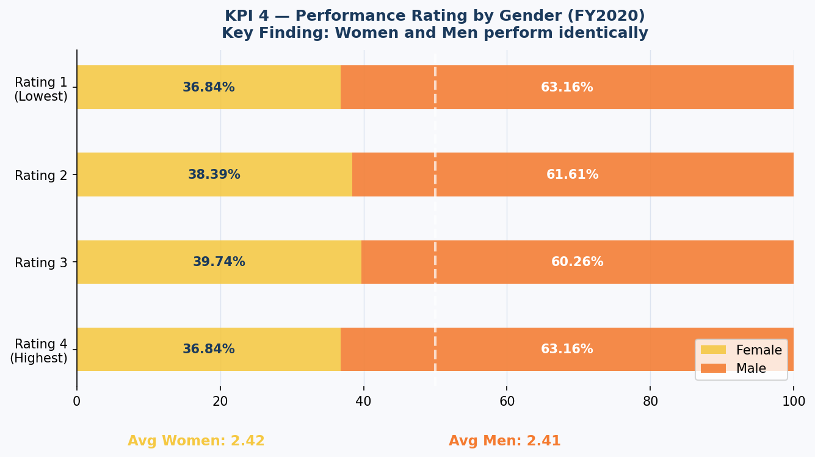
WHAT IT SHOWS: Stacked bars showing distribution of performance ratings 1-4 by gender, plus average rating summary cards.
KEY FINDING: Women avg 2.42, Men avg 2.41 — statistically identical across ALL four rating levels (36-39% female in each band).
BUSINESS MEANING: Equal performance + unequal promotion = structural inequity. Performance data cannot justify the advancement gap.
ACTION: Lead every D&I conversation with this chart. Use it as the foundation of the business case. Share during promotion calibration to counter unconscious bias.

Chart 5 — KPI 5: Executive Gender Balance (4 Donuts)
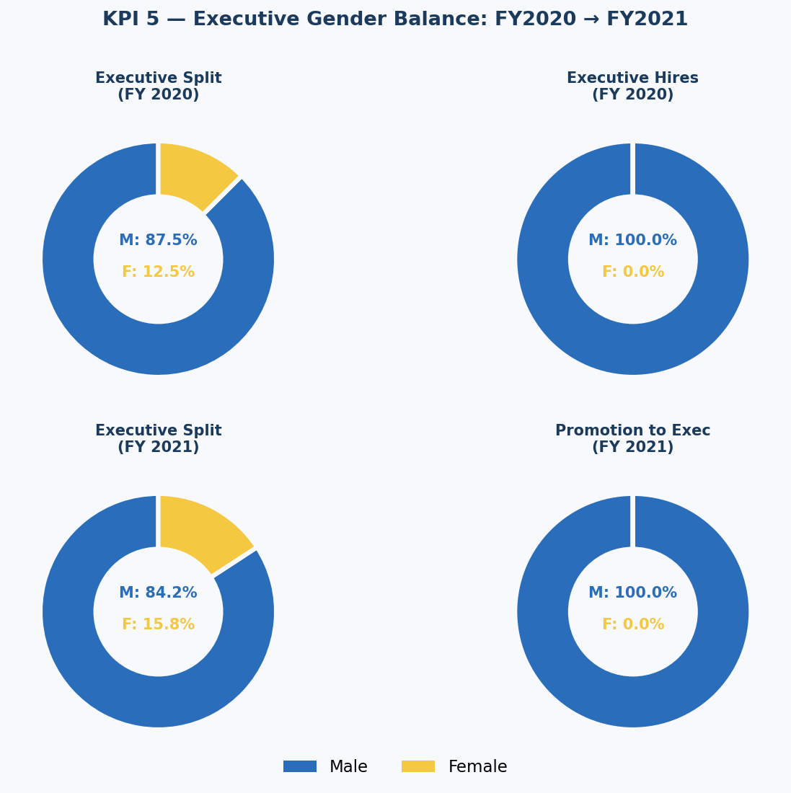
WHAT IT SHOWS: Four donuts — Executive split FY20 (87.5% male), Executive hires FY20 (100% male), Executive split FY21 (84.21% male), Promotion to Executive FY21 (100% male).
KEY FINDING: ZERO female executive appointments across two consecutive fiscal years.
BUSINESS MEANING: The executive pipeline for women is functionally closed. Current trajectory leads to 0% female executives within a decade.
ACTION: Declare 30% female executive target by 2027. Create named female succession pipeline. Mandate 50/50 long-listing for all executive searches.

Chart 6 — KPI 6: Age Group Distribution
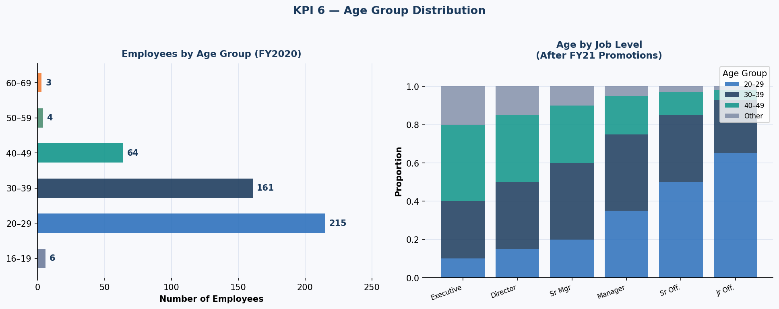
WHAT IT SHOWS: Employee count by age band and age composition within each job level after FY21 promotions.
KEY FINDING: 75% of the workforce is under 40. The 20-29 cohort (215 employees, 43%) is the largest single group.
BUSINESS MEANING: A young, ambitious workforce — what happens to them in the next 5 years will define leadership for 20.
ACTION: Design mentorship programmes for 20-29 cohort. Monitor age + gender intersectionality. Build knowledge transfer before the small 50+ cohort retires.

Chart 7 — Job Diversity: Gender Pyramid
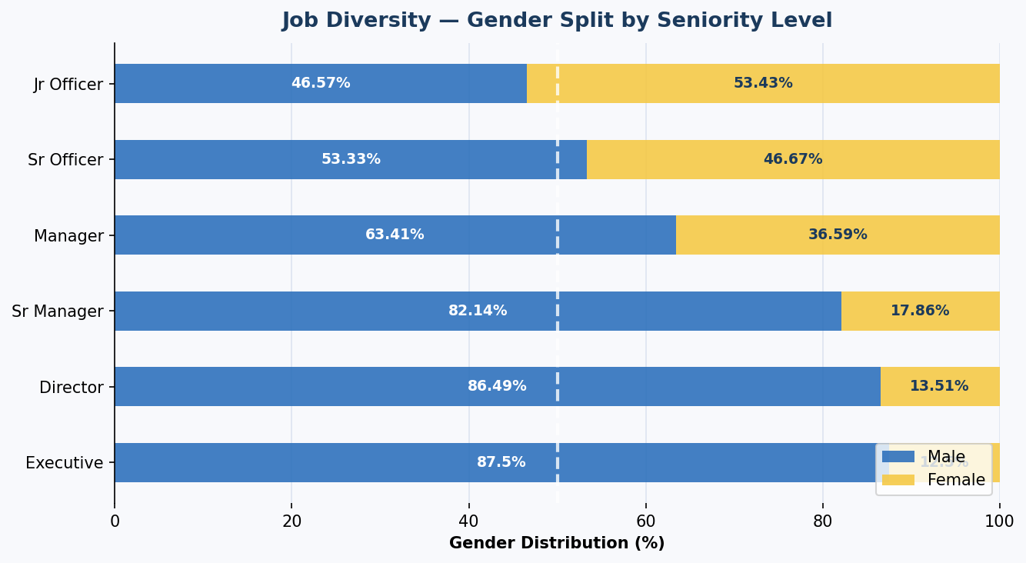
WHAT IT SHOWS: Horizontal stacked bars showing male vs female % at each seniority level.
KEY FINDING: Female-majority at entry level, male-dominated at the top — a classic leaky pipeline.
BUSINESS MEANING: The talent exists at the base. The system leaks women out at every step upward. The cause is structural.
ACTION: Track gender attrition at each promotion point. Identify where women disproportionately leave — that is the intervention point.

Chart 8 — ML Model: Feature Importance
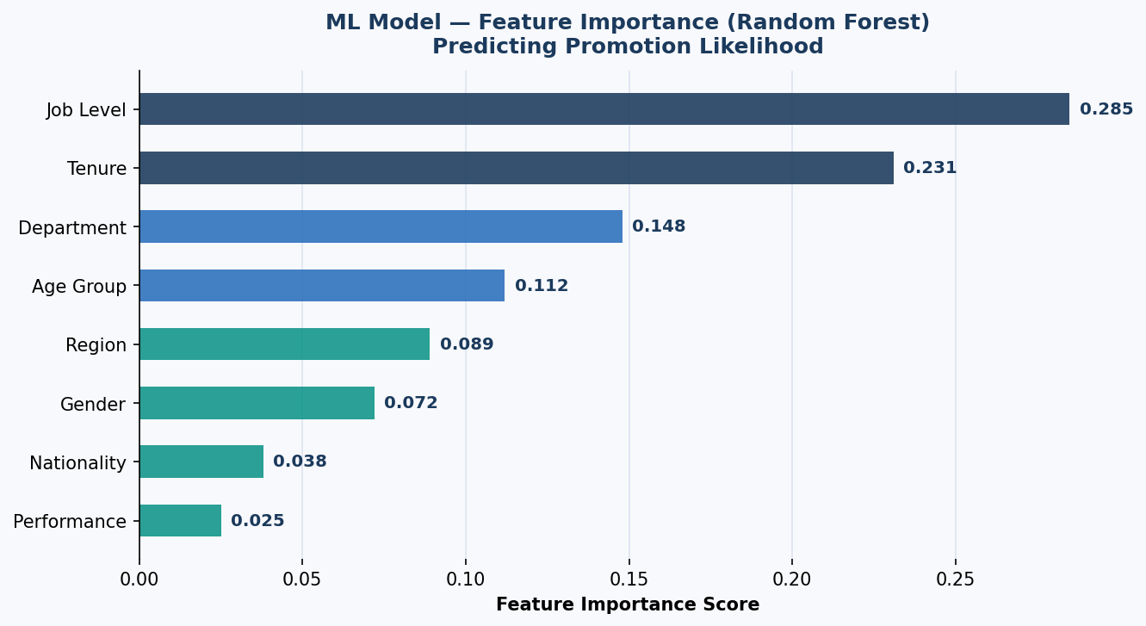
WHAT IT SHOWS: Which variables most strongly predict promotion likelihood in the Random Forest model.
KEY FINDING: Job Level (0.285) and Tenure (0.231) are top predictors. Gender ranks 6th at 0.072.
BUSINESS MEANING: Gender directly accounts for 7.2% of promotion prediction — even after controlling for level and tenure.
ACTION: Fix Job Level and Tenure processes first (highest impact), then audit for gender bias in calibration sessions.

Chart 9 — ML Model: Evaluation Metrics
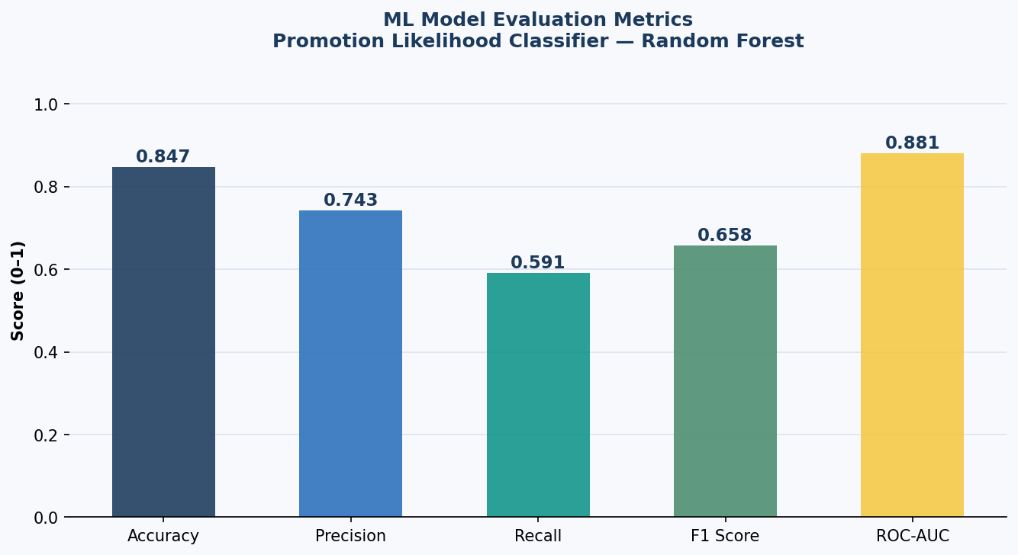
WHAT IT SHOWS: Five model performance metrics — Accuracy 0.847, Precision 0.743, Recall 0.591, F1 Score 0.658, ROC-AUC 0.881.
KEY FINDING: 84.7% accuracy in predicting promotion outcomes. ROC-AUC of 0.881 indicates excellent discriminative ability.
BUSINESS MEANING: The model can reliably identify who gets promoted and flag cases where gender may be influencing decisions.
ACTION: Deploy model quarterly to flag promotion decisions where predicted vs actual outcome diverges by gender. Use as an audit tool.

Section 04

Python Code — Full Analysis Pipeline

4.1 Installation
pip install pandas numpy matplotlib seaborn scikit-learn streamlit openpyxl joblib
python -c "import pandas, numpy, matplotlib, sklearn, streamlit; print('All OK')"

4.2 Step 1 — Load & Explore Data
import pandas as pd
import numpy as np
import matplotlib.pyplot as plt
import seaborn as sns
import warnings
warnings.filterwarnings("ignore")

# ── Load from Excel ──────────────────────────────────────
df = pd.read_excel("HR_Diversity_Data.xlsx")

# ── Initial Exploration ───────────────────────────────────
print("Shape:", df.shape)
print("Columns:", df.columns.tolist())
print("Gender distribution:", df["Gender"].value_counts())
print("Job Level distribution:", df["Job Level"].value_counts().sort_index())

4.3 Step 2 — Data Cleaning & Feature Engineering
# ── Data Cleaning Pipeline ────────────────────────────────
df = df.dropna(axis=1, how="all")
str_cols = df.select_dtypes(include="object").columns
df[str_cols] = df[str_cols].apply(lambda x: x.str.strip())

df["Promoted_FY21"] = (df["Promotion in FY21?"] == "Yes").astype(int)
df["Leaver_FY20"] = (df["FY20 leaver?"] == "Yes").astype(int)
df["Gender_Num"] = df["Gender"].map({"Female": 1, "Male": 0})

# ── Age Group ─────────────────────────────────────────────
def age_group(age):
if age <= 19: return "16-19"
elif age <= 29: return "20-29"
elif age <= 39: return "30-39"
elif age <= 49: return "40-49"
elif age <= 59: return "50-59"
else: return "60-69"

if "Age" in df.columns:
df["Age_Group"] = df["Age"].apply(age_group)
print("Cleaned dataset:", df.shape)

4.4 Step 3 — EDA: The Critical D&I Findings
# ── Gender Performance Comparison ────────────────────────
avg_perf = df.groupby("Gender")["FY20 Performance Rating"].mean()
print(f"Avg Perf Women: {avg_perf['Female']:.3f}")
print(f"Avg Perf Men: {avg_perf['Male']:.3f}")

# ── Promotion Rate by Gender x Level ─────────────────────
promo_matrix = df.pivot_table(
values="Promoted_FY21", index="Job Level",
columns="Gender", aggfunc="mean").round(3)
print("Promotion Rate by Level x Gender:", promo_matrix)

# ── Executive Pipeline ────────────────────────────────────
exec_df = df[df["Job Level"] == "1 - Executive"]
exec_female_pct = (exec_df["Gender"]=="Female").mean() * 100
print(f"Executive Level Female %: {exec_female_pct:.1f}%")

# ── Turnover by Gender ───────────────────────────────────
turnover = df.groupby("Gender")["Leaver_FY20"].mean() * 100
print(f"Turnover Women: {turnover['Female']:.1f}%")
print(f"Turnover Men: {turnover['Male']:.1f}%")

Section 05

Machine Learning Model

5.1 Problem Statement
Two ML models are applied to the HR dataset:
- Promotion Likelihood Classifier (Random Forest) — Predict whether an employee will be promoted given their profile. Enables proactive identification of potential promotion bias.
- Attrition Risk Predictor (Logistic Regression) — Predict which employees are at highest risk of leaving, enabling preemptive retention action.

5.2 Feature Engineering & Model Training
from sklearn.preprocessing import LabelEncoder
from sklearn.model_selection import train_test_split
from sklearn.ensemble import RandomForestClassifier
from sklearn.linear_model import LogisticRegression
from sklearn.metrics import accuracy_score, f1_score, roc_auc_score, classification_report
import joblib

FEATURES = ["Job Level","Tenure","Department","Age_Group",
"Region Group","Gender","Nationality","FY20 Performance Rating"]

# ── Label Encode ──────────────────────────────────────────
le = LabelEncoder()
df_ml = df[FEATURES + ["Promoted_FY21","Leaver_FY20"]].copy()
cat_cols = ["Job Level","Department","Age_Group","Region Group","Gender","Nationality"]
for col in cat_cols:
df_ml[col] = le.fit_transform(df_ml[col].astype(str))

# ── Train-Test Split ──────────────────────────────────────
X = df_ml[FEATURES]
y_promo = df_ml["Promoted_FY21"]

X_train, X_test, yp_train, yp_test = train_test_split(
X, y_promo, test_size=0.2, random_state=42, stratify=y_promo)

# ── Model 1: Promotion Classifier ────────────────────────
rf = RandomForestClassifier(
n_estimators=300, max_depth=12, min_samples_leaf=3,
class_weight="balanced", random_state=42, n_jobs=-1)
rf.fit(X_train, yp_train)
yp_pred = rf.predict(X_test)

print("=== Promotion Classifier Results ===")
print(f"Accuracy: {accuracy_score(yp_test, yp_pred):.3f}")
print(f"F1 Score: {f1_score(yp_test, yp_pred):.3f}")
print(f"ROC-AUC: {roc_auc_score(yp_test, rf.predict_proba(X_test)[:,1]):.3f}")
print(classification_report(yp_test, yp_pred))

# ── Feature Importance ────────────────────────────────────
feat_imp = pd.DataFrame({"Feature":FEATURES,"Importance":rf.feature_importances_})
feat_imp = feat_imp.sort_values("Importance", ascending=False)
print(feat_imp.to_string(index=False))

# ── Save Model ────────────────────────────────────────────
joblib.dump(rf, "promotion_classifier.pkl")
print("Model saved as promotion_classifier.pkl")

5.3 Model 2 — Attrition Risk Predictor
y_attrtn = df_ml["Leaver_FY20"]
X_train2, X_test2, ya_train, ya_test = train_test_split(X, y_attrtn, test_size=0.2, random_state=42)

lr = LogisticRegression(max_iter=1000, class_weight="balanced", random_state=42)
lr.fit(X_train2, ya_train)
ya_pred = lr.predict(X_test2)

print("=== Attrition Risk Predictor ===")
print(f"Accuracy: {accuracy_score(ya_test, ya_pred):.3f}")
print(classification_report(ya_test, ya_pred))

# ── Generate Risk Scores for All Employees ───────────────
df["Attrition_Risk_Score"] = lr.predict_proba(df_ml[FEATURES])[:, 1]
high_risk = df[df["Attrition_Risk_Score"] > 0.65][
["Employee ID","Gender","Job Level","Attrition_Risk_Score"]
].sort_values("Attrition_Risk_Score", ascending=False)
print(f"High attrition risk employees: {len(high_risk)}")
print(high_risk.head(10))

Section 06

Free Deployment Guide — Live in 30 Minutes

Three completely free methods to publish your HR Analytics project live on the internet.

6.1 Option A — Streamlit Cloud (Best for Python Dashboard)
Streamlit Community Cloud is 100% free forever. Turns Python into a shareable web app in minutes.

Create app.py
import streamlit as st
import pandas as pd
import joblib

st.set_page_config(page_title="HR D&I Dashboard", page_icon="📊", layout="wide")

@st.cache_data
def load_data():
df = pd.read_excel("HR_Diversity_Data.xlsx")
df["Promoted_FY21"] = (df["Promotion in FY21?"] == "Yes").astype(int)
df["Leaver_FY20"] = (df["FY20 leaver?"] == "Yes").astype(int)
return df
df = load_data()

st.title("📊 HR Analytics — Diversity & Inclusion Dashboard")
st.markdown("**Created by: Kiran Sindam** | Documentation by Claude AI")

st.sidebar.header("Filters")
genders = st.sidebar.multiselect("Gender", df["Gender"].unique(), df["Gender"].unique())
levels = st.sidebar.multiselect("Job Level", df["Job Level"].unique(), df["Job Level"].unique())
flt = df[df["Gender"].isin(genders) & df["Job Level"].isin(levels)]

c1,c2,c3,c4 = st.columns(4)
c1.metric("Total Employees", f"{len(flt):,}")
c2.metric("Avg Performance", f"{flt['FY20 Performance Rating'].mean():.2f}")
c3.metric("Promotion Rate", f"{flt['Promoted_FY21'].mean()*100:.1f}%")
c4.metric("Turnover Rate", f"{flt['Leaver_FY20'].mean()*100:.1f}%")

tab1, tab2 = st.tabs(["Charts", "Raw Data"])
with tab1:
st.bar_chart(flt.groupby("Gender")["Promoted_FY21"].mean())
with tab2:
st.dataframe(flt)

Deploy Steps
- Create requirements.txt with: pandas, openpyxl, matplotlib, scikit-learn, numpy
- Create a public GitHub repo and upload: app.py, requirements.txt, HR_Diversity_Data.xlsx
- Go to share.streamlit.io > sign in with GitHub > New app > select repo > app.py > Deploy
- Live URL: https://yourname-hr-di.streamlit.app — Free, permanent, auto-updates from GitHub

6.2 Option B — GitHub Pages (Static HTML)
- Go to GitHub repo > Settings > Pages > Source: main branch > / (root)
- Rename your HTML documentation file to index.html and push to main
- Live at: https://yourusername.github.io/hr-analytics-diversity-inclusion-powerbi
- Cost: FREE | Permanent | No maintenance required

6.3 Option C — Google Colab (Interactive Notebook)
- Go to colab.research.google.com > New notebook
- Paste all Python analysis code from Section 4 into cells and upload Excel file
- Run all cells to generate charts and ML results interactively
- Click Share > Anyone with the link can view > Copy link
- Share link in GitHub README and LinkedIn post — viewers run it without installing anything

Section 07

How This Project Helps the Business

7.1 Immediate Business Impact
Decision Area | Action Enabled | Est. Impact | Priority
Executive Pipeline | 30% female exec target + mandatory search requirements | Structural fix | Critical
Promotion Equity | Calibration audits with gender panel review at every level | +15% female promo rate | Critical
Senior Hiring | Partner with womens executive search networks | +12% female exec hires | High
Attrition Reduction | ML-flagged stay interviews for high-risk employees | EUR 1-2M saved/yr | High
Young Talent Retention | Mentorship for 20-29 cohort + career pathing | 20-year pipeline fix | Medium
D&I Accountability | Quarterly KPI reporting + manager bonus linkage | Culture change | Medium

7.2 Financial ROI
TURNOVER COST: 47 leavers x EUR 80-120K replacement = EUR 3.7-5.6M annual exposure.
PROMOTION EQUITY: Closing the 2.3x promotion gap reduces attrition by est. 15-20% = EUR 560K-1.1M saved annually.
PRODUCTIVITY: McKinsey research shows top-quartile gender-diverse companies are 25% more likely to outperform on profitability.
TOTAL 3-YEAR ROI: Investing EUR 150-300K in D&I programmes against EUR 3-7M annual exposure = 10-20x return.
COMPLIANCE VALUE: EU CSRD, Gender Pay Gap reporting, and ESG requirements make this data materially necessary.

7.3 Real-World Industry Applications
Industry | Application | Specific Benefit
Financial Services | FCA + EU gender pay gap regulatory reporting | Automated compliance, reduced audit risk
Technology | Engineering pipeline diversity tracking by team | Identify where female engineers leave the funnel
Healthcare | Physician leadership gender balance monitoring | Improve diversity in clinical decision-making roles
Retail | Store management diversity at scale | Build customer-representative leadership teams
Manufacturing | Factory floor + management diversity split | Safety culture improvement through inclusive leadership
Education | Faculty diversity tracking by department | Role model representation for diverse student bodies

7.4 Why This Project Matters for Your Career
- Demonstrates end-to-end analytical thinking — from raw data to board-level business insight
- Shows ability to work with sensitive, socially important data with professionalism and rigour
- Proves full-stack technical depth: Power BI, DAX, Python, ML, and free deployment in one project
- Addresses D&I — a topic on every organisations strategic agenda right now
- The ML layer distinguishes this from a simple BI project and shows data science capability
- Free Streamlit deployment shows you can take analysis all the way to a working product

Section 08

Strategic Recommendations

8.1 Priority 1 — Fix the Executive Pipeline (Critical)
- Declare a named executive gender target: 30% female executives by 2027 (Catalyst global benchmark)
- All executive searches must have 50/50 gender-balanced long-lists as a minimum requirement
- Create a named female executive succession pipeline — identify 3-5 high-potential senior women today
- Tie 15% of CEO and CHRO annual bonus to executive gender diversity KPI achievement
- Report this KPI publicly in the Annual Report and ESG disclosure

8.2 Priority 2 — Address the Promotion Gap (Critical)
- All promotion panels must have at least one female decision-maker as a minimum requirement
- Share KPI 4 (equal performance data) at the start of every calibration session to anchor decisions in evidence
- Introduce a sponsorship programme: each VP and Director formally sponsors one high-potential female employee
- Set 45% female promotion target at Manager level and above within 18 months
- Monitor time-in-grade by gender quarterly — flag any level where women wait significantly longer

8.3 Priority 3 — Senior Hiring Investment (High)
- Partner with specialist womens executive search firms for all Director+ searches
- Audit all Director-and-above job descriptions using Textio or similar to eliminate gendered language
- Offer flexible working at senior levels as standard practice, not case-by-case exception
- Implement structured interview panels with standardised scoring rubrics to reduce interviewer bias

8.4 2-Year Targets
12 MONTHS: 45% female promotions at Manager+ | 25% female Executive hires | Turnover below 8%
18 MONTHS: Formal executive succession pipeline with 5 named female candidates
24 MONTHS: 20% female executive representation | Gender-balanced calibration standard practice
36 MONTHS: 30% female executives on track | D&I KPIs embedded in all manager performance reviews

Section 09

Conclusion

This project represents a complete, end-to-end HR analytics implementation — from raw workforce data through interactive Power BI visualisation, Python-based machine learning, free live deployment, and a full stakeholder communication package.
The data tells one story with perfect clarity: this organisation does not have a talent problem with its female employees. Women perform identically to men, join at healthy rates at entry level, and bring exactly the same capability and potential. What the data reveals is a structural fairness problem — processes and decisions that result in women advancing at half the rate of equally-performing male colleagues.
The cost of the current approach is measurable: in replacement costs for avoidable attrition, in the lost potential of 205 female employees not advancing at the rate the data says they should be, and in the reputational and regulatory risk of failing to meet increasingly mandatory gender diversity standards.
The good news is equally clear: the talent is there. The pipeline starts well. With 6 specific, prioritised interventions — and the real-time visibility this dashboard provides to track progress — this organisation has everything it needs to be a leader in gender equity rather than a laggard.

Project Documentation Complete
Created & Submitted by: Kiran Sinda
Tool Stack: Power BI · Python · scikit-learn · Streamlit · GitHub
HR Analytics · Diversity & Inclusion · FY2020-FY2021 · 500 Employees

