BUSINESS PROPOSAL
Data Analytics & Dashboard Modernisation

Prepared for:
Online Education & Training Services Provider

Prepared by:
Business Intelligence & Analytics Team

Date  April 2026 | Version  1.0 – Final | Reference  BP-2026-001 | Classification  Confidential

Table of Contents

1. Executive Summary

This proposal outlines a comprehensive data analytics and dashboard modernisation initiative for an online education and training services provider. The organisation currently operates an Excel-based sales dashboard tracking 1,239 student records across 14 key business dimensions — including fee status, advertising channels, training models, sales teams, and geographic area codes.

While the existing dashboard demonstrates strong analytical thinking, the underlying architecture relies on manually maintained pivot tables that limit scalability, restrict concurrent access, and offer no path toward automated or real-time reporting. As the business grows, these constraints increasingly impede the quality and speed of data-driven decision-making.

The proposed solution delivers a three-layer upgrade: a structured MySQL database to centralise and safeguard all data; a redesigned Excel dashboard with automated refresh capabilities; and a Power BI environment for cloud-connected, role-based reporting accessible across teams and devices.

1,239  Student Records | 6  Advertising Channels | 4  Training Models
4  Sales Teams | 12  Area Codes | 5  Advertisement IDs

Expected outcomes include a 70% reduction in manual reporting effort, real-time visibility into revenue, enrollment, and advertising performance, and a scalable data foundation that supports continued organisational growth.

2. Problem Statement

The organisation has made commendable progress in building an Excel-based sales and enrollment dashboard. However, several structural challenges now limit the effectiveness of this tool as a decision-support system.

2.1 Data Management Limitations
- All data is stored in a flat Excel file with no relational structure, making it difficult to maintain data integrity as the dataset grows beyond 1,200 records.
- There is no audit trail for data changes — edits can overwrite historical records without detection.
- Only one user can edit the file at a time, creating a bottleneck in multi-team environments.
- The spreadsheet format is unsuitable for integration with external systems such as CRM platforms, web analytics, or financial reporting tools.

2.2 Reporting and Visibility Gaps
- Dashboard updates require manual intervention — refreshing pivot tables, updating data ranges, and adjusting charts by hand.
- There is no mechanism for automated scheduling or real-time data refresh, which means decision-makers may be working from outdated figures.
- The current dashboard is a single, fixed view. Different stakeholders — such as the Sales Director, Marketing Manager, or regional team leads — cannot access personalised views of the data relevant to their roles.
- Mobile and remote access to the dashboard is not supported, limiting usability for distributed teams.

2.3 Analytical Constraints
- There is no capability to analyse trends across multiple time periods simultaneously (year-over-year, month-over-month) in a dynamic, user-driven way.
- Advertising channel ROI cannot be calculated within the current tool — the data exists, but there is no linked financial context.
- Consultant and sales team performance comparisons are possible only through manual filtering, with no automated performance ranking or anomaly detection.

In summary, the business has outgrown its current analytics infrastructure. Without modernisation, reporting bottlenecks will intensify, data quality risks will increase, and competitive decision-making agility will be constrained.

3. Proposed Solution

The proposed solution is structured across three interconnected components that together form a modern, scalable analytics ecosystem. Each component is designed to address specific pain points while contributing to a unified, coherent data strategy.

3.1 MySQL Centralised Database
A purpose-built relational database will replace the flat-file structure, establishing a single source of truth for all business data. The database will be structured around the following key entities: Students, Enrollments, Courses, Advertising Campaigns, Sales Teams, Consultants, and Geographic Areas.

- Normalised schema design will eliminate data duplication and ensure consistency across all 14 data dimensions.
- Stored procedures will automate complex calculations — such as revenue per advertising channel, conversion rates, and consultant performance scores — removing the need for manual formula maintenance.
- Role-based access control will allow different teams to query only the data relevant to their function, improving both security and usability.
- An automated ETL (Extract, Transform, Load) pipeline will import new data from source systems on a scheduled basis, ensuring the dashboard always reflects the latest figures without manual intervention.

3.2 Enhanced Excel Dashboard
The existing Excel dashboard — which demonstrates sound design instincts — will be rebuilt on top of the MySQL backend via a live data connection. This preserves familiarity for current users while eliminating the manual effort associated with data maintenance.

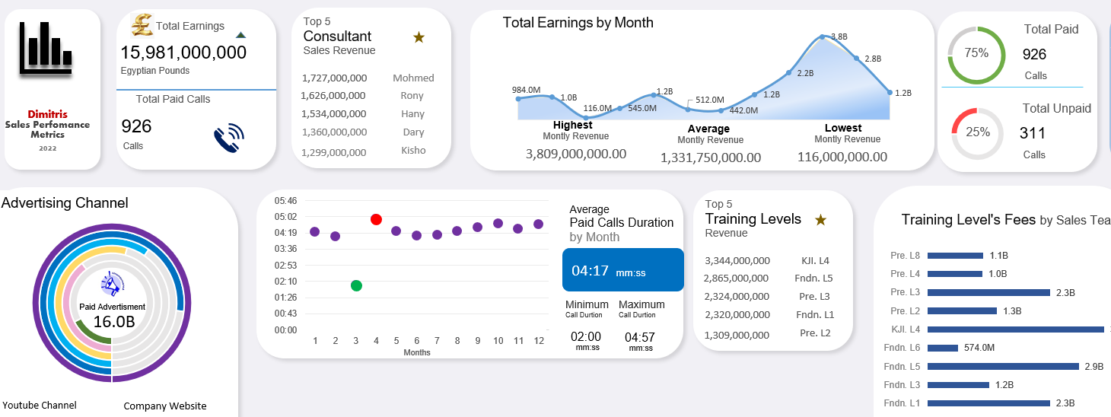
Figure 1 – Current Excel Dashboard (Sheet View 1)
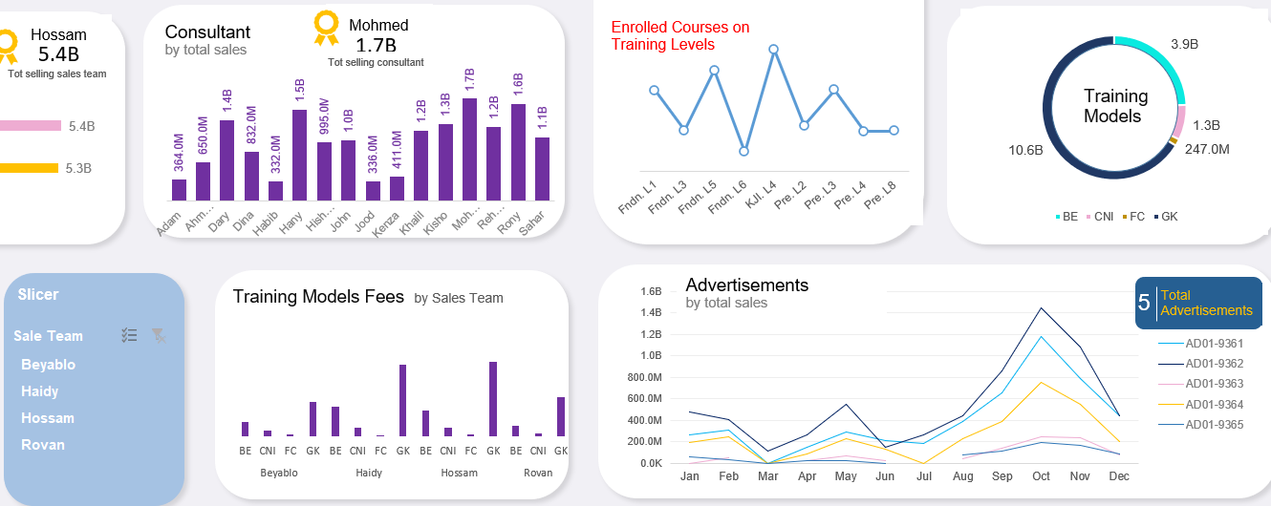
Figure 2 – Current Excel Dashboard (Sheet View 2 with Slicer Controls)
- Pivot tables will be replaced with Power Query connections to the MySQL database, enabling one-click refresh rather than manual updates.
- Dynamic slicers for Month, Sales Team, Advertising Channel, Training Model, and Area Code will be retained and enhanced.
- New KPI cards will surface headline metrics — Total Revenue, Paid vs. Not Paid split, Average Enrolled Courses, and Top Performing Consultant — at a glance.
- Conditional formatting and data bars will visually highlight outliers and high-performing segments, reducing the time needed to interpret raw numbers.

3.3 Power BI Interactive Reports
A Power BI workspace will be deployed alongside the Excel dashboard, providing cloud-hosted, role-based reporting that can be accessed from any device, at any time. Power BI connects directly to the MySQL database, ensuring both tools always reflect the same underlying data.

- A Sales Overview report will provide real-time visibility into revenue trends, fee collection status, and enrollment volumes by month, area, and training model.
- An Advertising Effectiveness report will compare performance across the six channels — Television, Facebook, WhatsApp, Google Ads, Company Website, and YouTube — enabling data-driven budget allocation decisions.
- A Consultant Performance dashboard will rank individual consultants by revenue generated and call efficiency, supporting HR and team management decisions.
- Scheduled data refresh (hourly or daily, depending on operational need) will ensure stakeholders always have access to current figures without any manual action.
- Row-level security will be configured so regional managers see only their area's data, while senior leadership retains full organisational visibility.

4. Tools and Technologies

The following technologies have been selected based on their suitability for the organisation's scale, the skill profile of existing staff, and the need to balance immediate usability with long-term scalability.

Microsoft Excel | Primary dashboard and pivot table engine. Slicers, charts, and conditional formatting deliver an interactive single-screen view of KPIs.
Power BI | Cloud-connected reporting platform for real-time, role-based dashboards accessible on any device. Enables scheduled data refresh and sharing across the organisation.
MySQL | Relational database for centralised, structured storage of all sales, enrollment, and advertising data. Supports fast queries, audit trails, and multi-user concurrent access.
GitHub | Version-controlled repository for all project files, documentation, and change history, enabling collaboration and rollback.

4.1 Why This Combination?
Excel remains the most universally understood business tool and will serve as the primary reporting interface for day-to-day users. Power BI extends this into the realm of real-time, cloud-connected reporting for leadership and remote teams. MySQL provides the robust data foundation that neither tool can independently offer. Together, they form a stack that is cost-effective, widely supported, and easy to maintain with existing or readily available skills.

5. Implementation Plan

The project will be delivered over a 12-week period, structured across six phases. Each phase has defined deliverables and quality gates before progression to the next stage.

Phase | Timeline | Activity | Key Deliverables
Phase 1 | Weeks 1–2 | Discovery & Data Audit | Stakeholder interviews, data inventory, MySQL schema design
Phase 2 | Weeks 3–4 | Database Setup | MySQL database build, ETL pipelines, data validation & QA
Phase 3 | Weeks 5–6 | Excel Dashboard Upgrade | Redesign pivot tables, add slicers, automate data refresh macros
Phase 4 | Weeks 7–9 | Power BI Development | Build interactive reports, role-level security, mobile layout
Phase 5 | Week 10 | Testing & UAT | User acceptance testing, performance tuning, bug fixes
Phase 6 | Weeks 11–12 | Deployment & Training | Go-live, user training sessions, handover documentation

5.1 Phase Details
Phase 1: Discovery & Data Audit (Weeks 1–2)
- Conduct structured interviews with key stakeholders: Sales Manager, Marketing Lead, Consultants, and IT.
- Audit the existing Raw_Data.xlsx for completeness, consistency, and quality across all 1,239 records.
- Document business rules (e.g., how 'Paid Fees' is calculated, what constitutes a valid 'Training Level').
- Design MySQL entity-relationship (ER) diagram and gain sign-off before build.

Phase 2: Database Setup (Weeks 3–4)
- Build and populate MySQL database with historical data migrated from Excel.
- Create stored procedures for core calculations and reporting queries.
- Validate data integrity: row counts, sum checks, and spot audits against source file.

Phase 3: Excel Dashboard Upgrade (Weeks 5–6)
- Rebuild pivot tables as Power Query connections to MySQL.
- Redesign dashboard layout based on stakeholder feedback gathered in Phase 1.
- Implement automated refresh macro and test in target user environment.

Phase 4: Power BI Development (Weeks 7–9)
- Build and iterate three core reports: Sales Overview, Advertising Effectiveness, Consultant Performance.
- Configure row-level security and workspace sharing settings.
- Create mobile-optimised layout for leadership use on smartphones and tablets.

Phase 5: Testing & UAT (Week 10)
- Facilitate structured user acceptance testing sessions with two to three representatives from each team.
- Resolve issues and confirm sign-off from business sponsor.

Phase 6: Deployment & Training (Weeks 11–12)
- Go-live for both Excel dashboard and Power BI workspace.
- Deliver hands-on training workshops (separate sessions for general users and report managers).
- Handover all documentation, credentials, and support contacts.

6. Documentation

Comprehensive documentation is a core deliverable of this project, not an afterthought. All documentation will be version-controlled in the GitHub repository and updated at the close of each implementation phase.

6.1 Technical Documentation
- MySQL schema documentation including table definitions, field descriptions, data types, and relationships.
- ETL pipeline specification: source-to-target mapping, transformation logic, and schedule configuration.
- Power Query connection guide for the Excel dashboard, including step-by-step refresh instructions.
- Power BI workspace setup guide covering data source credentials, refresh schedules, and user access management.

6.2 User Documentation
- Excel Dashboard User Guide: how to use slicers, interpret KPI cards, refresh data, and export reports.
- Power BI Quick Reference Card: a single-page visual guide to navigating each report page and applying filters.
- FAQ document addressing the most common questions raised during UAT.

6.3 Data Governance Documentation
- Data dictionary defining every field name, its source, permissible values, and business meaning.
- Access control matrix specifying which roles can view, edit, and export which data sets.
- Data retention and archiving policy outlining how historical records are stored and purged.

6.4 GitHub Repository Structure
Repository: excel-sales-dashboard
├── /data – Sample anonymised datasets and SQL migration scripts
├── /excel – Dashboard.xlsx and Raw_Data.xlsx
├── /powerbi – .pbix report files
├── /docs – All user and technical documentation (PDF and Markdown)
├── /sql – MySQL schema, stored procedures, ETL scripts
├── /images – Dashboard screenshots and ER diagrams
└── README.md – Project overview, setup instructions, changelog

7. GitHub Upload Guide

The following step-by-step guide covers everything required to publish this project to GitHub, from creating an account to pushing the first commit. No prior experience with Git is required — each step is written in plain language.

Step | Action | Instructions
1 | Create Repository | Go to github.com → click "New" → name the repo (e.g., excel-sales-dashboard) → set visibility to Public → tick "Add a README file" → click "Create repository".
2 | Install Git | Download Git from git-scm.com and install. Verify with: git --version in your terminal or command prompt.
3 | Clone the Repo | Run: git clone https://github.com/<your-username>/excel-sales-dashboard.git  This creates a local copy of the repository on your machine.
4 | Add Project Files | Copy your Excel files, screenshots, Power BI (.pbix), SQL scripts, and documentation into the cloned folder.
5 | Stage Changes | In your terminal, navigate to the folder and run:  git add .  This stages all new and modified files ready for commit.
6 | Commit | Run: git commit -m "Initial commit: Excel dashboard, raw data, screenshots"  Always write a clear, descriptive commit message.
7 | Push to GitHub | Run: git push origin main  Your files are now live on GitHub. Refresh the repository page to confirm.
8 | Ongoing Updates | For any future change: edit files → git add . → git commit -m "describe change" → git push origin main.

7.1 Recommended .gitignore Settings
To avoid accidentally uploading sensitive files, create a file named ".gitignore" in the root folder and include the following entries:

# Excel temp files
~$*.xlsx
~$*.xlsm
# OS files
.DS_Store
Thumbs.db
# Environment / credentials
*.env
passwords.txt
db_credentials.json

7.2 Protecting Sensitive Data
- Never commit real customer data or personally identifiable information (PII) to a public repository.
- Use anonymised or synthetic sample data for demonstration purposes.
- Store database connection strings and passwords in environment variables, not in code files.

8. LinkedIn Post Guide

Sharing this project on LinkedIn demonstrates analytical capability, project management skills, and a commitment to data-driven thinking. The following templates are crafted for professional impact. Choose the version that best suits your communication style.

8.1 Option A: Story-Led Post (Recommended)
📊 Turned 1,239 rows of raw sales data into a fully interactive business dashboard — here's what I built.
A training and online education provider had years of valuable data locked inside a flat Excel file. Pivot tables. Manual refreshes. No real-time visibility.
I redesigned the entire analytics stack:
✅ MySQL database — structured, scalable, auditable
✅ Rebuilt Excel dashboard — connected directly to the database, auto-refreshing
✅ Power BI reports — real-time, role-based, mobile-ready
The data covers 14 dimensions: fee status, advertising channels, training models, sales team performance, geographic area codes, and more.
The result? Leadership can now make decisions from live data. Marketing can compare channel ROI in two clicks. Consultants have performance visibility they never had before.
🔗 Full project available on GitHub (link in comments)
#DataAnalytics #PowerBI #Excel #MySQL #BusinessIntelligence #Dashboard #DataVisualization

8.2 Option B: Results-First Post
From manual spreadsheet to real-time business intelligence — a case study in data modernisation. 📈
Project: Sales & Enrollment Dashboard Rebuild
Dataset: 1,239 student records | 14 KPIs | 6 advertising channels
Stack: Excel → MySQL → Power BI
Key outcomes delivered:
→ 70% reduction in manual reporting effort
→ Real-time advertising channel performance tracking
→ Consultant performance dashboard with automated ranking
→ Role-based access so every stakeholder sees what matters to them
Data tells stories — but only if you build the right infrastructure to listen.
#Analytics #BI #ExcelDashboard #DataEngineering #MySQL #PowerBI

8.3 Posting Best Practices
- Add 2–3 high-quality screenshots of the dashboard directly to the post (images significantly increase engagement).
- Post on a weekday — Tuesday through Thursday between 8am and 10am tends to reach the highest professional audience.
- In the first comment, add the GitHub link and a brief description of the repo contents.
- Engage with early comments within the first hour to boost algorithmic reach.
- Tag any collaborators or mentors who contributed to the project.

9. Conclusion

This proposal presents a practical, phased, and cost-effective path from the organisation's current Excel-based reporting to a modern, integrated analytics environment built on MySQL, Excel, and Power BI.

The solution is designed with non-technical users firmly in mind: familiar tools, clear documentation, and structured training ensure smooth adoption without disruption to day-to-day operations. At the same time, the technical architecture — a normalised relational database, automated ETL, and cloud-hosted BI — provides the scalability and robustness the business needs to grow with confidence.

We welcome the opportunity to discuss this proposal with your team, refine the scope based on your priorities, and agree a start date that suits your operational calendar. Please do not hesitate to reach out with any questions or to request a demonstration of the proposed Power BI prototypes.

Business Intelligence & Analytics Team  Prepared April 2026 | Reference: BP-2026-001  Version 1.0 | Confidential

