# Pizza Sales Report

1. **KPI’S**

## **Total Revenue**

SELECT SUM(total_price) AS Total_Revenue FROM pizza_sales;

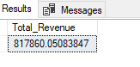

## **Average Order Value**

SELECT SUM(total_price) / COUNT(DISTINCT(order_id)) AS Avg_order_value FROM pizza_sales;

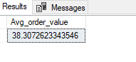

## **Total Pizza sales**

SELECT SUM(quantity) AS Total_pizza_sold FROM pizza_sales;

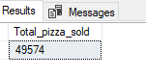

## **Total Order**

SELECT COUNT(DISTINCT(order_id)) AS Total_Orders FROM pizza_sales;

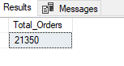

## **Average pizza per order**

SELECT CAST(CAST(SUM(quantity) AS DECIMAL(10,2)) / CAST(COUNT(DISTINCT(order_id)) AS DECIMAL(10,2)) AS DECIMAL(10,2)) AS Avg_pizza_sold_per_order FROM pizza_sales;

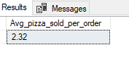

1. **Daily trend for total orders**

SELECT DATENAME(DW, order_date) AS order_day, COUNT(DISTINCT(order_id)) AS Total_orders

FROM pizza_sales

GROUP BY DATENAME(DW, order_date)

ORDER BY Total_orders DESC;

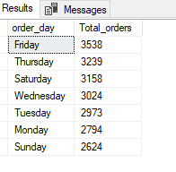

1. **Hourly trend for total orders**

SELECT DATEPART( HH, order_time) AS Order_hour, COUNT(DISTINCT(order_id)) AS Total_orders

FROM pizza_sales

GROUP BY DATEPART( HOUR, order_time)

ORDER BY Total_orders DESC;

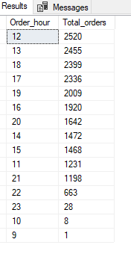

1. **Monthly trend for total orders**

SELECT DATENAME(MONTH, order_date) AS month_name, COUNT(DISTINCT(order_id)) AS total_order

FROM pizza_sales

GROUP BY DATENAME(MONTH, order_date)

ORDER BY total_order DESC;

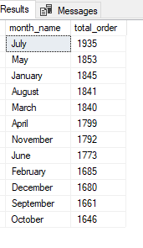

1. **Percentage of sales by pizza category**

SELECT pizza_category, CAST(SUM(total_price) AS DECIMAL (10,2)) AS Total_sales,

CONCAT(CAST(SUM(total_price) *100 / (SELECT SUM(total_price) FROM pizza_sales) AS DECIMAL(10,2)), '%') AS PCT

FROM pizza_sales

GROUP BY pizza_category;

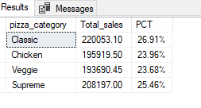

1. **Percentage of sales by pizza size**

SELECT pizza_size, CAST(SUM(total_price) AS DECIMAL (10,2)) AS Total_sales,

CONCAT(CAST(SUM(total_price) *100 / (SELECT SUM(total_price) FROM pizza_sales) AS DECIMAL(10,2)), '%') AS PCT

FROM pizza_sales

GROUP BY pizza_size;

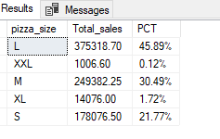

1. **Top 5 sellers by Revenue**

SELECT TOP 5 pizza_name, SUM(total_price) AS Revenue

FROM pizza_sales

GROUP BY pizza_name

ORDER BY Revenue DESC;

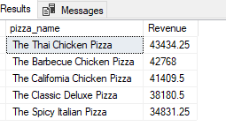

1. **Bottom 5 sellers by Revenue**

SELECT TOP 5 pizza_name, SUM(total_price) AS Revenue

FROM pizza_sales

GROUP BY pizza_name

ORDER BY Revenue ASC;

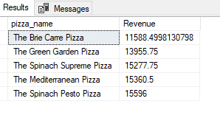

1. **Top 5 sellers by Total quantity**

SELECT TOP 5 pizza_name, SUM(quantity) AS Total_quantity

FROM pizza_sales

GROUP BY pizza_name

ORDER BY Total_quantity DESC;

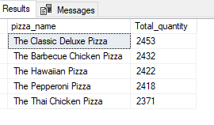

1. **Bottom 5 sellers by Total quantity**

SELECT TOP 5 pizza_name, SUM(quantity) AS Total_quantity

FROM pizza_sales

GROUP BY pizza_name

ORDER BY Total_quantity ASC;

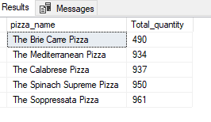

1. **Top 5 sellers by Total Orders**

SELECT TOP 5 pizza_name, COUNT(DISTINCT(order_id)) AS Total_orders

FROM pizza_sales

GROUP BY pizza_name

ORDER BY Total_orders DESC;

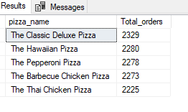

1. **Bottom 5 sellers by Total Orders**

SELECT TOP 5 pizza_name, COUNT(DISTINCT(order_id)) AS Total_orders

FROM pizza_sales

GROUP BY pizza_name

ORDER BY Total_orders ASC;

