**EECE 7205 : Fundamentals of Computer Engineering**

**Question 1 :**

SwapP and SwapR:

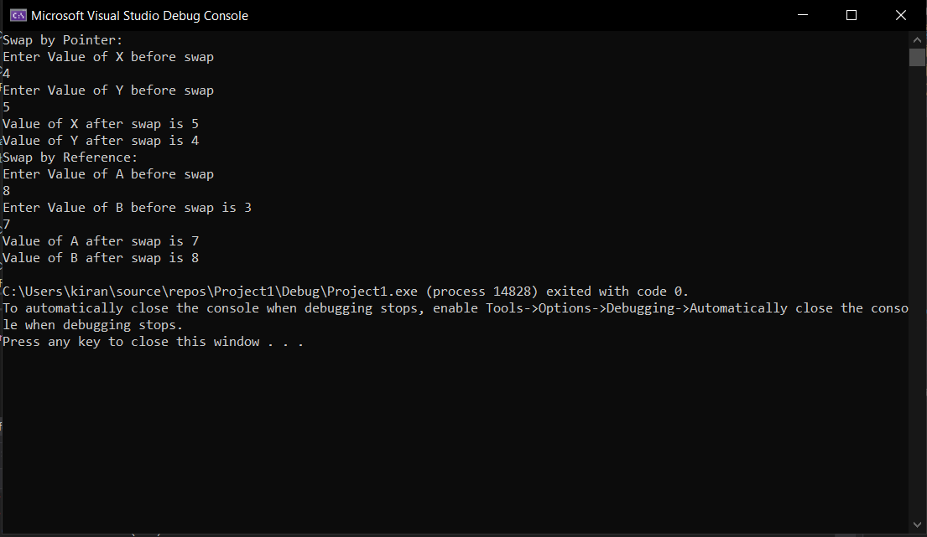

**Question 2:**

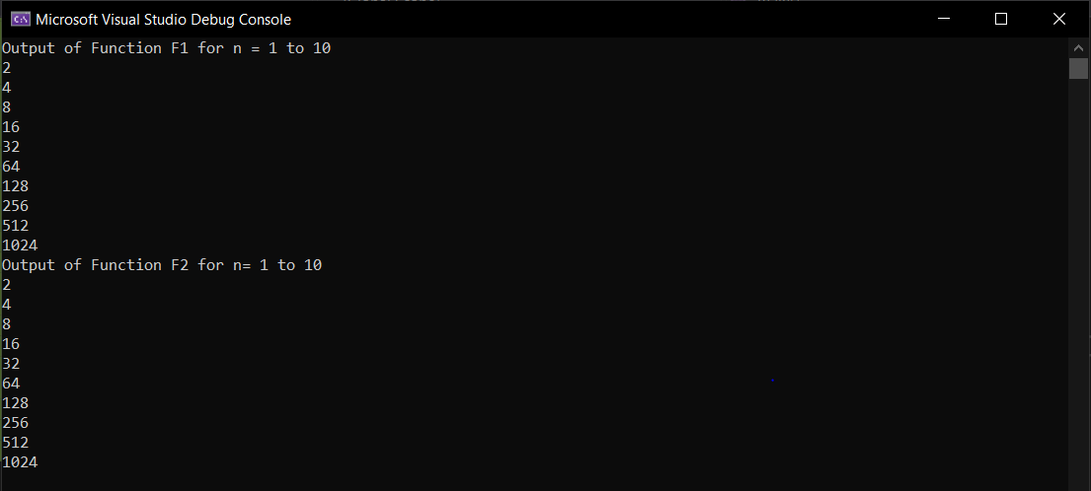

a. What does each function do?

Answer :

***Both the Functions return Power of 2 using recursion. Implies they return 2^(n).***

***For e.g.: if value of n=4 implies 2^(4) = 16 therefore the functions will return 16.***

b. Which function is faster?

Answer:

***Function F2 is faster than F1. If we increase value of n to say 40, we can see difference in execution time of each function. Function F2 is considerably faster than F1.***

c. Explain why one function is faster than the other?

Answer:

***Function F1 is slower as compared to F2 because it is called a greater number of times. For e.g. if we take n=4. Then Function F1(4) will return F1(3)+F1(3), now each F1(3) will return F1(2)*F1(2) and so on. In total F1 will be called 31 times.***

***Whereas in case of F2(4) it will return result*result where result = F2(2) which is called only once. After that F2 is called two more times. F2 will be called 4 times in total.***

***Therefore, F2 is Faster than F1.***

**Question 3:**

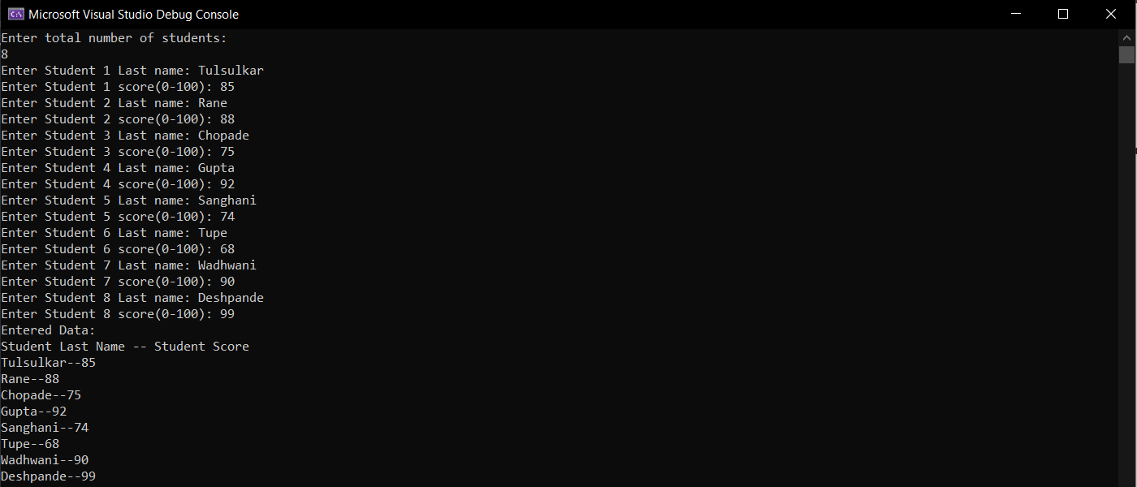

*Entered Data*

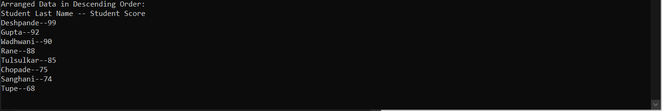

*Data Sorted by Insertion Sort*