**EECE 7205 : Fundamentals of Computer Engineering**

**Assignment 5**

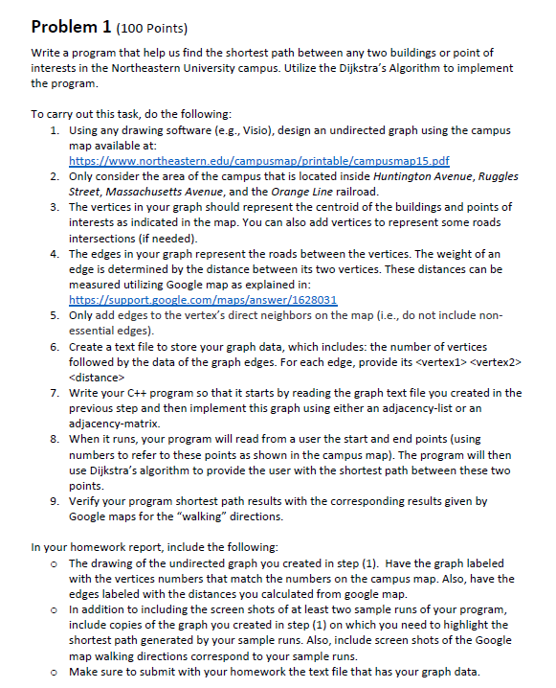

Rubenstein Hall 20 Gainsborough Parking Garage 45

Snell Engineering Center 58

Ryder Hall 24