**EECE 7205 : Fundamentals of Computer Engineering**

**Assignment 4**

Problem 1 :

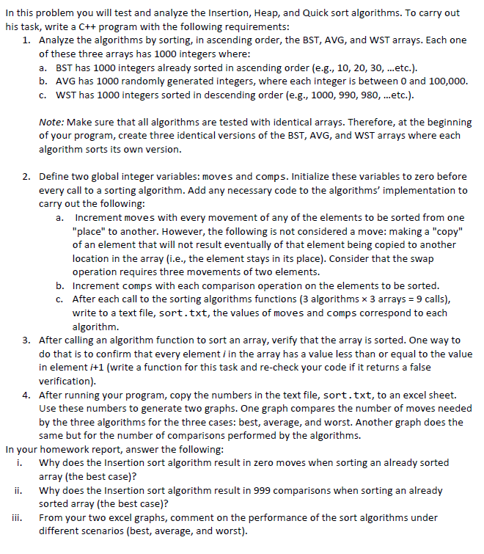

Results :

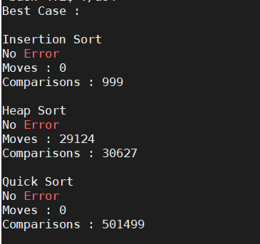

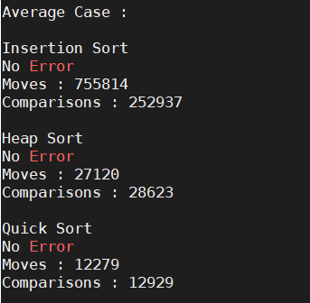

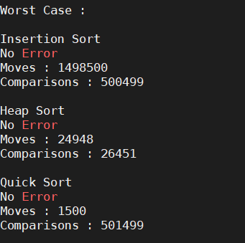

***Output for Problem 1***

Q1. Why does the Insertion sort algorithm result in zero moves when sorting an already sorted

array (the best case)?

In already sorted array all the numbers are in their correct positions and therefore when comparison takes place the condition becomes false leading to swap operation not being performed. Therefore, the insertion sort algorithm leads to zero moves.

Q2. Why does the Insertion sort algorithm result in 999 comparisons when sorting an already sorted array (the best case)?

For Insertion Sort 999 comparisons takes place even if the elements are already sorted because each element is compared with other in the for loop. Best case for insertion sort is O(n) implying for a best case that the algorithm will run and compare for n number of times. Hence, we get 999 comparisons for array of 1000 integers .

Q3. From your two excel graphs, comment on the performance of the sort algorithms under

different scenarios (best, average, and worst).

Let us consider Best Case :

For moves operation Insertion Sort and Quick Sort have least or minimum number of moves than heapsort. For compare operation Insertion Sort has least number of moves with Complexity of O(n) and 999 Comparisons. With Quicksort having highest number of comparisons.

Let us consider Average Case :

In Average case Quicksort Algorithm has least number of move and compare operations. Whereas insertion sort having the highest number of moves and compares.

Let us consider Worst Case :

In Worst case, Quicksort is the minimum number among the three for move operations and Heapsort is the minimum number for compare operations.

In insertion and quicksort where variation in move and compare operations have high variations, the heapsort algorithm has constant values. Which makes heapsort algorithm preferable among the three. From the graph it is evident that the heapsort has constant values in all the three cases for move and compare both the operations.

Graphs :