**EECE 7205 : Fundamentals of Computer Engineering**

**Assignment 5**

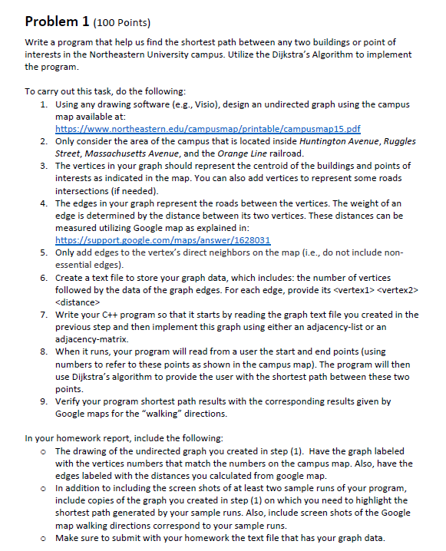

**Campus Map :**

Map is drawn using Creatly.com

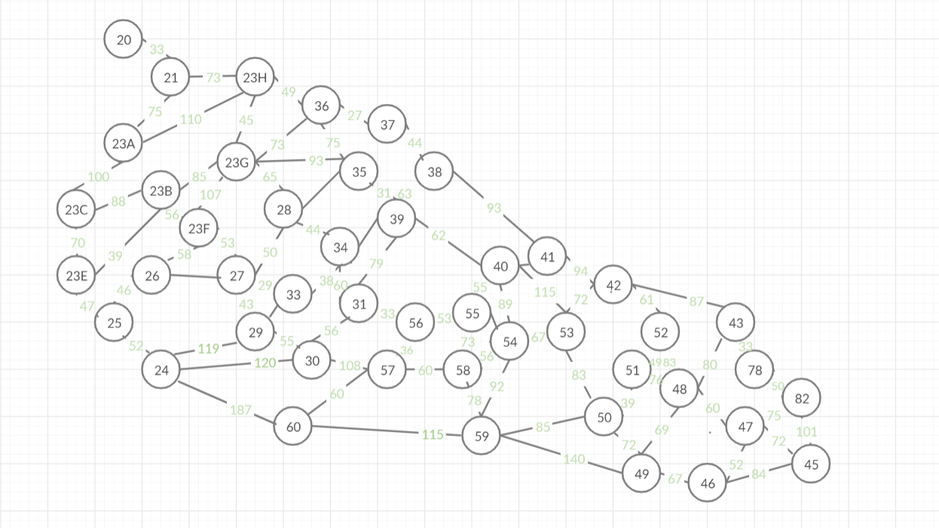

**Case 1 :**

Start : Rubenstein Hall ( 20 ) End : Gainsborough Parking Garage ( 45 )

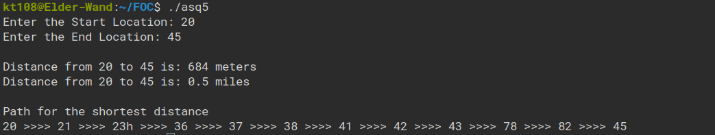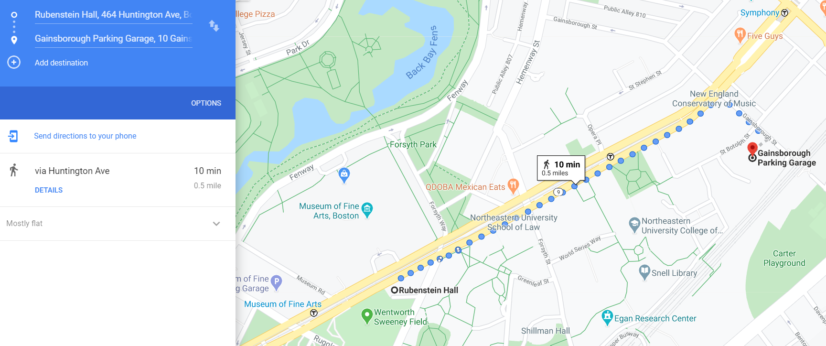

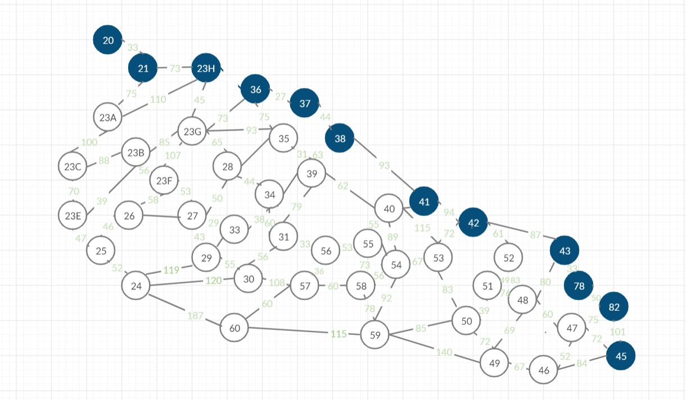

**Case 2 :**

Start : Rubenstein Hall ( 20 ) End : Ryder Hall ( 24 )

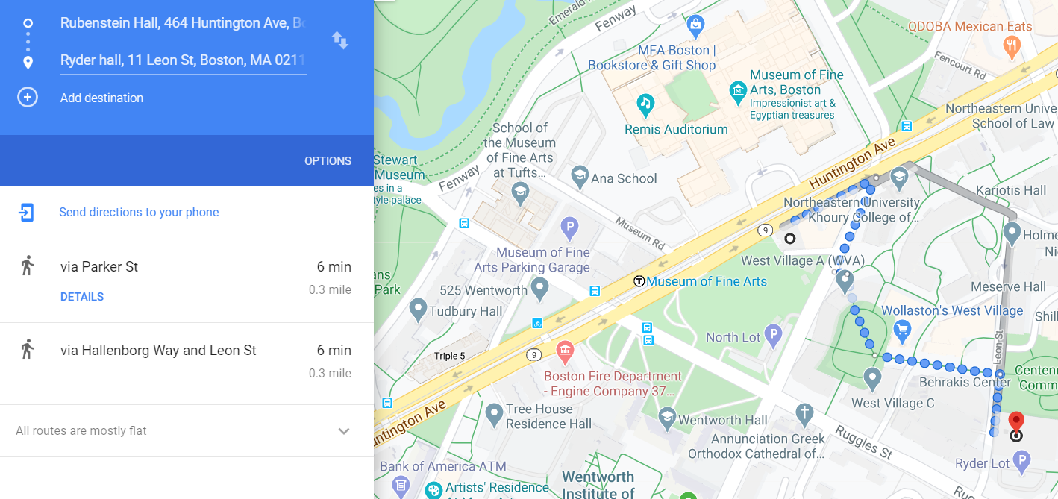

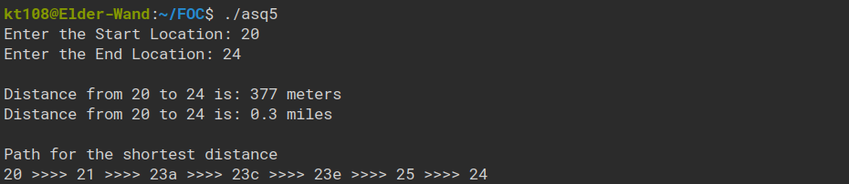

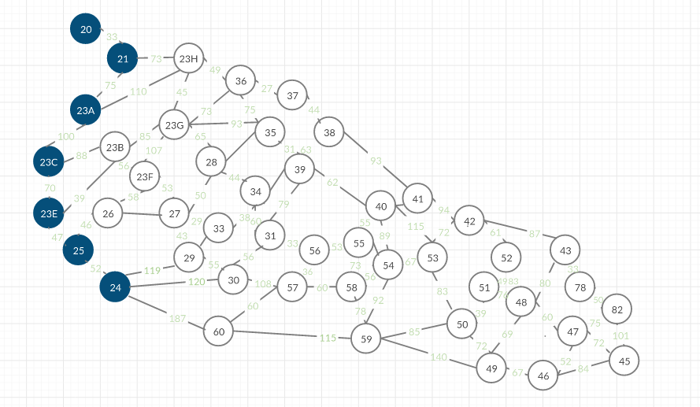

**Case 3 :**

Start : Rubenstein Hall ( 20 ) End : Ryder Hall ( 58 )

