Step-1.

Install node.js 4.4.6 LTS.

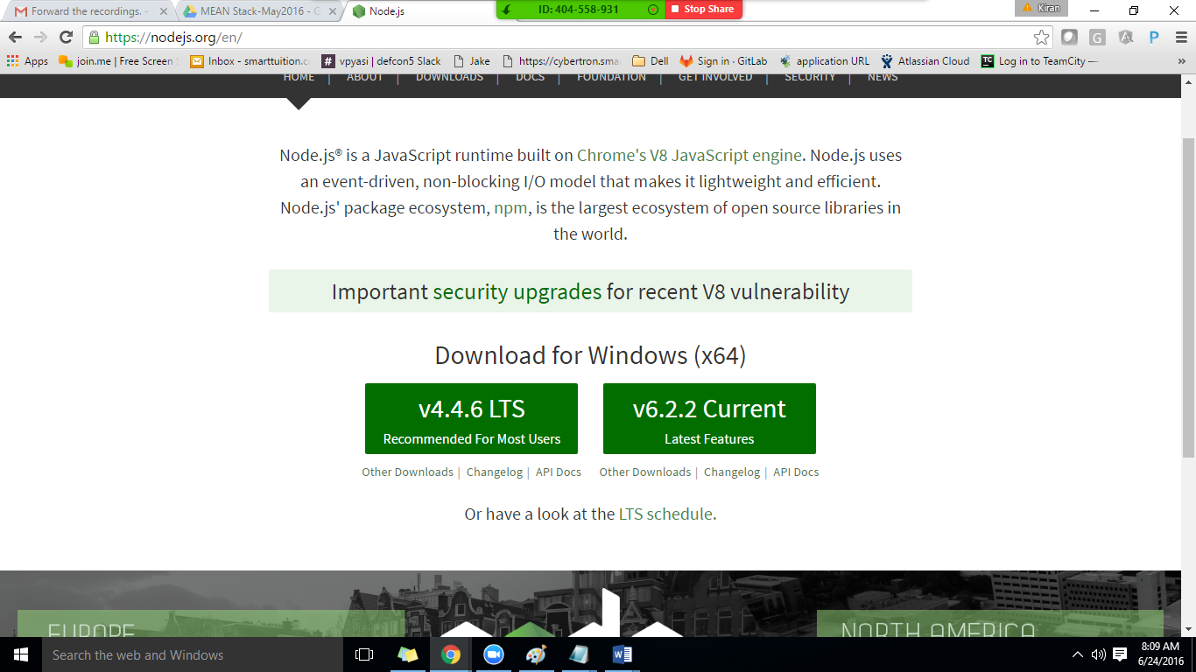

Step2: Check Node is properly Installed.

Open the command prompt

node –v

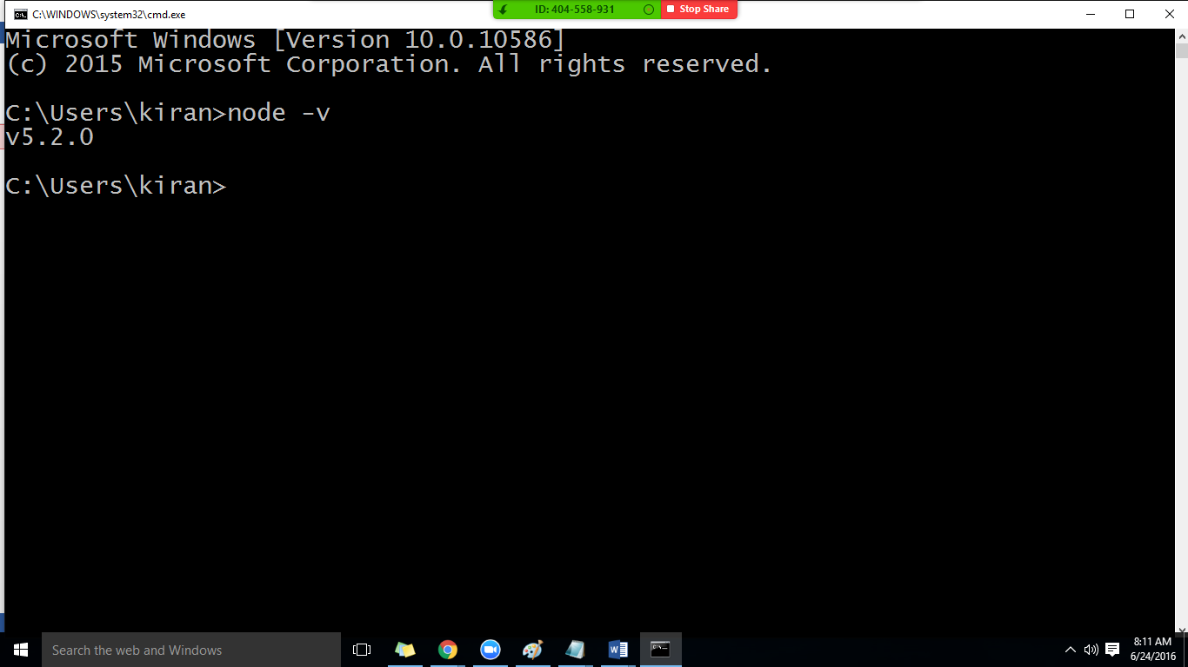

Step 3 : Installing the gulp.

npm install –g gulp

the above command will install the gulp globally.

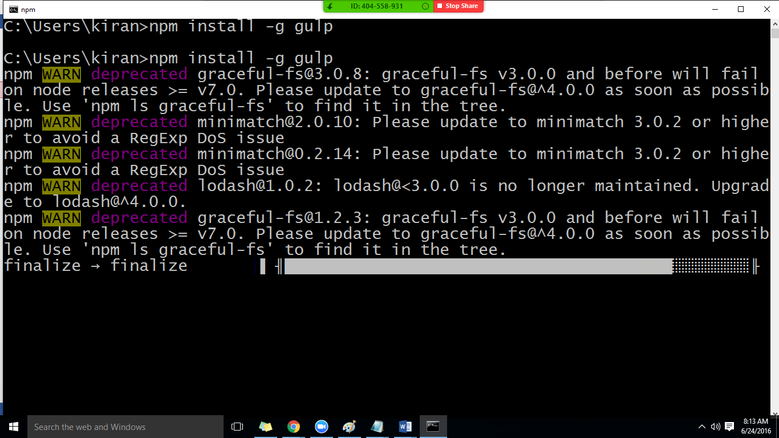

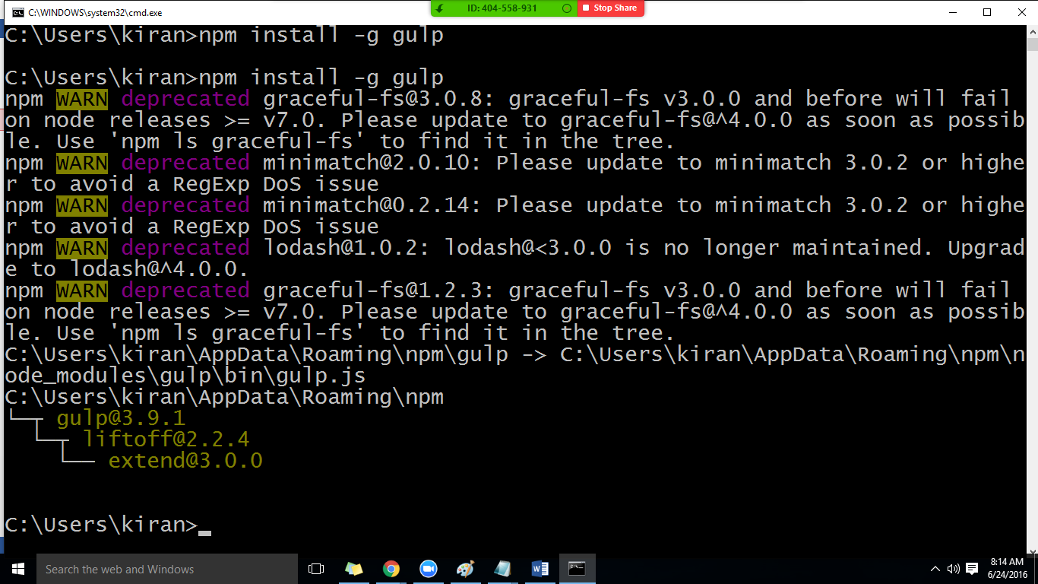

Make sure the gulp is installed by checking the version.

Step5: Create a folder and in the command prompt navigate to that folder.

Run the following command

npm init

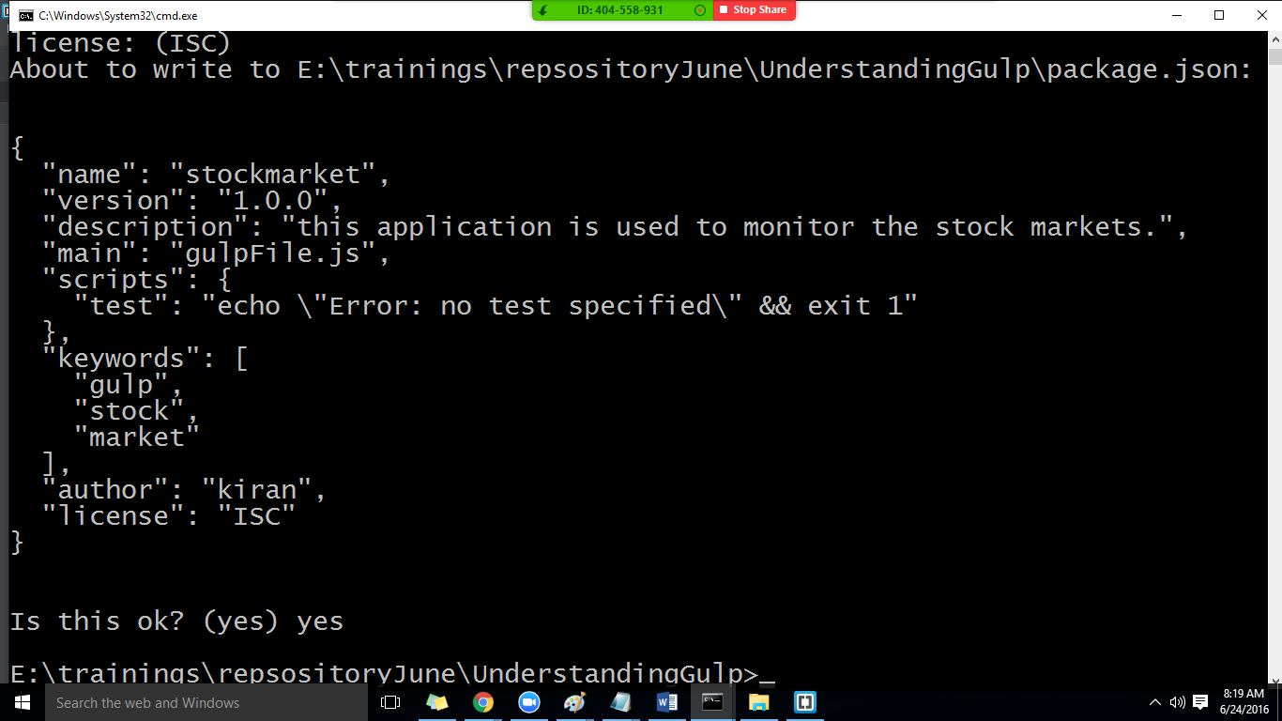

Install gulp locally

npm install gulp - -save-dev

npm install gulp-concat - -save-dev

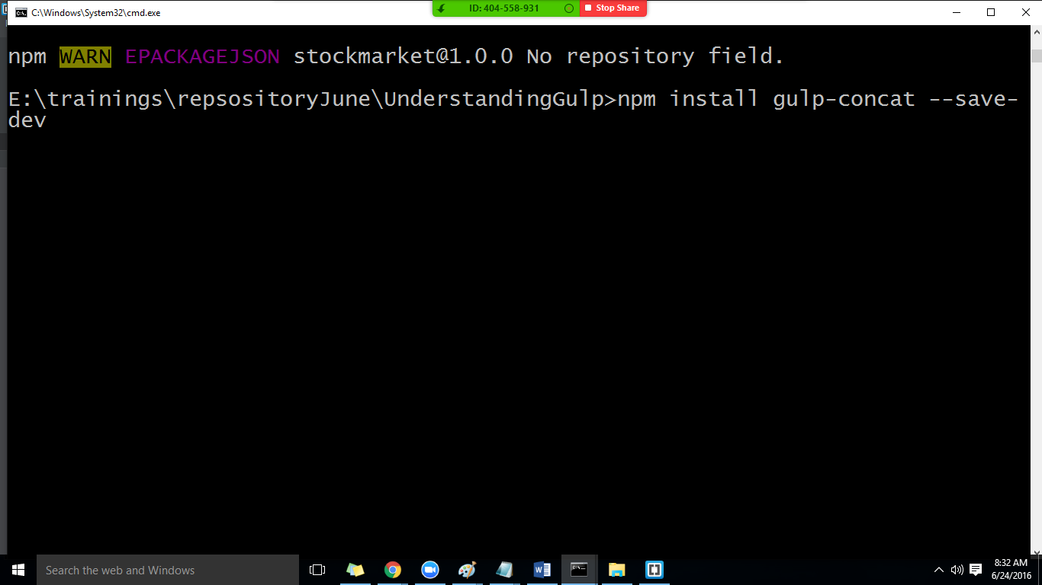

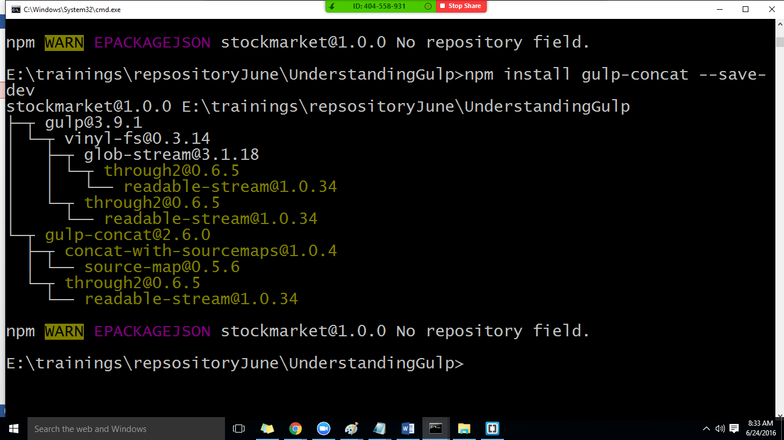

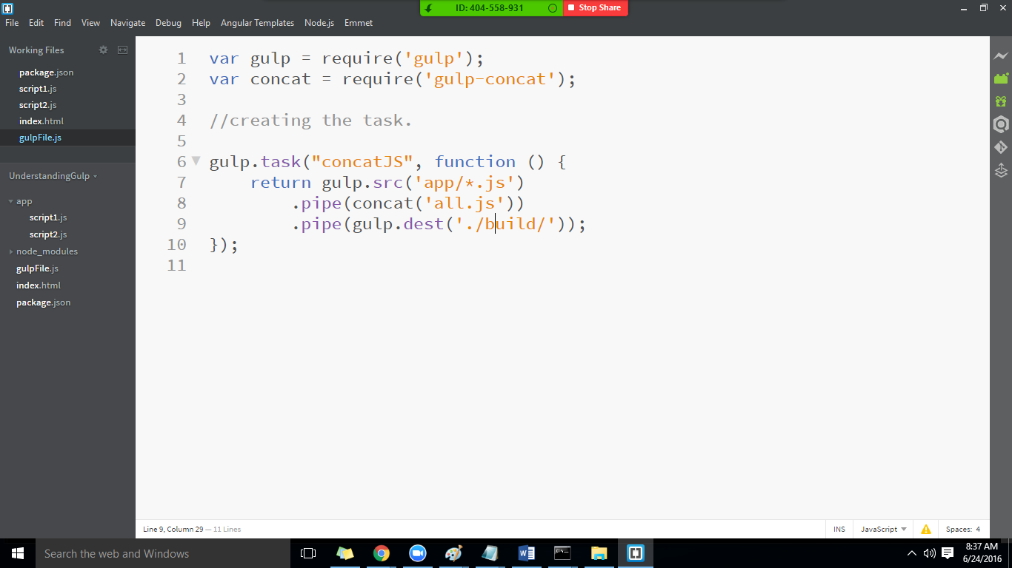

Runt the command gulp jsconcat