Global Scope: Any variable that will be stored in the window object will be treated as global variable. Global scope is a place all the global variables are stored.

Immediate functions:

Immediate functions are self executable functions.

Immediate functions are anonymous functions. 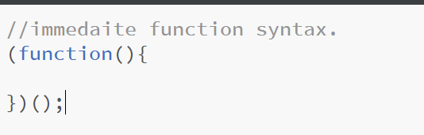

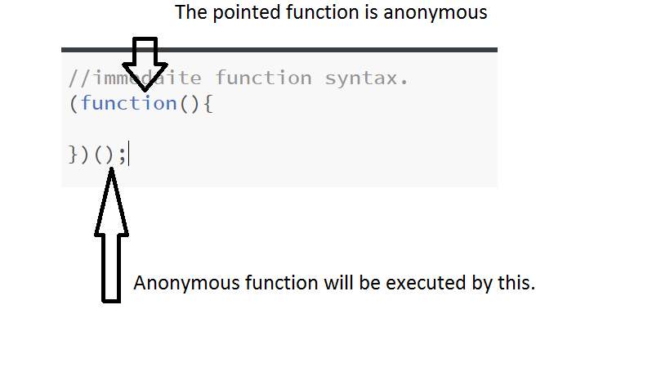

Experienced programmers will use the immediate functions to avoid polluting the global scope.