Inheritance

In typescript we will use the key word **extends** to inherit the parent class properties.

class parent {

surname:string

private personalBike:string

}

class child extends parent{

}

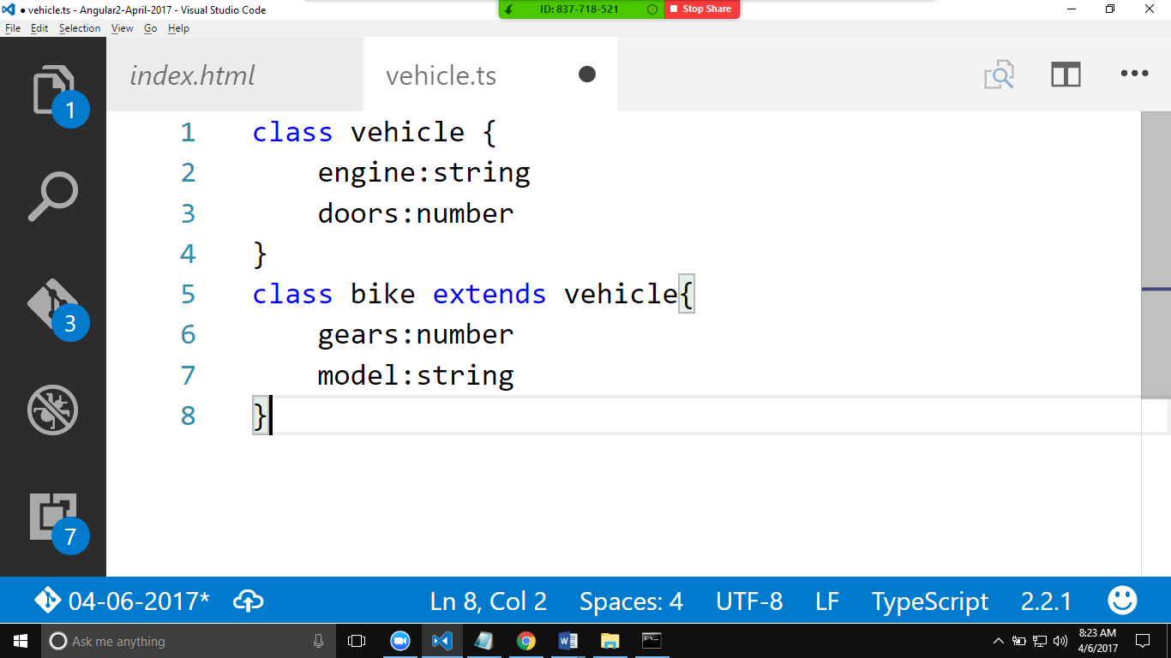

Bike will be having the properties of vehicle+bike.

Example2:

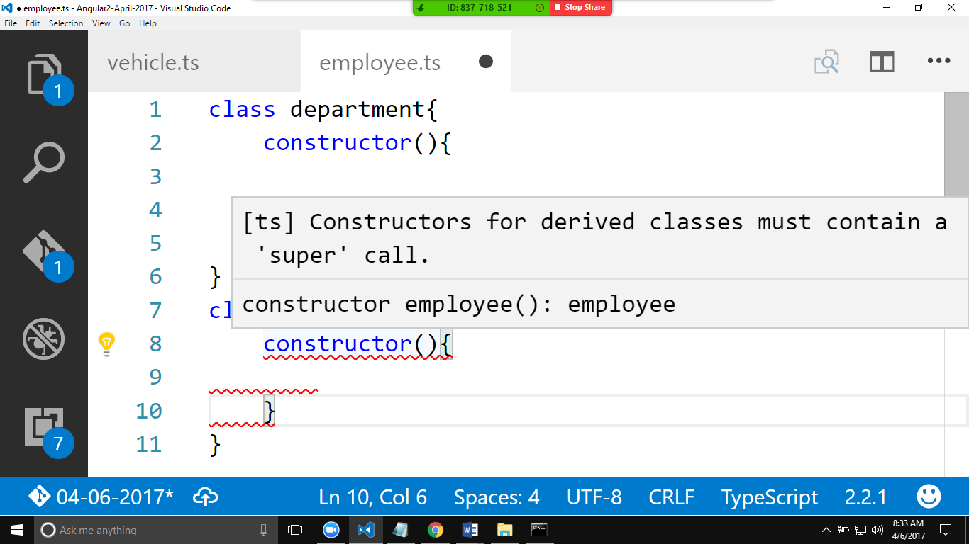

“Super”

super() is a keyword that will be used in the child class constructor.

super will always refers to the immediate parent.

It should the first line of the child constructor.

Functions in typescript.

------------------------------

//declaring function outside the class.

//void is a keyword which indicate the function

//donot have a return type

function getDetails():void{

}

//in the below example function returns a string.

function getFullName():string{

    return "kiran paturi";

}

//in the below example function returns a boolean.

function iAgree():boolean{

    return false;

}

