Angular cli.

Installing angular cli.



After installing to verify the installation.



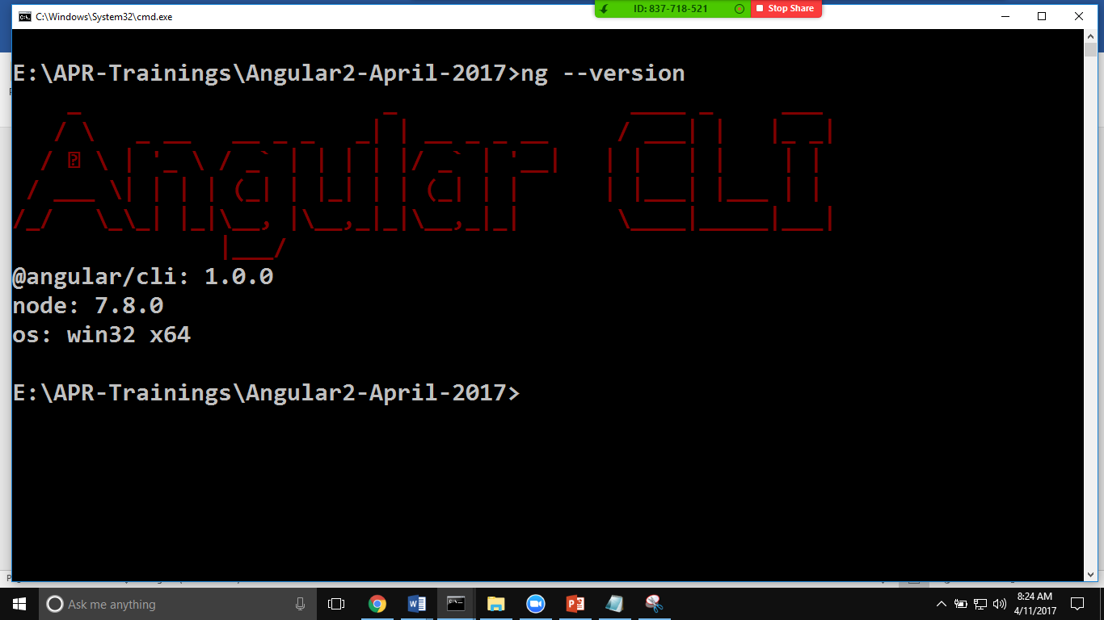

To create a new project.

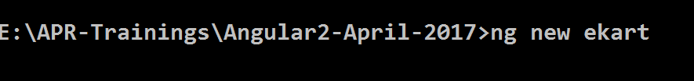

Aftet the above step do this.

