1. Why Angular2 ??

It is pretty easy to develop and to implement.

It is based on component model.

It follows Model View pattern.

Type script.

Prerequisites:

1. Nodejs installed in your systems

2. Good editor Visual Studio code.

3. HTML and CSS

4. Typescript.

1. No syntax errors on html or css.

Angular-CLI

Angular CLI it is command line interface.

1. Angular cli offers a web server to run the application.

2. Angular cli offers scaffolding environment. i.e. it will offer you a predefined folder structure.

3. it will offer you commands to generate different features automatically.

Installing Angular cli globally.

-- npm install -g angular-cli



Open a folder and navigate to the folder in the command prompt.

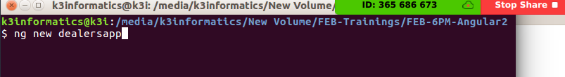

Creating Project: open the command prompt in the newly created folder and execute the belwo command.

-- ng new <projectname>

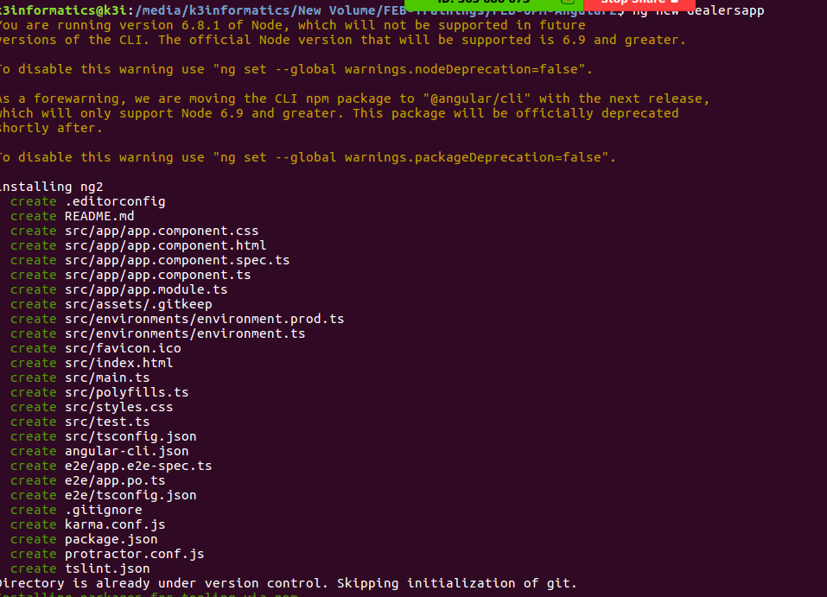

after creating the project structure go to the root folder of the project and install the required dependencies.

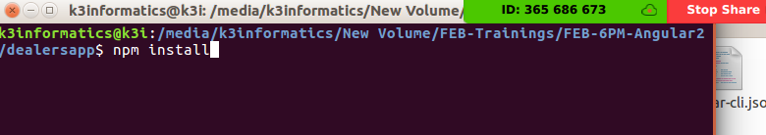

Angular is built on top of varaious modules.

Whichever the module we need we will import that module.

-- main.ts

-- appmodule

-- appcomponent