To check if the git is properly installed or not

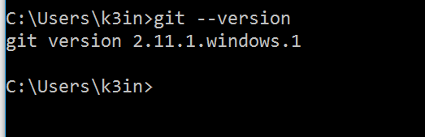

**Cloning a repository.**

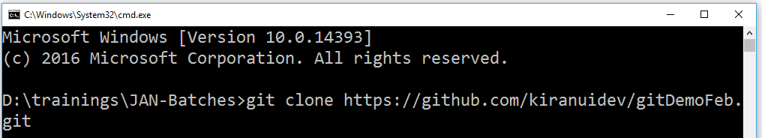

**After executing the above command we will get the remote repository into our system**

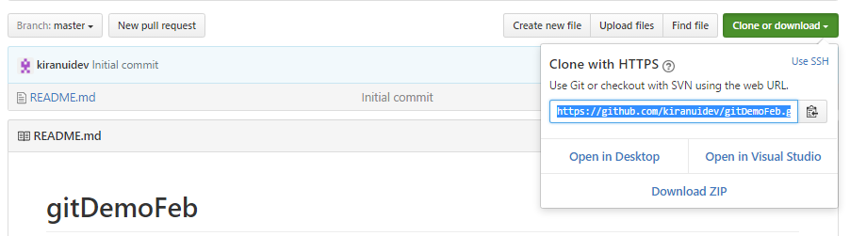

**Default branch will be master you can find the branches at the left side**

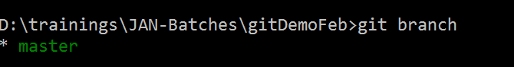

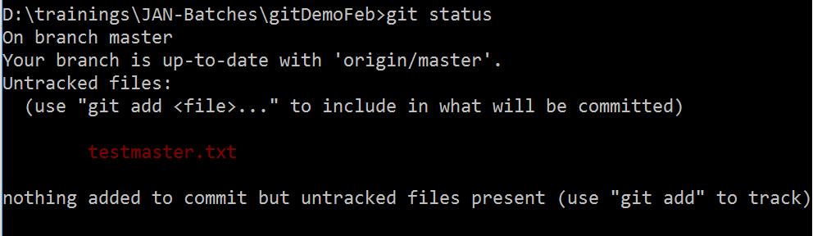

**Adding single file changes to the local git.**

**Adding multiple file changes**



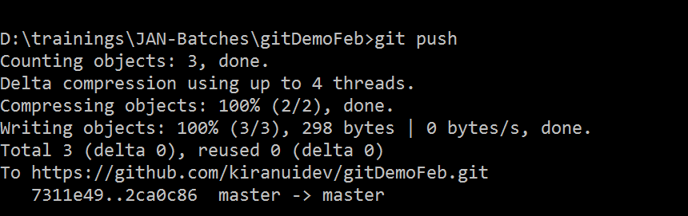

**Handling multiple file changes.**

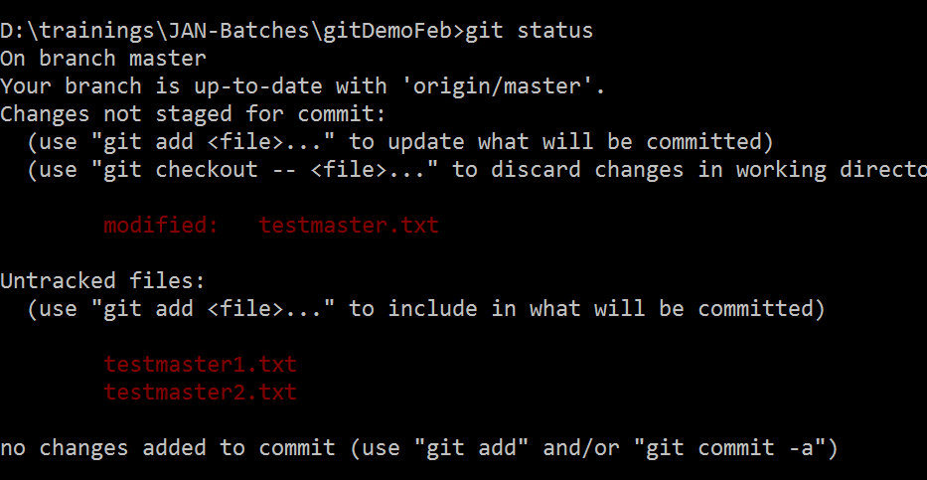

**Adding multiple files to the local repo**



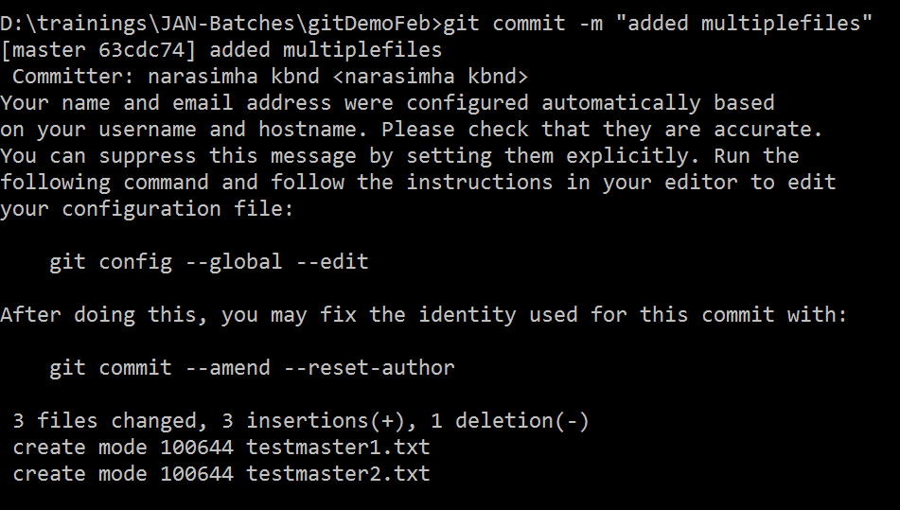

**Creating a new branch.**

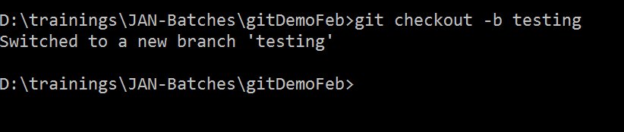

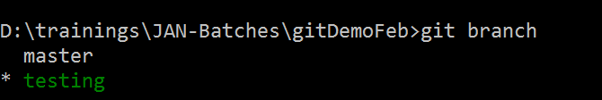

**To get the latest changes made by the team from server.**



