**Google Map User Control For ASP.net**

Google Map User control enables the faster generation of Google map on the ASP.net Web Page. Using this user control it will be possible to the user to build Google map at the server end without interacting with JavaScript.  For example, If you want to pull latitude longitude information from a SQL Server database and then use them to insert pushpins on Google map. You can directly loop through the server data and created map points along with custom pushpins just like shown below:

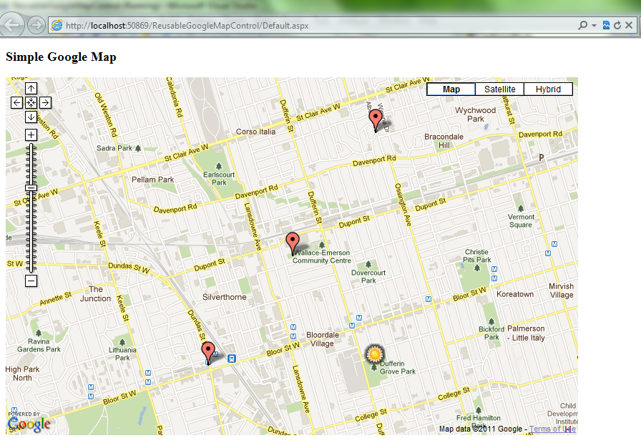

**Features**

* Enables you to draw Google map. No JavaScript knowledge required. Just drag and drop control on your page.
* Enables you to change pushpin positions on the fly.
* Enables you to change pushpin icons, positions from asp.net code behind.
* Enables you to set map zoom, type from code behind.
* Enables you to add notes (in HTML) for markers.

**How to use**

* Copy the Google Map user control folder to you project

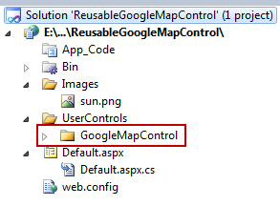

* Add reference to “GoogleMapAPILibrary.dll” provided here with the project in Bin folder.
* On the page where you want to generate Google map register the user control and generate the control just as shown in highlighted section on below screen shot:

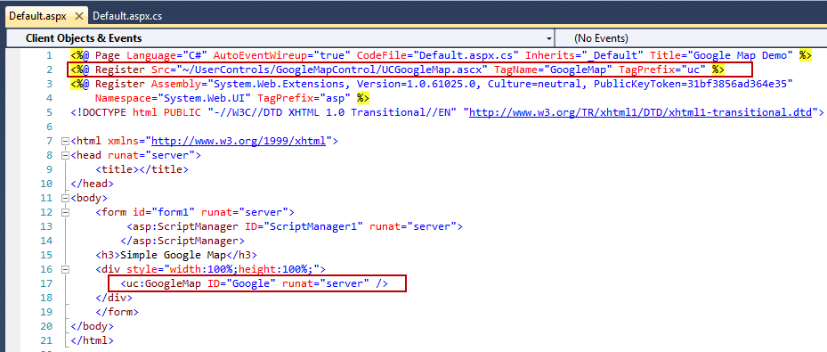

* At the code behind set the map height and width, zoom level, etc. And add the points to the map using GooglePoint() class object.

GooglePoint googleMapPoint = new GooglePoint();

googleMapPoint.ID = “1”;

googleMapPoint.Latitude = 49.663;

googleMapPoint.Longitude = -72.629;

Google.Map.Points.Add(googleMapPoint);

* That’s it. You can now run the project and map should get generated on the web page.