**Localization in ASP.Net MVC**

Attached sample application demonstrates the usage of localization in ASP.Net MVC to achieve multilingual support.

**How to implement**

* Create separate c# library project that will contain resource file (.resx) for each of the language
* Include that library in your MVC project.
* In the Globlal.asax file under the “Application_BeginRequest” event set the language culture as shown below:

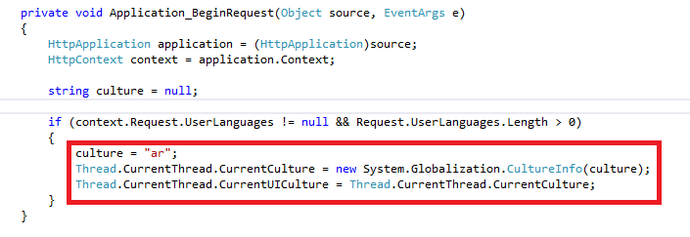

Now, when you run the page you see localized labels on the pages.

ASP.net MVC,Localization,multilingual

**References**

<http://adamyan.blogspot.in/2010/02/aspnet-mvc-2-localization-complete.html>

<http://afana.me/post/aspnet-mvc-internationalization.aspx>

http://afana.me/post/aspnet-mvc-internationalization-store-strings-in-database-or-xml.aspx