Sass: Syntactically Awesome Style Sheets

Sass (Syntactically Awesome Stylesheets) is a stylesheet language. Sass is a scripting language that is interpreted into Cascading Style Sheets (CSS). SassScript is the scripting language itself.

**Features**

1. **Variables** - Variables are the way to store information that you want to reuse throughout your stylesheet.

*$primary-color: #333;*

*body {*

*font: 100% $font-stack;*

*color: $primary-color;*

*}*

1. **Nesting -** Sass will let you nest your CSS selectors in a way that follows the same visual hierarchy of your HTML.

*nav {*

*ul {*

*margin: 0;*

*padding: 0;*

*list-style: none;*

*}*

*li { display: inline-block; }*

*}*

1. **Partials-** You can create partial Sass files that contain little snippets of CSS that you can include in other Sass files. Sass partials are used with the @import directive. CSS has an import option that lets you split your CSS into smaller, more maintainable portions.
2. **Mixins -** A mixin lets you make groups of CSS declarations that you want to reuse throughout your site.

*@mixin border-radius($radius) {*

*-webkit-border-radius: $radius;*

*-moz-border-radius: $radius;*

*-ms-border-radius: $radius;*

*border-radius: $radius;*

*}*

*.box { @include border-radius(10px); }*

1. **Extend/Inheritance -** This is one of the most useful features of Sass. Using @extend lets you share a set of CSS properties from one selector to another.

*.message {*

*border: 1px solid #ccc;*

*padding: 10px;*

*color: #333;*

*}*

*.success {*

*@extend .message;*

*border-color: green;*

*}*

1. **Operators -** Doing math in your CSS is very helpful. Sass has a handful of standard math operators like +, -, *, /, and %

*aside[role="complimentary"] {*

*float: right;*

*width: 300px / 960px * 100%;*

*}*

**How to Use:**

1. Install SCOUT - Since Sass and Compass are Ruby gems, they require that you have a working knowledge of Ruby and the command line. Not all designers will know how or want to use command line tools, and that's where Scout steps in.

Scout runs Sass and Compass in a self-contained Ruby environment, letting you effortlessly manage all of your Sass projects with a handful of clicks. You'll never have to worry about your Ruby setup or deal with technical issues. Scout does all of the heavy lifting, giving you more time to do what you love.

Go to <https://mhs.github.io/scout-app/> and download and install SCOUT app

**Please Note:** Make sure you have latest version of JDK (6+) installed on your machine as well as java exe path appropriately set in process_interaction.js file to avoid scout ArgumentError: Error #3214

1. Follow the steps given in the screenshot below to configure the SCOUT to compile your SCSS to CSS files:

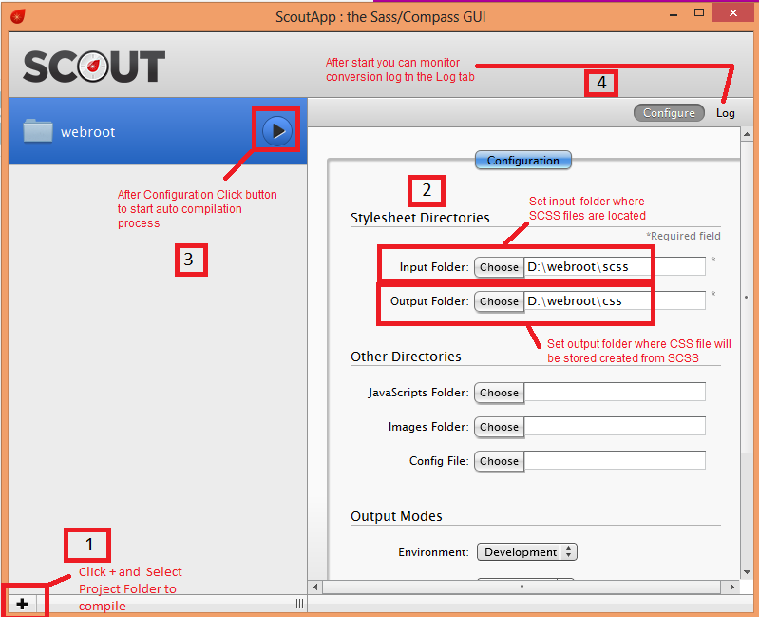

Please find the attached sample application that demonstrate usage of the SCSS files with its available features

SCSS,SASS, Syntactically Awesome StyleSheets

**References:**

* <http://sass-lang.com/guide>
* <https://mhs.github.io/scout-app/>