NuGet is a free and open source package manager for the .NET Framework (formerly known as NuPack). NuGet is distributed as a Visual Studio extension, integrated with SharpDevelop, and included in the C# code snippet tool LINQPad.

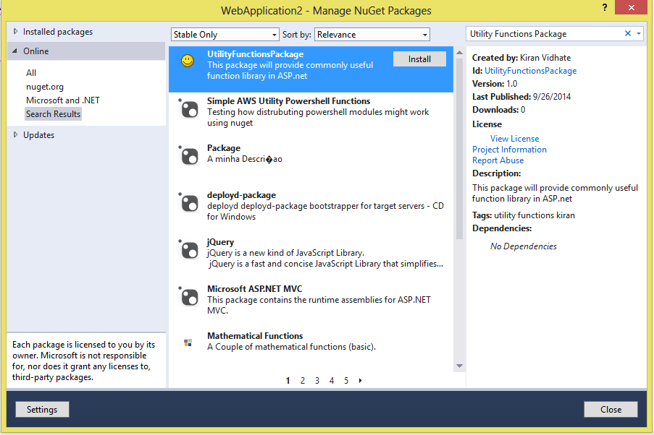b