AngularJS Assignment:

Create an AJAX based AngularJS application which allows a user to display information on cities. Use the following actual city data:

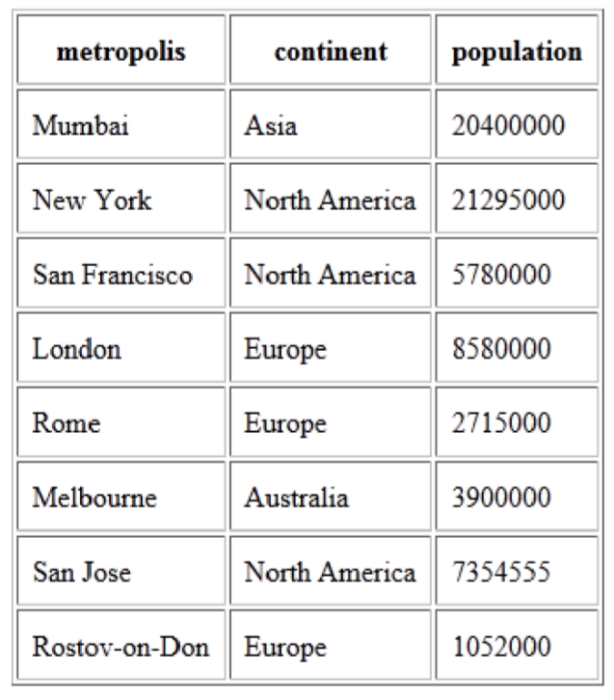

Include a single text field which can be used to filter based on information contained in any of the columns. Here are a few screen shots of the application in action:

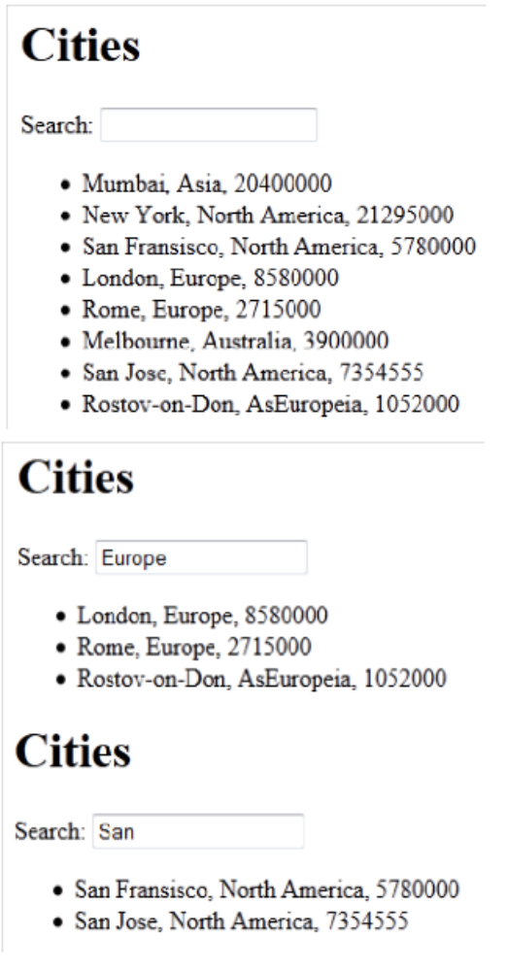
To store the city data, you may use SQL database/JSON/XML/CSV.

