Contents

Software development process models 2

Waterfall (1790 Winston Royce) 2

V-Model (1986 Paul E Brook) 3

Agile 4

Agile Software Development Methodologies 4

# Software development process models

## Waterfall (1790 Winston Royce)

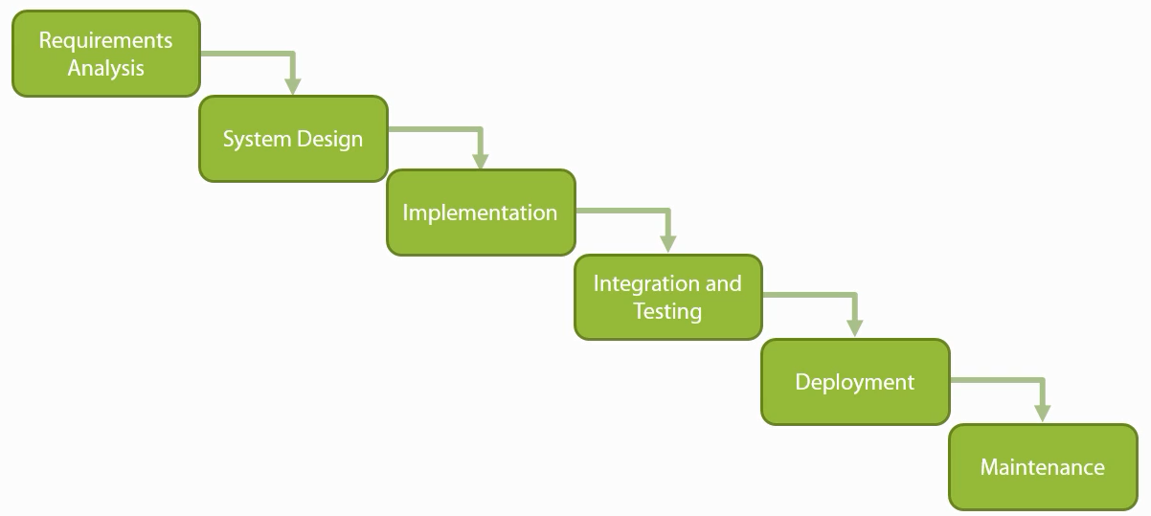

Suitable when:

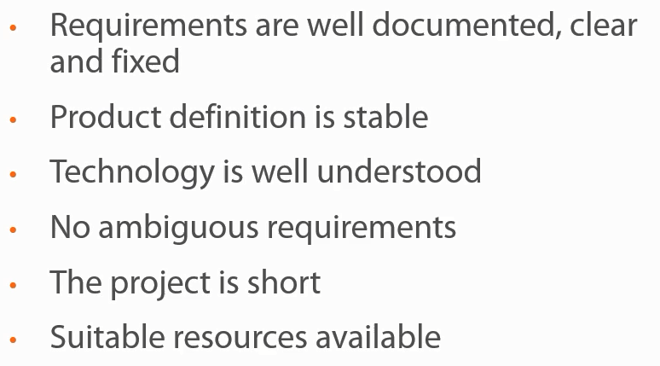

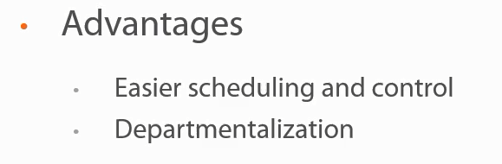

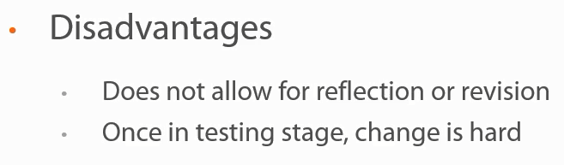

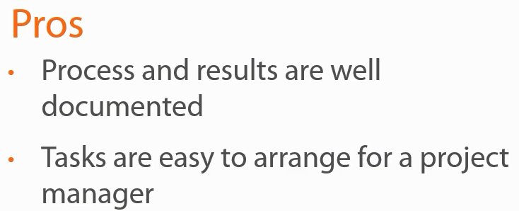

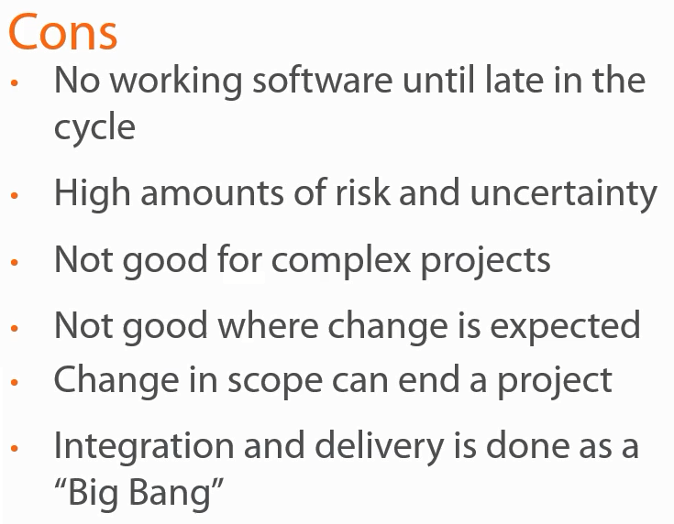

## V-Model (1986 Paul E Brook)

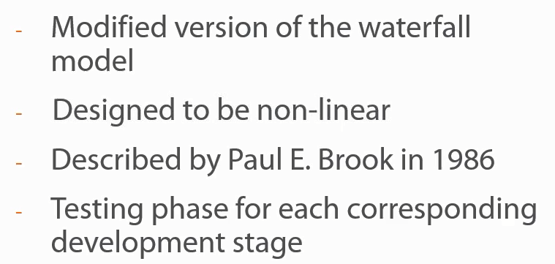

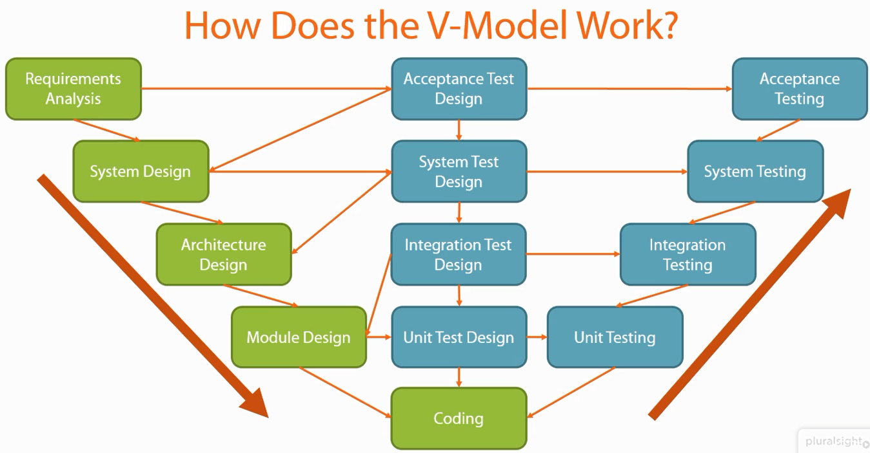

Suitable when:

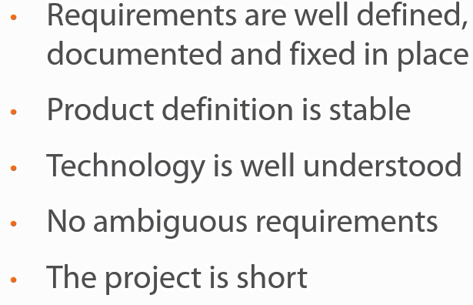

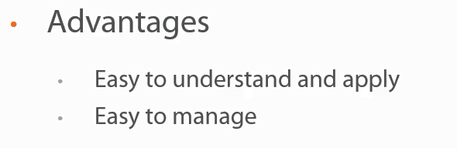

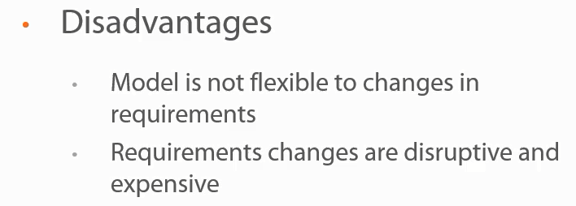

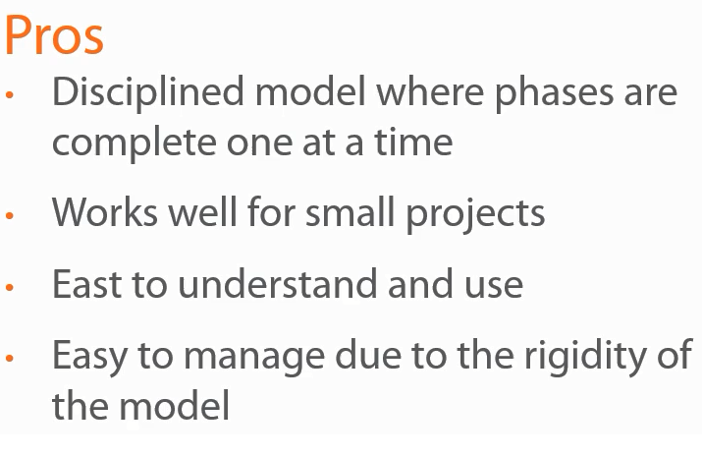

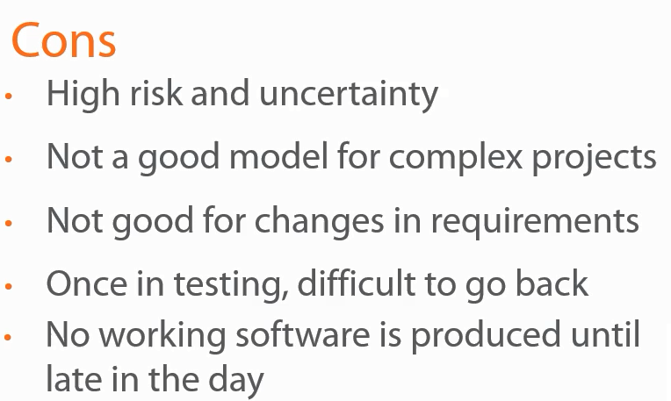

## Agile

# Agile Software Development Methodologies

1. **Extreme Programming (XP)**
2. **Scrum**
3. Lean
4. Kanban
5. DSDM (Dynamic Software Development Method)
6. Crystal

## Agile Diagram

