Notes

# What is PMBOK

Provides guidelines for managing individual projects and defines project management related concepts. It also describes the project management life cycle and its related processes, as well as the project life cycle.

Guide contains the globally recognized standard and guide for the project management profession

# PMBOK Structure

* Section 1 and 2 provide an introduction to key concepts in the project management field
* Section 3 summarizes the Process Groups and provides an overview of process interactions among the ten

Knowledge Areas and five Process Groups

* Sections 4 through 13 are the guide to the project management body of knowledge by describing the inputs and outputs, as well as tools and techniques used in managing projects
* Project Management Institute Code of Ethics and Professional Conduct describes the expectations that practitioners should hold for themselves and others. When interacting with any stakeholder, practitioners should be committed to honest, responsible, fair practices and respectful dealings. Acceptance of the code is essential for project managers, and is a requirement for the following PMI® exams:
  + Certified Associate in Project Management (CAPM)®
  + Project Management Professional (PMP)®
  + Program Management Professional (PgMP)®
  + PMI Agile Certified Practitioner (PMI-ACP)SM
  + PMI Risk Management Professional (PMI-RMP)®
  + PMI Scheduling Professional (PMI-SP)®

# Terms

* “Generally recognized” - means the knowledge and practices described are applicable to most projects most of the time.
* “Good practice” – means application of the knowledge, skills, etc. can enhance the chances of success over many projects. This doesn’t always be applied uniformly to all projects.

# Project

* A project is a temporary endeavor undertaken to create a unique product, service, or result.
* The temporary nature of projects indicates that a project has a definite beginning and end.
* Every project creates a unique product, service, or result.

# The Relationships among Portfolios, Programs, and Projects

* **Portfolio:** A Collection of projects, programs, sub-portfolios, and operations managed as a group to achieve strategic objectives
* **Programs:** are grouped within a portfolio and are comprised of subprograms, projects, or other work that are managed in a coordinated fashion in support of the portfolio.
* **Projects:** are either within or outside of a program are still considered part of a portfolio.

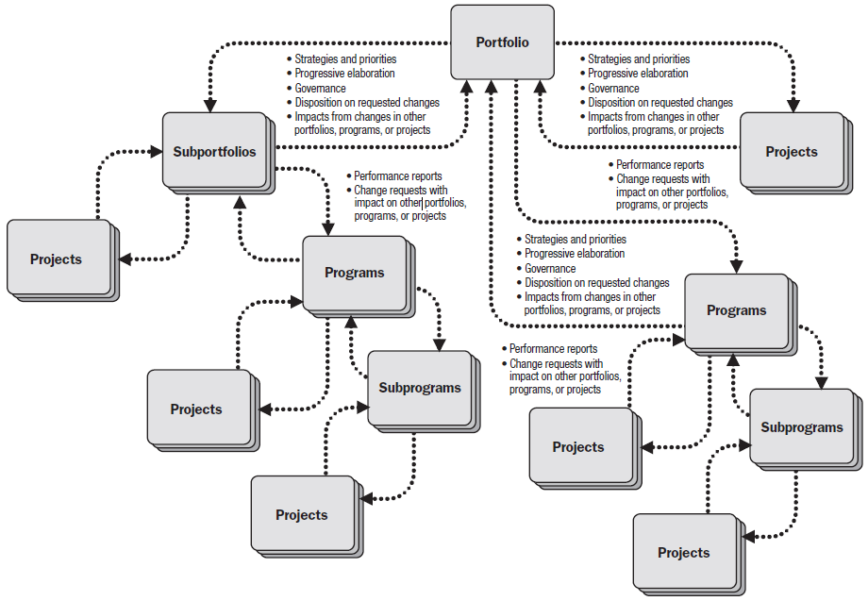

# Project Management

Is the application of knowledge, skills, tools, and techniques to project activities to meet the project requirements. Project management is accomplished through the appropriate application and integration of the 47 logically grouped project management processes, which are categorized into five Process Groups. These five Process Groups are:

* Initiating,
* Planning,
* Executing,
* Monitoring and Controlling, and
* Closing.

Managing a project typically includes, but is not limited to:

* Identifying requirements;
* Addressing the various needs, concerns, and expectations of the stakeholders in planning and executing the project;
* Setting up, maintaining, and carrying out communications among stakeholders that are active, effective, and collaborative in nature;
* Managing stakeholders towards meeting project requirements and creating project deliverables;
* Balancing the competing project constraints, which include, but are not limited to:
  + Scope,
  + Quality,
  + Schedule,
  + Budget,
  + Resources, and
  + Risks.

The relationship among these factors is such that if any one factor changes, at least one other factor is likely to be affected. E.g. Schedule and Resources.

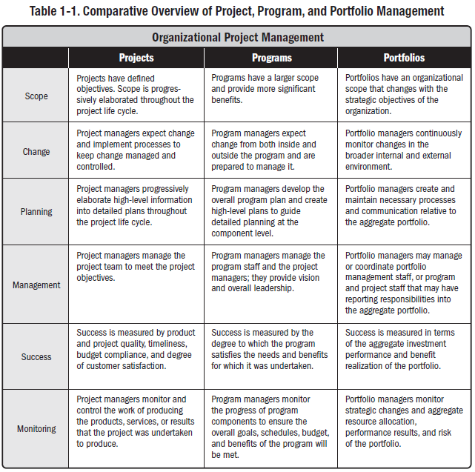

# 4.1 Develop Project Charter

* **Definition -** Process of developing a document that formally authorizes the existence of a project and provides the project manager with the authority to apply organizational resources to project activities
* **Key Benefits -** A well-defined project start and project boundaries, creation of a formal record of the project, and a direct way for senior management to formally accept and commit to the project.

# 4.2 Develop Project Management Plan

* **Definition** - process of defining, preparing, and coordinating all subsidiary plans and integrating them into a comprehensive project management plan
* **Key Benefits -** A central document that defines the basis of all project work

# 4.3 Direct and Manage Project Work

* **Definition** - Process of leading and performing the work defined in the project management plan and implementing approved changes to achieve the project’s objectives.
* **Key Benefits –** Provides overall management of the project work.

# 4.4 Monitor and Control Project Work

* **Definition** - Process of tracking, reviewing, and reporting the progress to meet the performance objectives defined in the project management plan.
* **Key Benefits -** It allows stakeholders to understand the current state of the project, the steps taken, and budget, schedule, and scope forecasts.

# 4.5 Perform Integrated Change Control

* **Definition** - Process of reviewing all change requests; approving changes and managing changes to deliverables, organizational process assets, project documents, and the project management plan; and communicating their disposition.
* **Key Benefits -** It allows for documented changes within the project to be considered in an integrated fashion while reducing project risk, which often arises from changes made without consideration to the overall project objectives or plans.

# Close Project or Phase

* **Definition** - Process of finalizing all activities across all of the Project Management Process Groups to formally complete the project or phase.
* **Key Benefits -** It provides lessons learned, the formal ending of project work, and the release of organization resources to pursue new endeavors.

# Plan Scope Management

* **Definition** - Process of creating a scope management plan that documents how the project scope will be defined, validated, and controlled.
* **Key Benefits -** It provides guidance and direction on how scope will be managed throughout the project.

# 5.2 Collect Requirements

* **Definition** - Process of determining, documenting, and managing stakeholder needs and requirements to meet project objectives.
* **Key Benefits -** Provides the basis for defining and managing the project scope including product scope.

# 5.3 Define Scope

* **Definition** - Process of developing a detailed description of the project and product.
* **Key Benefits -** It describes the project, service, or result boundaries by defining which of the requirements collected will be included in and excluded from the project scope

# Create WBS

* **Definition** - Process of subdividing project deliverables and project work into smaller, more manageable components.
* **Key Benefits -** It provides a structured vision of what has to be delivered.

# 5.5 Validate Scope

* **Definition** - Process of formalizing acceptance of the completed project deliverables.
* **Key Benefits -** It brings objectivity to the acceptance process and increases the chance of final product, service, or result acceptance by validating each deliverable.

# 5.6 Control Scope

* **Definition** - Process of monitoring the status of the project and product scope and managing changes to the scope baseline.
* **Key Benefits -** It allows the scope baseline to be maintained throughout the project.

# Plan Schedule Management

* **Definition** - Process of establishing the policies, procedures, and documentation for planning, developing, managing, executing, and controlling the project schedule.
* **Key Benefits -** Provides guidance and direction on how the project schedule will be managed throughout the project.

# 6.2 Define Activities

* **Definition** - Process of identifying and documenting the specific actions to be performed to produce the project deliverables.
* **Key Benefits -** Break down work packages into activities that provide a basis for estimating, scheduling, executing, monitoring, and controlling the project work.

# 6.3 Sequence Activities

* **Definition** - Process of identifying and documenting relationships among the project activities.
* **Key Benefits -** Defines the logical sequence of work to obtain the greatest efficiency given all project constraints.

# 6.4 Estimate Activity Resources

* **Definition** - Process of estimating the type and quantities of material, human resources, equipment, or supplies required to perform each activity.
* **Key Benefits -** Identifies the type, quantity, and characteristics of resources required to complete the activity which allows more accurate cost and duration estimates.

# 6.5 Estimate Activity Durations

* **Definition** - Process of estimating the number of work periods needed to complete individual activities with estimated resources.
* **Key Benefits -** Provides the amount of time each activity will take to complete, which is a major input into the Develop Schedule process.

# 6.6 Develop Schedule

* **Definition** - Process of analyzing activity sequences, durations, resource requirements, and schedule constraints to create the project schedule model.
* **Key Benefits -** By entering schedule activities, durations, resources, resource availabilities, and logical relationships into the scheduling tool, it generates a schedule model with planned dates for completing project activities.

# 6.7 Control Schedule

* **Definition** - Process of monitoring the status of project activities to update project progress and
* manage changes to the schedule baseline to achieve the plan.
* **Key Benefits –** Provides the means to recognize deviation from the plan and take corrective and preventive actions and thus minimize risk.

# 7.1 Plan Cost Management

* **Definition** - Process that establishes the policies, procedures, and documentation for planning, managing, expending, and controlling project costs.
* **Key Benefits -** Provides guidance and direction on how the project costs will be managed throughout the project.

# 7.2 Estimate Costs

* **Definition** - Process of developing an approximation of the monetary resources needed to complete project activities.
* **Key Benefits -** Determines the amount of cost required to complete project work.

# 7.3 Determine Budget

* **Definition** - Process of aggregating the estimated costs of individual activities or work packages to establish an authorized cost baseline.
* **Key Benefits -** Determines the cost baseline against which project performance can be monitored and controlled.

# 7.4 Control Costs

* **Definition** - Process of developing an approximation of the monetary resources needed to complete project activities.
* **Key Benefits -** Determines the amount of cost required to complete project work.

# 8.1 Plan Quality Management

* **Definition** - Process of identifying quality requirements and/or standards for the project and its deliverables, and documenting how the project will demonstrate compliance with relevant quality requirements.
* **Key Benefits -** Provides guidance and direction on how quality will be managed and validated throughout the project.

# 8.2 Perform Quality Assurance

* **Definition** - Process of auditing the quality requirements and the results from quality control measurements to ensure that appropriate quality standards and operational definitions are used.
* **Key Benefits -** Facilitates the improvement of quality processes.

# 8.3 Control Quality

* **Definition** - Process of monitoring and recording results of executing the quality activities to assess performance and recommend necessary changes.
* **Key Benefits -** (1) identifying the causes of poor process or product quality and recommending and/or taking action to eliminate them; and (2) validating that project deliverables and work meet the requirements specified by key stakeholders necessary for final acceptance.

# 9.1 Plan Human Resource Management

* **Definition** - Process of identifying and documenting project roles, responsibilities, required skills, reporting relationships, and creating a staffing management plan.
* **Key Benefits -** Establishes project roles and responsibilities, project organization charts, and the staffing management plan including the timetable for staff acquisition and release.

# 9.2 Acquire Project Team

* **Definition** - Process of confirming human resource availability and obtaining the team necessary to complete project activities.
* **Key Benefits -** Outlining and guiding the team selection and responsibility assignment to obtain a successful team.

# 9.3 Develop Project Team

* **Definition** - Process of improving competencies, team member interaction, and overall team environment to enhance project performance.
* **Key Benefits -** Results in improved teamwork, enhanced people skills and competencies, motivated employees, reduced staff turnover rates, and improved overall project performance.

# 9.4 Manage Project Team

* **Definition** - Process of tracking team member performance, providing feedback, resolving issues, and managing team changes to optimize project performance
* **Key Benefits -** Influences team behavior, manages conflict, resolves issues, and appraises team member performance.

# 10.1 Plan Communications Management

* **Definition** - Process of developing an appropriate approach and plan for project communications based on stakeholder’s information needs and requirements, and available organizational assets.
* **Key Benefits -** Identifies and documents the approach to communicate most effectively and efficiently with stakeholders.

# 10.2 Manage Communications

* **Definition** - Process of creating, collecting, distributing, storing, retrieving, and the ultimate disposition of project information in accordance to the communications management plan.
* **Key Benefits -** Enables an efficient and effective communications flow between project stakeholders.

# 10.3 Control Communications

* **Definition** - Process of monitoring and controlling communications throughout the entire project life cycle to ensure the information needs of the project stakeholders are met.
* **Key Benefits -** Ensures an optimal information flow among all communication participants, at any moment in time.

# 11.1 Plan Risk Management

* **Definition** - Process of defining how to conduct risk management activities for a project.
* **Key Benefits -** Ensures that the degree, type, and visibility of risk management are commensurate with both the risks and the importance of the project to the organization.

# 11.2 Identify Risks

* **Definition** - Process of determining which risks may affect the project and documenting their characteristics.
* **Key Benefits -** Documentation of existing risks and the knowledge and ability it provides to the project team to anticipate events.

# 11.3 Perform Qualitative Risk Analysis

* **Definition** - Process of prioritizing risks for further analysis or action by assessing and combining their probability of occurrence and impact.
* **Key Benefits -** Enables project managers to reduce the level of uncertainty and to focus on high-priority risks.

# 11.4 Perform Quantitative Risk Analysis

* **Definition** - Process of numerically analyzing the effect of identified risks on overall project objectives.
* **Key Benefits -** Produces quantitative risk information to support decision making in order to reduce project uncertainty.

# 11.5 Plan Risk Responses

* **Definition** - Process of developing options and actions to enhance opportunities and to reduce threats to project objectives.
* **Key Benefits -** Addresses the risks by their priority, inserting resources and activities into the budget, schedule and project management plan as needed.

# 11.6 Control Risks

* **Definition** - Process of implementing risk response plans, tracking identified risks, monitoring residual risks, identifying new risks, and evaluating risk process effectiveness throughout the project.
* **Key Benefits -** Improves efficiency of the risk approach throughout the project life cycle to continuously optimize risk responses.

# 12.1 Plan Procurement Management

* **Definition** - Process of documenting project procurement decisions, specifying the approach, and identifying potential sellers.
* **Key Benefits -** Determines whether to acquire outside support, and if so, what to acquire, how to acquire it, how much is needed, and when to acquire it.

# 12.2 Conduct Procurements

* **Definition** - Process of obtaining seller responses, selecting a seller, and awarding a contract.
* **Key Benefits -** Provides alignment of internal and external stakeholder expectations through established agreements.

# 12.3 Control Procurements

* **Definition** – Process of managing procurement relationships, monitoring contract performance, and making changes and corrections to contracts as appropriate.
* **Key Benefits –** Ensures that both the seller’s and buyer’s performance meets procurement requirements according to the terms of the legal agreement.

# 12.4 Close Procurements

* **Definition** - Process of completing each procurement.
* **Key Benefits -** Documents agreements and related documentation for future reference.

# 13.1 Identify Stakeholders

* **Definition** - Process of identifying the people, groups, or organizations that could impact or be impacted by a decision, activity, or outcome of the project, analyzing and documenting relevant information regarding their interests, involvement, interdependencies, influence, and potential impact on project success.
* **Key Benefits -** Allows the project manager to identify the appropriate focus for each stakeholder or group of stakeholders.

# 13.2 Plan Stakeholder Management

* **Definition** - Process of developing appropriate management strategies to effectively engage stakeholders throughout the project life cycle, based on the analysis of their needs, interests, and potential impact on project success.
* **Key Benefits -** Provides a clear, actionable plan to interact with project stakeholders to support the project’s interests.

# 13.3 Manage Stakeholder Engagement

* **Definition** - Process of communicating and working with stakeholders to meet their needs/expectations, address issues as they occur, and foster appropriate stakeholder engagement in project activities throughout the project life cycle.
* **Key Benefits -** Allows the project manager to increase support and minimize resistance from stakeholders, significantly increasing the chances to achieve project success.

# 13.4 Control Stakeholder Engagement

* **Definition** - Process of monitoring overall project stakeholder relationships and adjusting strategies and plans for engaging stakeholders
* **Key Benefits –** Maintain or increase the efficiency and effectiveness of stakeholder engagement activities as the project evolves and its environment changes.