Kiran Vidhate

v1.0, 01 January 2015.

Abstract

This document is a quick guide and provides short notes of the CMMi v1.3 for development

*CMMI for Development, Version 1.3 Notes*

**Contents**

Capability Maturity Model Integration 1

• CMMI models 1

• Maturity levels in CMMI for development 1

• Process Area 2

• Numbering Scheme 3

• Understanding Levels 5

• Equivalent Staging: 7

**CMMi**

Capability Maturity Model Integration(CMMI) is a process improvement training and appraisal program and service administered and marketed by Carnegie Mellon University and required by many DOD and U.S. Government contracts, especially in software development

# Why Needed

Many organizations find value in measuring their progress by conducting an appraisal and earning a maturity level rating or a capability level achievement profile. These types of appraisals are typically conducted for one or more of the following reasons:

* + To determine how well the organization’s processes compare to CMMI best practices and identify areas where improvement can be made
  + To inform external customers and suppliers about how well the organization’s processes compare to CMMI best practices To meet the contractual requirements of one or more customers

# CMMI models

* + CMMI for Development (**CMMI-DEV**), v1.3 was released in November 2010. It addresses product and service development processes.
  + CMMI for Acquisition (**CMMI-ACQ**), v1.3 was released in November 2010. It addresses supply chain management, acquisition, and outsourcing processes in government and industry.
  + CMMI for Services (**CMMI-SVC**), v1.3 was released in November 2010. It addresses guidance for delivering services within an organization and to external customers.

# Maturity levels in CMMI for development

* There are five maturity levels. Maturity level ratings are awarded for levels 2 through 5.

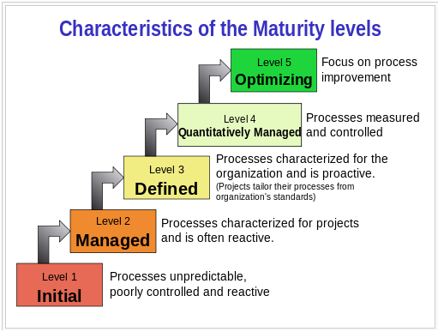

* CMMI-DEV contains 22 process areas. Of those process areas, 16 are core process areas, 1 is a shared process area, and 5 are development specific process areas.
* A core process area is a process area that is common to all CMMI models. A shared process area is shared by at least two CMMI models, but not all of them.

The process areas below and their maturity levels are listed for the CMMI for Development model:

* + **Maturity Level 2 – Managed**

|  |  |  |  |
| --- | --- | --- | --- |
| **Sr.** | **Abbreviation** | **Process Area** | **Category** |
| 1 | CM | Configuration Management | Support |
| 2 | MA | Measurement and Analysis | Support |
| 3 | PPQA | - Process and Product Quality Assurance | Support |
| 4 | PMC | Project Monitoring and Control | Project Management |
| 5 | PP | Project Planning | Project Management |
| 6 | REQM | Requirements Management | Project Management |
| 7 | SAM | Supplier Agreement Management | Project Management |

* + **Maturity Level 3 – Defined**

|  |  |  |  |
| --- | --- | --- | --- |
| **Sr.** | **Abbreviation** | **Process Area** | **Category** |
| 1 | DAR | Decision Analysis and Resolution | Support |
| 2 | IPM | Integrated Project Management | Project Management |
| 3 | RSKM | Risk Management | Project Management |
| 4 | PI | Product Integration | Engineering |
| 5 | RD | Requirements Development | Engineering |
| 6 | TS | Technical Solution | Engineering |
| 7 | VAL | Validation | Engineering |
| 8 | VER | Verification | Engineering |
| 9 | OPD | Organizational Process Definition | Process Management |
| 10 | OPF | Organizational Process Focus | Process Management |
| 11 | OT | Organizational Training | Process Management |

* + **Maturity Level 4 - Quantitatively Managed**

|  |  |  |  |
| --- | --- | --- | --- |
| **Sr.** | **Abbreviation** | **Process Area** | **Category** |
| 1 | QPM | Quantitative Project Management | Process Management |
| 2 | OPP | Organizational Process Performance | Process Management |

* + **Maturity Level 5 – Optimizing**

|  |  |  |  |
| --- | --- | --- | --- |
| **Sr.** | **Abbreviation** | **Process Area** | **Category** |
| 1 | CAR | Causal Analysis and Resolution | Support |
| 2 | OPM | Organizational Performance Management | Process Management |

# Process Areas Relationship

A process area is a cluster of related practices in an area that, when implemented collectively, satisfies a set of goals considered important for making improvement in that area.

* **Support** process areas cover the activities that support product development and maintenance. The Support process areas address processes that are used in the context of performing other processes. There are **five** support process areas in CMMI-DEV.

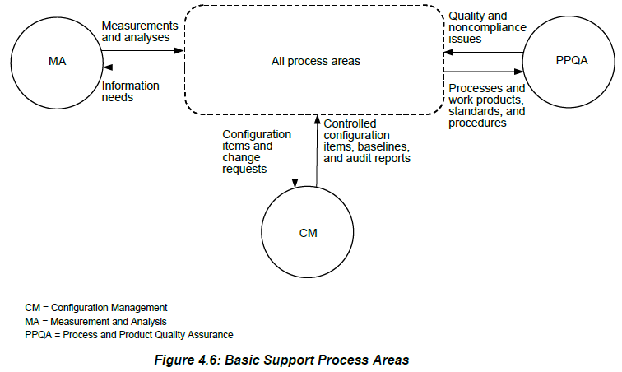

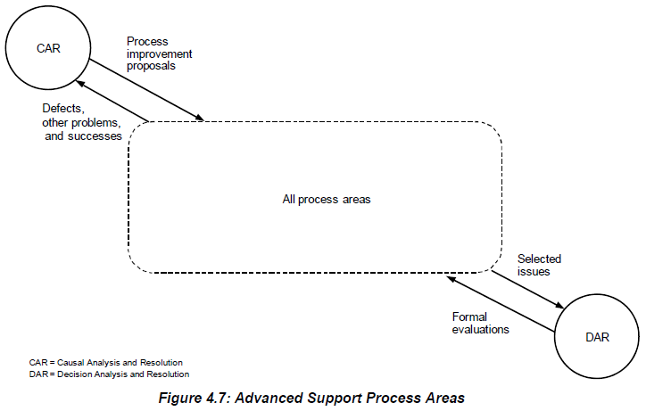

* **Project** **Management** process areas cover the project management activities related to planning, monitoring, and controlling the project. There are **seven** Project Management process areas in CMMI-DEV.

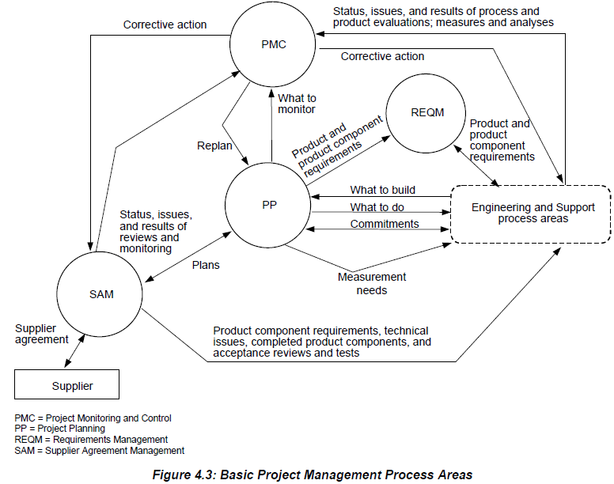

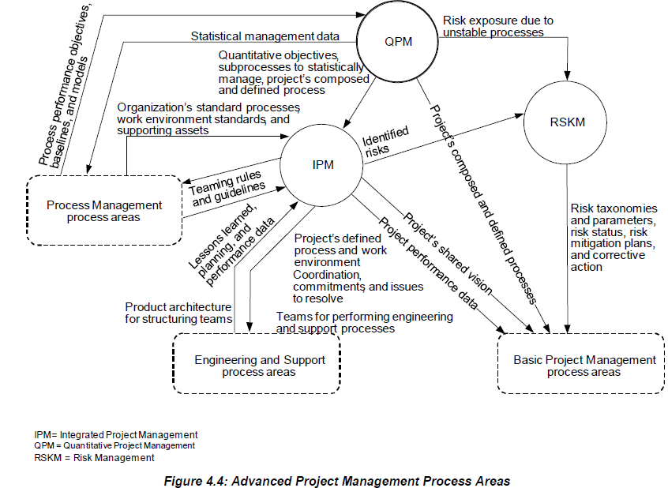

* **Engineering** process areas cover the development and maintenance activities that are shared across engineering disciplines. There are **five** engineering process areas in CMMI-DEV.

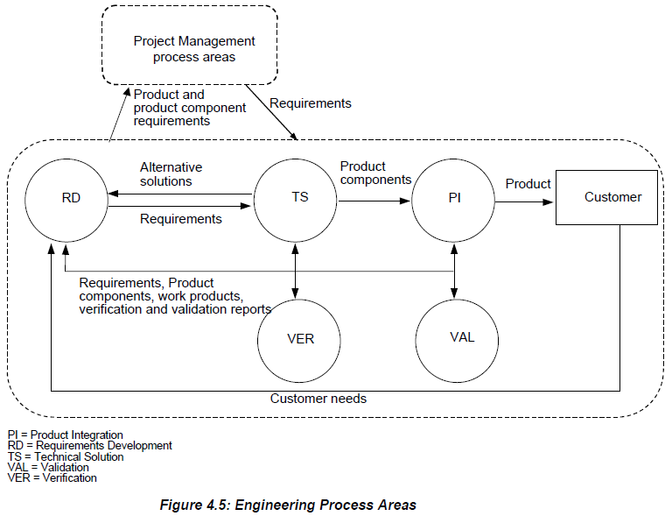

* **Process Management** process areas contain the cross-project activities related to defining, planning, deploying, implementing, monitoring, controlling, appraising, measuring, and improving processes. There are **five** Process Management process areas in CMMI-DEV.

The Basic Process Management process areas provide the organization with a capability to document and share best practices, organizational process assets, and learning across the organization.

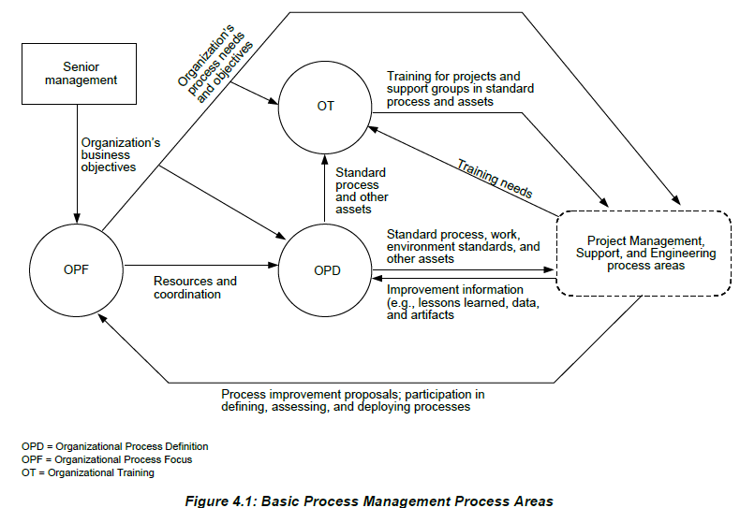

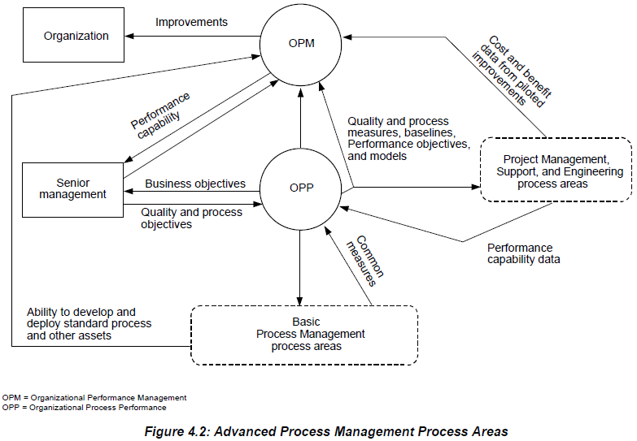

# Process Area Structure

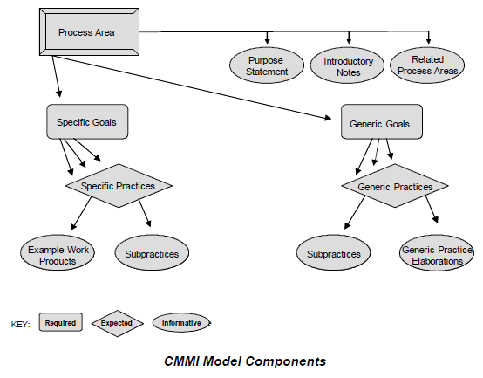

* + **Purpose Statements -** A purpose statement describes the purpose of the process area and is an informative component
  + **Introductory** **Notes -** The introductory notes section of the process area describes the major concepts covered in the process area and is an informative component.
  + **Related Process Areas - l**ists references to related process areas and reflects the high-level relationships among the process areas.
  + **Specific Goals -** Describes the unique characteristics that must be present to satisfy the process area
  + **Generic Goals - C**alled “generic” because the same goal statement applies to multiple process areas.
  + **Specific Practices -** A specific practice is the description of an activity that is considered important in achieving the associated specific goal.
  + **Example Work Products -** Lists sample outputs from a specific practice.
  + **Sub-practices -** Is a detailed description that provides guidance for interpreting and implementing a specific or generic practice.
  + **Generic Practices -** Called “generic” because the same practice applies to multiple process areas.
  + **Generic Practice Elaborations -** Appear after generic practices to provide guidance on how the generic practices can be applied uniquely to process areas. A

# Numbering Scheme

Specific and generic goals are numbered sequentially. Each specific goal begins with the prefix “SG” (e.g., SG 1). Each generic goal begins with the prefix “GG” (e.g., GG 2.1).

For Example, Below is the DAR Process document:

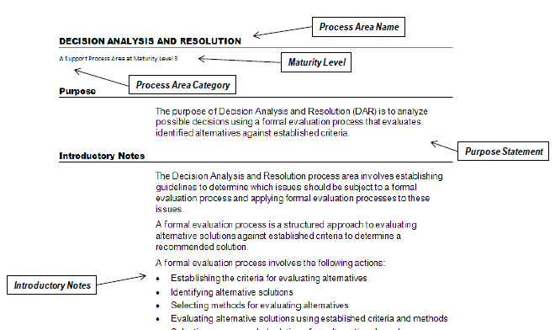

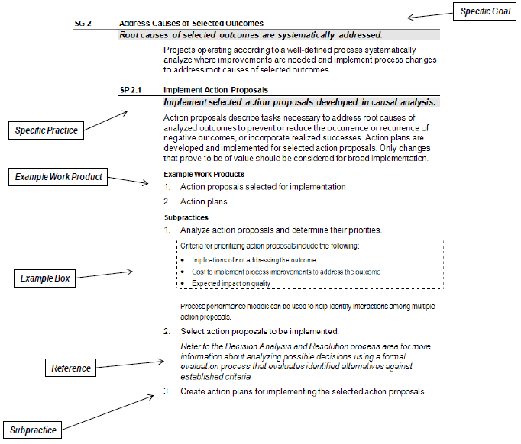

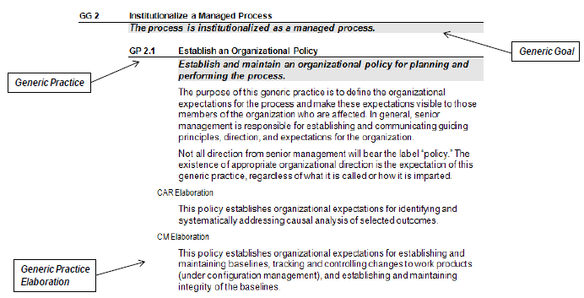

* Understanding Levels **-** Two improvement paths are associated with the two types of levels: capability levels and maturity levels. These levels correspond to two approaches to process improvement called “representations.” The two representations are called “continuous” and “staged.” Using the continuous representation enables you to achieve “capability levels.” Using the staged representation enables you to achieve “maturity levels.”

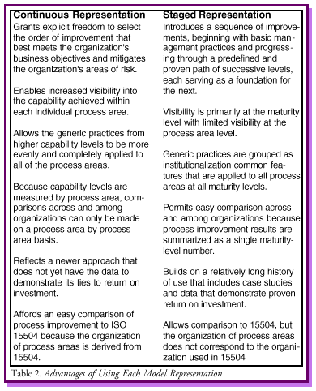

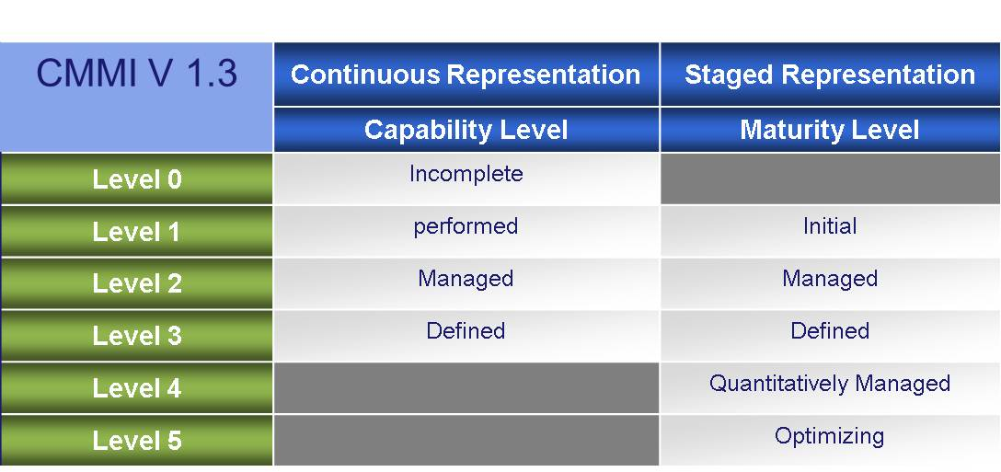

* + **Capability Levels –**

The capability levels of a process area are achieved through the application of generic practices or suitable alternatives to the processes associated with that process area.

1. **Capability Level 0: Incomplete** - Process that either is not performed or is partially performed. One or more of the specific goals of the process area are not satisfied and no generic goals exist for this level.
2. **Capability Level 1: Performed** - Process that accomplishes the needed work to produce work products; the specific goals of the process area are satisfied. Improvements can be lost over time if they are not institutionalized.
3. **Capability Level 2: Managed** – A managed process is a performed process that is planned and executed in accordance with policy; employs skilled people having adequate resources to produce controlled outputs; involves relevant stakeholders; is monitored, controlled, and reviewed; and is evaluated for adherence to its process description.
4. **Capability Level 3: Defined** - A defined process is a managed process that is tailored from the organization’s set of standard processes according to the organization’s tailoring guidelines; has a maintained process description; and contributes process related experiences to the organizational process assets.
   * **Maturity Levels**

Organizations can achieve progressive improvements in their maturity by achieving control first at the project level and continuing to the most advanced level—organization-wide performance management and continuous process improvement—using both qualitative and quantitative data to make decisions

1. **Maturity Level 1: Initial -** Processes are usually ad hoc and chaotic. The organization usually does not provide a stable environment to support processes. Success in these organizations depends on the competence and heroics of the people in the organization and not on the use of proven processes.
2. **Maturity Level 2: Managed** - Projects have ensured that processes are planned and executed in accordance with policy; the projects employ skilled people who have adequate resources to produce controlled outputs; involve relevant stakeholders; are monitored, controlled, and reviewed; and are evaluated for adherence to their process descriptions.
3. **Maturity Level 3: Defined** - Processes are well characterized and understood, and are described in standards, procedures, tools, and methods. The organization’s set of standard processes, which is the basis for maturity level 3, is established and improved over time. These standard processes are used to establish consistency across the organization.
4. **Maturity Level 4: Quantitatively Managed** - The organization and projects establish quantitative objectives for quality and process performance and use them as criteria in managing projects. Quality and process performance is understood in statistical terms and is managed throughout the life of projects.
5. **Maturity Level 5: Optimizing** - An organization continually improves its processes based on a quantitative understanding of its business objectives and performance needs. The organization uses a quantitative approach to understand the variation inherent in the process and the causes of process outcomes.

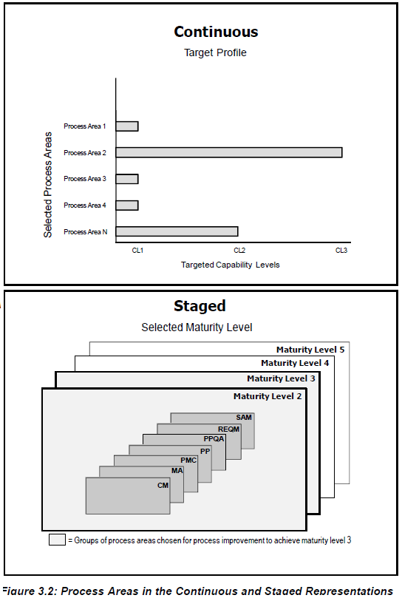

# Equivalent Staging

Equivalent staging is a way to compare results from using the continuous representation to results from using the staged representation. The following rules summarize equivalent staging:

* + To achieve maturity level 2, all process areas assigned to maturity level 2 must achieve capability level 2 or 3.
  + To achieve maturity level 3, all process areas assigned to maturity levels 2 and 3 must achieve capability level 3.
  + To achieve maturity level 4, all process areas assigned to maturity levels 2, 3, and 4 must achieve capability level 3.
  + To achieve maturity level 5, all process areas must achieve capability level 3.

# Relationships among Process Areas

* + Process Management Process Area

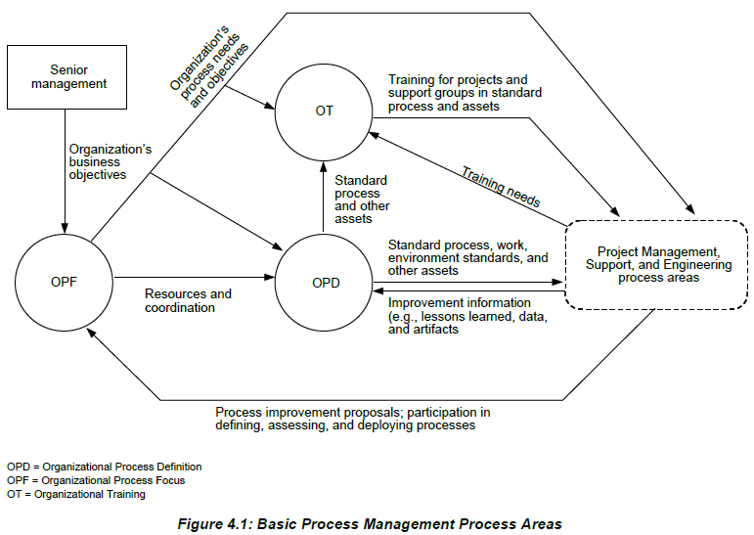

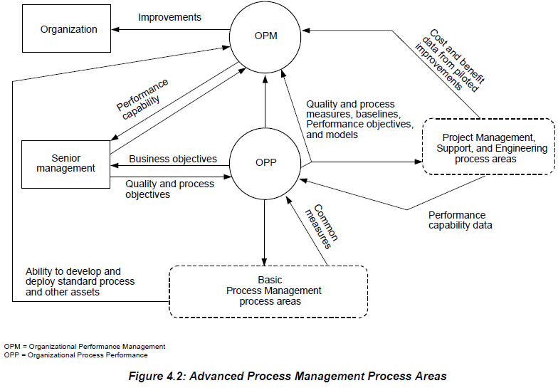

* + Project Management Process Area

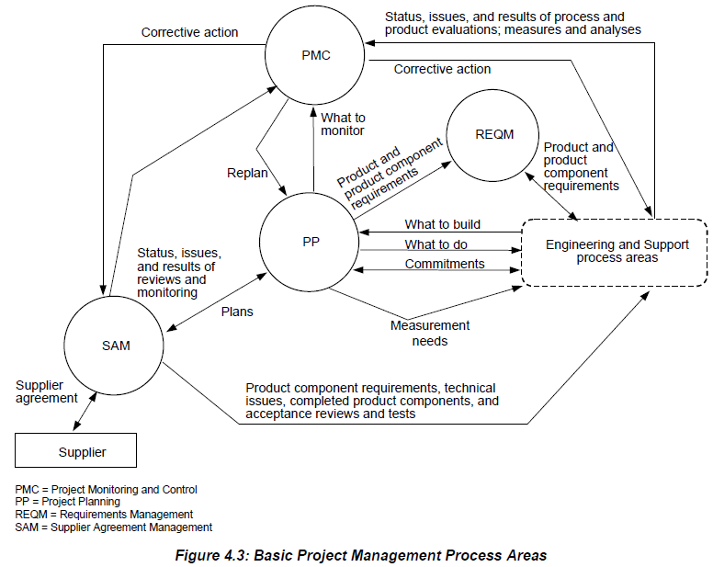

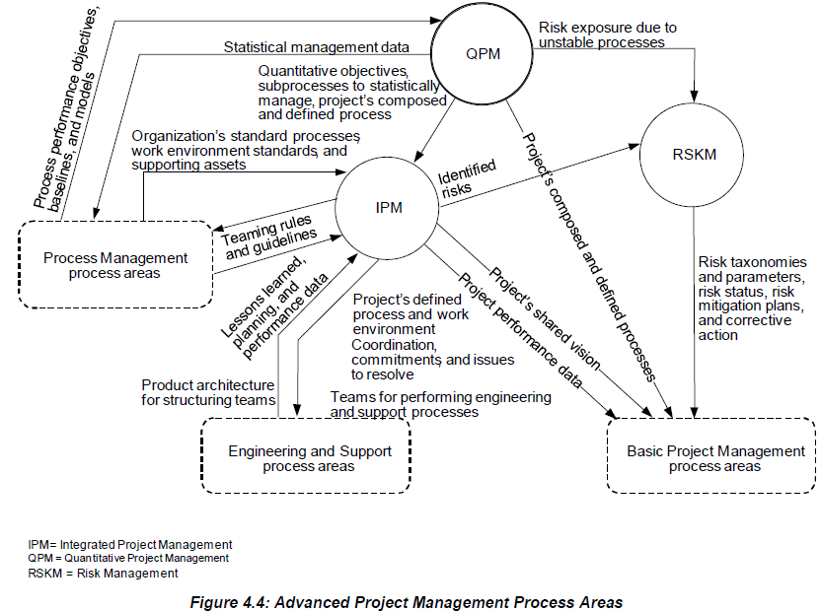

* + Engineering Process Area

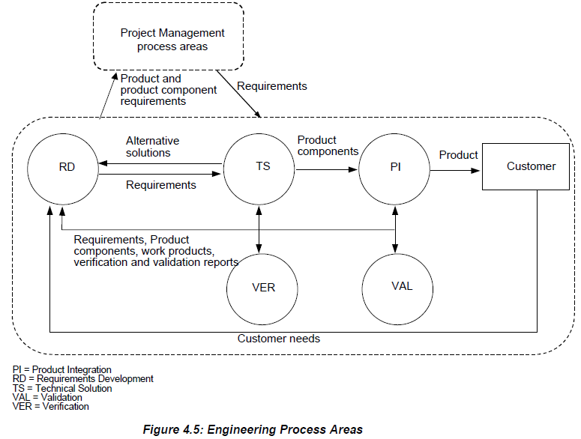

* + Support Process Area

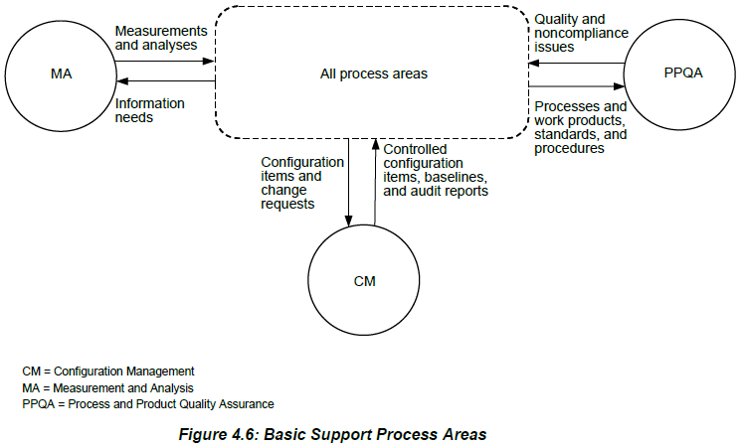

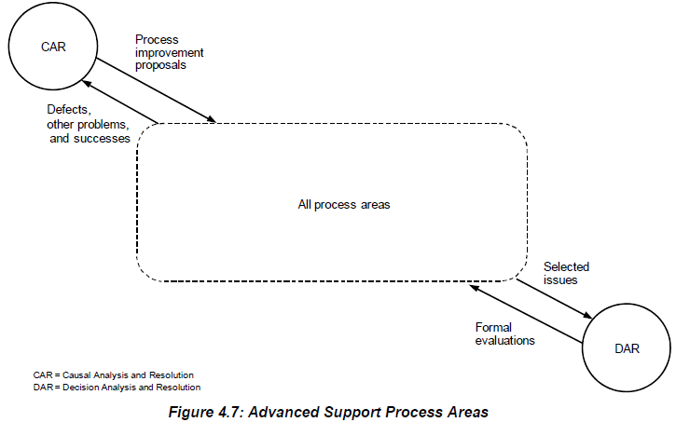

# CMMI Improvement process

You must make three selections to apply CMMI to your organization for process improvement:

* + Select a part of the organization - Selecting the projects
  + Select a model – i.e. DEV or ACQ or SVC
  + Select a representation- i.e. capability or maturity levels

# CMMI Related Training

The SEI and its Partner Network offer the introductory course, Introduction to CMMI for Development.

* + **Maturity Level 2 – Managed**

|  |  |  |  |
| --- | --- | --- | --- |
| **Sr.** | **Abbreviation** | **Process Area** | **Category** |
| 1 | CM | Configuration Management | Support |
| 2 | MA | Measurement and Analysis | Support |
| 3 | PPQA | - Process and Product Quality Assurance | Support |
| 4 | PMC | Project Monitoring and Control | Project Management |
| 5 | PP | Project Planning | Project Management |
| 6 | REQM | Requirements Management | Project Management |
| 7 | SAM | Supplier Agreement Management | Project Management |

* + **Maturity Level 3 – Defined**

|  |  |  |  |  |
| --- | --- | --- | --- | --- |
| **Sr.** | **Abbreviation** | **Process Area** | **Category** | **Tasks** |
| 1 | DAR | Decision Analysis and Resolution | Support |  |
| 2 | IPM | Integrated Project Management | Project Management |  |
| 3 | RSKM | Risk Management | Project Management |  |
| 4 | PI | Product Integration | Engineering |  |
| 5 | RD | Requirements Development | Engineering |  |
| 6 | TS | Technical Solution | Engineering |  |
| 7 | VAL | Validation | Engineering |  |
| 8 | VER | Verification | Engineering |  |
| 9 | OPD | Organizational Process Definition | Process Management | |  | | --- | | 1. Establish Organizational Process Needs | | 1. Appraise the Organization’s Processes | | 1. identify the Organization’s Process Improvements | | 1. Plan the steps to make improvements/ Establish Process Action Plans | | 1. Review and Approval of Process Improvement Plan | | 1. Implement Process Action Plans | | 1. Establishing the Standard Process | | 1. Review and Approval of the Associated Process Elements | | 1. Process Tailoring Guideline | | 1. Review and Approve of Process Tailoring Guideline | | 1. Establishing the organization environment standards | | 1. Setup organization measurement library | | 1. Prepares Process Asset Library | | 1. Establish Lifecycle Model Descriptions | | 1. Establish Teaming Guidelines | | 1. Prepare a Release Notes | | 1. Review and Approval of Release Notes | | 1. Training plan for training the Organization | | 1. Review and Approval of Training Plan | | 1. Execution of training | | 1. Deploy Standard Processes/ Organizational Process Assets | | 1. Monitor the process implementation | | 1. Feedback from the organization/people | | 1. SEPG Process Improvement Meetings | |
| 10 | OPF | Organizational Process Focus | Process Management |  |
| 11 | OT | Organizational Training | Process Management |  |