- Who will use the system?
- Primary user is a Software Tester / QA Engineer.
- Developer: to verify application works acc to requirements.
- What knowledge should the user need?
- The user should not need advanced programming or automation knowledge.
- The goal of our system is to make web testing easier by hiding much of the complexity of Playwright/browser automation.
- Basic computer and web knowledge requirements should be known.
For example: Login Page>Enter Email>Enter Password>Click Login>Dashboard
- Knowledge of the application being tested. For example,
  - What the different portals are.
  - What each user role can do.
  - How authentication works.
  - Which pages require authentication.
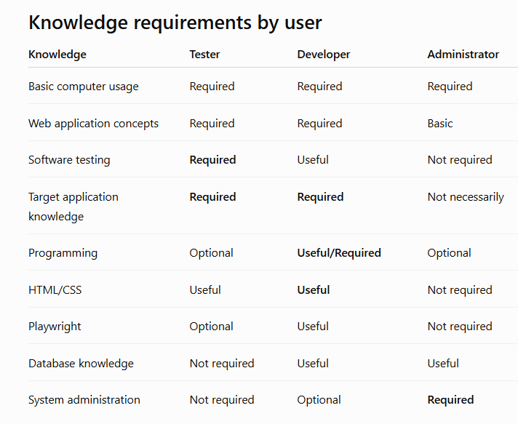

3) How should tests be submitted?
Tests should be submitted through a simple test builder/interface.
- User can provide:
- Website URL.
- Test case name.
- Test steps/actions.
- Expected results.
- Browser to be used.
- Tests can also be submitted using a structured format such as JSON.
Example:
URL → Select Browser → Define Steps → Define Expected Result → Run Test

4) How should results be presented?
Results should be presented in a clear PASS/FAIL format.
- The system should show:
- Test status.
- Passed and failed steps.
- Execution time.
- Error details for failed tests.
- Screenshots/evidence of failures.
- Test execution history.
Example:
Test → Execute → PASS/FAIL → Step Results → Error/Screenshot → Report

