Exercise 1

Logger.java

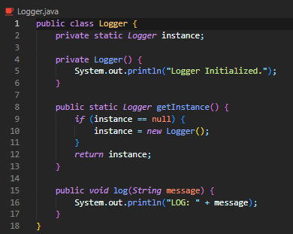

Main.java



Output –



Exercise 2

Document.java

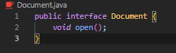

WordDocument.java

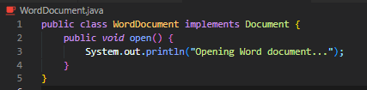

PdfDocument.java

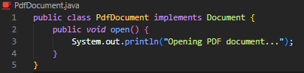

ExcelDocument.java

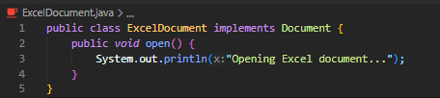

Documentfactory.java

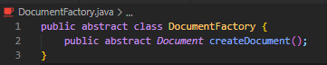

WordDocumentFactory.java

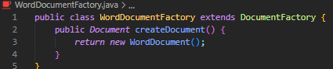

PdfDocumentFactoy.java

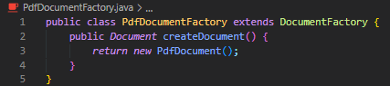

ExcelDocumentFactory.java

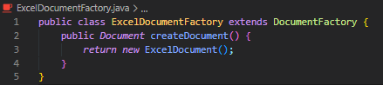

Main.java

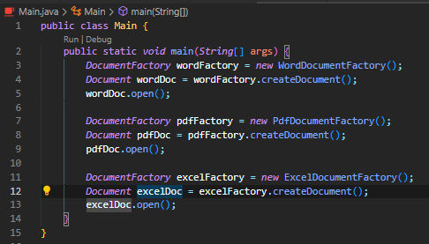

Output –

