**Exercise 1**

pom.xml –

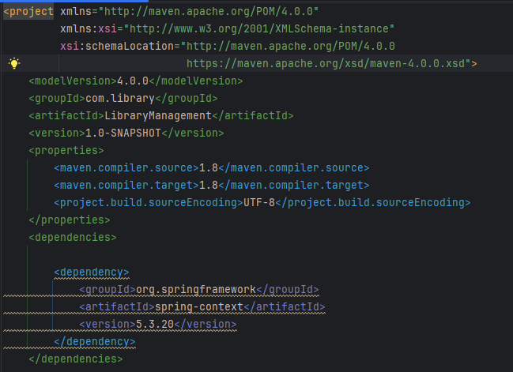

BookRepository.java –

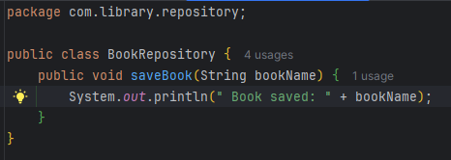

BookService.java –

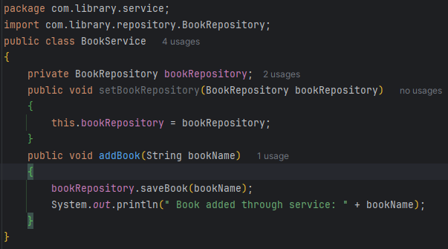

LibraryApp.java—

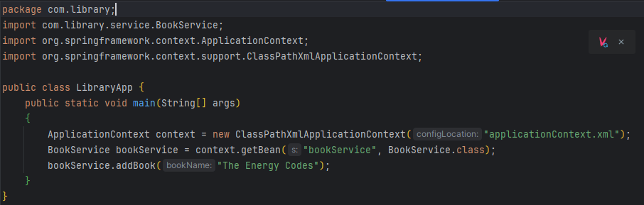

applictionContext.xml

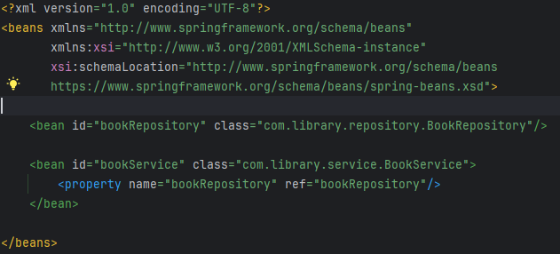

**Exercise 2**

LibraryApp.java-- 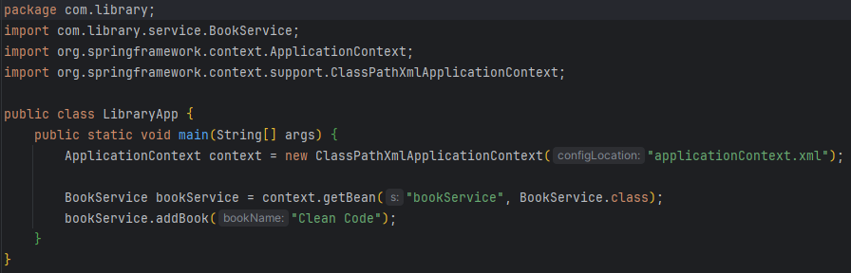

**Exercise 3**

LoogingAspects.java –

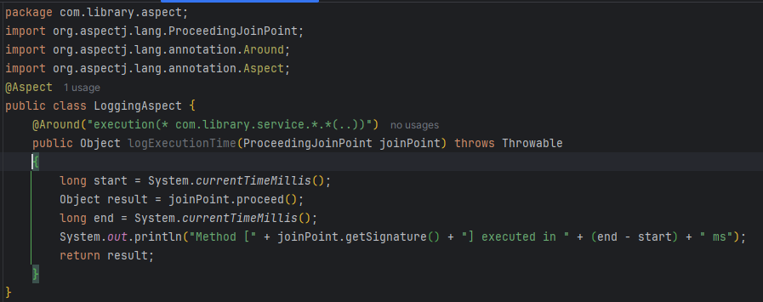

applicationContext.xml –

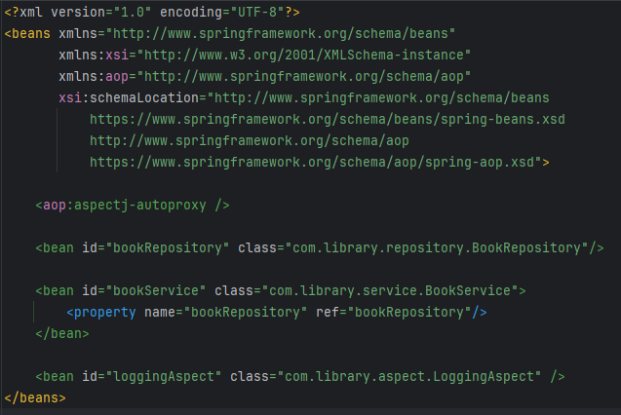

Pom.xml—

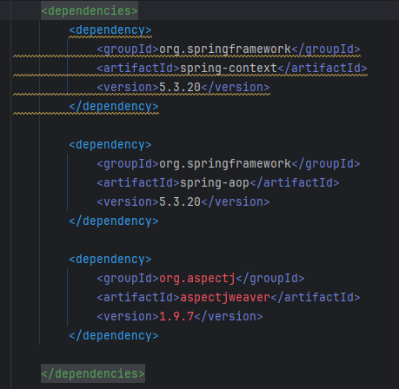

Output –

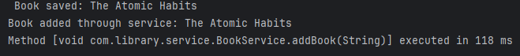

**Exercise 4**

Pom.xml –

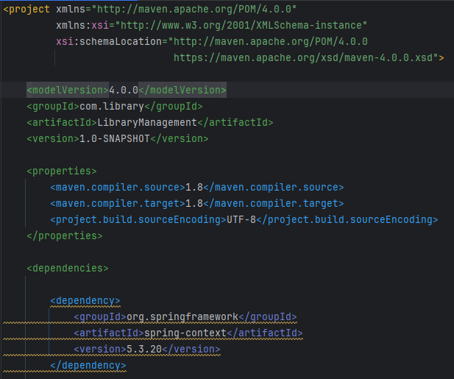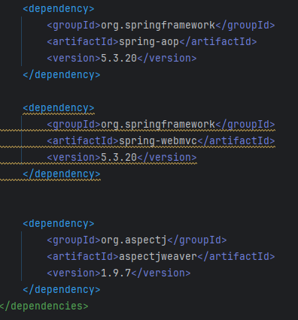

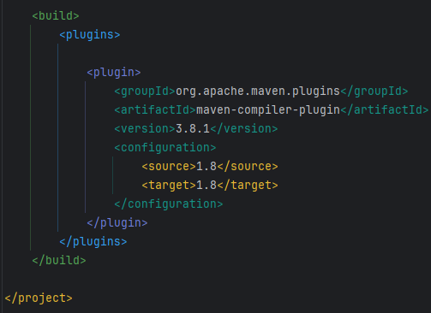

**Exxercise 5**

LibraryApp.java-

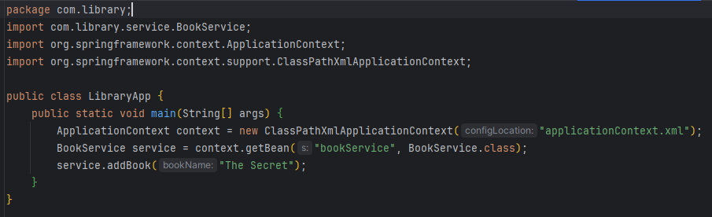

Output –



**Exercise 6**

applicationContext.xml –

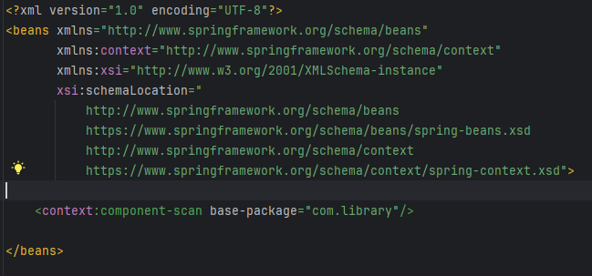

BookRepository.java—

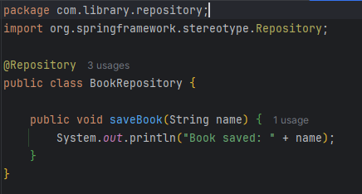

BookService.java—

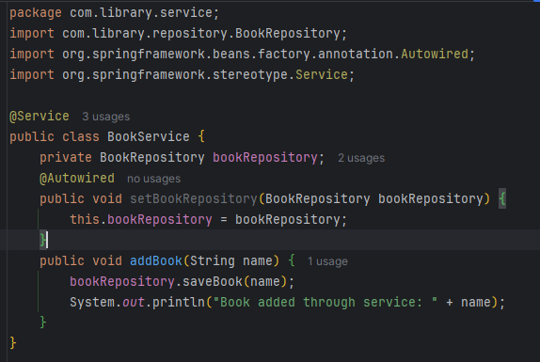

LibraryApp.java—

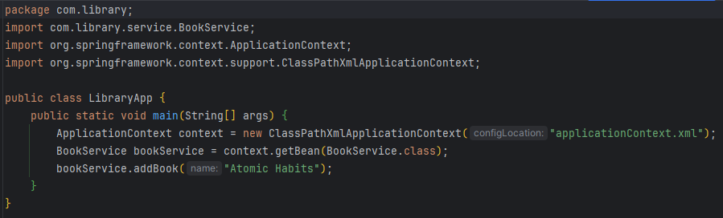

Output—



**Exercise 7**

applicationContext.xml—

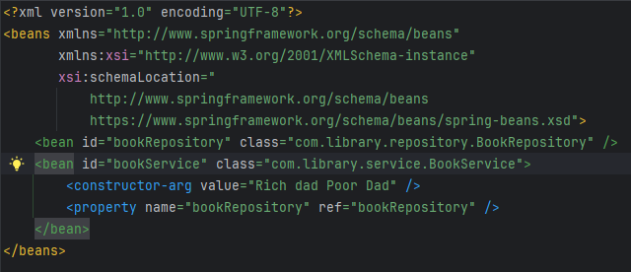

BookService.java—

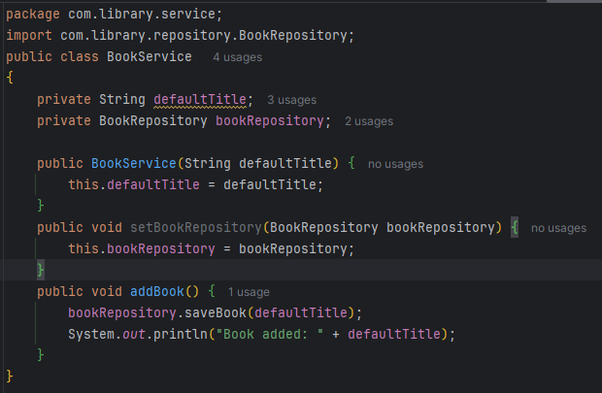

LibraryApp.java—

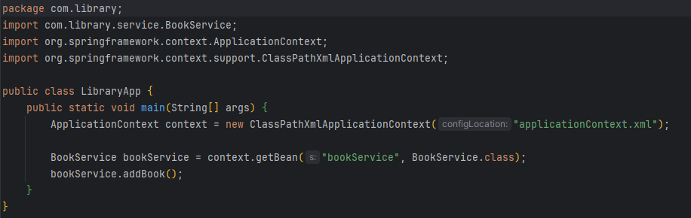

Output—



**Exercise 8**

LoogingAspect.java—

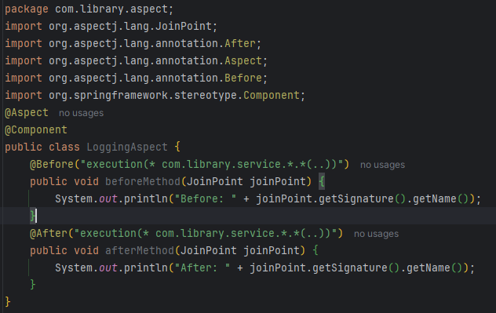

BookService.java—

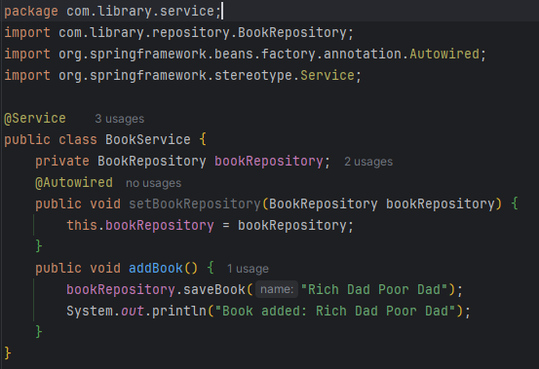

LibraryApp.java—

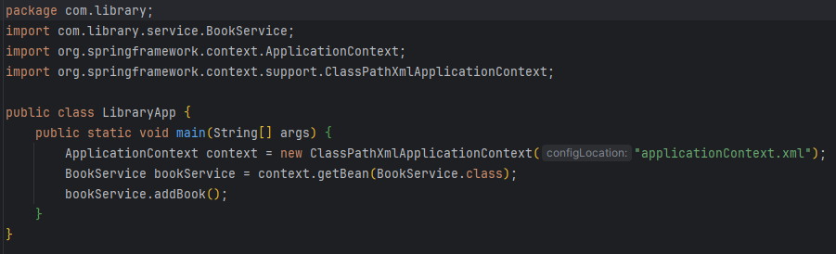

applicationContext.xml—

