**Guru Nanak Dev Engineering College, Ludhiana**

**Department of Information Technology**



**Subject Code: LPCIT-107**

**Subject Name: Web Technologies Laboratory**

**SUBMITTED BY: SUBMITTED TO:**

**HARKIRAT KAUR ER. HANIT KAUR**

**BTECH D2 IT A2**

**1921036/1905334**

**INDEX:**

|  |  |  |
| --- | --- | --- |
| SR.NO. | PRACTICAL NAME | PAGE NO. |
| 1. | Create a simple web page by writing HTML using a simple text editor, Notepad. Demonstrate the following components of the web page: Page titles and Headings Paragraphs and Inline images. | 3-5 |
| 2. | Demonstrate the use of Links, Lists and Tables in HTML. You should be able to link separate pages and create named links within a document, using them to build a “table of contents”. | 6-9 |
| 3. | Create simple Forms in HTML and demonstrate the use of various form elements like input box, textarea, submit and radio buttons etc. | 10-11 |
| 4. | Demonstrate the use of cascading style sheets (CSS) (inline, internal and external) to specify various aspects of style, such as colours and text fonts and sizes, in HTML document. | 12-16 |
| 5. | Creation of Web pages using HTML5 and CSS3. | 17-24 |
| 6. | Demonstrate the use of Bootstrap Framework. | 25-32 |
| 7. | Creating web pages using PHP. | 33-39 |

**1.Create a simple web page by writing HTML using a simple text editor, Notepad. Demonstrate the following components of the web page: Page titles and Headings Paragraphs and Inline images.**

INPUT:

<html>

<head>

<title>

practical1

</title>

</head>

<body bgcolor="powderblue">

<u>HTML HEADINGS </u><br>

<p> There are 6 types of headings in html . These start from h1 (greatest) to h6(smallest). Lets take a look how it displays on our webpage:

<h1> THIS IS HEADING 1</h1>

<h2> THIS IS HEADING 2</h2>

<h3> THIS IS HEADING 3</h3>

<h4> THIS IS HEADING 4</h4>

<h5> THIS IS HEADING 5</h5>

<h6> THIS IS HEADING 6</h6>

<U>HTML PARAGRAPHS</U><BR><p>

HTML paragraphs are defined with the <p> tag: Example: <p>My name is HARKIRAT KAUR.</p> With HTML, you cannot change the output by adding extra spaces or extra lines in your HTML code. The browser will remove any extra spaces and extra lines when the page is displayed: <p> This paragraph contains a lot of lines in the source code, but the browser ignores it. </p>

</p>

<u>HTML IMAGES</u><br>

HTML images are defined with the <img> tag. • The filename of the image source is specified in the src attribute. • HTML images also have width and height attributes, which specifies the width and height of the image. • The alt attribute specifies an alternative text to be used, if an image cannot be displayed.The value of the alt attribute can be read by screen readers.<br> <img src="logo.png" alt="Gndec" width="1000" height="300" >

</body>

</html>

OUTPUT: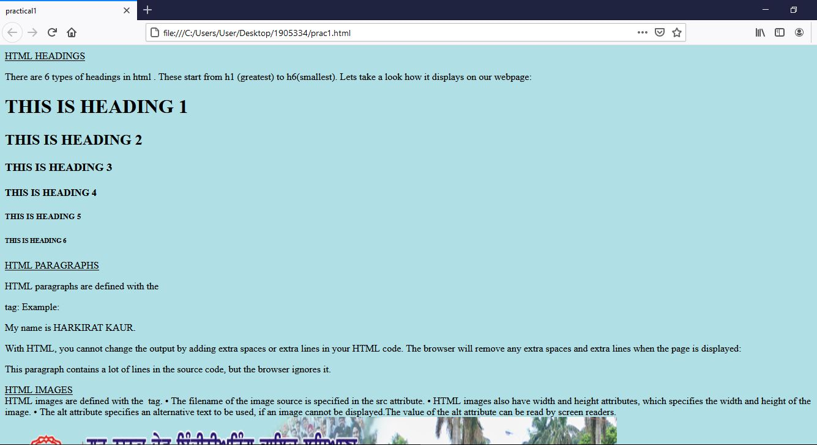

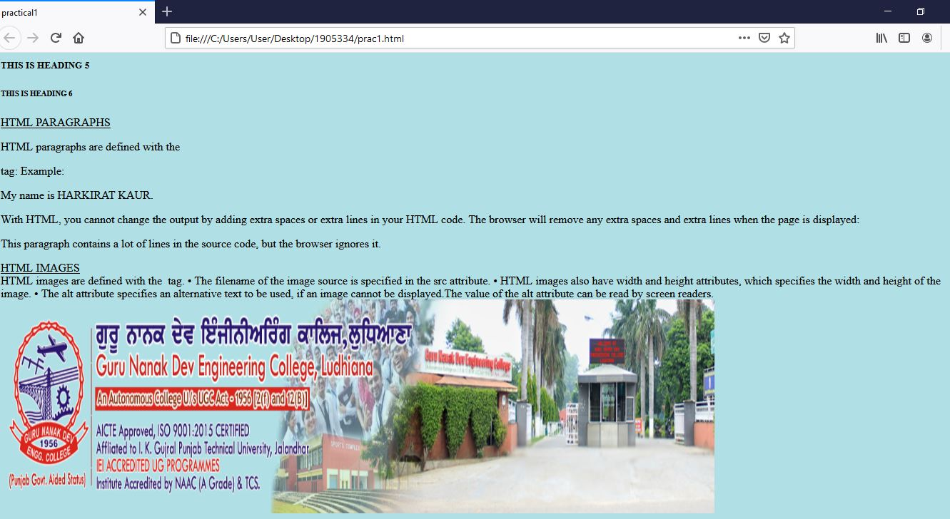

**2. Demonstrate the use of Links, Lists and Tables in HTML. You should be able to link separate pages and create named links within a document, using them to build a “table of contents”.**

Input: <!DOCTYPE html>

<html>

<head> <title>prcatical2</title> <style>

table, th, td {

border: 1px solid black;

}

</style> </head>

<body bgcolor="#e6ffe6">

<h1> HTML TABLES WITH LINKS AND LISTS </h1>

<b><u>Unordered HTML List:</b></u><br>

An unordered list starts with the ul tag. Each list item starts with the li tag.The list items will be marked with bullets (small black circles) by default as shown in flipkart row.<br>

<b><u>Ordered HTML List:</b></u><br>

An ordered list starts with the ol tag. Each list item starts with the li tag.

The list items will be marked with numbers by default as shown in amazon row.<br>

<b><u>HTML Description Lists:</b></u><br>

HTML also supports description lists.A description list is a list of terms, with a description of each term.

The dl tag defines the description list, the dt tag defines the term (name), and the dd tag describes each term.

<table>

<tr bgcolor="#ff8080"> <th>SR. NO.</th>

<th>SHOPPING SITES NAMES</th><th> LINKS</th> </tr>

<tr bgcolor="#b3cccc"> <td>1</td>

<td>AMAZON

<ol>

<li>men wear </li>

<li>women wear </li>

<li>kids wear </li>

</ol> </td>

<td><a href=" https://www.amazon.in/"> VISIT AMAZON</td> </tr>

<tr bgcolor="#ff8080"> <td>2</td>

<td>FLIPKART

<ul> <li>clothes for men ,women,kids</li> <li> household items </li><li>electronic items</li>

</ul></td> <td><a href=" https://www.flipkart.com/"> VISIT FLIPKART</td> </tr>

<tr bgcolor="#b3cccc"> <td>3</td> <td>MYNTRA

<ul> <li>deals with brands :</li>

<ol>

<li>PUMA </li>

<li>H&M</li>

<li>ADDIDAS </li>

</ol></ul></td>

<td><a href="https://www.myntra.com/ "> VISIT MYNTRA</td></tr>

</table>

</body>

</html>

Output: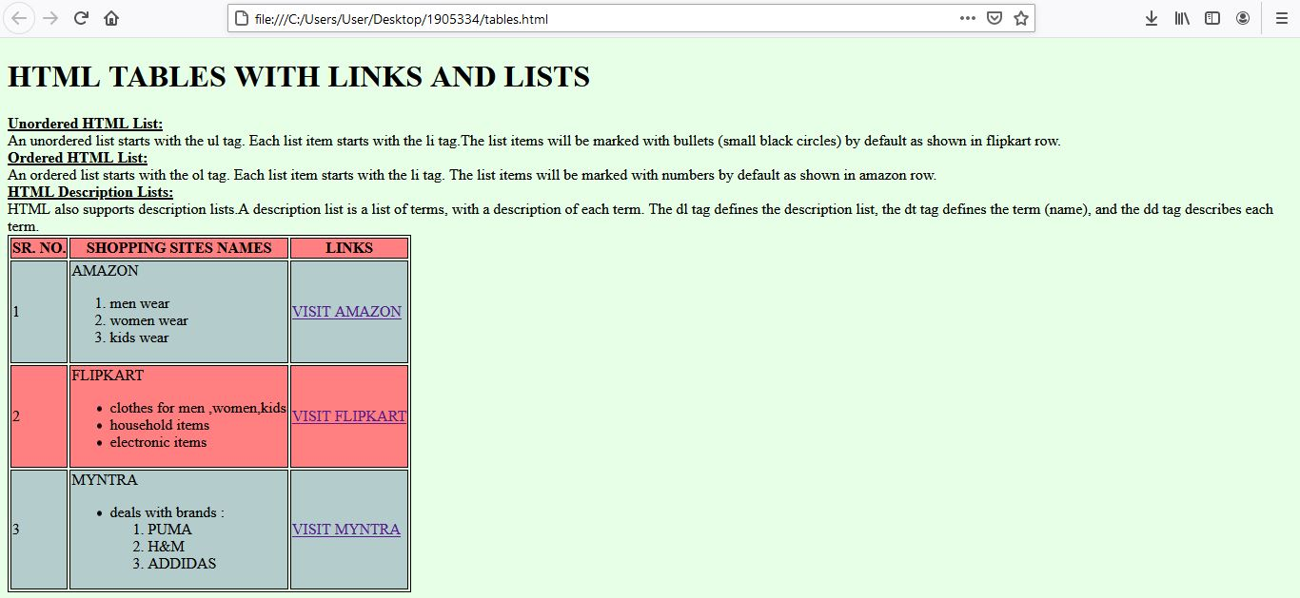

**3. Create simple Forms in HTML and demonstrate the use of various form elements like input box, textarea, submit and radio buttons etc**.

Input: <html>

<head>

<title>PRACTICAL3</title>

</head>

<body bgcolor="lightgrey">

<h3>Fill the details for appointment:</h3>

<form action="/action_page.php">

<label for="fname">Patient name:</label>

<input type="text" id="fname" name="fname"><br>

<label for="phone">Mobile no.:</label>

<input type="text" id="phone" name="phone"><br>

<label for="email">E-mail</label>

<input type="text" id="address" name="address"><br>

<label for="address">Address</label>

<input type="text" id="email" name="email"><br>

<p>Please select your gender:</p>

<input type="radio" id="male" name="gender" value="male">

<label for="male">Male</label><br>

<input type="radio" id="female" name="gender" value="female">

<label for="female">Female</label><br>

<input type="radio" id="other" name="gender" value="other">

<label for="other">Other</label>

<br>

<input type="submit" value="Submit">

<input type="submit" formaction="/action_page2.php">

</form>

</body>

</html>

Output:

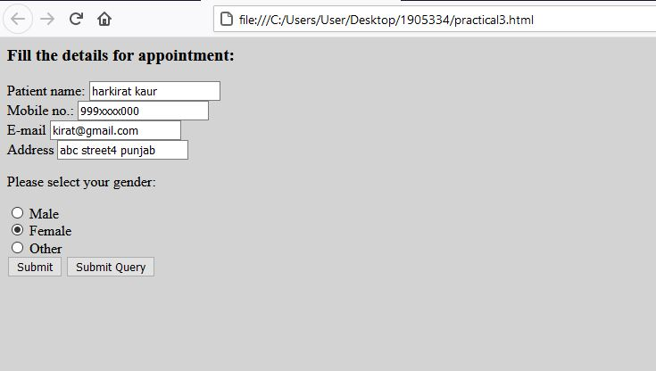

**4. Demonstrate the use of cascading style sheets (CSS) (inline, internal and external) to specify various aspects of style, such as colours and text fonts and sizes, in HTML document.**

Input: external css

<!DOCTYPE html>

<html>

<head>

<title>HTML External CSS</title>

<link rel = "stylesheet" type = "text/css" href = "style.css">

</head>

<body bgcolor="lightyellow">

<h1 class = "red">INFORMATION TECHNOLOGY DEPARTMENT</h1>

<p class = "thick green"> This Department was established in 2001. The mission of the Department of Information Technology is to impart high quality post graduate and under-graduate education and carry out leading-edge research in the discipline of Information Technology. The department currently runs academic program leading to the award of B.Tech. in Information Technology degree of Punjab Technical University Jalandhar. The Department has various laboratories equipped with state-of-the-art computing facilities to support the research and teaching activities. A library with a lot of books on Information Technology for the exclusive use of the faculty and students is located in the premises of the Department. At present, Dr. Kulvinder Singh Mann is Head of the Department.</p> <img src="https://it.gndec.ac.in/sites/default/files/3dfxhu.gif ">

</body></html>

Style.css:.red {

color: red;

}

.thick {

font-size:20px;

}

.green {

color:green;

}

Output:

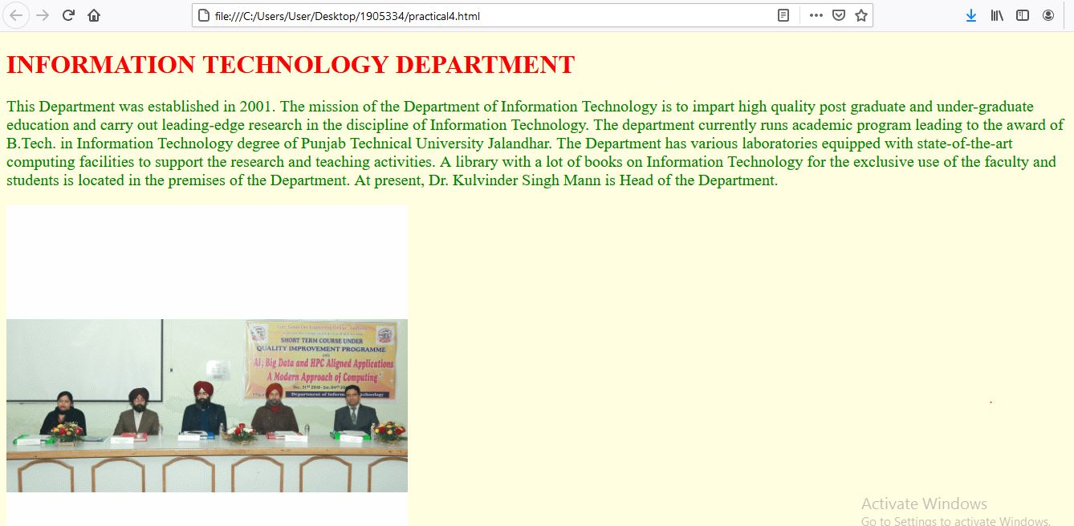

Input: internal and inline css

<!DOCTYPE html>

<html>

<head><style>

<style>

div {

background-color: green;

opacity: 0.3;

}

p {

background-image: url("GNE.jpg");

}

</style></head>

<body>

<h1 style="color:Tomato;">GURU NANAK DEV ENGINEERING COLLEGE</h1>

<h3><p style="color:DARKBLACK;"> Guru Nanak Dev Engineering College, one of the prestigious, oldest and minority institution of Northern India, was established under the aegis of Nankana Sahib Education Trust (NSET) in 1956. NSET was founded in memory of the most sacred temple of Nankana Sahib, birth place of Guru Nanak Dev Ji. Shiromani Gurudwara Prabandhak Committee, Amritsar, a premier organization of universal brotherhood, which is the main force behind the mission of "Removal of Economic Backwardness through Technology" and NSET with the same mission, established a Polytechnic in 1953 and Guru Nanak Dev Engineering College (GNDEC) in 1956.

</p></h3>

<h3 style="border:2px solid Tomato;">The college is also ISO 9001-2015 CertifiedThe College has been ranked consistently within first 50 engineering colleges of the country which includes IITs and NITs by different independent national agencies like India Today, Outlook, CSR, Star TV etc. since 2006.GNDEC runs seven Engineering Branches (Civil Engg., Mech. Engg, Elect.Engg., Electronics & Comm. Engg. Computer Sc. & Engg,, Information Technology, Production Engg.) at UG level and 15 PG level courses including MBA, MCA. The college has Ph.D in all Engineering Branches and it is a QIP Centre under AICTE for Ph.D in streams viz. Civil Engg., Mech. Engg. Electrical Engineering. Nearly 25,000 Graduates and 7500 Post Graduates have passed out from this college and are at present successfully employed on high profile jobs in India & abroad making their alma mater proud of them.

</h3>

<h3 style="background-color:#ff6347;">The College was affiliated with Punjab University, Chandigarh since its inception. On establishment of Punjab Technical University, Jalandhar, since 1997 the college is affiliated with it, which is now known as I.K.Gujral Punjab Technical University (IKGPTU). The College courses are approved by All India Council for Technical Education, New Delhi. This is the first Engineering College of Punjab, which was conferred Autonomous Status by University Grants Commission (UGC), New Delhi in 2012 under section 2(f) and 12(B) of UGC Act 1956. Most of the undergraduate courses are accredited by National Board of Accreditation about 3 times since 2004. The college is accredited with ‘A” Grade by NAAC, UGC. Tata Consultancy Services (TCS) has accredited this college twice for placement purpose. </h3>

</body>

</html>

Output:

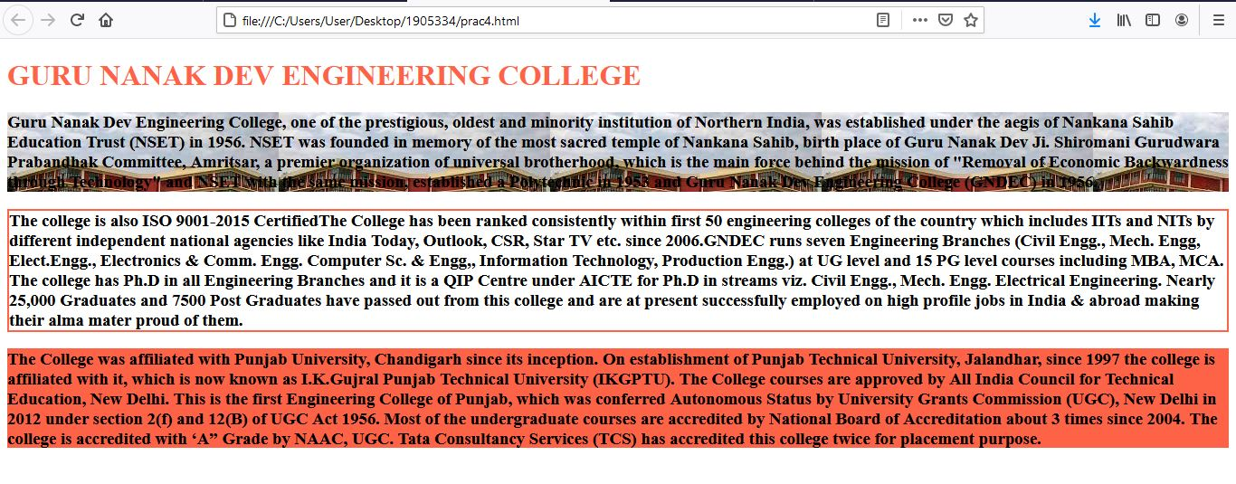

**5. Creation of Web pages using HTML5 and CSS3.**

Input: CSS file: body {

background-color:lightyellow;

columns: #555;

font: Arial, Helvetica, sans-serif 16px;

line-height: 1.6em;

margin: 0;

}

.container {

width: 80%;

margin: auto;

overflow: hidden;

}

#main-header {

background-color: lightyellow;

color: #fff;

}

#navbar {

background-color: green;

color: #fff;

}

#navbar ul {

padding: 0;

list-style: none;

}

#navbar li {

display: inline;

}

#navbar a {

color: #fff;

text-decoration: none;

font: 18px;

padding-right: 15px;

}

#showcase {

min-height: 100px;

margin-bottom: 30px;

text-align: center;

margin: auto;

width: 70%;

}

#showcase h1 {

color: #333;

font-size: 40px;

line-height: 1.2em;

padding-top: 30px;

}

#main {

float: left;

width: 70%;

padding: 0 30px;

box-sizing: border-box;

}

#sidebar1 {

float: right;

width: 30%;

background-color: lightgreen;

color: black;

padding: 10px;

box-sizing: border-box;

}

#main-footer {

background-color: lightgreen;

color:black;

text-align: center;

padding: 20px;

margin-top: 40px;

margin-bottom: 0;

}

HTML file:

<!DOCTYPE html>

<html lang="en">

<head>

<title>Practical 5</title>

<link rel="stylesheet" href="./Practical5.css" />

</head>

<body>

<header id="main-header">

<div class="container">

<IMG SRC="logo.png">

</div>

</header>

<nav id="navbar">

<div class="container">

<ul>

<li><a href="#">Home</a></li>

<li><a href="#">About Us</a></li>

<li><a href="#">Departments</a></li>

<li><a href="#">Gallery</a></li>

<li><a href="#">Faculty</a></li>

</ul>

</div>

</nav>

<div class="container">

<section id="showcase">

<h1>WELCOME TO THE OFFICIAL SITE OF GURU NANAK DEV ENGINEERING COLLEGE,LDH </h1>

</section>

<section id="main">

<h1>ABOUT US</h1>

<p>

Guru Nanak Dev Engineering College, one of the prestigious, oldest and minority institution of Northern India, was established under the aegis of Nankana Sahib Education Trust (NSET) in 1956. NSET was founded in memory of the most sacred temple of Nankana Sahib, birth place of Guru Nanak Dev Ji. The Trust deed was registered on 24th February 1953 with a commitment by Nankana Sahib Education Trust to uplift the vast weaker section of Indian polity comprising Rural India by admitting 70% students every year from Rural Areas. This commitment was made to the nation on 8th April, 1956. The day when foundation stone of the College was laid by Late Dr. Rajendra Prasad Ji, the First President of India. <br><IMG SRC="GNEe.JPG" WIDTH="700" HEIGHT="250">the College was affiliated with Punjab University, Chandigarh since its inception. On establishment of Punjab Technical University, Jalandhar, since 1997 the college is affiliated with it, which is now known as I.K.Gujral Punjab Technical University (IKGPTU). This is the first Engineering College of Punjab, which was conferred Autonomous Status by University Grants Commission (UGC), New Delhi in 2012 under section 2(f) and 12(B) of UGC Act 1956. Most of the undergraduate courses are accredited by National Board of Accreditation about 3 times since 2004. The college is accredited with ‘A” Grade by NAAC, UGC. Tata Consultancy Services (TCS) has accredited this college twice for placement purpose. The college is also ISO 9001-2015 Certified.

</p> </section><img src="gne.jpg" width="30%" height="235">

<aside id="sidebar1">

<H3>ADMISSION CORNER<H3><p>Admission (2021-22) Helpline Numbers<BR>7341116064 7341116065 7341116067<BR>Admission Query Form Frequently Asked Questions<BR>Information Brochure </p>

</aside><img src="clg.jpg" width="30%" align="right"> </div>

<footer id="main-footer"> <p>Contact Info:<a href="mailto:support@gndec.ac.in">support@gndec.ac.in</p>

</footer>

</body></html>

Output:

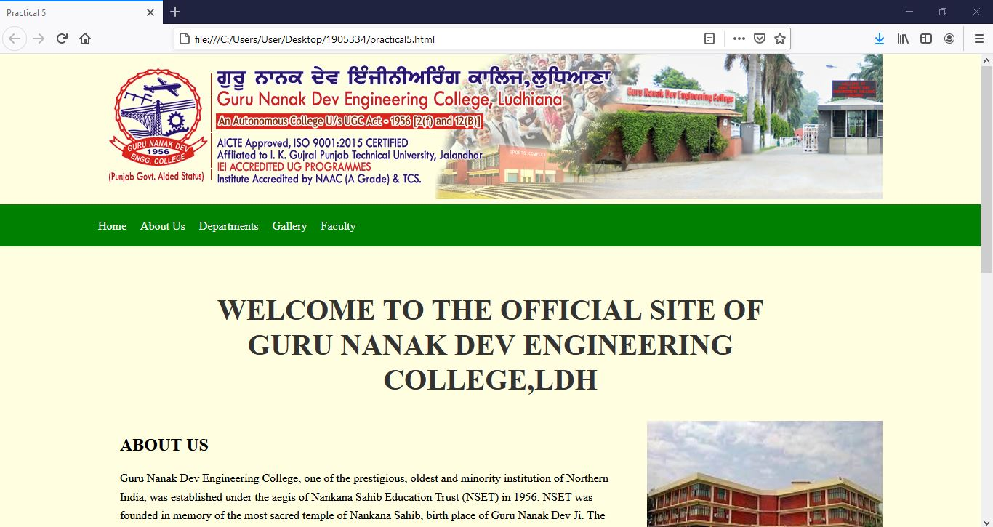

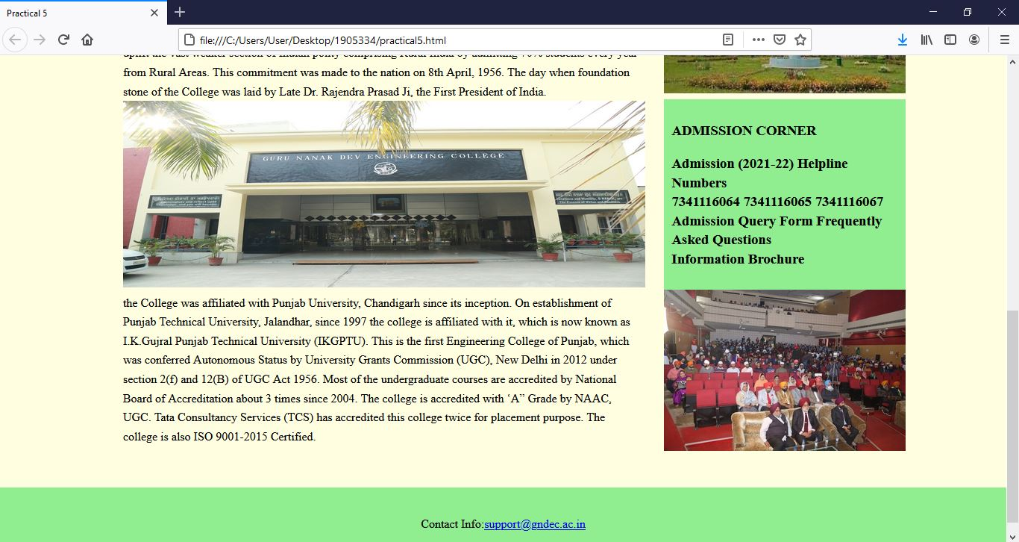

**6. Demonstrate the use of Bootstrap Framework**.

Input: <!DOCTYPE html>

<html lang="en">

<head>

<title>Bootstrap framework</title>

<meta charset="utf-8">

<meta name="viewport" content="width=device-width, initial-scale=1">

<link rel="stylesheet" href="https://maxcdn.bootstrapcdn.com/bootstrap/3.4.1/css/bootstrap.min.css">

<script src="https://ajax.googleapis.com/ajax/libs/jquery/3.5.1/jquery.min.js"></script>

<script src="https://maxcdn.bootstrapcdn.com/bootstrap/3.4.1/js/bootstrap.min.js"></script>

<style>

.row.content {height: 1500px}

.sidenav {

background-color: #f1f1f1;

height: 100%;

}

footer {

background-color: #555;

color: white;

padding: 15px;

}

@media screen and (max-width: 767px) {

.sidenav {

height: auto;

padding: 15px;

}

.row.content {height: auto;}

}

</style>

</head>

<body>

<div class="container-fluid">

<div class="row content">

<div class="col-sm-3 sidenav">

<h4>KAIR's Blog</h4>

<ul class="nav nav-pills nav-stacked">

<li class="active"><a href="#section1">Home</a></li>

<li><a href="#section2">Friends</a></li>

<li><a href="#section3">Family</a></li>

<li><a href="#section3">Photos</a></li>

</ul><br>

<div class="input-group">

<input type="text" class="form-control" placeholder="Search Blog..">

<span class="input-group-btn">

<button class="btn btn-default" type="button">

<span class="glyphicon glyphicon-search"></span>

</button>

</span><br>

</div><img src="food.jpg">

</div>

<div class="col-sm-9">

<h4><small>RECENT POSTS</small></h4>

<hr>

<h2>I Love Food</h2>

<h5><span class="glyphicon glyphicon-time"></span> Post by Jane Dane, Sep 27, 2015.</h5>

<h5><span class="label label-danger">Food</span> <span class="label label-primary">Ipsum</span></h5><br>

<p>There's nothing better than having your whole family home around the same table for dinner. Food is a catalyst that brings people together. Having the entire family together at your grandparents' house for Christmas Eve dinner or a Thanksgiving meal, treating a friend to a birthday dinner, or annual family celebrations are perfect ways to keep in touch and connect with your family and friends that you might not see regularly.</p>

<br><br>

<h4><small>RECENT POSTS</small></h4>

<hr>

<h2>food is fun to make</h2>

<h5><span class="glyphicon glyphicon-time"></span> Post by John Doe, Sep 24, 2015.</h5>

<h5><span class="label label-success">Lorem</span></h5><br>

<p>Once I set my mind to making the multilayered rainbow cake I saw on Pinterest, there's no one who can stop me. Food is straight up fun to make. Getting recipes online, inspo from Pinterest pages, watching Barefoot Contessa on the Food Network, or even making your family's traditional Christmas cookie recipe is so enjoyable. There's nothing more satisfying than pulling your gooey, homemade, and delicious smelling creation of out the oven and of course snapping pics to all your friends showing them how much of a chef you really are.

</p>

<hr>

<h4>Leave a Comment:</h4>

<form role="form">

<div class="form-group">

<textarea class="form-control" rows="3" required></textarea>

</div>

<button type="submit" class="btn btn-success">Submit</button>

</form>

<br><br>

<p><span class="badge">2</span> Comments:</p><br>

<div class="row">

<div class="col-sm-2 text-center">

<img src="ava1.jpg" class="img-circle" height="65" width="65" alt="Avatar">

</div>

<div class="col-sm-10">

<h4>Kira <small>April 29, 2021, 9:12 PM</small></h4>

<p>Keep up the GREAT work! I am cheering for your blog channel.</p>

<br>

</div>

<div class="col-sm-2 text-center">

<img src="ava2.jpg" class="img-circle" height="65" width="65" alt="Avatar">

</div>

<div class="col-sm-10">

<h4>John Row <small>April 25, 2021, 8:25 PM</small></h4>

<p>I am so happy for you man! Finally. I am looking forward to read about your trendy life. </p>

<br>

<p><span class="badge">1</span> Comment:</p><br>

<div class="row">

<div class="col-sm-2 text-center">

<img src="ava3.jpg" class="img-circle" height="65" width="65" alt="Avatar">

</div>

<div class="col-xs-10">

<h4>Nested Bro <small>April 25, 2021, 8:28 PM</small></h4>

<p>Me too! WOW!</p>

<br>

</div>

</div>

</div>

</div>

</div>

</div>

</div>

<footer class="container-fluid">

<p>Footer Text</p>

</footer>

</body>

</html>

Output:

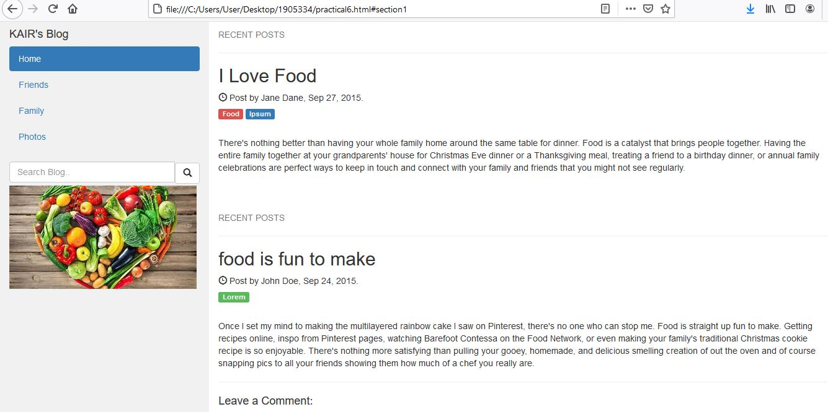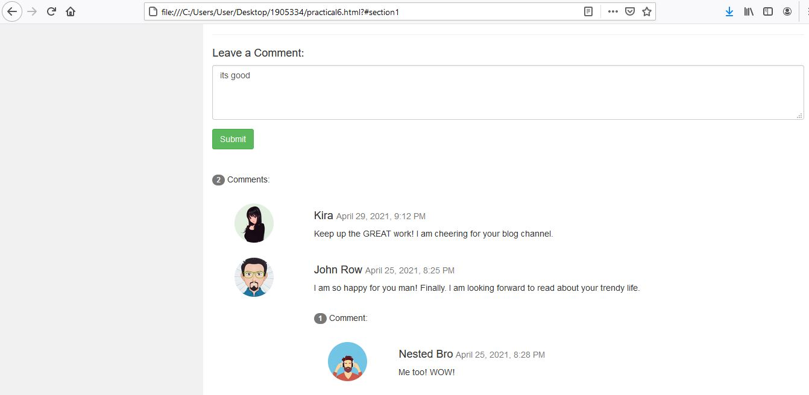

**7. Creating web pages using PHP.**

Input: css file: body {

margin: 0;

padding: 0;

text-align: center;

background:#1affb2;

background-repeat: no-repeat;

height: 100%;

background-attachment: fixed;

background-position: center;

}

.contact-title {

margin-top: 100px;

color:black;

text-transform: uppercase;

transition: all 4s ease-in-out;

}

.contact-title h1 {

font-size: 32px;

line-height: 10px;

}

.contact-title h2 {

font-size: 16px;

}

form {

margin-top: 50px;

transition: all 4s ease-in-out;

}

.form-control {

width: 600px;

background: transparent;

border: none;

outline: none;

border-bottom: 1px solid #333;

color:black;

font-size: 18px;

margin-bottom: 16px;

}

input {

height: 45px;

form .submit {

background: #ff5722;

border-color: transparent;

color: black;

font-size: 20px;

font-weight: bold;

letter-spacing: 2px;

height: 50px;

margin-top: 20px;

}

form .submit:hover {

background-color: grey;

cursor: pointer;

}

Php file:

<?php

$name=$_POST['name'];

$visitor_email=$_POST['email'];

$query=$_POST['query'];

$email_from='harkirat1921036@gndec.ac.in';

$email_subject="New Form Submission";

$email_body="User Name: $name.\n"."User Email: $visitor_email.\n"."User query: $query.\n";

$to="kiratubii@gmail.com";

$headers="From: $email_from \r\n";

$headers .="Reply-To: $visitor_email \r\n";

mail($to,$email_subject,$email_body,$headers);

header("Location: practical7.html");

?>

Html code:

<!DOCTYPE html>

<html lang="en">

<head>

<meta charset="UTF-8" />

<meta http-equiv="X-UA-Compatible" content="IE=edge" />

<meta name="viewport" content="width=device-width, initial-scale=1.0" />

<title>Practical 7</title>

<link rel="stylesheet" href="./web.css" />

</head>

<body>

<div class="contact-title">

<h1>CUSTOMER CARE </h1>

<h2>Drop your queries below :)</h2>

</div>

<div class="contact-form">

<form action="php.php" method="POST" id="contact-form">

<input

type="text"

name="name"

class="form-control"

placeholder="Your Name"

required

/>

<br />

<input

type="email"

name="email"

class="form-control"

placeholder="Your Email"

required

/>

<br />

<textarea

name="query"

class="form-control"

placeholder=" Your query"

rows="4"

required

></textarea>

<br />

<input type="submit" class="form-control submit" value="Send query" />

</form>

</div>

</body>

</html>

Output:

