Kirby Pagunsan

UCF0328FSF

Final Project: Deliverable #1

Overview - The intended application will be used as an educational tool for younger or beginner music students. It will provide a resource for students to search for their fingering charts and will help them better learn their instrument. While fingering charts are already found in their physical schoolbooks, students will soon be able to select specific notes and compile fingerings according to a particular song they are learning.

Students will utilize this application by first selecting their instrument, then the note they would like to learn. The application will then show a detailed diagram of the correct keys to push in order for students to play the note. They will have a login in which they can save their favorite fingerings and their compilations.

For future development, the application will allow teachers to administer homework and quizzes through the application. Teachers can assign fingerings for students to learn and keep track of their students’ progress. The students’ knowledge can be assessed by having the application show the student a particular fingering and the student will be required to select the correct note being played.

Layouts - Homepage

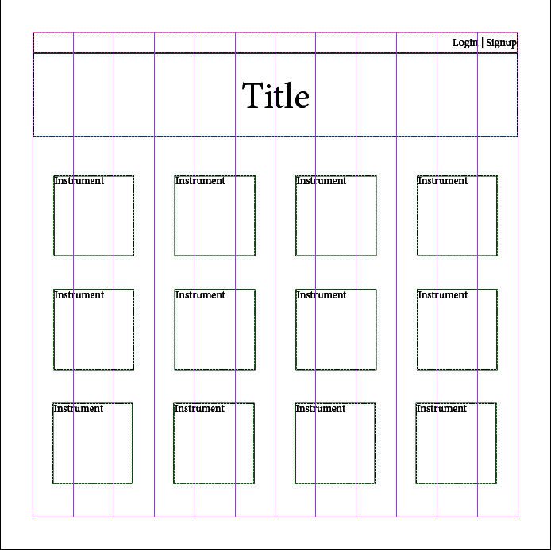

* Simple layout
* Buttons for each instrument

Instrument Page

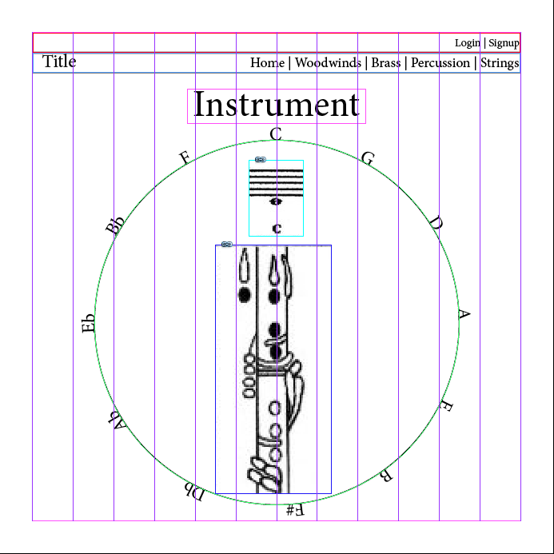

* Diagram of instrument
* Circle of fifths / Notes to choose from

Schedule - **Aug 20 – Plan, Design, Research**

Aug 27 – Page layouts/hierarchy

– Basic HTML/CSS/JavaScript logic

Sep 03 – Login accounts

– Database utilization

* Interactive results (animation?)
  + When note is selected, will dynamically show correct fingering instantly

**Sep 10** – **Ready MVP, Mini-Presentation**

Sep 17 – Additional Instruments

* Add teacher/student accounts
* Design/UI finalized

**Sep 17 – Project Polish, Functionality Push, Final Plan**

**Sep 28 – Project Demo Day**