* Plan
* I’ve never actually seen any
* The purpose would be to show off my code, audience being company hirers
* Main screen would be links to different classes under that wouold be each type of code

Under that would be each assignment

* Design
* 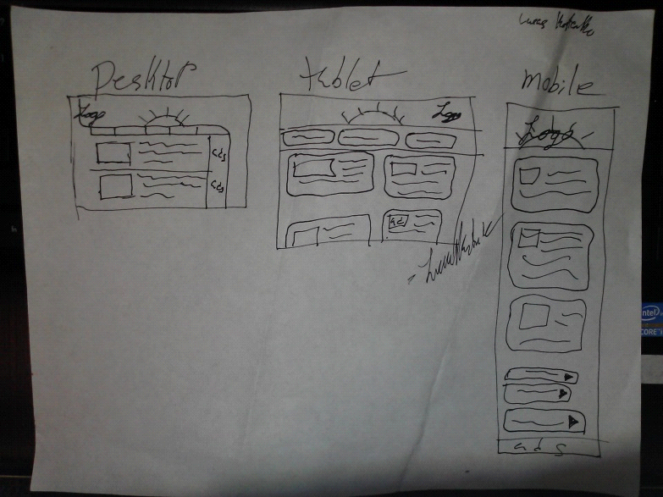
* Various generic facebook-esq blues
* 