Lab 1

**Task 1: Java Basics**

Question 1:

The Mainfest file contains the meta information about the files packaged in a JAR file. C would become the main class if there were three classes and C had the main method

Question 2:

The if statement is visited four times.

**Task 2: Scrum – Task Board**

**Task 3: Gantt Diagram**

Untitled Gantt Project Aug 31, 2024

http://

Project manager

Project dates Aug 30, 2024 - Dec 7, 2024

Completion 0%

Tasks 87

Resources 5

Untitled Gantt Project

|  |  |  |  |
| --- | --- | --- | --- |
| Tasks |  |  | 2 |
| Name | Begin date | End date |  |
| Iteration 1 | 8/30/24 | 9/20/24 |  |
| Analysis | 8/30/24 | 9/5/24 |  |
| project vision | 8/30/24 | 9/5/24 |  |
| team assembly | 8/30/24 | 9/5/24 |  |
| infrastructure initialization | 8/30/24 | 9/5/24 |  |
| requirements analysis | 8/30/24 | 9/5/24 |  |
| use cases | 8/30/24 | 9/5/24 |  |
| traceability matrix | 8/30/24 | 9/5/24 |  |
| system sequence diagrams | 8/30/24 | 9/5/24 |  |
| system operations | 8/30/24 | 9/5/24 |  |
| wireframes | 8/30/24 | 9/5/24 |  |
| domain model | 8/30/24 | 9/5/24 |  |
| presentation and reporting | 8/30/24 | 9/5/24 |  |
| Design | 9/6/24 | 9/12/24 |  |
| design model | 9/6/24 | 9/12/24 |  |
| sequence diagrams | 9/6/24 | 9/12/24 |  |
| package diagrams | 9/6/24 | 9/12/24 |  |
| GRAPS patterns | 9/6/24 | 9/12/24 |  |
| test coverage | 9/6/24 | 9/12/24 |  |
| prototyping | 9/6/24 | 9/12/24 |  |
| presentation and reporting | 9/6/24 | 9/12/24 |  |
| Implementation | 9/13/24 | 9/20/24 |  |
| backend | 9/13/24 | 9/20/24 |  |
| user interface | 9/13/24 | 9/20/24 |  |
| user input validation | 9/13/24 | 9/20/24 |  |
| imports/exports | 9/13/24 | 9/20/24 |  |
| unit-testing | 9/13/24 | 9/20/24 |  |
| documentation | 9/13/24 | 9/20/24 |  |
| presentation and reporting | 9/13/24 | 9/20/24 |  |
| Iteration 2 | 9/23/24 | 10/25/24 |  |
| Analysis | 9/23/24 | 10/2/24 |  |
| project vision | 9/23/24 | 10/2/24 |  |
| team assembly | 9/23/24 | 10/2/24 |  |
| infrastructure initialization | 9/23/24 | 10/2/24 |  |
| requirements analysis | 9/23/24 | 10/2/24 |  |
| use cases | 9/23/24 | 10/2/24 |  |
| traceability matrix | 9/23/24 | 10/2/24 |  |
| system sequence diagrams | 9/23/24 | 10/2/24 |  |
| system operations | 9/23/24 | 10/2/24 |  |
| wireframes | 9/23/24 | 10/2/24 |  |
| domain model | 9/23/24 | 10/2/24 |  |
| presentation and reporting | 9/23/24 | 10/2/24 |  |

|  |  |  |  |
| --- | --- | --- | --- |
| Tasks |  |  | 3 |
| Name | Begin date | End date |  |
| Design | 10/3/24 | 10/14/24 |  |
| design model | 10/3/24 | 10/14/24 |  |
| sequence diagrams | 10/3/24 | 10/14/24 |  |
| package diagrams | 10/3/24 | 10/14/24 |  |
| GRAPS patterns | 10/3/24 | 10/14/24 |  |
| test coverage | 10/3/24 | 10/14/24 |  |
| prototyping | 10/3/24 | 10/14/24 |  |
| presentation and reporting | 10/3/24 | 10/14/24 |  |
| Implementation | 10/15/24 | 10/25/24 |  |
| backend | 10/15/24 | 10/25/24 |  |
| user interface | 10/15/24 | 10/25/24 |  |
| user input validation | 10/15/24 | 10/25/24 |  |
| imports/exports | 10/15/24 | 10/25/24 |  |
| unit-testing | 10/15/24 | 10/25/24 |  |
| documentation | 10/15/24 | 10/25/24 |  |
| presentation and reporting | 10/15/24 | 10/25/24 |  |
| Iteration 3 | 10/28/24 | 12/6/24 |  |
| Analysis | 10/28/24 | 11/8/24 |  |
| project vision | 10/28/24 | 11/8/24 |  |
| team assembly | 10/28/24 | 11/8/24 |  |
| infrastructure initialization | 10/28/24 | 11/8/24 |  |
| requirements analysis | 10/28/24 | 11/8/24 |  |
| use cases | 10/28/24 | 11/8/24 |  |
| traceability matrix | 10/28/24 | 11/8/24 |  |
| system sequence diagrams | 10/28/24 | 11/8/24 |  |
| system operations | 10/28/24 | 11/8/24 |  |
| wireframes | 10/28/24 | 11/8/24 |  |
| domain model | 10/28/24 | 11/8/24 |  |
| presentation and reporting | 10/28/24 | 11/8/24 |  |
| Design | 11/11/24 | 11/22/24 |  |
| design model | 11/11/24 | 11/22/24 |  |
| sequence diagrams | 11/11/24 | 11/22/24 |  |
| package diagrams | 11/11/24 | 11/22/24 |  |
| GRAPS patterns | 11/11/24 | 11/22/24 |  |
| test coverage | 11/11/24 | 11/22/24 |  |
| prototyping | 11/11/24 | 11/22/24 |  |
| presentation and reporting | 11/11/24 | 11/22/24 |  |
| Implementation | 11/25/24 | 12/6/24 |  |
| backend | 11/25/24 | 12/6/24 |  |
| user interface | 11/25/24 | 12/6/24 |  |
| user input validation | 11/25/24 | 12/6/24 |  |
| imports/exports | 11/25/24 | 12/6/24 |  |

Untitled Gantt Project

|  |  |  |  |
| --- | --- | --- | --- |
| Tasks |  |  | 4 |
| Name | Begin date | End date |  |
| unit-testing | 11/25/24 | 12/6/24 |  |
| documentation | 11/25/24 | 12/6/24 |  |
| presentation and reporting | 11/25/24 | 12/6/24 |  |

|  |  |  |
| --- | --- | --- |
| Resources |  | 5 |
| Name | Default role |  |
| Samuel Choi | Team Lead |  |
| Kirby Dyson | Analyst |  |
| Candor Miller | Tester |  |
| Eugene Pak | Developer |  |
| Aiden Grajo | Developer |  |

Gantt Chart 6

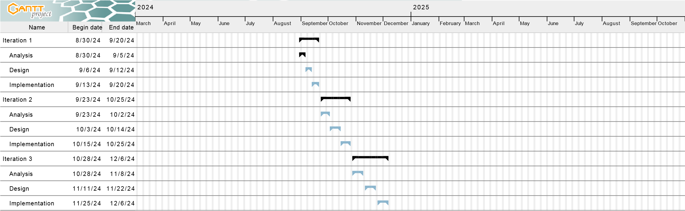

Resources Chart 7

