RFID-Based Attendance Tracking System with Web Interface and Excel Integration (AttendEX)

__________________________________________________

The Project Study Presented to
The Faculty of South East Asian Institute of Technology
College of Information and Communication Technology

__________________________________________________

In Partial Fulfillment
of the Requirement for the subject
IT 412: Capstone Project and Research 2

__________________________________________________

By:

Celis, Summer Dyan
Elloren, Christine Joy P.
Lictawa, Mitch Azaira G.

May 2024

Abstract
“RFID-Based Attendance Tracking and Evaluation System with Web Interface and Excel Integration:” moderating system for recording and communicating between the moderator and officers, it is a crucial solution for concerns of SEAIT Supreme Student Council attendance record and performance management. With the help of the Agile approach, researchers will build up the RFID-Based Attendance Tracking System emphasizing on the capabilities including easy point of use, quick attendance record and to the moderator SMS notification functions. Extensive trials have proved the correctness, transparency, and sturdiness of the system with the users giving very positive feedback for the product and scoring it highly on the effectiveness of safety and security attributes. The system was successfully implemented by utilizing both RFID and SMS technology in the process, which resulted in efficient monitoring and management of attendance and logs of the officers, which provided supreme student council security and efficient information management.

Keywords: RFID-Based Attendance Tracking System, SMS notification, Agile approach, Managing and Recording Solutions

ACKNOWLEDGEMENT
This study would not have been made possible without the help and guidance of a number of people to whom this acknowledgement is owed. The researchers would like to extend their deepest gratitude to the people who encouraged us to persevere and who contributed much through an extensive amount of effort, patience and knowledge that set an essential role in the accomplishment of the study.
To our subject adviser and dean, Mr. Reginald S. Prudente, MIT we express our sincere gratitude for her patience, motivation, enthusiasm, and immense knowledge and for the effort in correcting and for the advice's our study.
To our Research Adviser, Mr. Hernie B. Deduro, LPT, and Mr. Kenmark Tuan Celis for their assistance, constant support, and advice in the completion of this endeavor. Thank you for sharing your knowledge and offering us technical advice as well as constructive comments and suggestions that aided us in our research project. Please accept our heartfelt gratitude for your patience and understanding.
To the school staffs and the faculty of CICT department for prompt inspirations, timely suggestions, warm accommodation, enthusiasm, great knowledge, and dedication for becoming an instrument in providing us the opportunity to enhance our knowledge as students and as researchers that enabled us to complete this research.

To our parents and guardians, Felicisma B. Celis, Gina P. Elloren, Joselito P. Elloren, Corazon G. Lictawa, Michael F. Lictawa Sr. for their unconditional love and persistent effort in supporting the researchers spiritually, emotionally, and more especially, morally and financially.
To our classmates and friends, who gave us the encouragement, we appreciate the laughter, support and generosity that you continually show that provides to us the inspiration in pursuing this study.
To the panel of examiners of this thesis, Ms. Melissa Zolina, LPT., Ms. Mary Joy M. Fernandez, MIT, LPT., Ms. Queenie Mae C. Agramon, MIT, LPT. For giving us advice, suggestions, positive thoughts and positive feedback in order to make this project a very successful one.
To the SEAIT Supreme Student Council Officers and committees, for their willing cooperation, and support during the project development.
And above all, we would like to give back all the praises and thanksgiving to our Almighty God for the guidance, strength and protection He gives us every day. His mercy and love has made us endure all the obstacles and hardships. Thank you for being our source of wisdom, strength and love.
To God be the glory!

DEDICATION
The researchers would like to dedicate this study to the SEAIT Supreme Student Council Officers and committees, for letting them conduct research in relation to their profession; to does who have given us strength to overcome pressure while doing their project; to their beloved guardian and parents Felicisma B. Celis, Gina P. Elloren, Joselito P. Elloren, Corazon G. Lictawa, Michael F. Lictawa Sr., To our dean Mr. Reginald S. Prudente, MIT, to our panels Ms. Melissa Zolina, LPT., Ms. Mary Joy M. Fernandez, MIT, LPT., Ms. Queenie Mae C. Agramon, MIT, LPT. And especially to our project adviser during Capstone Project and Research 1, Mr. Hernie B. Deduro, LPT, and to our Capstone Project and Research 2, Mr. Kenmark Tuan Celis for without them they wouldn’t be in this endeavor; and to the school - South East Asian Institute of Technology, Inc.

Table of Contents

Title Page I
Abstract I
Acknowledgement II
Dedication IV
Table of Contents V
List of Tables VIII
List of Figures IX
Chapter
I INTRODUCTION 1
General Objectives 5
Specific Objective 5
Scope and Limitation 7
Scope of the Study 7
Limitations of the Study 7
Significance of the Study 8
Flow of the Study 9
Definition of Terms 10
II REVIEW OF RELATED LITERATURE 12
Foreign Literature 12
Local Literature 15
Foreign Study 17
Local Study 20
III RESEARCH METHODOLOGY 24
Environment 24
Software Engineering Methodology 24
System Development Phase 25
Business Model Canvas 38
Gantt Chart 39
Functional Decomposition 40
Analysis Design Phase 41
Use Case Diagram 41
Use Case Matrix 43
Class Diagram 47
Sequence Diagram 48
Activity Diagram 50
User Interface Design 55
Storyboard 56
Database Design 69
Database Design 69
Entity Relationship Diagram 70
Data Dictionary 71
Network Design 76
Network Model 76
Network Topology 77
List of Module 78
Testing/Quality Assurance Phase 80
Unit Testing 80
Integration Testing 81
Alpha Testing 83
Evaluation Methodology 83
Respondent of the Study 83
Acceptance Testing 85
Implementation/Development Phase 88
Deployment Diagram 88
Implementation budget/Cost Specification 89
Technology Stack 90
Software Specification 90
Hardware Specification 90
Program Specification 91
Human Resources Specification 91
Risk Management Plan/Framework 92
User Guide 94
Installation Guide 95
IV CONCLUSION AND RECOMMENDATIONS 97
Summary 97
Conclusion 97
Recommendations 98
References 99
Curriculum Vitae 102
Approval Letter 106
Appendices
Appendix A. Transmittal Letter 108
Appendix B. Title Proposal 110
Appendix C. Questionnaires 117
Appendix D. Map of the Research Environment 120
Appendix E. Documentation 122

LIST OF Tables
No. Title Page
3.1 Data Dictionary 71
3.6 Integration Testing 82
3.7 Interpretative Scale 85
3.8 Evaluation Result for System Functionality 85
3.9 Evaluation Result for System Accuracy 86
3.10 Evaluation Result for System Acceptability 87
3.11 Overall Evaluation Result of the System 87

LIST OF FIGURES
No. Title Page
1.1 Flow of the Study 9
3.1 Software Development Life Cycle (SDLC) 24
3.2 Business Model Canvas 38
3.3 Gantt Chart 39
3.4 Functional Decomposition Diagram 40
3.5 Software Use Case Diagram 41
3.6 Hardware Use Case Diagram 42
3.7 Class Diagram 47
3.8 Sequence Diagram 48
3.10 Activity Diagram 50
3.15 User Interface Designs 55
3.24 Storyboard 61
3.39 Database Design 69
3.40 Entity Relationship Diagram 70
3.41 Software Network Model 76
3.42 Hardware Network Model 77
3.43 Network Topology 77
3.44 Integration Testing 81
3.45 Deployment Diagram 88
3.46 Implementation Budget/Cost Specification 89
3.47 Technology Stacks 90
3.48 Risk Management Plan/ Framework 92

CHAPTER I
Rationale of the Study
The AttendEX system is an RFID-Based Attendance Tracking and Evaluation System with a Web Interface and Excel Integration is a software developed for timely and daily monitoring logbook information of the officers and committee in South East Asian Institute of Technology, Inc. (SEAIT). It will be a great advantage to the student officers, committee and school, for the reason that it will be providing a quicker and smarter way to monitor the regular attendance. It is designed to simplify attendance management for administrators and users, providing a more efficient and user-friendly solution. In educational institutions and various organizations, attendance tracking is a critical process. In our modern era, where digital tools and systems have the potential to revolutionize everyday processes, it is essential to optimize attendance management. The AttendEX system aims to achieve that objective. It has a variety of features that greatly improve the administrator's capacity to handle attendance easily. From the moment of registration, the system associates each user with an RFID card or tag, ensuring a smooth and efficient start. It enhances attendance accuracy, reducing the likelihood of errors. Moreover, the system exports attendance data into Excel, serving as a secondary database for the system. The AttendEX system provides SMS alerts to the administrator, ensuring timely awareness of attendance. Every time attendance is recorded, it automatically sends a notification through an SMS alert to the administrator. Additionally, it includes a peer assessment feedback feature, promoting interaction and feedback. Furthermore, it offers report generation and visualization capabilities, allowing administrators to analyze data and make informed decisions with ease.
The current process of the Supreme Student Council (SSC) is the official student governing body at the South East Asian Institute of Technology. The attendance of the officers and committee uses pen and paper when recording all the data of the student officers. Upon their arrival, and departure required to record their names, date, and time in a logbook to monitor attendance. Based on the statement of Mitch Azaira G. Lictawa, SSC Business Manager. The process of the officers and committee during events and daily duties is using the logbook that has 150 pages with a regular size of 7”x11” which is not appropriate considering that they needs more spaces for column of collection of data. According to the statement of the officers they are the ones who that will draw lines so that the information will be written in their perspective data column. After receiving the data all day, they will have to check and return the collected data and information to the moderator, Mr. Clar Don L. Evangelio, MEqEng.. This process extends to student organizations such as Silakbo, Peer Facilitators, ROTC, and other clubs willing to contribute, each of which must manually document their attendance, affiliation, date, and time in the logbook.
The problem encountered of manual attendance tracking system used by the Supreme Student Council (SSC) at the South East Asian Institute of Technology faces several significant challenges. (1) One prominent issue is the manual recording of names and times for both time-in and time-out, resulting in redundant data entries. This not only consumes valuable time but also creates opportunities for errors and erasures, making the logbook cluttered and unreliable. (2) Additionally, manual attendance methods often suffer from inaccuracies, especially during events, and lack precise timestamp information. When attendance records are manually transferred to Excel, it worsens these problems, introducing the potential for data entry errors and inconsistent records. (3) Slow communication of attendance information to moderators can lead to delays in decision-making and accountability issues during meetings and events. (4) Furthermore, the difficulty in assessing individual officer contributions hinders teamwork and overall effectiveness. (5) Nevertheless, the process of manually analyzing data for decision-making remains slow and error-prone, impacting the efficiency of meetings and events.
The benefits of having system, AttendEx, offers a range of practical features to address the ongoing challenges faced by the Supreme Student Council (SSC) at the South East Asian Institute of Technology. At its core, AttendEx simplifies the registration of officers and committee members through a user-friendly interface, ensuring that important details like names and unique student IDs are captured with ease. This system relies on RFID technology, associating each officer and committee member with RFID cards or tags to make attendance tracking effortless. Improved attendance accuracy and efficiency come from automatically recording attendance during duties, activities, and events, including significant occasions like Intramural, College Week, and Foundation Day. AttendEx captures attendance accurately, providing detailed date and time information for thorough tracking. To simplify data management, the system smoothly integrates attendance data with Excel, acting as a secondary database. Introducing SMS alerts customized for the moderator ensures that they receive real-time information, aiding swift decision-making and accountability during SSC meetings and events. Moreover, AttendEx includes a Peer Assessment Feedback feature, empowering SSC officers to evaluate their peers' contributions and performance, fostering a culture of teamwork and collaboration within the SSC. These peer assessments are accessible to the moderator for team assessment and continuous improvement. To top it all, AttendEx automatically creates reports and visualizations, making it simple for the moderator to analyze data and make informed decisions. To top it all, AttendEx is set to modernize attendance management within the SSC, making processes more efficient, improving accuracy, and creating a more cohesive and effective student governing body.
Conclusion, The system needs to be implemented to lessen the workload of the moderator, to monitor the attendance of the officers legitimately, and to prevent some Supreme Student Council from tampering with the lack of personnel during the events and activities.This will show the easiest way of performing their tasks that will create a whole new set of learning and performance processes in favor to the school, student body.
Objectives of the Study
General Objectives
The researcher aims to study and develop a RFID-Based Attendance Tracking and Evaluation System with Web Interface and Excel Integration (AttendEX) for the Supreme Student Council (SSC) in South East Asian Institute of Technology, Inc.
Specific Objectives
- To be able to develop a system that will simplify officer and committee registration, with an RFID card or tag that will provide an easy-to-use interface for capturing essential details, including names and unique student IDs.
- To be able to develop a system that automatically records attendance by scanning RFID cards during duties, activities or events which are College Week, Foundation Day and other activities and events.
- To be able to develop a system that will send SMS alerts specifically to the moderator regarding the attendance of officers and committees during duties, events, or activities.
- To be able to develop a system that includes a Peer Evaluation Assessment Feedback, allowing SSC officers to provide evaluations and feedback on their peers' contributions and performance visible to the moderator for team assessment and improvement.
- To be able to develop a system that will automatically generates attendance reports and evaluation visualizations, making it easy for the moderator to analyze data and make informed decisions.

Scope and Limitations of the Study
Scope of the Study
The study will focus on the development and implementation of RFID-Based Attendance Tracking and Evaluation System with Web Interface and Excel Integration. This study will be conducted and implemented at the Supreme Student Council Office of the South East Asian Institute of Technology.
The scope of the study is centered on RFID-Based Attendance with Web Interface and Excel Integration where the following are possible:
Register officers, and committees.
Explanation
RFID scanning attendance
Explanation
SMS alerts message and monitor attendance tracking.
Explanation
Peer assessment feedback of officer’s evaluation form.
Explanation
Generate attendance reports in excel and analysis visualizations.
Explanation

Limitation of the Study
The system is solely implemented within the SSC Office at South East Asian Institute of Technology, and its use is limited to the officers and committees of the Supreme Student Council. The system is incapable on identifying the awardees, producing any layout certificates, calculate the budgetary plan for events, and produce picture of the officers.
Significance of the Study
Our study is significant to the following group:
Organization
To provide a system that will accurately and reliably handle the attendance of SSC officers and committees at the South East Asian Institute of Technology, Inc.
SSC Moderators
The study's findings are crucial for SSC moderator, as they simplify attendance management, save time, and provide accurate data.
Researchers
The researcher gains a comprehensive understanding of the challenges faced by SSC moderators/officers/committees in tracking attendance and how technology can address them.
Future Researchers
Future researchers can build upon the findings of this study; expanding the knowledge base and making further advancements in RFID-Based Attendance Tracking System with Web Interface and Excel Integration.

Flow of the Study
Figure 1.1:
Flow of the study of RFID-based Attendance Tracking and Evaluation System with Web Interface and Excel Integration (AttendEX).
INPUT PROCESS OUTPUT
- Create officers and committee details

- Verify officers and committee attendance.

- Send SMS alert to the moderator

- Review evaluation assessment

- Create attendance reports
- Add officers and committee and details

- Scanning of RFID card of the officers and committee

- Scan ID card and monitor the attendance of officers and committee

- Input officers evaluation assessment

- Gather all attendance reports

- System title

Definition of terms
The definition of terms of RFID-Based Attendance Tracking and Evaluation System with Web Interface and Excel Integration are statements expressing the essential nature of the study that enables a common understanding of key terms within the system.
AttendEX - is a cutting-edge attendance management system that combines innovation and efficiency to revolutionize the way attendance is handled. The 'E' in 'AttendEx' represents seamless Excel integration, allowing for effortless data management and analysis. The 'X' signifies the system's commitment to harnessing the power of technology to provide an innovative and user-friendly solution.
Attendance Tracking - is a method used to monitor officers duty schedule and performance.
Committees - are group of individuals, typically appointed or elected with a specific task or purpose within an organization, including Peer Facilitator, Silakbo, and etc.
Excel Integration - the process of integrating attendance data of officers into a Microsoft Excel spreadsheet. This integration allows for easy manipulation, analysis, and visualization of attendance data.
Moderator - is an individual appointed or selected to oversee and facilitate discussions, meetings, or activities within a group, organization, or event.
Peer Evaluation - is a process in which officers within an organization evaluate each other's performance. This method is used to assess the strengths and weaknesses of each officer, identify areas for improvement, and provide feedback to help them grow professionally.
RFID-Based Attendance Tracking and Evaluation with Web Interface and Excel Integration - a system that will manage attendance data and records attendance by scanning RFID card or tag and can export attendance data in Excel.
RFID - Radio-Frequency Identification (RFID) is a technology that uses wireless communication to identify and track objects, people, or animals. It consists of RFID tags or labels, and RFID readers or scanners that capture this data.
SSC - Supreme Student Council (SSC) refers to the official student governing body at South East Asian Institute of Technology.
SMS - refers to a notification system that sends a text message to a designated recipient which id the SSC Moderator when an officer has arrived at or left a designated location.
CHAPTER II
Review of Related Literature and Studies
This chapter includes ideas, finished thesis, generalization or conclusion, methodologies and others. Those that were included in this chapter helps in familiarizing information that are relevant and similar to the present study.

Review of Related Literature
Foreign Literature
A New Model of the Student Attendance Monitoring System Using RFID Technology
According to Ula et al., (2021), today, the development of information technology has been widely applied to make work easier, faster and more streamlined. The timekeeping system still in place is of the paper-based, manual timekeeping precession type and is inefficient in terms of time, compiling data on the existence and accuracy or authenticity of the data presented. Leaving a signature as proof of the employee's presence is still commonly done. This research aims to provide a new model for promoting attendance, a timekeeping system using RFID technology. RFID will use sensors to read data. The use of RFID is intended to make it easier for teachers and students to track course participation. On RFID tags, radio frequencies are attached to the reader; the system will automatically send student data to the database. So, students can do it quickly and data can also be unified quickly and completely. In addition, students and lecturers are also motivated to arrive early because the system can store and display live data.
Attendance System Design And Implementation Based On Radio Frequency Identification (RFID) And Arduino
According to Alrikabi et al., (2018), In the modern era, there is an increasing need for safety systems to be integrated into automatic identification technology programs. The objective of this article is to design and implement an access control system to create one of the most popular automatic identifications using a radio frequency identification (RFID) tool controlled by Arduino technology. RFID applications are very efficient and fast and can identify any physical object such as an automatic attendance recording system. The system has been implemented in this article and includes RFID, Arduino Mega, SD card module, keypad, LED and 7 segments. To control the accompanying students inside the classroom or laboratory takes a lot of time. Therefore, this article is designed to overcome these problems using the design and implementation of a connected RFID-ARDUINO system in a classroom or web-based laboratory timekeeping system. The referral system will help instructors register and get students enrolled without delay. In short, with the proposed system, all the obstacles and errors previously encountered by researchers have been resolved. By placing this low-cost device in every classroom in our department and creating a card for everyone like an RFID card to give each person their card to be used for registration without any hassle.

IoT-School Attendance System Using RFID Technology
According to Mrabet & Moussa (2020), today, the world has witnessed tremendous changes that have increased the pace of life. For their part, students expect a simple and engaging learning experience that takes into account this fast pace and helps them solve stereotypical learning problems. The analyzes performed in this article show that recording class attendance reduces teaching-learning time. So, the article is talking about researching an effective way to record school attendance without hindering learning. This article presents and discusses the smart attendance monitoring system in smart classroom as a means to reduce the dropout rate, using connected objects and RFID technology. This system can facilitate the recording of students' attendance via the Internet of things (IoT) at presential while transmitting attendance record to the administration. At the same time, parents can keep track of their children's attendance to classes through a notification they receive via Email or SMS. In addition, the system automatically sends missed lessons to absent students. The implemented system offers a lot of benefits over traditional system. In traditional method of attendance system, the recording of attendance in classrooms is always done at the expense of the learning time. The IoT-Attendance system help teachers allocate more time to students learning rather than spend their time on traditional recording. The IoT-Attendance evaluate shows that the model is effective and has a potential impact to improve student performance and strengthen collaboration between parents and school to monitor student attendance in the classroom. Moreover, when students miss class, missed lessons can be automatically sent to absent students, which increase learning opportunities for all students and get good marks in their exams. The performance of student is also positively affected by the use of the IoT-Attendance system.
Local Literature
RFID Based Attendance System
According to Joshi et al., (2021), RFID is an acronym for “radio-frequency identification” RFID technology is an automatic wireless identification system that works by the help of two components: a card and a reader. Using the RFID technology, the conventional system of taking attendance can be completely transformed to be more in line with strides in digitalization. This system will help the authorities manage the attendance system in a more methodical, efficient and time saving manner. The proposed system has been implemented through a prototype that has proved the effectiveness of the concept in easing the logistics of taking attendance as a result of the automation due to the use of the RFID technology. The design of the system is simple, cost effective and agile making it a good candidate for commercial and academic purposes. The successful design and implementation of an automated attendance system based on RFID technology has been successfully presented through the means of this paper. The system developed provides an accurate, simple and cost-effective means to register the attendance in educational institutions and effectively shifts the paradigm towards a digital and contactless environment. Moreover, owing to the compactness and the portability of the system, it makes it all the more conducive to be deployed as and when required.
Student Attendance System Using RFID
According to Nivetha et al., (2020), in an educational system, attendance is considered as an important criterion to assess the performance of the student. A student is expected to perform well if he is regular to college. The traditional method of marking the student’s attendance is by calling the student one by one. This method consumes more time. In this technological era, everything is automized. In this paper we propose a system to monitor and record the attendance of the system using RFID and Arduino. Every student will be given unique RFID. When the students scan RFID card in front of RFID card reader, the attendance is automatically marked by reading the RFID tag in the card. It is then stored in Microsoft Excel file. Utilizing RFID technology for marking attendance is extremely well effective and saves the time of both the teacher and the student.
Web-Based Attendance Monitoring System
According to Amora et al., (2020), wireless attendance monitoring system is a system developed to track student attendance during school days. This project features student’s ID card tapping in the terminal and displays student profile in the portal. An area for announcements is also added in the portal aside from sending it via SMS. More so, it also features an admin panel, including a dashboard that displays reports in graphical view for easy system monitoring as well as it has full wireless computing technology. The software and technologies used in this project are Raspberry Pi, Database Server, RFID Reader, Arduino NMCU, Python, PHP, MySQL, Bootstrap, and CSS. A wireless web-based attendance monitoring system was developed using the scrum framework of agile methodology. Aside from its wireless feature which is not implemented in existing systems, the system also has prominent features like SMS notification, reports management and announcement management. This could help not only in monitoring the attendance of students but also in generating reports. Hence, this system would likely support academic institutions which would need to monitor students’ attendance daily.
Review of Related Studies
Foreign Studies
Smart Attendance Monitoring System using IoT and RFID
According to Bharathy et al., ( 2021), Maintaining track of students' attendance in a school is a difficult endeavor. An ongoing challenge is managing attendance by hand. The project's goal is to create an intelligent attendance system that effectively and automatically tracks students' attendance in a facility. RFID readers and an Arduino Uno microcontroller are used in the development of the entire system. Students' ID cards can be equipped with individual RFID tags. Additionally, Wi-Fi communication modules are used to enable convenient communication contingent on network availability. A student database has to be established. Parents' mobile phones receive alerts regarding their child's attendance status via a GSM module. A GPS module is utilized to determine the student's current location. The system will reduce a lot of manual work of teachers and administrators of any institution. The proposed work comprises of two most popular trend in technology research; IoT and RFID.
Attendance and Information System using RFID and Web-Based Application for Academic Sector
According to Rjeib et al., (2018), recently, student attendance is considered one of the important factors or issues that reflect the academic results and performance of any university compared to traditional methods that are time-consuming and ineffective. Fruit. Various automatic identification technologies are becoming more popular, such as radio frequency identification (RFID). Extensive research and several applications were carried out to make the most of this technology and raised some concerns. RFID is a wireless technology used for the purpose of identifying and tracking an object through radio waves to transmit data from an electronic tag, called an RFID tag or tag to send data to an RFID reader. The present study focuses on proposing an RFID-based attendance management system “AMS”; at the same time, it is an information service system serving the academic field using RFID technology in addition to programmable logic circuits (such as Arduino) and web applications. The proposed system aims to manage student attendance and also provide a means to track absent students. Support information services include student grades, daily timetables, class hours and class numbers as well as other student-related guidance provided by the department's faculty staff. Based on the results, the proposed information and timekeeping system is fast, reduces recording effort, and consumes no energy. Furthermore, students studying the proposed RFID-based systems are also analyzed and critiqued regarding the system features and key conclusions. Future directions for future researchers are targeted and identified.
The Proposed Implementation of RFID based Attendance System
According to Qureshi (2020), recent trends in information and communication technology (ICT) include a number of smartphone applications in various educational and industrial sectors in recent years. This research aims to solve one of the promising problems of the education field: smart attendance using radio frequency identification (RFID) system. The current attendance system at King Abdul-Aziz University (KAU) in Saudi Arabia partly solves the attendance problem. There are a number of problems in the current attendance system such as wastage of time, risk of errors, truancy issues, lack of communication with parents/guardians and inefficiencies due to attendance as well as grades craft name. The proposed RFID-based time attendance system provides robust, secure, and automated time attendance capabilities. The proposed system will use modern technology and support institutions and parents to solve most of the problems of the existing school attendance system. There are several other benefits of RFID-based systems such as web and mobile interfaces, daily absence reporting, automatic SMS alerts to parents/guardians, reduced administrative work, improved School attendance rate, economy and high efficiency. The case study method will be used as the research model. The proposed system was developed and tested at KAU Saudi Arabia. The proposed system will have both web and mobile interfaces. The web interface will need the Internet to access the proposed system, and the mobile interface will use the Android platform for testing scenarios. Users will access the system to generate personalized reports to review student status for a specific course. It is expected that the proposed system will significantly improve the student monitoring mechanism, thereby facilitating parents and teachers to make appropriate decisions.
Local Studies
iNotify&Monitor System with Data Analytics using RFID and Mobile Broadband Technology
According to Santander (2018), Effective reporting and monitoring of student attendance is one of the important developments that any higher education institution must have. This research mainly focuses on the design and development of the iNotify&Monitor system with the ability to analyze data using RFID and mobile broadband technology. This is a 3-in-1 software that helps Jose Rizal Memorial State Campus-Katipunan (JRMSU-K) improve its processes by notifying students whenever there are important announcements such as course cancellations, delays, activity schedule. or even alert in an emergency for student safety, monitor student attendance, and review registration and attendance records to make better decisions. The tools used to develop this software are Microsoft Visual Studio C#, PHP and MySQL. Based on the system's evaluation, it was rated as “very effective.” Subsequently, we strongly encourage the immediate use of this system as it is expected to improve student management at the university. In summary, after extensive analysis and design, the iNotify&Monitor system at the JRMSU-K campus was successfully developed. It was developed not only to improve current methods of reporting and tracking student attendance, but also to minimize or eliminate problems encountered when using current systems. During the design and development of this system, all functional and non-functional requirements specified by the end user are considered and applied. Students, SSG staff and IT professionals trust and believe that this system is very effective. Therefore, it is highly recommended that the system should be immediately implemented in order to instantly notify students on important announcements and conveniently and effectively monitor students' attendance. Even while the study focused on the JRMSU-K Campus in the development of the system, the structure and the processes presented in the study is generic enough for any higher education institution to pattern the development of its respective notification and student attendance monitoring system.

In-Classroom Faculty Attendance Monitoring System based on Ultra High Frequency (UHF) Radio Frequency Identification (RFID) with Captured Image Cross-verification Mechanism
According to Calo et al., (2021), teacher attendance at school is monitored based on the Daily Time Record (DTR), which records teachers' daily entry and exit times on and off school premises using a variety of technologies and methods. However, research on teacher supervision is rare. Attendance in the classroom itself. Therefore, this study aims to develop a teacher attendance monitoring system based on ultra-high frequency (UHF) radio frequency identification (RFID) with a mechanism for cross-verification of captured images. Method: The system includes two modules, which are the Teacher's Time Attendance Module and the Time Attendance Monitoring Web Application Module. The teacher presence module includes a UHF-RFID reader and a camera module that communicates with a Raspberry Pi card. Passive labels are integrated into the teacher's identification card so that the UHF-RFID reader can uniquely identify them when they are there within a 2-meter reading distance. Meanwhile, the attendance monitoring web application module is developed using a PHP framework connected to a MySQL database. It aggregates attendance data collected from the Teacher Attendance Module for tracking purposes, which both monitoring staff and teachers can access via a web browser. Result: Based on the evaluation results, the proposed system received positive feedback from end users regarding functionality and usability, and was found to be more beneficial than existing attendance monitoring systems. Novelty: This system provides a non-intrusive way to verify teacher attendance using UHF-RFID technology that has a longer read range than other types of RFID used in previous studies. Additionally, unlike existing solutions, the system checks attendance multiple times, not just at entry and exit, and then calculates the teacher's total attendance time during a class session. More importantly, the system can prevent fraudulent activities through the camera module.
IT Center Attendance Monitoring System using RFID
According to Dultiao & Duldulao (2019), the development of the student attendance system at the university's computer center is based on radio frequency identification (RFID) technology. The development of technology to improve the delivery of educational services has become widespread, but some educational institutions do not adopt it and want to live by tradition. The attendance tracking system in some universities and high schools is still done manually. Therefore, this study proposes an attendance monitoring system using RFID to manage student attendance records and ensure easy attendance tracking in the computer center. It is expected that after implementing the system, teachers will benefit from the ability to effectively monitor student attendance; Therefore, the quality of teaching and student learning outcomes can be improved.

CHAPTER III
Research Methodology and Design
This chapter presents theories associated in obtaining necessary to be used in this study, software methodology, research design and system development phases which include the strategy, design, development, testing, deployment and maintenance.
Environment
The study took place at Supreme Student Council Office at South East Asian Institute of Technology in National Highway, Crossing Rubber, Tupi, 9505, South Cotabato, Philippines.
Software Engineering Methodology
The Agile Software Development Life Cycle (SDLC) was used in the software development for the completion of AttendEX System as it is the combination of both iterative and incremental process. The said model comprises six (6) phases, which include;
Figure 3.1:
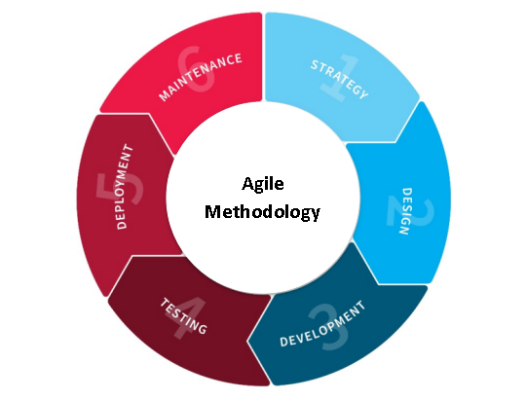
Agile Model has six phases for AttendEX or RFID-Based Attendance Tracking and Evaluation System with Web Interface and Excel Integration that illustrates the System Development Process.

System Development Phases
Strategy
- Strategy for S.O.1 (To be able to develop a system that will simplify officer and committee registration, with an RFID card or tag that will provide an easy-to-use interface for capturing essential details, including names and unique student IDs)
To simplify officer and committee registration, the researchers strategized to create an easy-to-use registration system for capturing essential details, including names and unique student IDs.
- Strategy for S.O.2 (To be able to develop a system that enhances attendance accuracy and efficiency, the system automatically records attendance by scanning RFID cards during duties, activities or events which are College Week, Foundation Day and other activities and events.)
To enhance attendance accuracy and efficiency, the researchers have strategized to associate each officer and committee with an RFID card for the system to scan, ensuring a smooth process.
- Strategy for S.O.3 (To be able to develop a system that will send SMS alerts specifically to the moderator regarding the attendance of officers and committees during duties, events, or activities.)
To ensure that the moderator stays informed in real-time about the attendance, the researchers have strategized to include an SMS alert feature in the system, which will send notifications to the moderator every time an attendance is recorded.
- Strategy for S.O.4 (To be able to develop a system that includes a Peer Evaluation Assessment Feedback feature, allowing SSC officers to provide evaluations and feedback on their peers' contributions and performance, promoting teamwork and collaboration within the SSC. The submitted peer assessments are visible to the moderator for team assessment and improvement.)
To allow SSC officers to provide evaluations and feed back on their peer’s contributions and performance. The researchers have strategized to include a Peer Assessment Feedback feature in the system.
- Strategy for S.O.5 (To be able to develop a system that will automatically generates attendance reports and evaluation visualizations, making it easy for the moderator to analyze data and make informed decisions.)
To assist the moderator in data analysis, the researchers have strategized to incorporate report generation and visualization feature into the system.

Design
- Design for S.O.1 (To be able to develop a system that will simplify officer and committee registration, with an RFID card or tag that will provide an easy-to-use interface for capturing essential details, including names and unique student IDs.)
In the design phase, the researchers conceptualize an easy-to-use registration system that captures essential details, including names and unique student IDs, to simplify officer and committee registration.
- Design for S.O.2 (To be able to develop a system that enhances attendance accuracy and efficiency, the system automatically records attendance by scanning RFID cards during duties, activities or events which are College Week, Foundation Day and other activities and events.)
In the design phase, the researchers plan to incorporate RFID card integration to ensure a smooth process for associating each officer and committee with an RFID card or tag, enhancing attendance tracking.
- Design for S.O.3 (To be able to develop a system that enhances attendance accuracy and efficiency, the system automatically records attendance by scanning RFID cards during duties, activities or events which are College Week, Foundation Day and other activities and events.)
In the design phase, the researchers strategized to design an SMS alert feature in the system. This feature is intended to send real-time notifications to the moderator every time an attendance is recorded, aiding in decision-making and accountability during meetings and events.
- Design for S.O.4 (To be able to develop a system that includes a Peer Evaluation Assessment Feedback feature, allowing SSC officers to provide evaluations and feedback on their peers' contributions and performance, promoting teamwork and collaboration within the SSC. The submitted peer assessments are visible to the moderator for team assessment and improvement.)
In the design phase, the researchers plan to include a Peer Assessment Feedback feature in the system. This feature will allow SSC officers to provide evaluations and feedback on their peers' contributions and performance, promoting teamwork and collaboration within the SSC.
- Design for S.O.5 (To be able to develop a system that will automatically generates attendance reports and evaluation visualizations, making it easy for the moderator to analyze data and make informed decisions.)
In the design phase, the researchers aim to design a system that automatically generates reports and visualizations. This design will make it easy for the moderator to analyze data and make informed decisions.

Development
- Development for S.O.1 (To be able to develop a system that will simplify officer and committee registration, with an RFID card or tag that will provide an easy-to-use interface for capturing essential details, including names and unique student IDs.)
In the development phase, the researchers work on creating an easy-to-use registration system that captures essential details, including names and unique student IDs, to simplify officer and committee registration.
- Development for S.O.2 (To be able to develop a system that enhances attendance accuracy and efficiency, the system automatically records attendance by scanning RFID cards during duties, activities or events which are College Week, Foundation Day and other activities and events.)
In the development phase, the researchers focus to implementing RFID card integration, ensuring a smooth process for associating each officer and committee with an RFID card or tag, enhancing attendance tracking.
- Development for S.O.3 (To be able to develop a system that will send SMS alerts specifically to the moderator regarding the attendance of officers and committees during duties, events, or activities.)
In the development phase, the researchers implement an SMS alert feature in the system. This feature is designed to send real-time notifications to the moderator every time an attendance is recorded, aiding in decision-making and accountability during meetings and events.
- Development for S.O.4 (To be able to develop a system that includes a Peer Evaluation Assessment Feedback feature, allowing SSC officers to provide evaluations and feedback on their peers' contributions and performance, promoting teamwork and collaboration within the SSC. The submitted peer assessments are visible to the moderator for team assessment and improvement.)
In the development phase, the researchers work on including a Peer Assessment Feedback feature in the system. This feature will allow SSC officers to provide evaluations and feedback on their peers' contributions and performance, promoting teamwork and collaboration within the SSC. The submitted peer assessments become visible to the moderator for team assessment and improvement.
- Development for S.O.5 (To be able to develop a system that will automatically generates attendance reports and evaluation visualizations, making it easy for the moderator to analyze data and make informed decisions.)
In the development phase, the researchers focus on implementing a system that automatically generates reports and visualizations. This development makes it easy for the moderator to analyze data and make informed decisions.
Testing
- Testing for S.O.1 (To be able to develop a system that will simplify officer and committee registration, with an RFID card or tag that will provide an easy-to-use interface for capturing essential details, including names and unique student IDs.)
In the testing phase, the researchers evaluate the registration system's functionality, ensuring it simplifies officer and committee registration. They check if it effectively captures essential details, including names and unique student IDs.
- Testing for S.O.2 (To be able to develop a system that enhances attendance accuracy and efficiency, the system automatically records attendance by scanning RFID cards during duties, activities or events which are College Week, Foundation Day and other activities and events.)
In the testing phase, the researchers assess the RFID card integration and attendance tracking features. This evaluation ensures that the system effectively enhances attendance tracking and associates each officer and committee with RFID cards or tags.
- Testing for S.O.3 (To be able to develop a system that will send SMS alerts specifically to the moderator regarding the attendance of officers and committees during duties, events, or activities.)
In the testing phase, the researchers assess the SMS alert feature's performance. They confirm that the feature sends real-time notifications to the moderator every time an attendance is recorded, aiding in decision-making and accountability during meetings and events.
- Testing for S.O.4 (To be able to develop a system that includes a Peer Evaluation Assessment Feedback feature, allowing SSC officers to provide evaluations and feedback on their peers' contributions and performance, promoting teamwork and collaboration within the SSC. The submitted peer assessments are visible to the moderator for team assessment and improvement.)
In the testing phase, the researchers evaluate the Peer Assessment Feedback feature. They ensure that SSC officers can provide evaluations and feedback on their peers' contributions and performance, promoting teamwork and collaboration. They also check that submitted peer assessments are visible to the moderator for team assessment and improvement.

- Testing for S.O.5 (To be able to develop a system that will automatically generates attendance reports and evaluation visualizations, making it easy for the moderator to analyze data and make informed decisions.)
In the testing phase, the researchers validate the report generation and visualization features. They confirm that the system automatically generates reports and visualizations, making it easy for the moderator to analyze data and make informed decisions.
Deployment
- Deployment for S.O.1 (To be able to develop a system that will simplify officer and committee registration, with an RFID card or tag that will provide an easy-to-use interface for capturing essential details, including names and unique student IDs.)
In the deployment phase, the researchers roll out the registration system to the intended users, ensuring that it simplifies officer and committee registration by providing an easy-to-use interface for capturing essential details, including names and unique student IDs.
- Deployment for S.O.2 (To be able to develop a system that enhances attendance accuracy and efficiency, the system automatically records attendance by scanning RFID cards during duties, activities or events which are College Week, Foundation Day and other activities and events.)
In the deployment phase, the researchers implement the RFID card integration and attendance tracking features, making them available to users. This deployment ensures a smooth process for associating each officer and committee with RFID cards or tags, enhancing attendance tracking.
- Deployment for S.O.3 (To be able to develop a system that will send SMS alerts specifically to the moderator regarding the attendance of officers and committees during duties, events, or activities. )
In the deployment phase, the SMS alert feature is activated and accessible to users. This deployment ensures that the moderator receives real-time notifications every time an attendance is recorded, aiding in decision-making and accountability during meetings and events.
- Deployment for S.O.4 (To be able to develop a system that includes a Peer Evaluation Assessment Feedback feature, allowing SSC officers to provide evaluations and feedback on their peers' contributions and performance, promoting teamwork and collaboration within the SSC. The submitted peer assessments are visible to the moderator for team assessment and improvement.)
In the deployment phase, the Peer Assessment Feedback feature is made available to SSC officers. This deployment allows SSC officers to provide evaluations and feedback on their peers' contributions and performance, promoting teamwork and collaboration. It also makes submitted peer assessments visible to the moderator for team assessment and improvement.
- Deployment for S.O.5 (To be able to develop a system that will automatically generates attendance reports and evaluation visualizations, making it easy for the moderator to analyze data and make informed decisions.)
In the deployment phase, the researchers make the report generation and visualization features accessible to the moderator. This deployment ensures that the system automatically generates reports and visualizations, making it easy for the moderator to analyze data and make informed decisions.
Maintenance
- Maintenance for S.O.1 (To be able to develop a system that will simplify officer and committee registration, with an RFID card or tag that will provide an easy-to-use interface for capturing essential details, including names and unique student IDs.)
In the maintenance phase, the researchers ensure the ongoing functionality and effectiveness of the registration system. They continue to provide support and updates to maintain its ability to simplify officer and committee registration, including capturing essential details.

- Maintenance for S.O.2 (To be able to develop a system that enhances attendance accuracy and efficiency, the system automatically records attendance by scanning RFID cards during duties, activities or events which are College Week, Foundation Day and other activities and events.)
In the maintenance phase, the researchers the researchers continue to monitor and support the RFID card integration and attendance tracking features. Regular updates and maintenance are performed to ensure a smooth process for associating each officer and committee with RFID cards or tags, enhancing attendance tracking.
- Maintenance for S.O.3 (To be able to develop a system that will send SMS alerts specifically to the moderator regarding the attendance of officers and committees during duties, events, or activities.)
In the maintenance phase, the automated attendance recording system is regularly checked and updated. This ongoing maintenance ensures the system continues to enhance attendance accuracy and efficiency by automatically recording attendance during duties, activities, and events using RFID cards.
- Maintenance for S.O.4 (To be able to develop a system that includes a Peer Evaluation Assessment Feedback feature, allowing SSC officers to provide evaluations and feedback on their peers' contributions and performance, promoting teamwork and collaboration within the SSC. The submitted peer assessments are visible to the moderator for team assessment and improvement.)
In the maintenance phase, the researchers maintain the Peer Assessment Feedback feature. Ongoing support and updates are provided to ensure SSC officers can continue to provide evaluations and feedback on their peers' contributions and performance. The feature's ongoing maintenance promotes teamwork and collaboration within the SSC and maintains visibility of submitted peer assessments for team assessment and improvement.
- Maintenance for S.O.5 (To be able to develop a system that will automatically generates attendance reports and evaluation visualizations, making it easy for the moderator to analyze data and make informed decisions.)
In the maintenance phase, ongoing support and updates are provided to maintain the system's ability to automatically generate reports and visualizations. This ensures that the moderator can continue to analyze data and make informed decisions with ease.

Planning / Conception - Initiation Phase
Business Model Canvas
Figure 3.2:
Business Model Canvas of AttendEX. This is the strategic management and lean startup template for the development AttendEX. This is the overview that lays out both what is the system for and how it will run.

Key Partners  SEAIT | Key Activity  Research & Development  System Maintenance | Value  Proposition  Registration of Officers/ Committees  Peer Evaluation  SMS Alerts  RFID Scanning Attendance  Reports |  | Customer Relationship  Personal Assistance | Customer Segment  SSC Moderator  Officers
 | Key Resources  IT Infrastructure  Developers |  |  | Channels  SMS Alerts  Web Interface
Cost Structure  System Development  Miscellaneous  Salaries and Wages |  |  | Revenue Streams  Maintenance Fee  Usage Fee

Gantt Chart /Pert Chart
Figure 3.3:
Gantt Chart of AttendEX. This chart illustrates this project’s schedule. It illustrates the task of the researchers and duration of the terminal elements and summary elements of the project AttendEX.
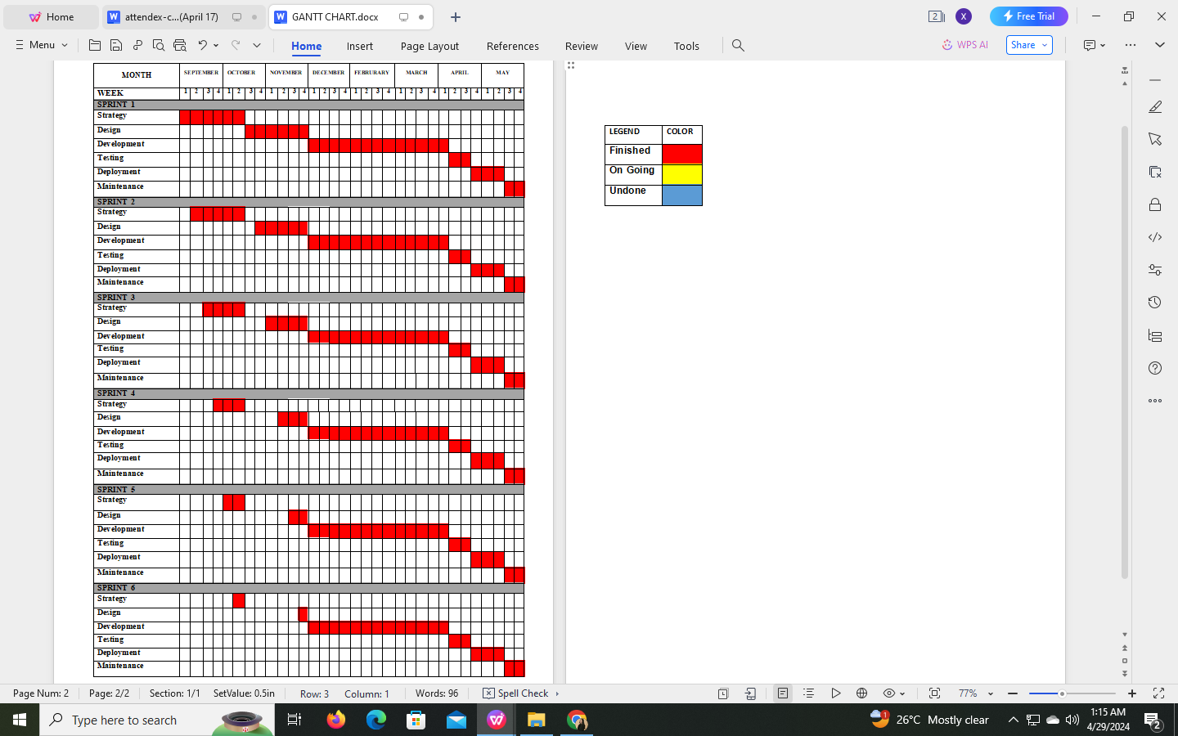

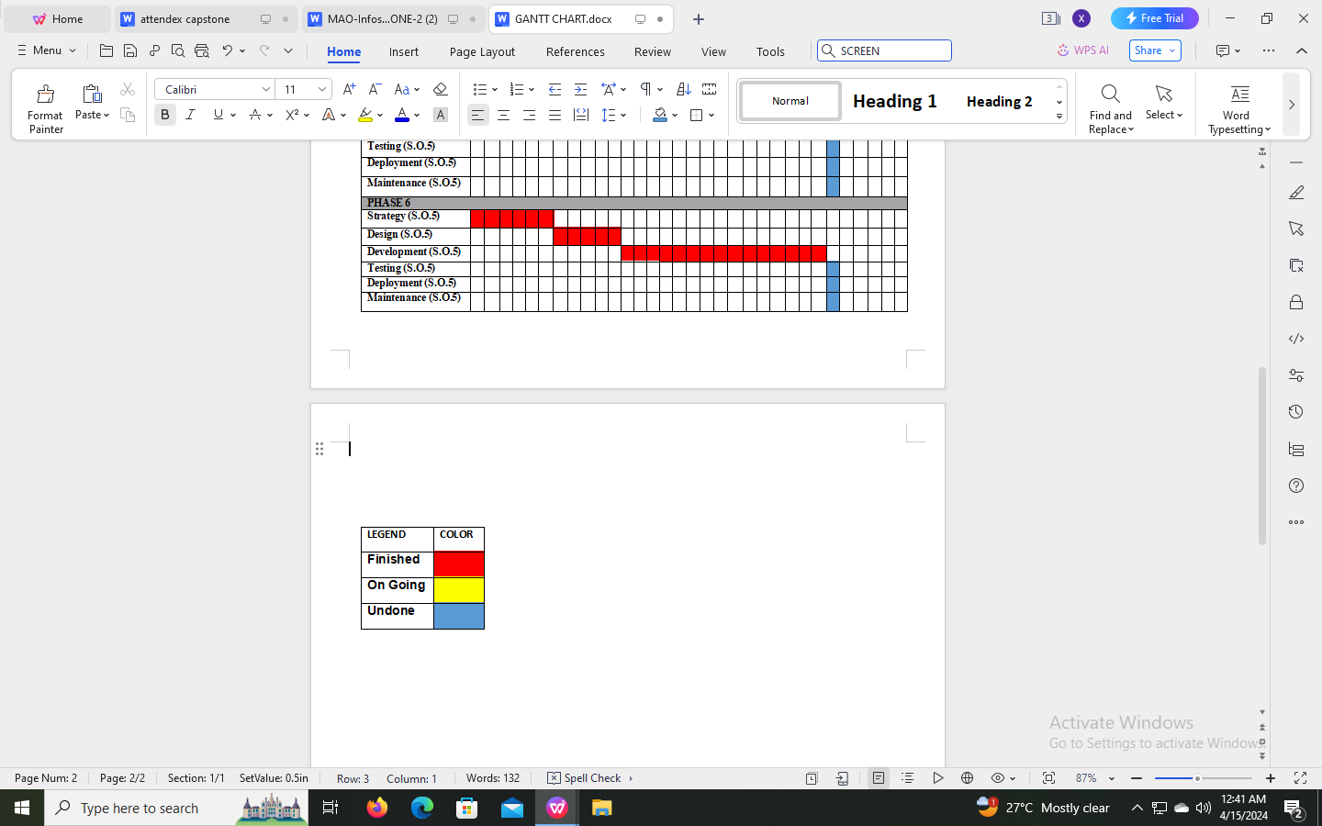

Functional Decomposition Diagram
evScan RFID
Figure 3.4:
Functional Decomposition Diagram of AttendEX. This figure shows that flow of RFID-based Attendance Tracking and Evaluation System with Web Interface and Excel Integration (AttendEX).
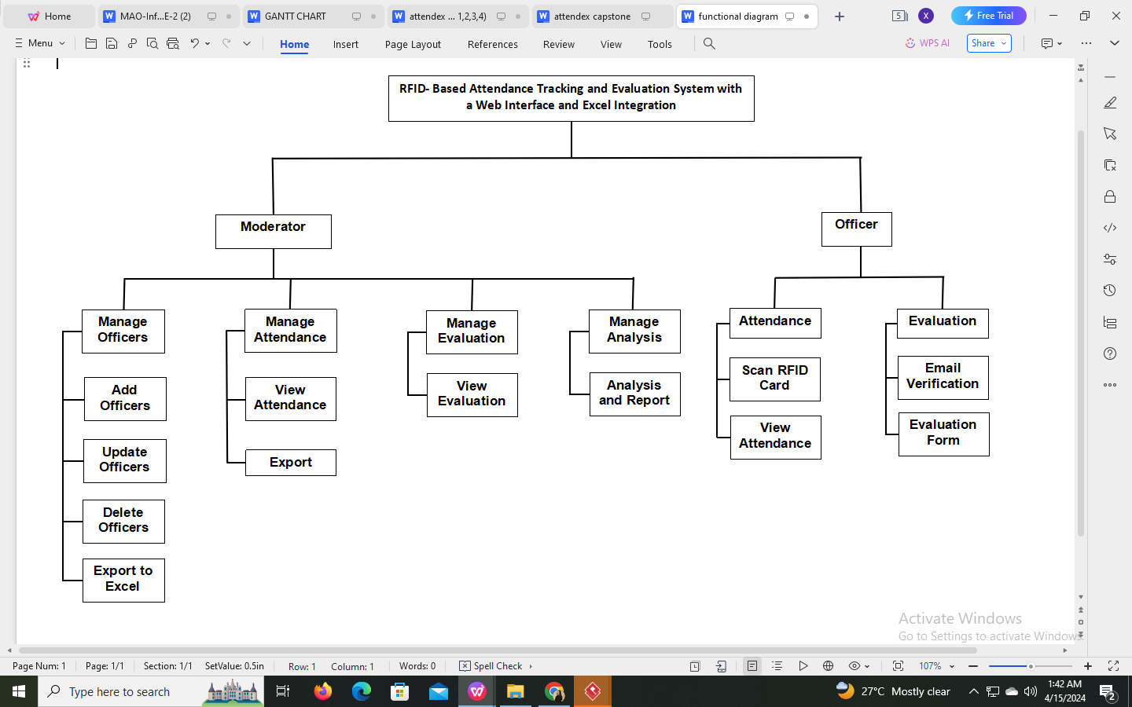

Analysis - Design Phase
Use Case Diagrams
Figure 3.5:
Use Case Diagrams Software of RFID-based Attendance Tracking and Evaluation System with Web Interface and Excel Integration (AttendEX).
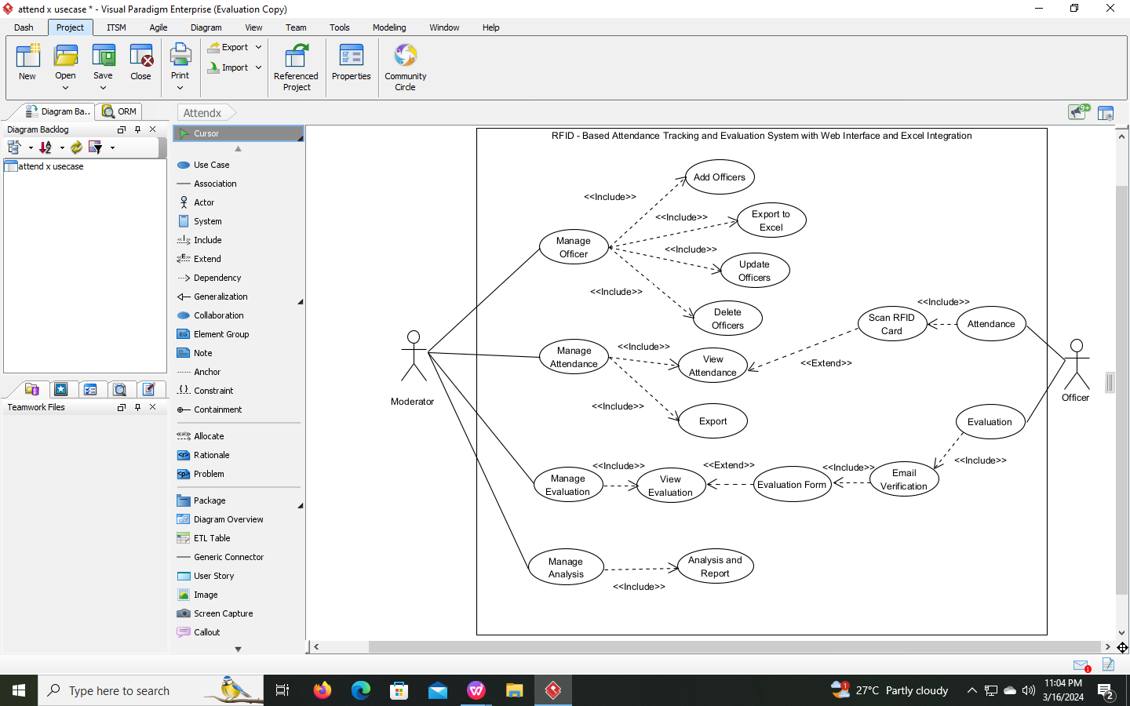

Figure 3.6:
Use Case Diagrams Hardware of RFID-based Attendance Tracking and Evaluation System with Web Interface and Excel Integration (AttendEX).
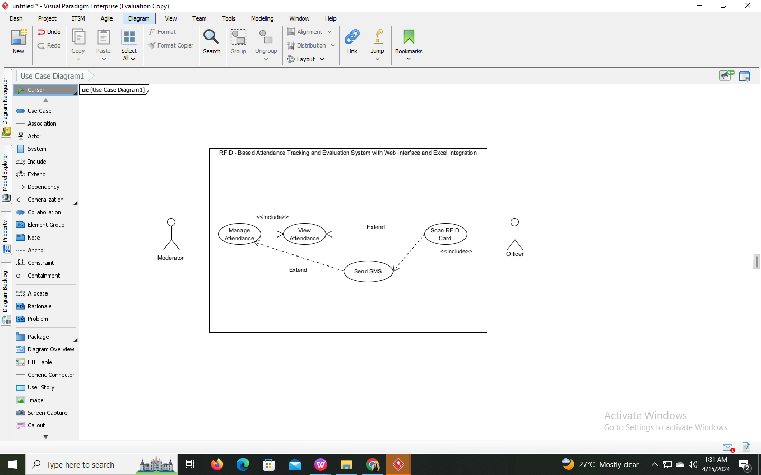

Use Case Matrix
Use Case Name:  RFID-based Attendance Tracking and Evaluation System with Web Interface and Excel Integration | AttendEX
Primary Actor: Moderator
Description:
This use case describes how the moderator or administrator manages the attendance and evaluation records of the officers using the advance RFID.
Preconditions:
The developer must assist the moderator for using this system especially the monitoring the officers attendance. Administrator must have the username and password of the system.
Dynamic Precondition:
The moderator must explore the system for them to memorize all the functions that run without having a problem.
Trigger/ Event:
- Admin will sign up/register into the system
- Admin will input name, position, phone number,username and password to have account
- Admin will login using username and password
- Admin can update administrator information's
- Admin view the total record of officers and total record of present for the current date in the dashboard
- Admin will register or add officers information into the RFID cards
- Admin can view officers information
- Admin can update the officers information
- Admin can delete the officers information
- The admin will export the of the records to excel
- Admin can restore all the information if needed
- Admin will print all the officers information
- Admin manage the scanning of attendance for entrance
- Admin can view officers attendance after scanning RFID cards or tags
- Admin can search the officers attendance record includes name, position, course and time in
- Admin manage the scanning of attendance for entrance
- The admin will have a record or view the officers time out
- Admin manage the evaluation forms and answer of the officers
- Admin search the email/ name of the officers who have a evaluation
- Admin input from date and to date to analyse/view the record of the officers present and absences
Type: External Temporary
Basic Flow
- The moderator register the information need
- The system requests that the actor enters his/her username and password.
- The moderator enter username and password that is given.
- The system validates the username and password.
- The moderator is logged into the system.
- Admin/moderator user click on account button.
- Admin/moderator update information.
- Admin user click on officers menu button.
- Admin collect the information of the officers.
- Admin can now add users/ officers information into the RFID and system.
- Admin scan the RFID cards or tags to generated attendance report.
- Admin or moderator reserve an SMS alert of the attendance of officers.
- Admin user click the on attendance menu button.
- Admin view the officer information and time in and out of the officers.
- System save or retrieve from the database or excel.
- Admin user click the on evaluation menu button.
- Admin view the answers of the officer into the evaluation form.
- Admin search the officers evaluation.
- Admin user click the on analysis menu button.
- Admin manage and view the analysis officers present and absences
- Admin export attendance report to excel.
Post Condition
After the moderator login their account, all the function and features that based on the current problem was running successfully without any preconditions.
Secondary Actor: Officers
Description:
This use case describes how the officers take the attendance and evaluation using the advance RFID. It is the one who is responsible to use the RFID attendance and evaluation.
Preconditions:
The developer must assist the officer on how the system works especially taking of attendance and answering the evaluation.
Dynamic Precondition:
The users should scan and explore the system.
Trigger/ Event:
- Officer register the information which include name, ID no., Card ID, Position, Course, Schedule of duty.
- Officers scan the RFID card or tag.
-Officer can view attendance record.
- The officers will export the of the attendance records to excel.
- Officers enter email address.
-Officers answer evaluation form.
Type: External Temporary
Basic Flow
- Officer register or add the information by the admin
- Officer scan the RFID card or tags
- Officers view attendance information, date, time in and out
- Officer enter the valid email address into the system.
- Officer can now answer the evaluation form.
- Officers input assessors name, assess name and position
- Officers answer by rating process 1-5.
- Officers click submit to record the answered evaluation form.
Post Condition
The successful scanning of RFID cards and tags process that will produce tracking of attendance and evaluation form for the SSC Officers

Class Diagram
Figure 3.7:
Class Diagrams of RFID-based Attendance Tracking and Evaluation System with Web Interface and Excel Integration (AttendEX).
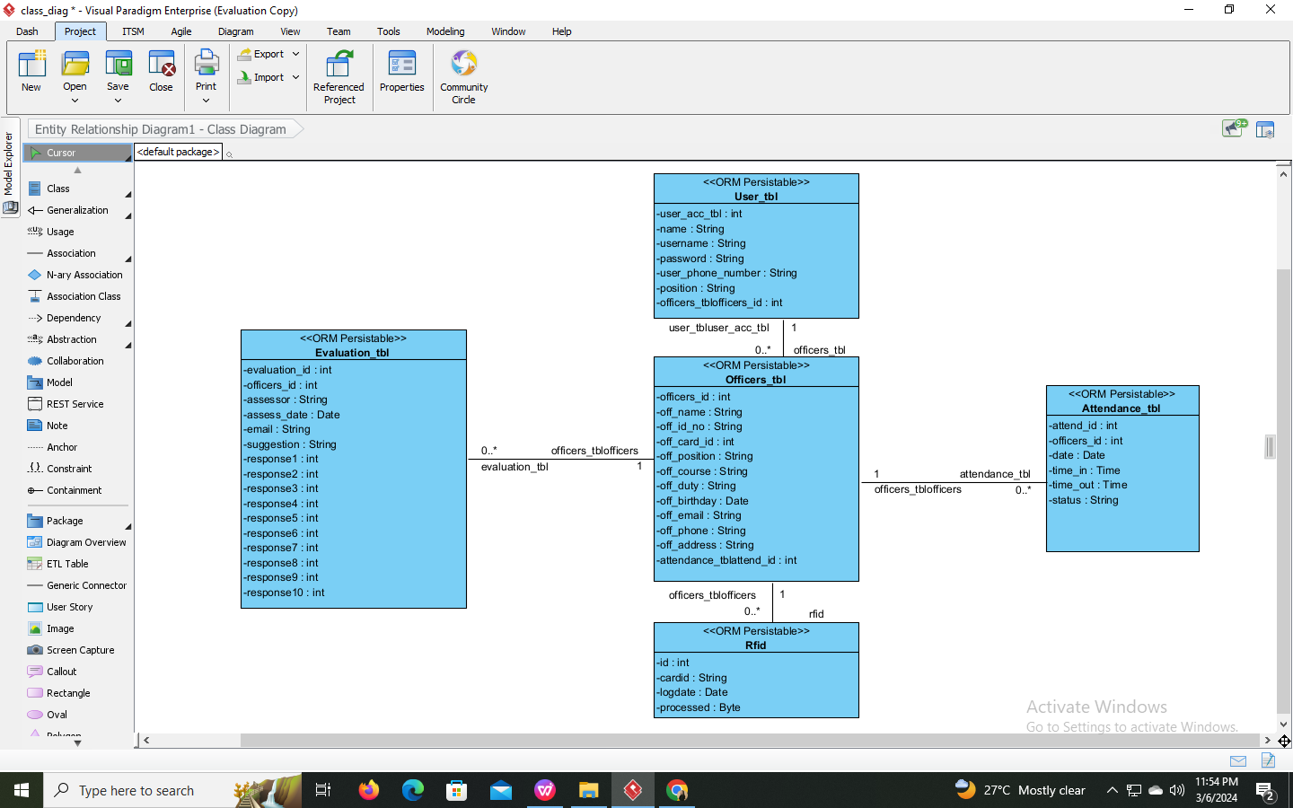

Sequence Diagram
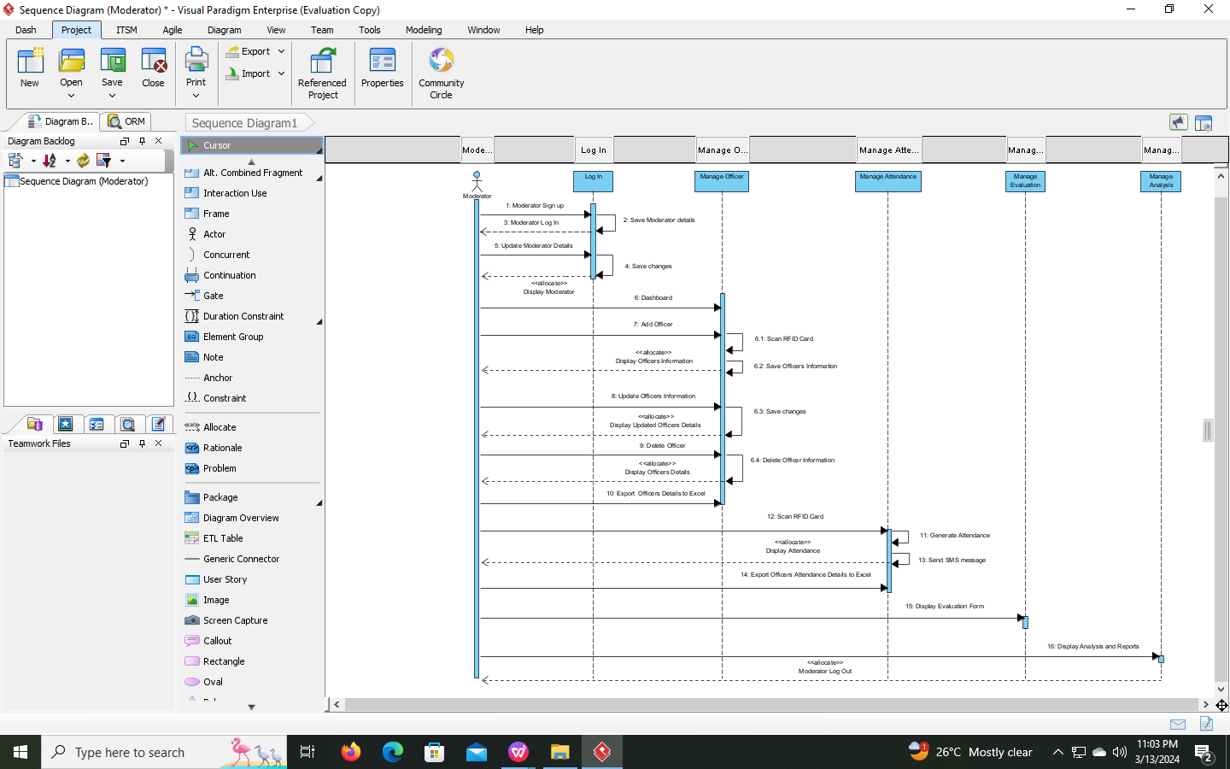
Moderator/ Admin Sequence Diagram
Figure 3.8: Moderator Sequence Diagram of RFID-based Attendance Tracking and Evaluation System with Web Interface and Excel Integration (AttendEX).

Officer Sequence Diagram
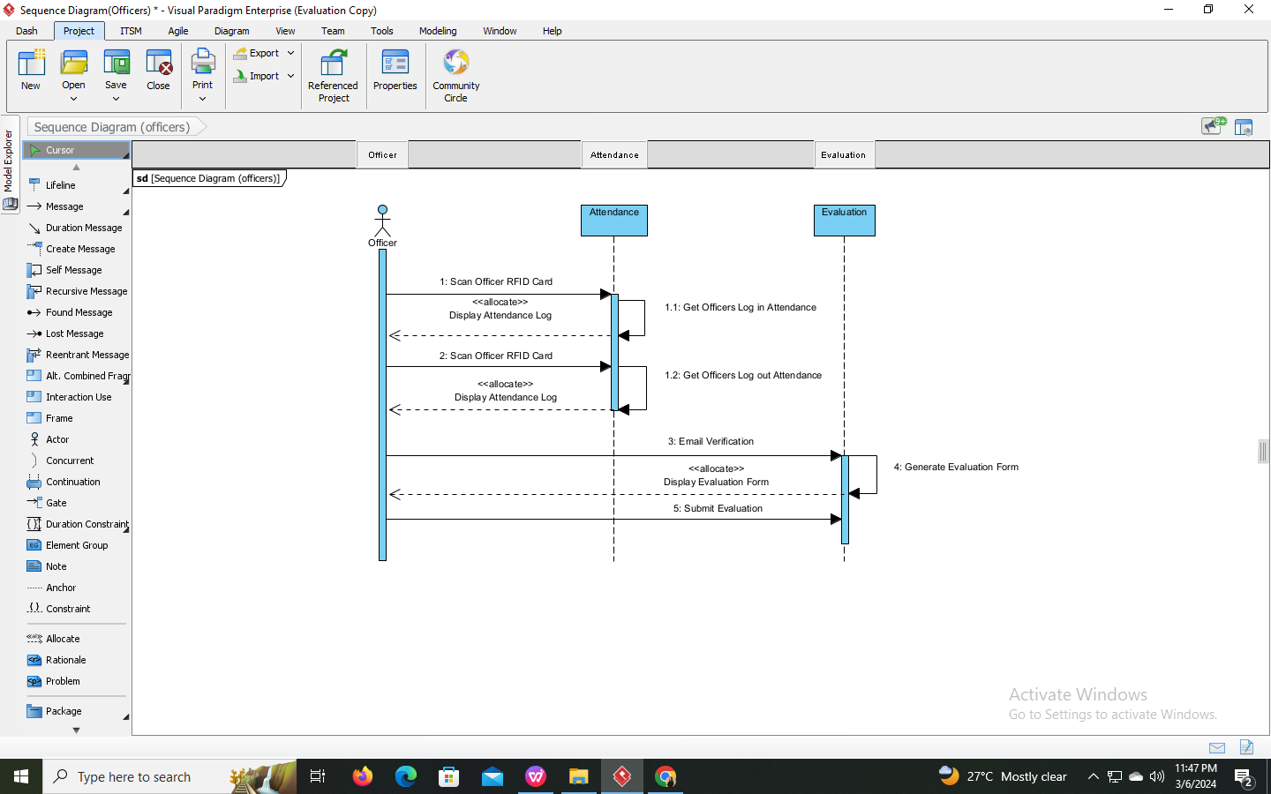
Figure 3.9: Officer Sequence Diagram of RFID-based Attendance Tracking and Evaluation System with Web Interface and Excel Integration (AttendEX).

Activity Diagram
Moderator Activity
(Manage Officers)
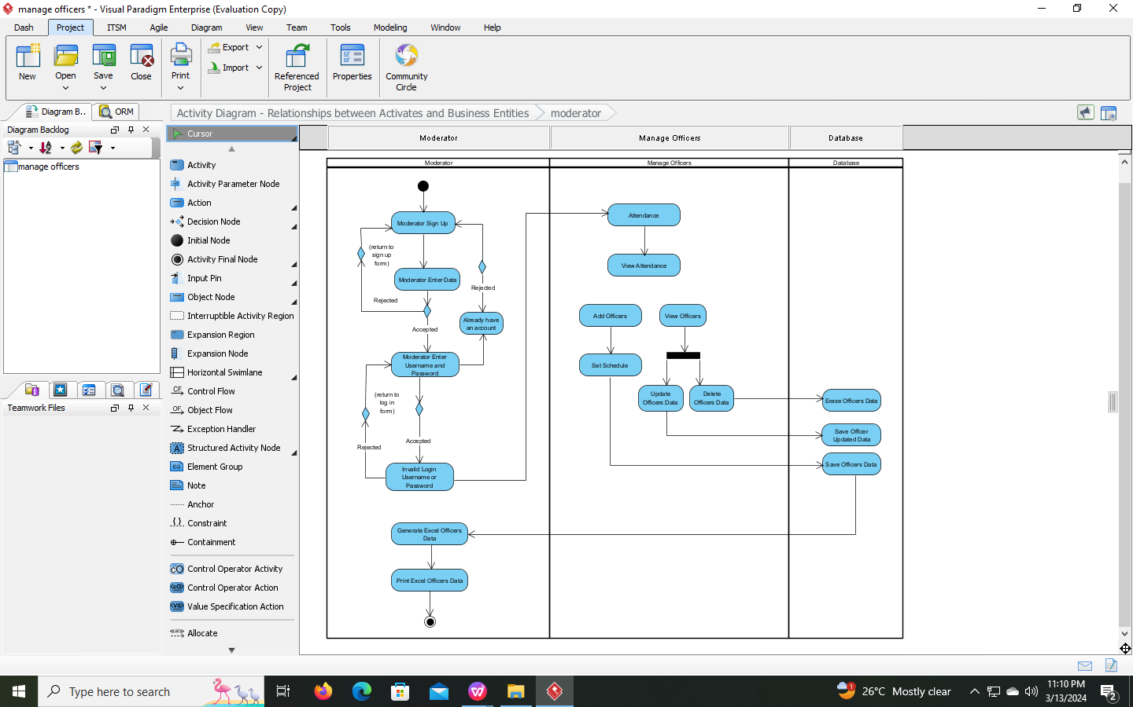
Figure 3.10: Moderator Activity Diagram Officers Module of RFID-based Attendance Tracking and Evaluation System with Web Interface and Excel Integration (AttendEX).

Moderator Activity
(Manage Attendance)
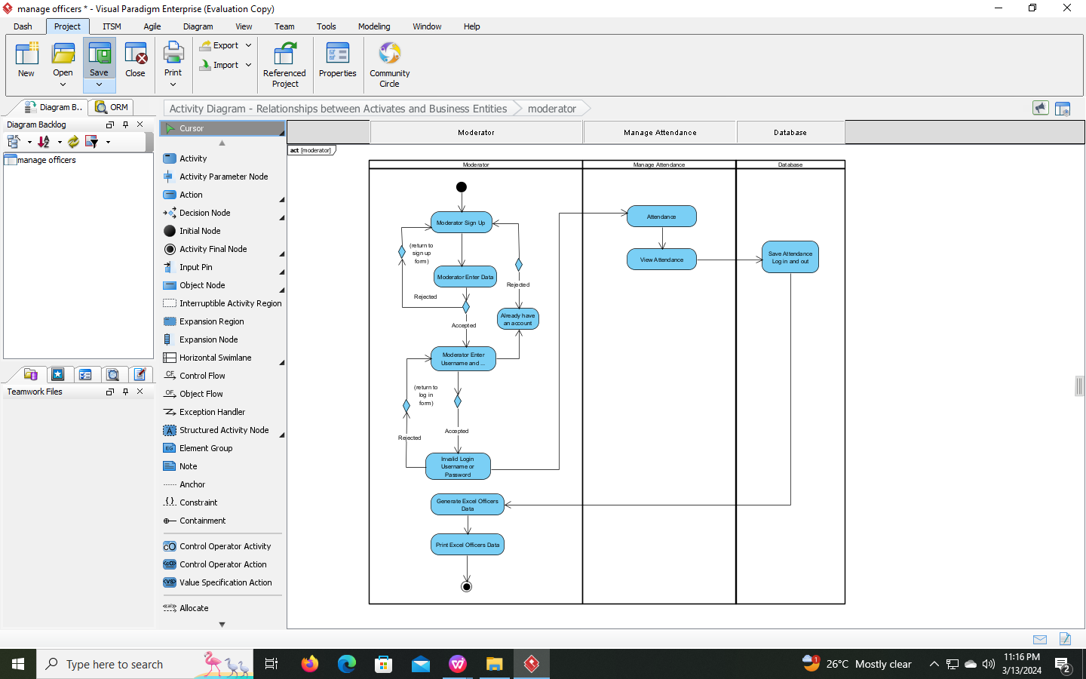
Figure 3.11: Moderator Activity Diagram Attendance Module of RFID-based Attendance Tracking and Evaluation System with Web Interface and Excel Integration (AttendEX).

Moderator Activity
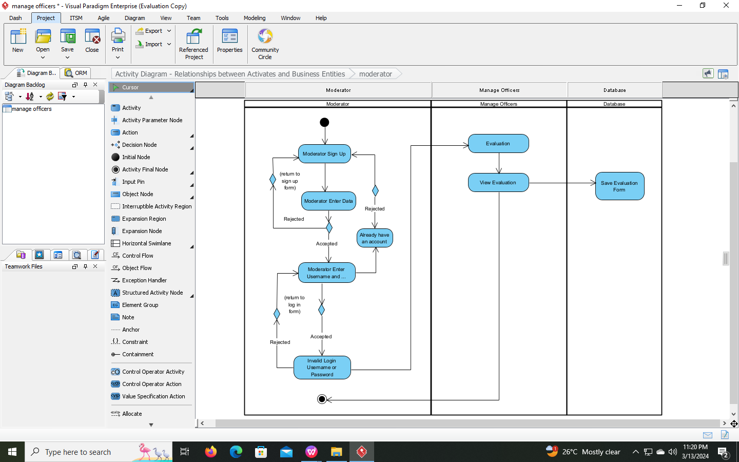
(Manage Evaluation)

Figure 3.12: Moderator Activity Diagram Evaluation Module of RFID-based Attendance Tracking and Evaluation System with Web Interface and Excel Integration (AttendEX).

Moderator Activity
(Manage Analysis)
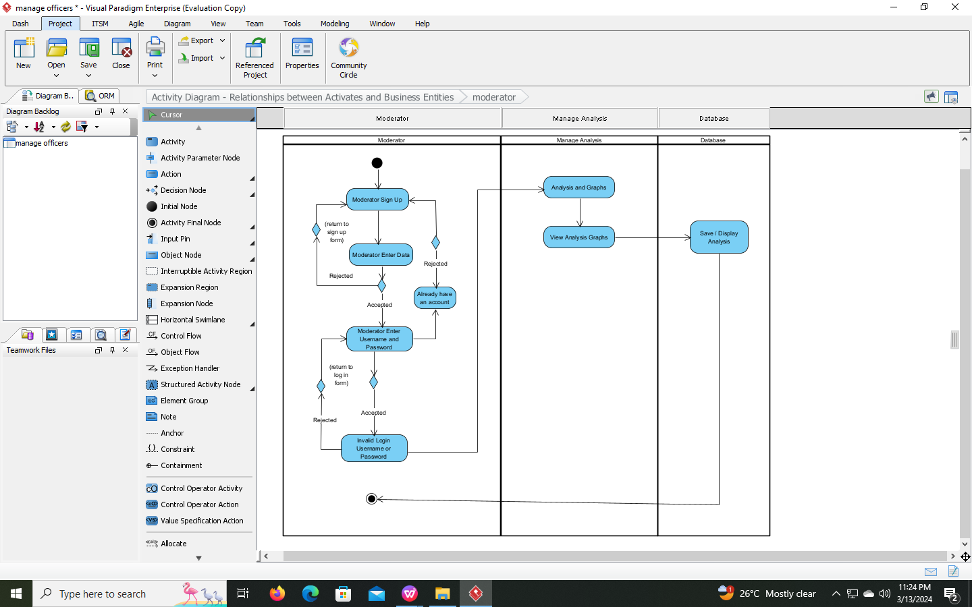
Figure 3.13: Moderator Activity Diagram Analysis Module of RFID-based Attendance Tracking and Evaluation System with Web Interface and Excel Integration (AttendEX). Moderator Activity Diagram to show the process of managing the officers information, attendance logs, evaluation, analysis.

Officer Activity
Figure 3.14: Moderator Activity Diagram to show the process of the officers through scanning RFID card to process attendance and answer the evaluation form.
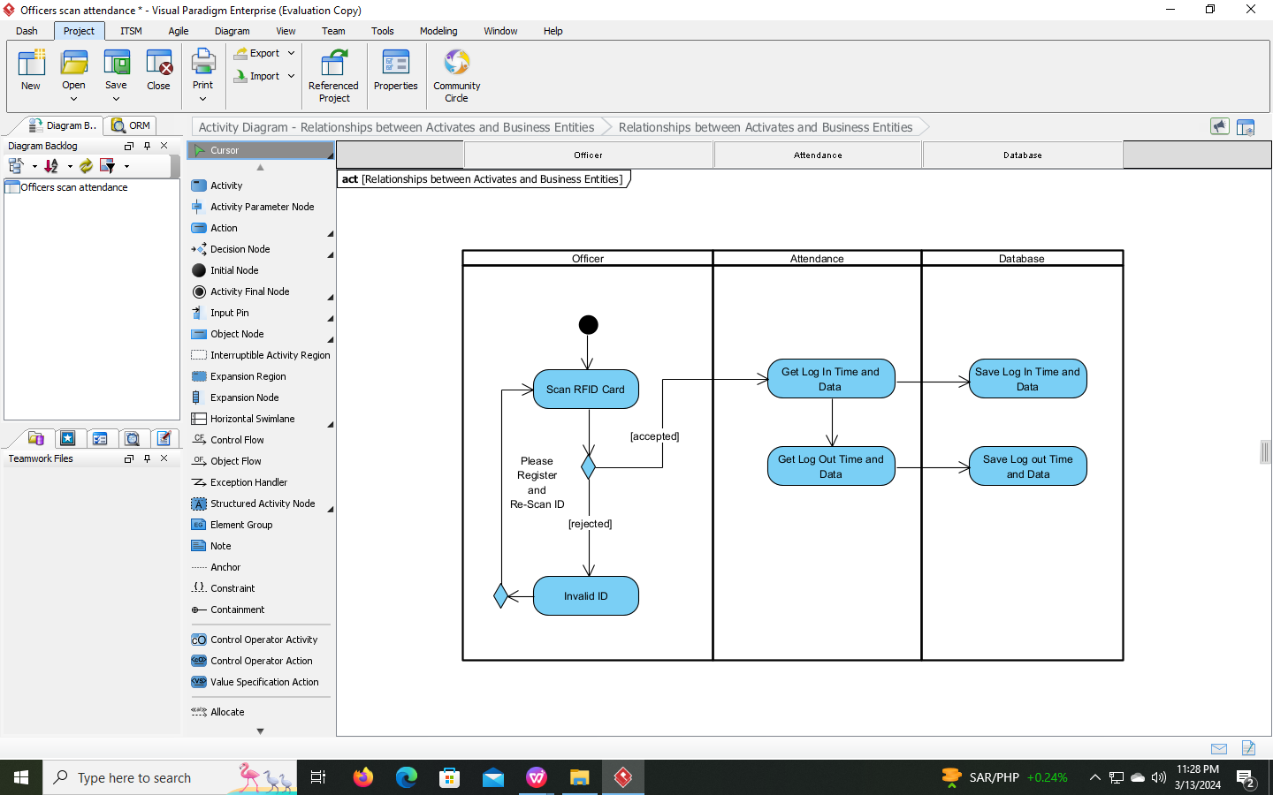

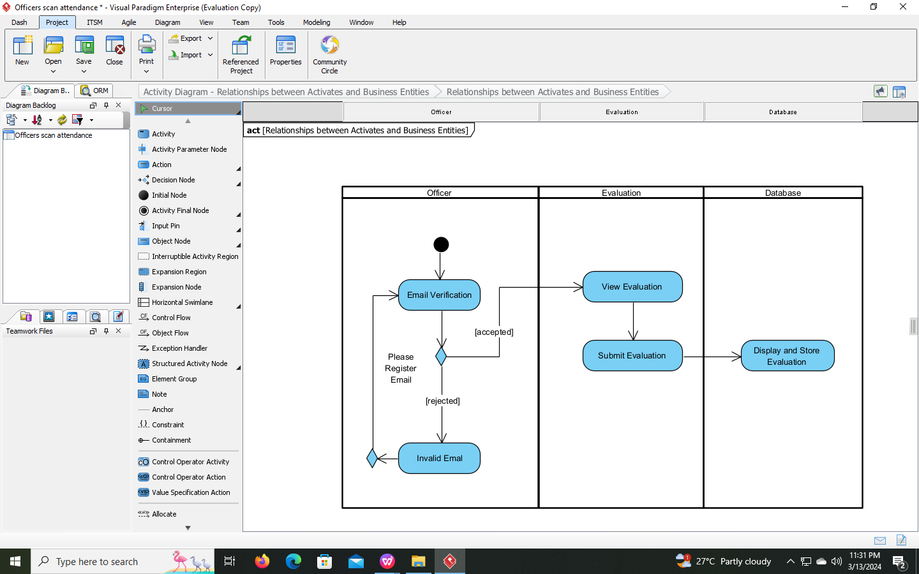

User Interface Designs

Moderators User Interface

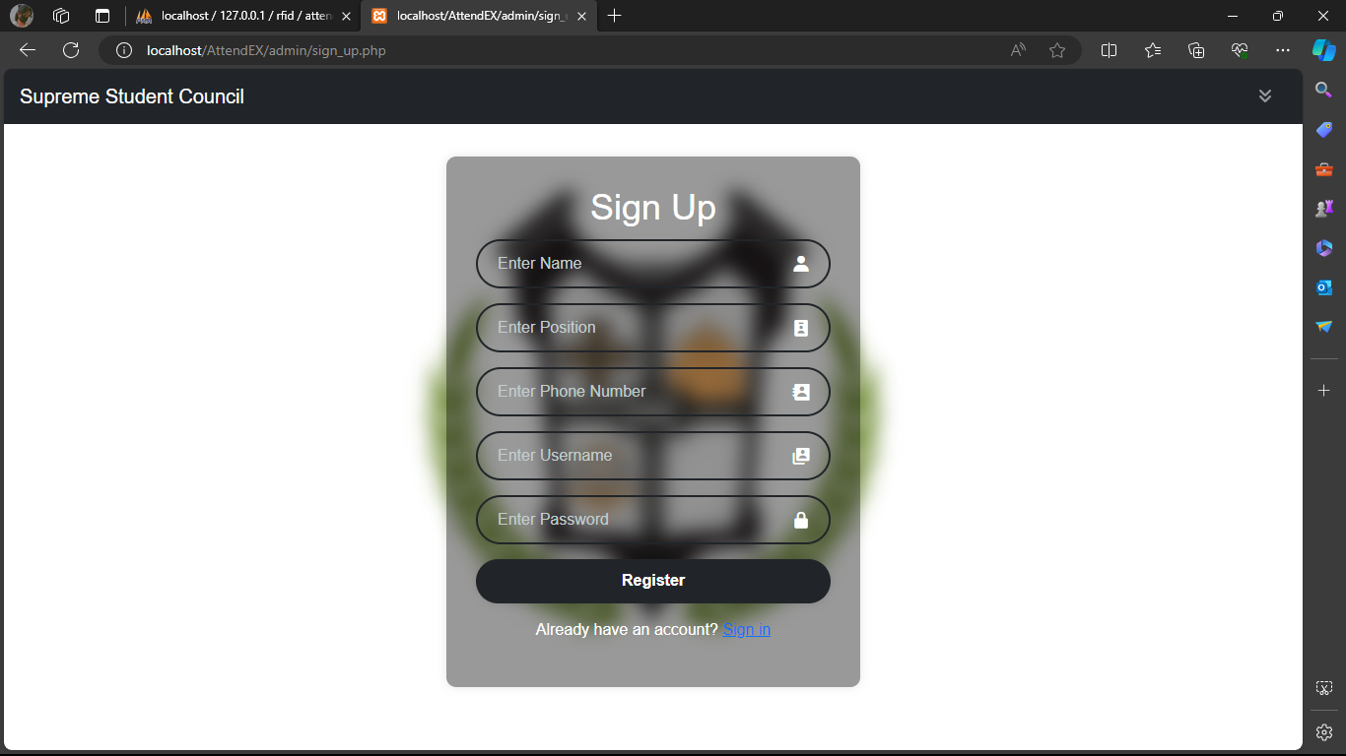
Sign up Interface
Figure 3.15: Moderator Sign up Interface. This figure displays the first frame shown to the system.
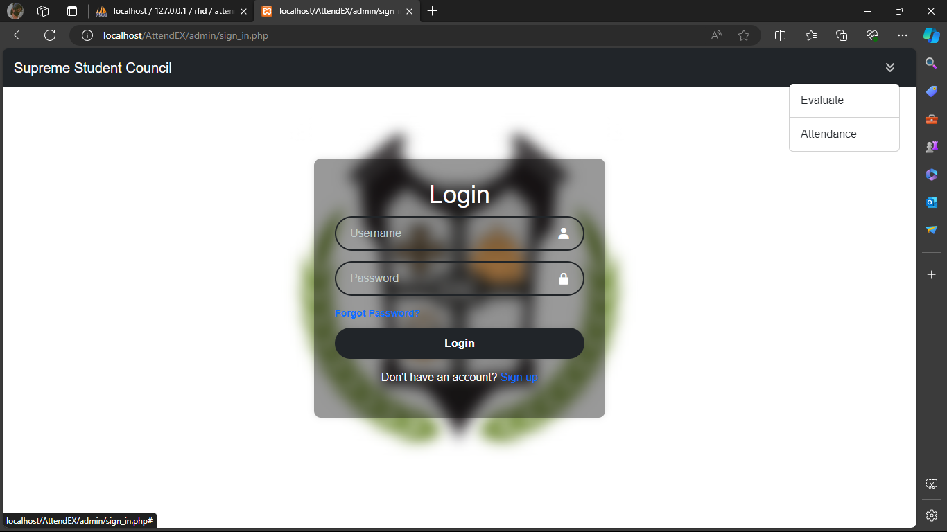
Log In Interface
Figure 3.16: Moderator Sign up Interface. This figure displays the log in frame shown to the system.
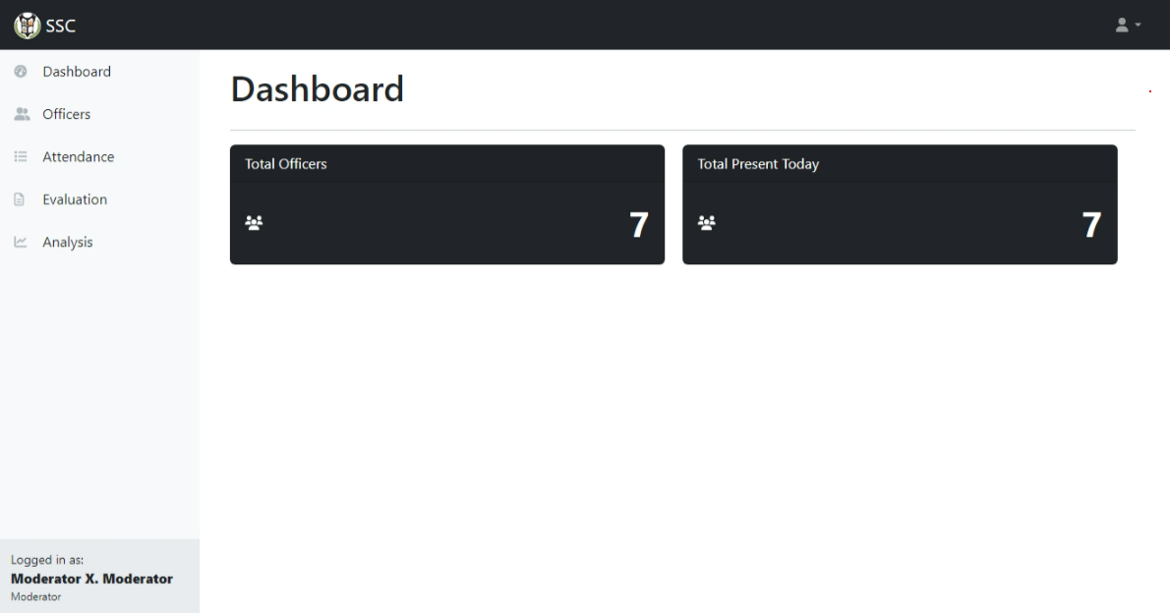
Dashboard Interface
Figure 3.17: Moderator Dashboard Interface. This figure displays the dashboard frame shown to the system.
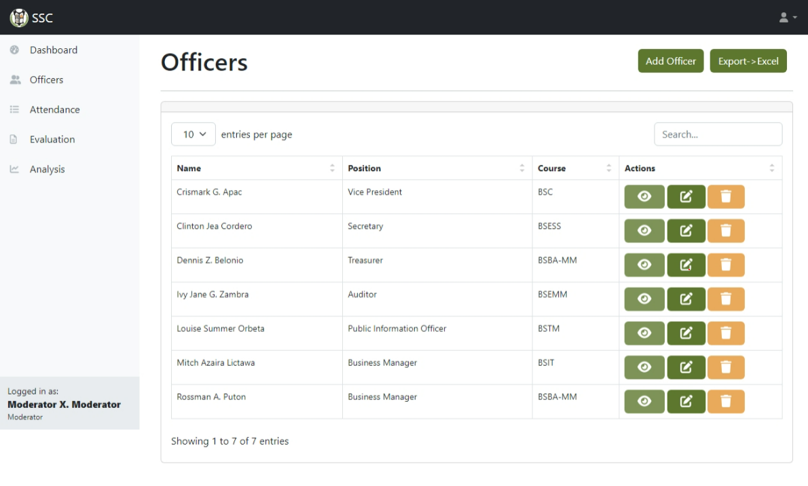
Manage Officers Interface
Figure 3.18: Moderator Manage Officers Interface. This figure displays the officers dat5a frame shown to the system.

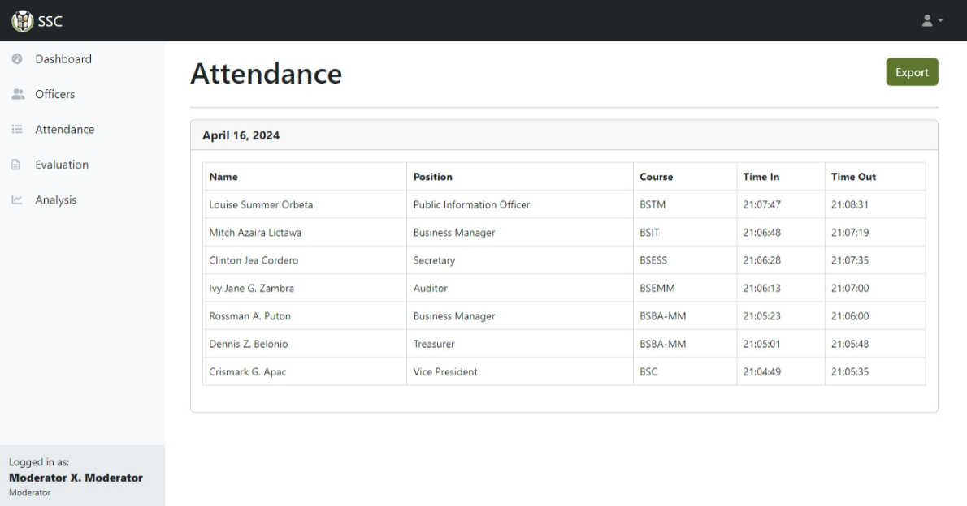
Manage Attendance Interface
Figure 3.19: Moderator Manage Attendance Interface. This figure displays the attendance data frame shown to the system.
Manage Evaluations Interface
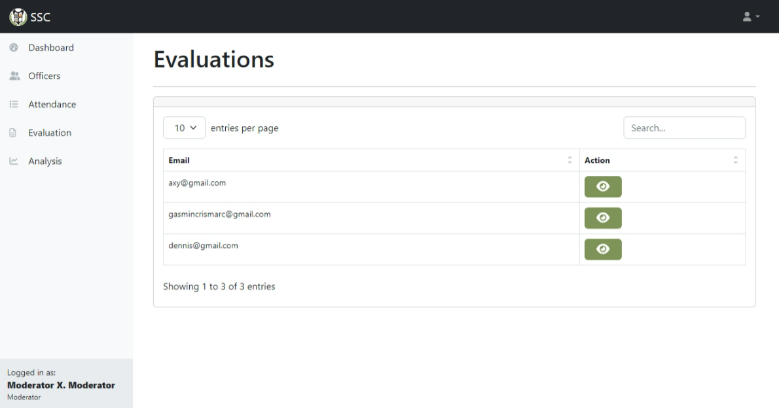
Figure 3.20: Moderator Manage Evaluation Interface. This figure displays the evaluation frame shown to the system.

Manage Analysis Interface
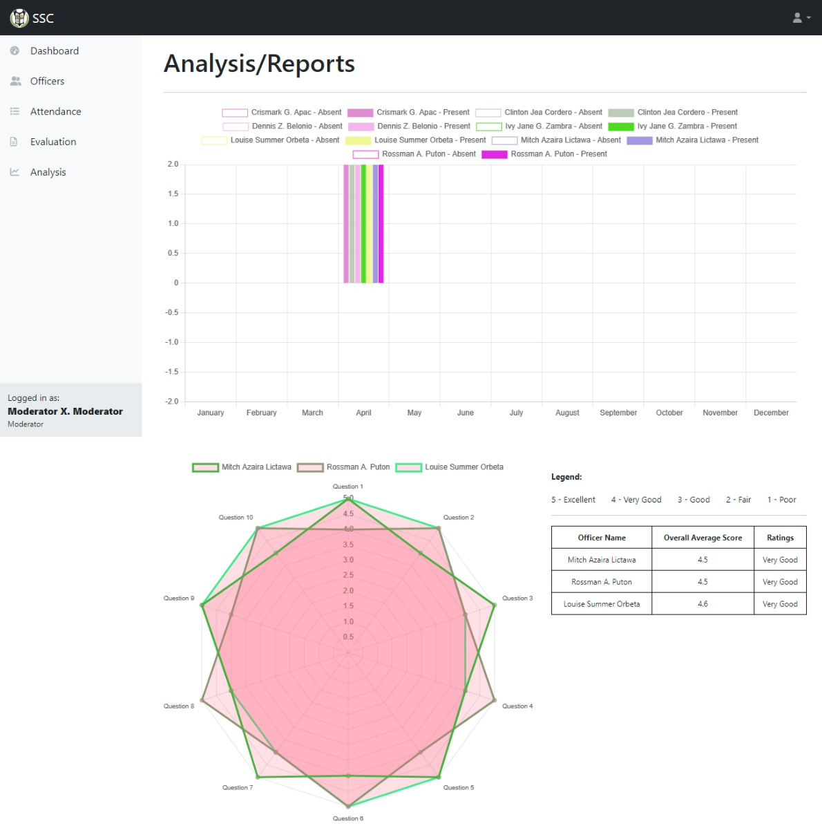
Figure 3.21: Moderator Manage Analysis Interface. This figure displays the analysis/reports frame shown to the system.

Officers User Interface
Officers Attendance
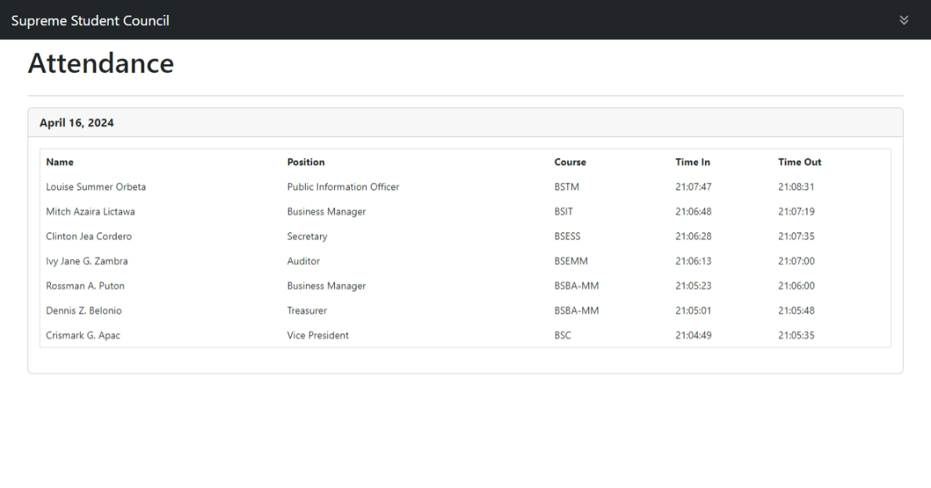
Figure 3.22: Officers Attendance Interface. This figure displays the attendance frame shown to the system.

Officers Evaluation
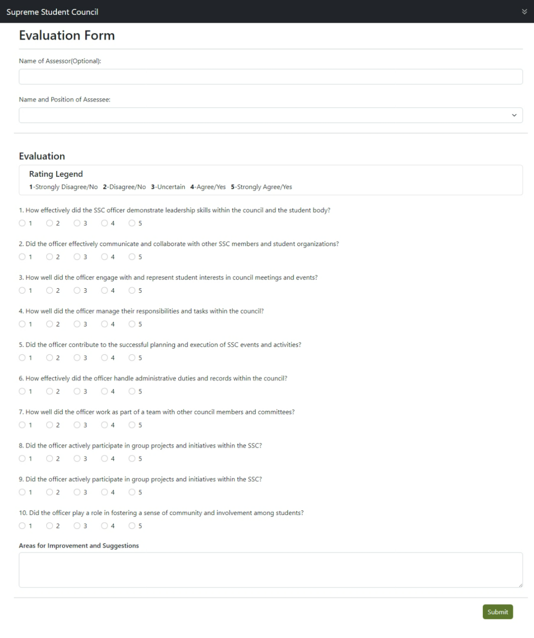
Figure 3.23: Officers Evaluation Interface. This figure displays the evaluation frame shown to the system.

Storyboard

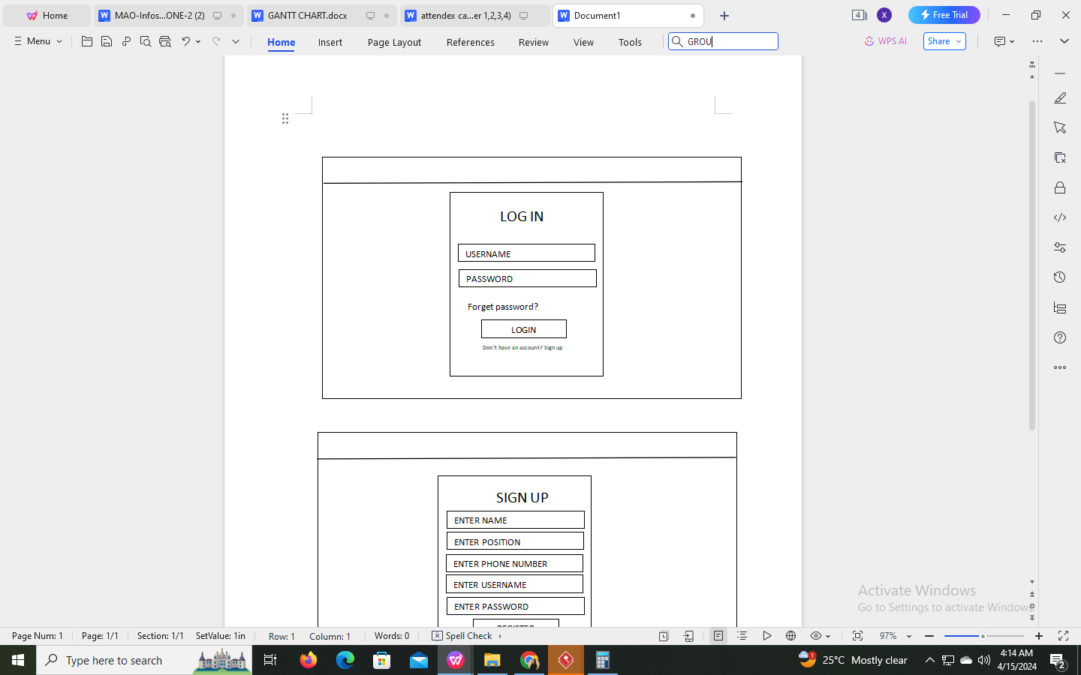
Admin Login Page
Evaluation
Peer Assessment Evaluation Form
View attendance for officers
Attendance

Input username

Input password

Login

Figure 3.24: This is the login page where administrators access the system. And this is where the officers access the evaluation form and attendance.
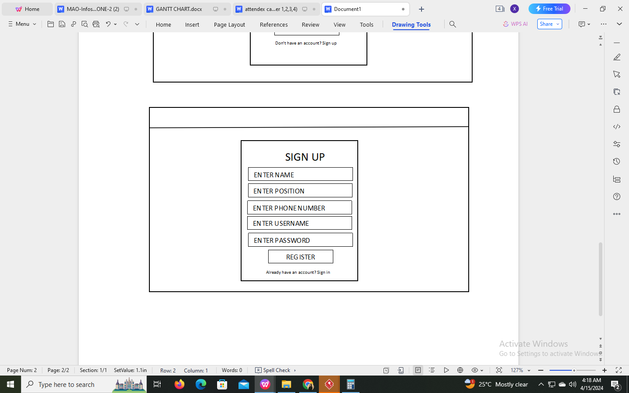
Admin/Officers Sign Up Page

Input name
Input position

Input phone number
Input username
Input password

Register

Figure 3.25: This is the sign up page where administrators access the system. And this is where the officers access the evaluation form and attendance.

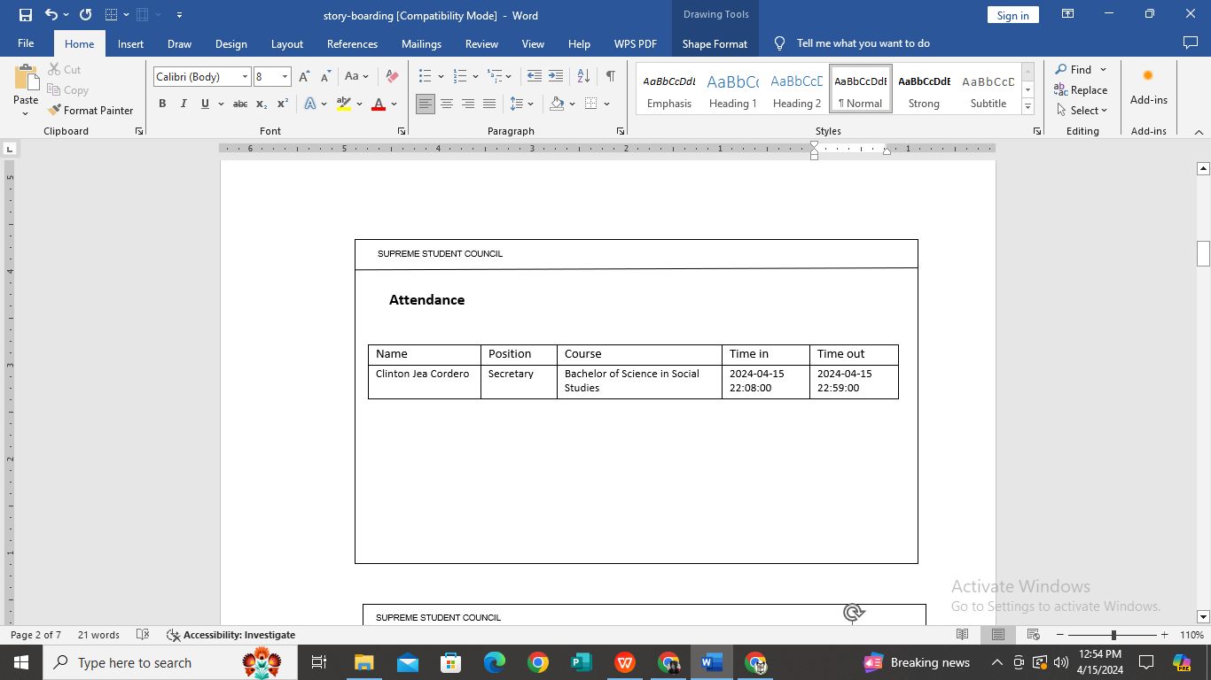
Officer Attendance Page

Figure 3.26: This is the sign up page where administrators access the system. And this is where the officers access the evaluation form and attendance.
Peer Assessment Evaluation Form Page
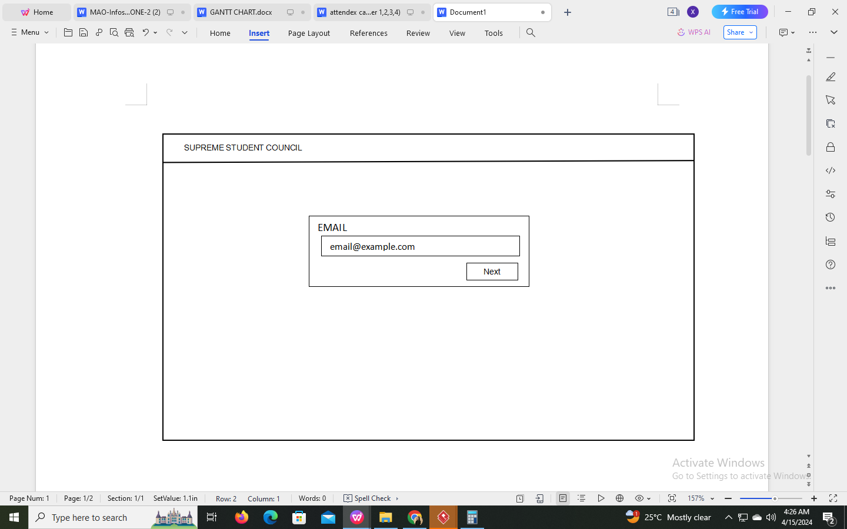

Input email

Figure 3.27: Officers need to input their email address before evaluating.
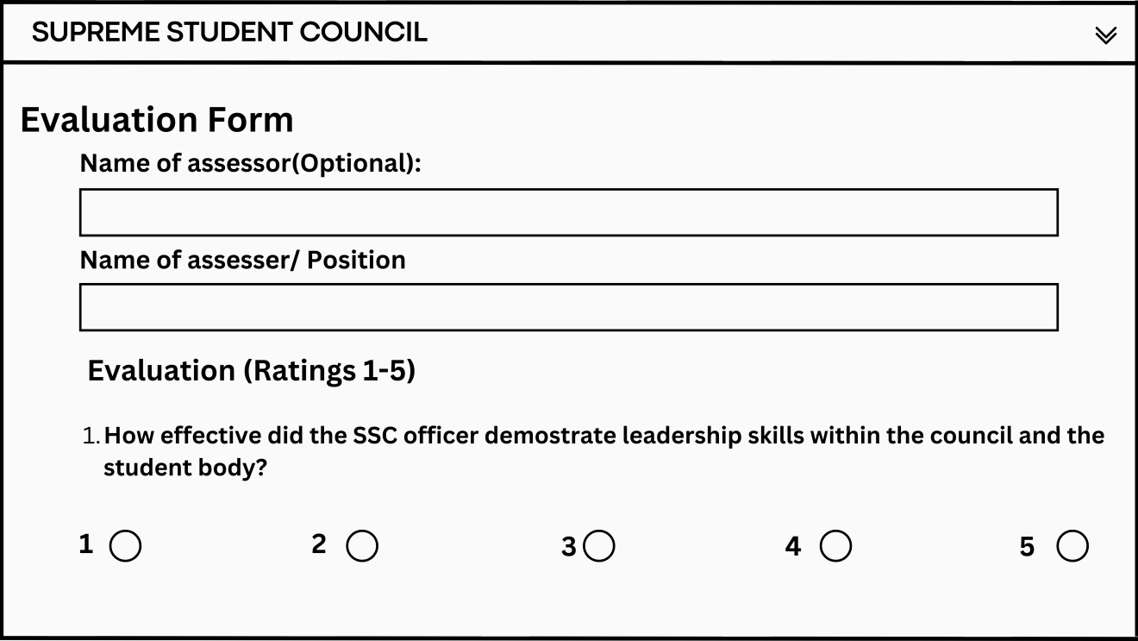
Ratings from 1-5
Input assessee’s name and position
Input assessors name
Figure 3.28: SSC officers access this page to provide peer evaluations and feedback.
Front Page
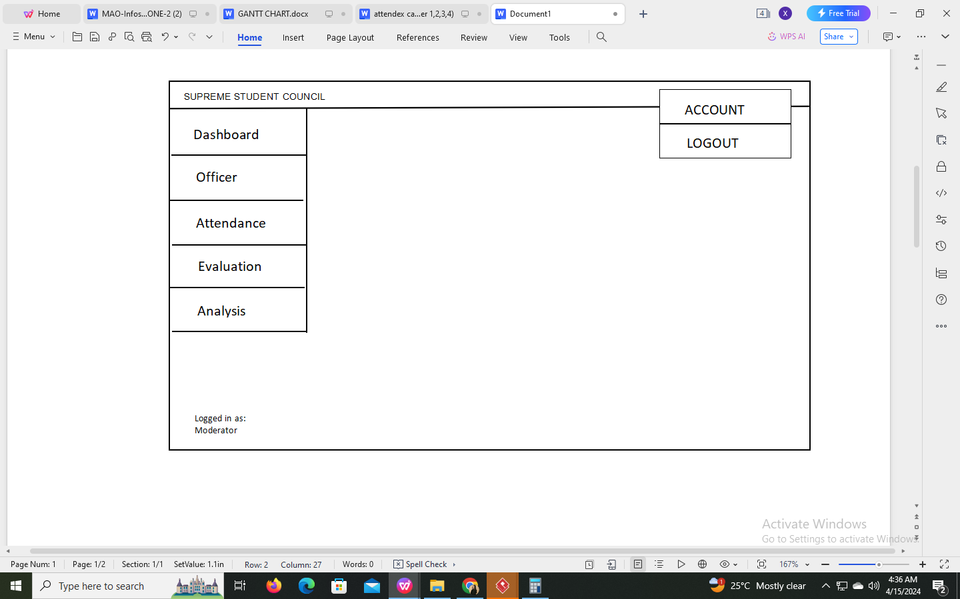
Logout
Admin’s account
Figure 3.29: Administrator’s front page.

Admin’s Account Information Page
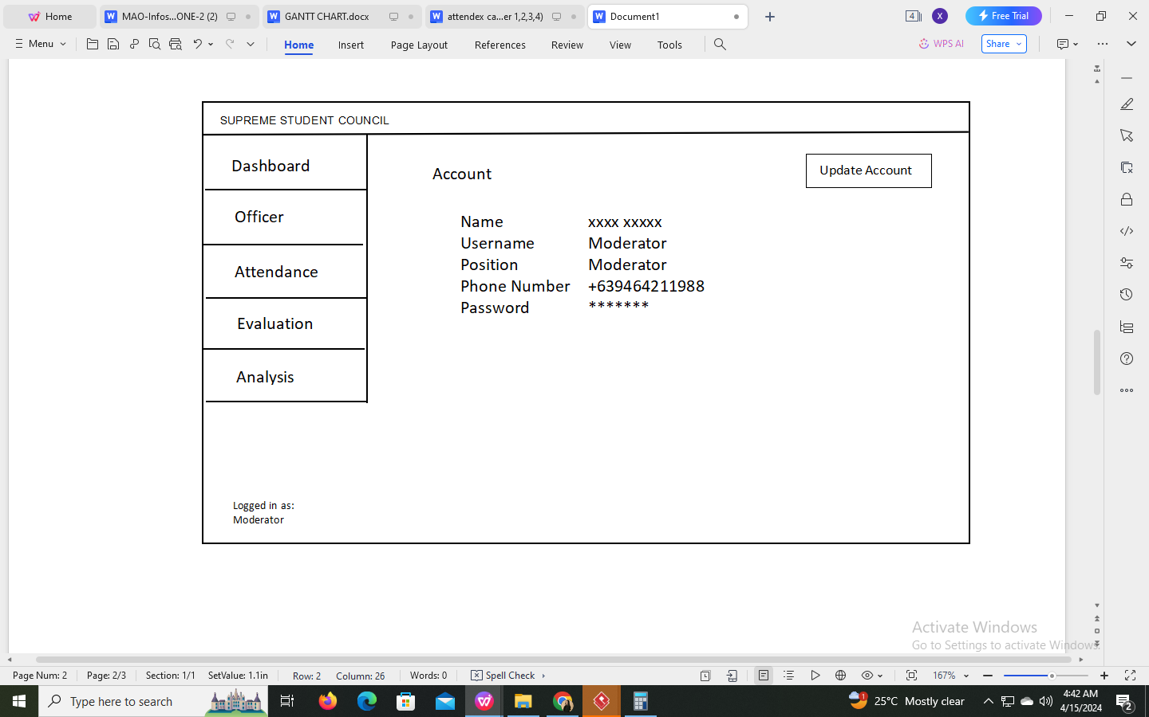
Update information
Figure 3.30: Administrator’s account information where they can update their information.
Update Account Information Page
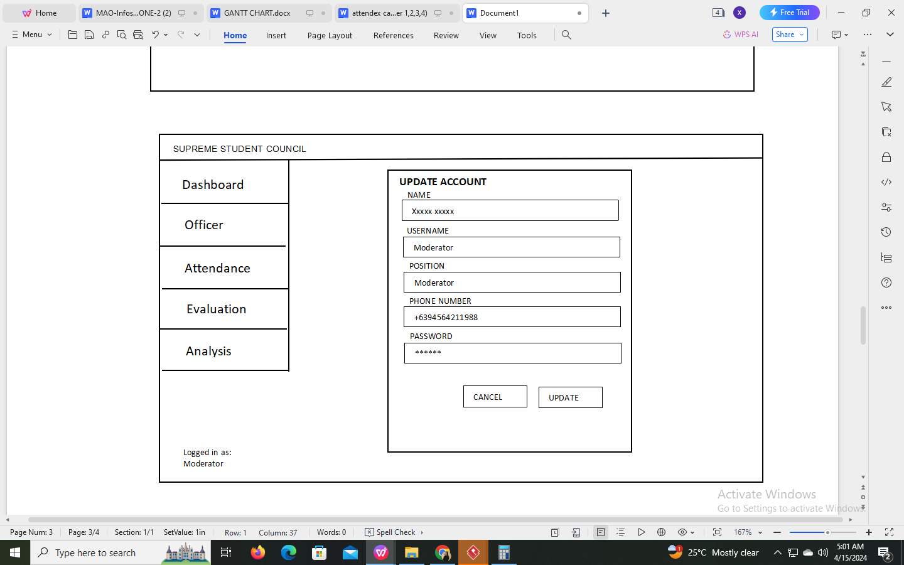
Update password
Update number
Update position
Update username
Update name
Update
Cancel
Figure 3.31: Administrator’s update account page.

Dashboard Page
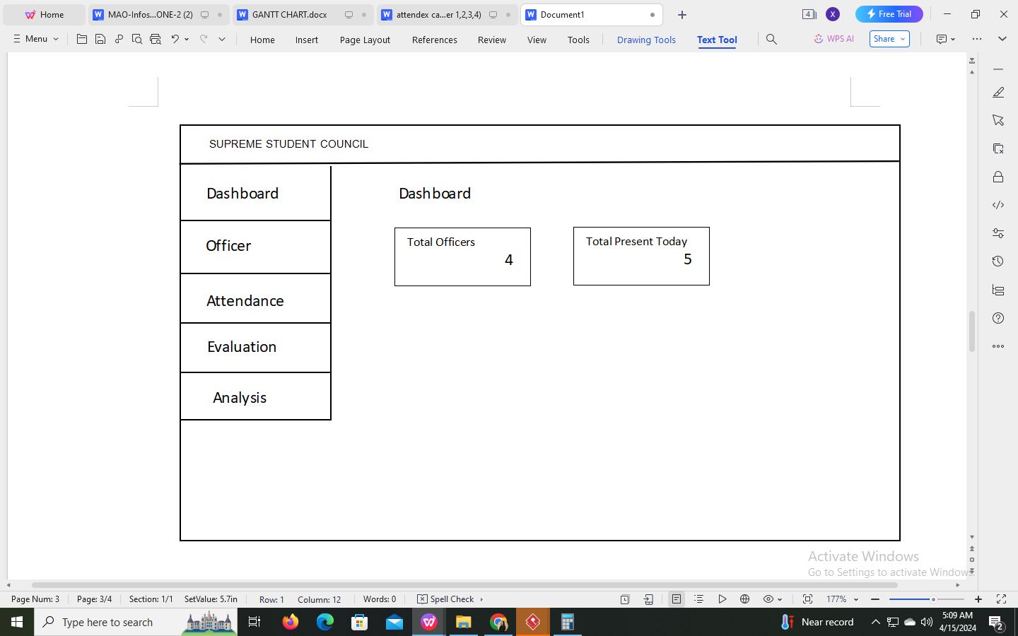
Total present for current date
Total officers
Dashboard
Figure 3.32: The dashboard provides an overview of total officers, and total present.
Officer’s Page
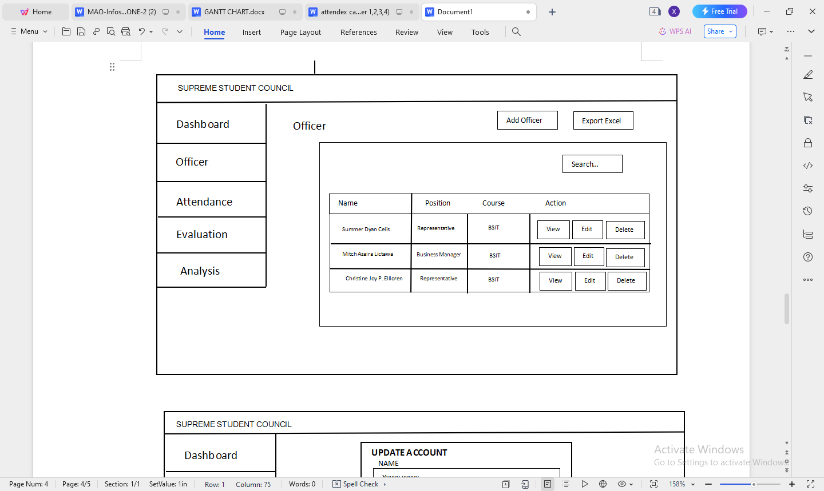
Edit
View officers information
Officers
Delete
Export to Excel
Search Information
Add officer
Figure 3.33: This page contains the list of officers and facilitates the registration of SSC officers.

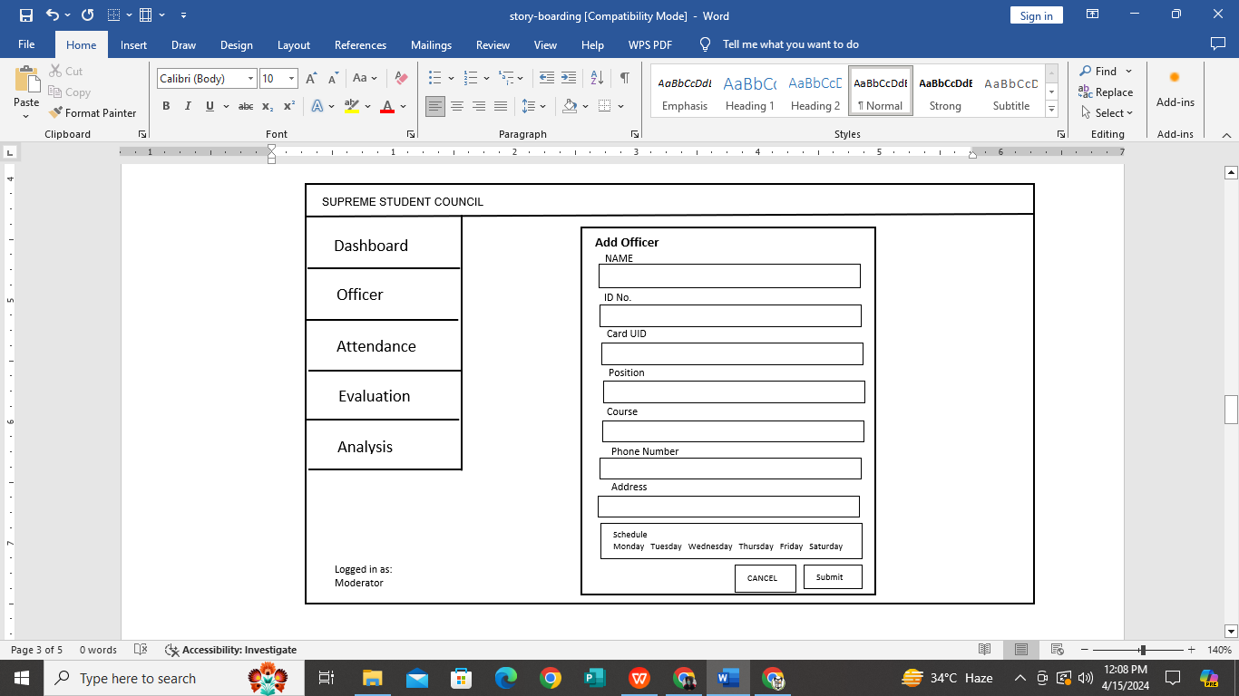
Add Officer’s Page

Input name

Input student ID no.
Scan RFID card
Input position
Input course

Input phone number
Input address
Select scheduled duty
Cancel

Submit

Figure 3.34: In this page the admin can enter essential details, assign roles, and scan RFID cards.
Update Officer’s Page
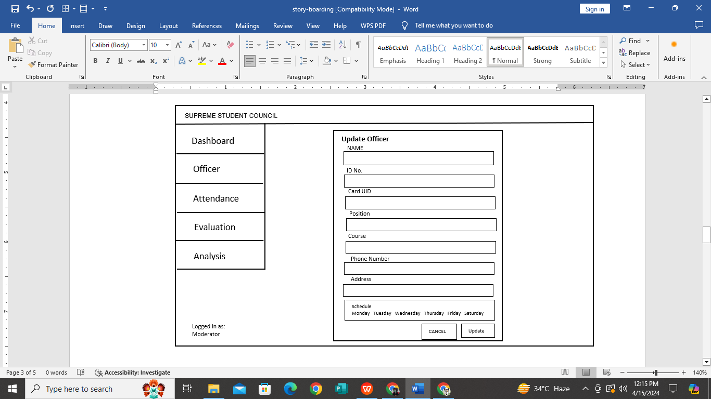
Update
Cancel
Update address
Input phone number
Update course
Update position
Update name
Update student ID no.
Scan RFID card
Update scheduled duty
Figure 3.35: In this page the admin can enter essential details, assign roles, and scan RFID cards.

Attendance Page
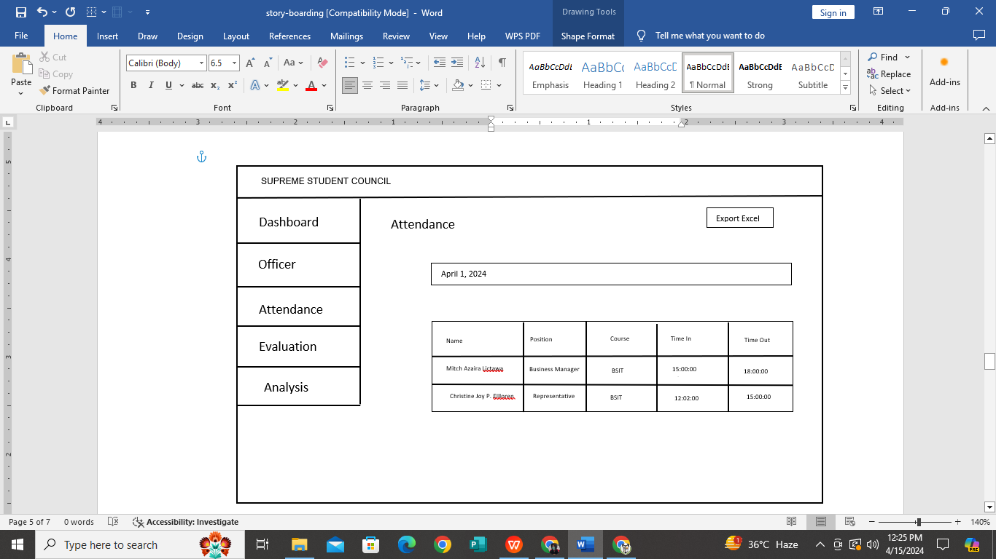
Attendance
Export attendance
Figure 3.36: The attendance overview page where both moderator and officers can view attendance records. And this is where the record goes when the officers taps their RFID cards.
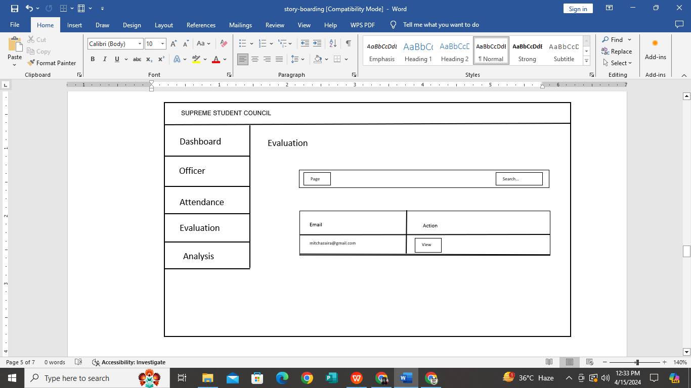
Evaluation Page

Search name

Evaluation

View evaluation

Figure 3.37: This page consolidates all completed peer evaluations submitted by officers.

Analysis/ Report’s Page

Analysis
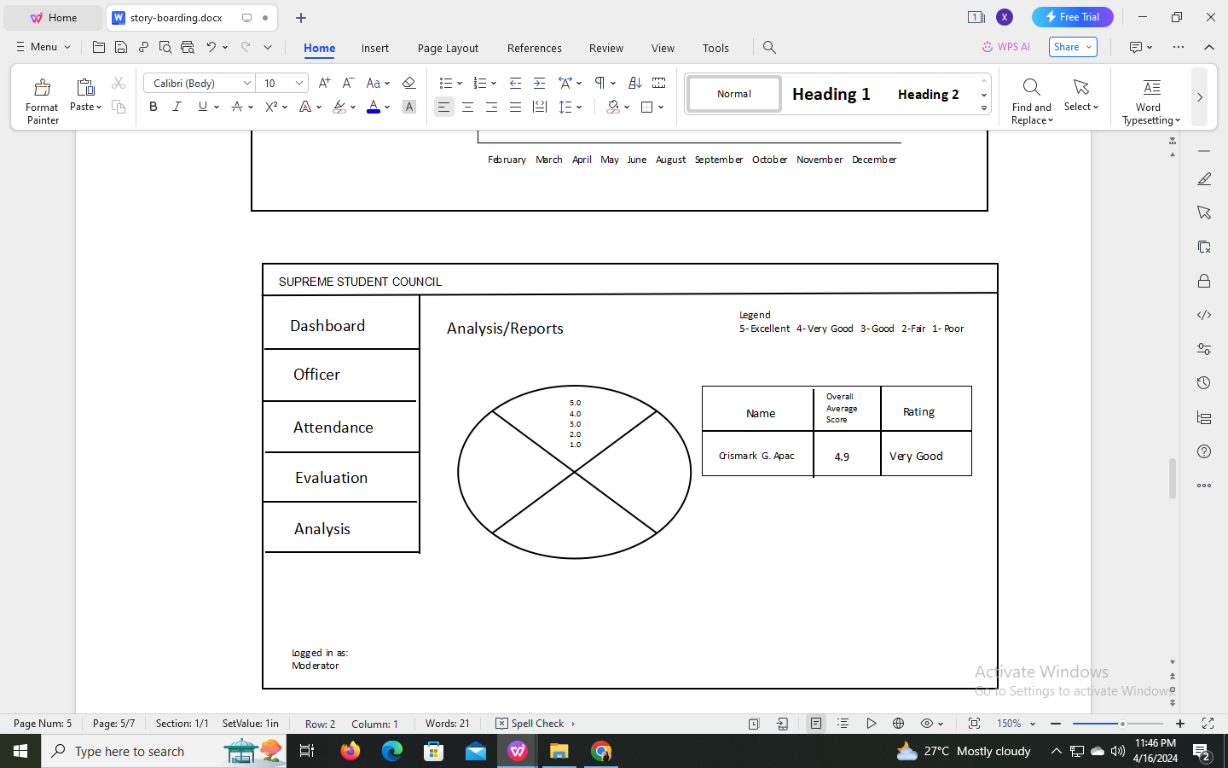
Rating report
Figure 3.38: The Analysis and Reports Overview page serves as a comprehensive analytic, providing moderators with valuable insights derived from attendance and evaluation data.

Database Design
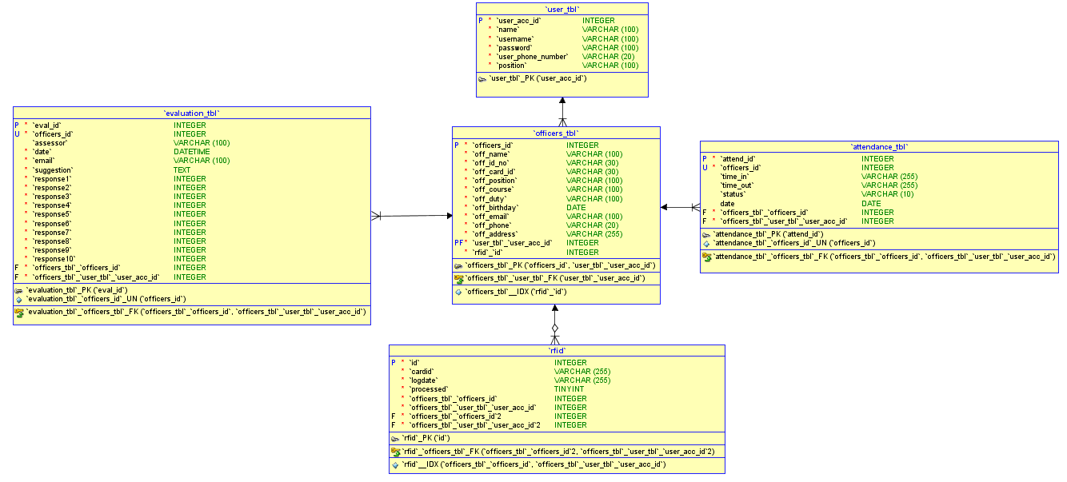
1:1
1:1
1:M
M:1
Figure 3.39: Database Design of RFID-based Attendance Tracking and Evaluation System with Web Interface and Excel Integration (AttendEX).

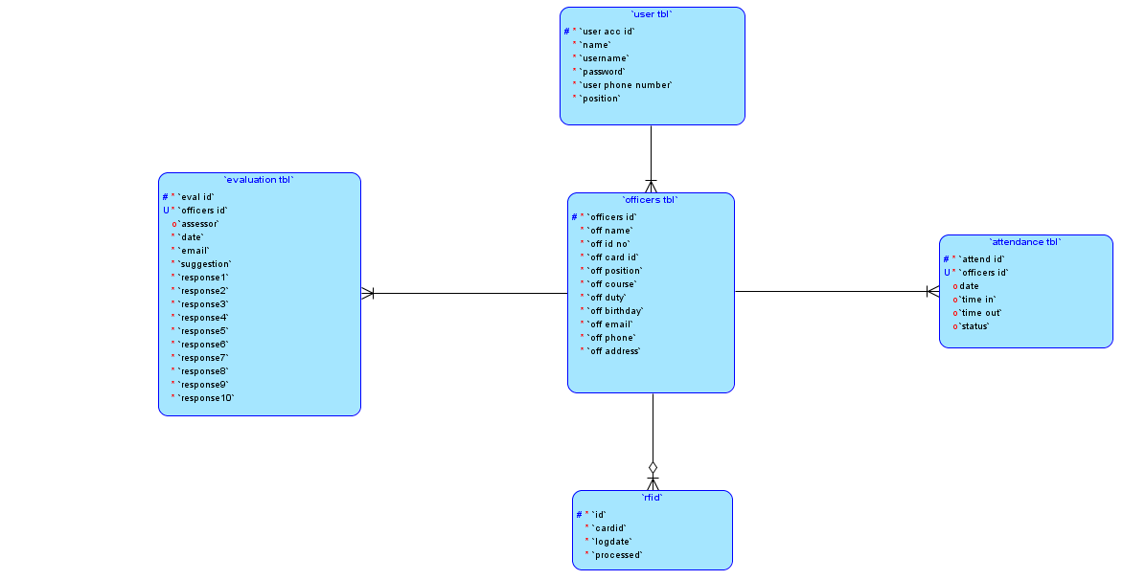
Entity Relationship Diagram

on
include

submit
scan
submitted by
scan by

required
on

Figure 3.40: Entity Relationship Diagram of RFID-based Attendance Tracking and Evaluation System with Web Interface and Excel Integration (AttendEX).
Data Dictionary
Table Name: | user_table
Description: | Displays the user information.
Attribute Name | Description | Data Type | Default Value | Null
user_account_id | User ID number | int(11) | PK | No
name | User’s name | varchar(100) | None | No
username | User’s username | varchar(100) | None | No
password | User’s password | varchar(100) | None | No
user_phone_number | User’s phone number | varchar (20) | None | No
position | User’s position | varchar(100) | None | No
Table 3.1: Data Dictionary of User Table of the AttendEX System.
Table Name: | officers_tbl
Description: | Displays the officers information.
Attribute Name | Description | Data Type | Default Value | Null
officers_id | Officer’s ID number | int(11) | PK | No
off_name | Officer’s name | varchar(100) | None | No
off_id_no | Officer’s student ID number | varchar(30) | None | No
off_card_id | Officer’s card ID | int(20) | None | No
off_position | Officer’s position | varchar(100) | None | No
off_course | Officer’s course | varchar(100) | None | No
off_duty | Officer’s scheduled duty | varchar(100) | None | No
off_birthday | Officer’s birthday | Date | None | No
off_email | Officer’s email address | varchar(100) | None | No
off_phone | Officer’s phone number | varchar(20) | None | No
off_address | Officer’s Address | varchar(255) | None | No
Table 3.2: Data Dictionary of Officers Table of the AttendEX System.
Table Name: | attendance_tbl.
Description: | Displays the attendance information
Attribute Name | Description | Data Type | Default Value | Null
attend_id | Attendance ID number | int(11) | PK | No
officers_id | Officer’s ID number | int(11) | FK | Yes
date | Officer’s attendance date | date | currrent_timestamp() | Yes
time_in | Officer’s time in | time | currrent_timestamp() | Yes
time_out | Officer’s time out | time | currrent_timestamp() | Yes
status | Officer’s attendance status | varchar(10) | None | No
Table 3.3: Data Dictionary of Attendance Table of the AttendEX System.

Table Name: | evaluation_tbl
Description: | Displays the evaluation information.
Attribute Name | Description | Data Type | Default Value | Null
eval_id | Evaluation ID number | int(11) | PK | No
officers_id | Officer assessed | int(11) | FK | No
assessors | Assessor’s name | varchar(100) | None | Yes
email | Assessor’s email address | varchar(100) | None | No
date | Evaluation’s date | Datetime | currrent_timestamp() | No
suggestion | Assessor’s suggestion | text | None | No
response1 | Assessors rating for first question | int(5) | None | No
response2 | Assessors rating for second question | int(5) | None | No
response3 | Assessors rating for third question | int(5) | None | No
response4 | Assessors rating for fourth question | int(5) | None | No
response5 | Assessors rating for fifth question | int(5) | None | No
response6 | Assessors rating for sixth question | int(5) | None | No
response7 | Assessors rating for seventh question | int(5) | None | No
response8 | Assessors rating for eight question | int(5) | None | No
response9 | Assessors rating for ninth question | int(5) | None | No
response10 | Assessors rating for tenth question | int(5) | None | No
Table 3.4: Data Dictionary of Evaluation Table of the AttendEX System.

Table Name: | rfid
Description: | Displays the rfid cards log.
Attribute Name | Description | Data Type | Default Value | Null
id | RFID ID number | int(11) | PK | No
cardid | RFID card id | int(20) | None | No
logdate | RFID card log date | Datetime(30) | None | No
processed | Indicator for processed card/record | tinytint(4) | None | No
Table 3.5: Data Dictionary of Questions Table of the AttendEX System.

Network Design
Network design is the integration of different network devices to achieve end-to-end communication between network hosts, and to identify what type of topology is going to be used RFID-Based Attendance with Web Interface and Excel Integration.
Network Model
The network model that will be using is star topology model, In a star topology, the messages and each component is directly connected to the central hub that acts as a server and the connecting nodes as a client.
Figure 3.41:
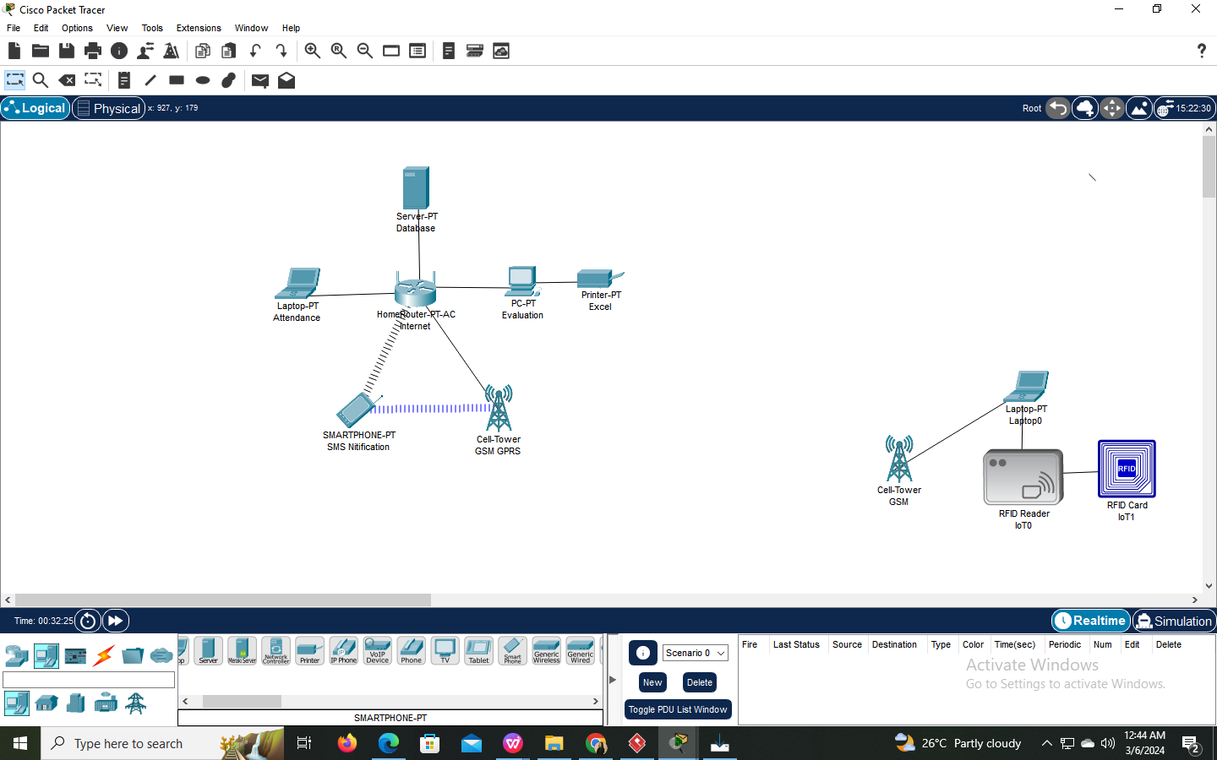
Software Network Model of RFID-based Attendance Tracking and Evaluation System with Web Interface and Excel Integration (AttendEX).

Figure 3.42:
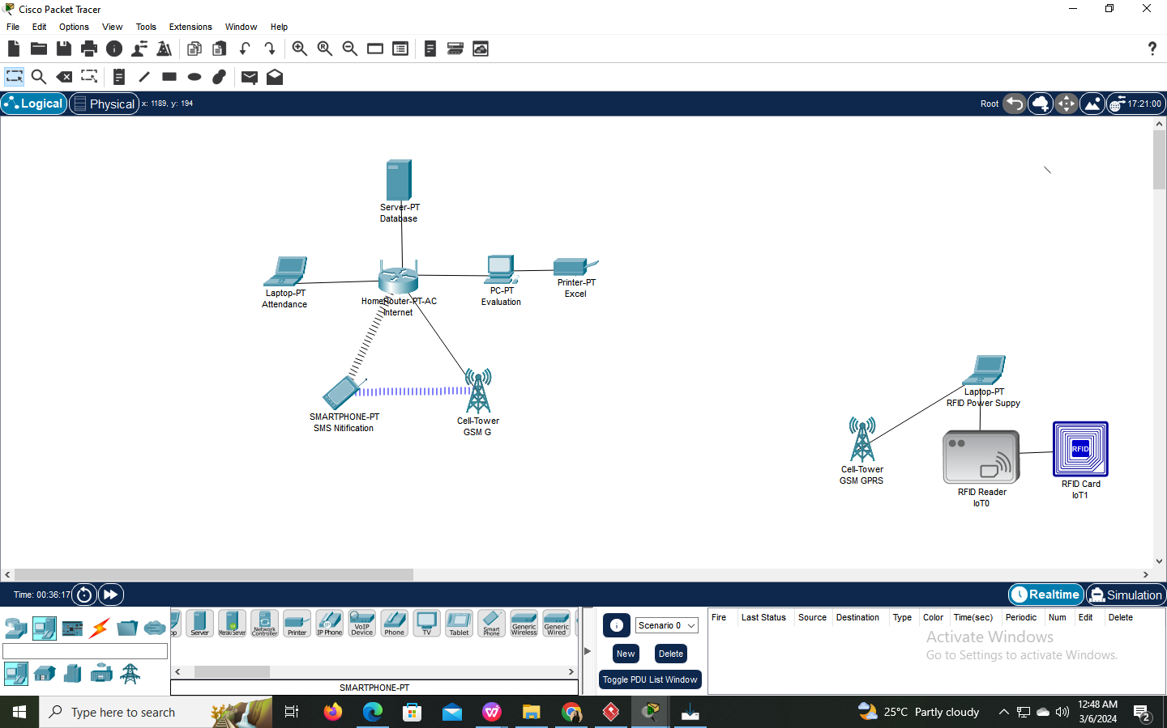
Hardware Network Model of RFID-based Attendance Tracking and Evaluation System with Web Interface and Excel Integration (AttendEX).

Network Topology
Star topology, a star network topology is characterized by a central hub or server that serves as the focal point of the network. Devices, such as RFID scanners, GPRS shields, PCs with user interfaces, and Wi-Fi access points, connect directly to the central hub. Data communication is efficiently managed through the hub, ensuring centralized control and reliability. This topology allows for easy scalability and isolates device issues, minimizing network disruptions.









Figure 3.43: Star Networking Topology of RFID-based Attendance Tracking and Evaluation System with Web Interface and Excel Integration (AttendEX).

HUB

List of Modules
Manage Officers
This module provide the administrator a process of registering SSC officers and committee members the system provide a key feature that is user-friendly interface for capturing essential user details, including names and unique student IDs.
Manage Attendance
This module provide the administrator RFID attendance optimizes attendance tracking for SSC officers and committees the system provide a key feature that are association of RFID cards or tags with SSC officers and committee members, automatic attendance recording through RFID card scanning and provide a SMS alerts sent to the moderator in real-time regarding attendance during duties, events, or activities.
Manage Evaluation
This module provide administrator an evaluation for the fosters teamwork and collaboration within the Supreme Student Council, this will provide SSC moderator a visualized evaluations and feedback of the team assessment.
Manage Report
This module provide the administrator generated reports and visual data representations for data analysis. The system provide a key feature that will provide automatic report and visualization generation, facilitating data analysis and decision-making.
Attendance
This module provide the officers and committee a fast and accurate attendance by scanning of RFID that will automatically store attendance data time in and out during duties, events, and activities.
Evaluation
This module provide the officers an evaluations and feedbacks of their peer which are visible to the moderator for team assessment and improvement.

Testing/ Quality Assurance Phase

Unit Testing
During this phase, the project researcher are testing every function and codes entered match each feature of the system, Additionally, they verify that the data in the database and the system are identical. Researchers implement unit testing for RFID-Based Attendance Tracking and Evaluation System with a Web Interface and Excel Integration to make every component operate as intended. This method enhances the system's maintainability and dependability by assisting in the early detection and correction of faults. For such a system, the following is an organized method for carrying out unit tests:
Accessibility: Allow users to assess the main features of the software modules to see if they are functioning properly. Additionally, it enabled them to determine whether it meshes well with the system's interface design.
Accuracy: Provide users with the ability to assess the speed and accuracy of data initiated and encoded, as well as forms and outcomes that demonstrate how well all information provided by the software program conforms to the standard format required by the software application. Examine test results to find any issues. Examine and resolve the codebase's underlying problems. To verify the fixes, run the tests again.
Functionality: Provide users with the ability to assess how the system applies its modules' functions. describing in detail whether each goal was reached and completed correctly. Continue to update and add additional tests to cover the changes as development moves forward and new features are added.

Integration Testing
The system modules that are logically integrated and tested application projects are being tested by the researchers. focuses on verifying that the system's various modules or components interact as intended by testing their interactions. The importance of this kind of testing lies in its ability to find problems that unit testing could miss, like data flow issues, mismatched interfaces, and integration concerns.

Figure 3.44:

Integration Testing figure of RFID-based Attendance Tracking and Evaluation System with Web Interface and Excel Integration (AttendEX).
INTEGRATION TESTING

NON-INCREMENTAL INTERGRATION TESTING

INCREMENTAL INTERGRATION TESTING

TOP - DOWN INTERGRATION TESTING
BOTTOM - UP INTERGRATION TESTING

Integration Testing: Bottom-Up Integration Approach
ID | Test Case Objective | Test Case Description | Expected Result
1 | Register officers essential details, including names, unique student IDs and etc. | View officers details. | Displayofficers details.
2 | Automatically records attendance by scanning RFID cards during duties, activities or events. | Scan the RFID card and Review the attendance record | Stored Officers Attendance.
3 | Send SMS alerts specifically to the moderator regarding the attendance of officers and committees during duties, events, or activities. | Generate SMS message. | Send and view SMS alert message.
4 | Peer Evaluation Assessment Feedback, allowing SSC officers to provide evaluations and feedback. | Generate and Review Evaluation. | Store evaluation
5 | Automatically generate attendance excel reports. | Display officers attendance. | Generate attendance in excel.

Table 3.6: Case Table of RFID-based Attendance Tracking and Evaluation System with Web Interface and Excel Integration Test

Alpha Testing
The researchers try and test it to find any errors and make sure that it meets all the requirements for the features and goals required. Make sure that all of the hardware, software, and problem fixes from the earlier testing are operational to ensure that everything is functioning properly. In order to provide the product to the SEAIT Supreme Student Council, the system software must be fully operational.
Evaluation Methodology
Evaluation of the system is a critical part of development. This will be evaluated based on how well the system functions, meets its objectives, and delights its users. The study assessed the system's usability, accessibility, and acceptability using the descriptive-development research methodology.
Respondent of the Study
The respondent of the study was composed of 2 possible users the moderator and officer
This study used a checklist and a rating scale questionnaire to gather the needed data and the responses to evaluate the system.
The checklist was used to evaluate the functionality contains a checklist form. included in the system, and for the accuracy, and accessibility contains the list of all system objectives and deliverables that the researchers want the respondents to check and evaluate. The frequency counts and the percentage will be computed.
Weighted Mean. This tool was used to provide answer to the questions.
The formula is:
WM
Where:
WM = weighted mean
X = number of respondents
Wi = Weight given to each respondent
N = number of cases
To check the functionality, accessibility, acceptability, and accuracy of the system, a 5-point Likert Scale is shown in the table. The mean was computed and interpreted in the table below.

Table 3.7:

Interpretative Scale used to interpret the Weighted Mean

CODE | MEAN RANGE | DESCRIPTION
5 | 4.20-5.00 | Strongly Agree
4 | 3.40-4.19 | Agree
3 | 2.60-3.39 | Moderately Agree
2 | 1.80-2.59 | Disagree
1 | 1.00-1.79 | Strongly Disagree

Acceptance Testing
The Supreme Student Council Office served as the testing and evaluation site for this project.This was participated with the moderator and officers. The assessment form and a follow-up interview were used in this project to gather data. We created and distributed questionnaires to the participants.
Table 3.8:

Evaluation Result of the System’s Functionality

No. | Functionality | Weighted Mean | Interpretation
1.1 The system typically measured 4.1 Agree
the accuracy of officer’s
attendance reports.
1.2 The system can assist users 4.7 Strongly Agree
to loo for User Satisfaction
1.3 The system can display 5.0 Strongly Agree
attendance reports
and provide SMS alert
1.4 The system can generate excel 4.8 Strongly Agree
attendance and statistical reports
TOTAL |  | 4.65 | Strongly Agree

Table 3.8: Shows the result of the system’s functionality with a weighted mean of 4.65 denotes that the respondents “Strongly Agree” that the system has the capability to provide functions which met the stated and implied the needs of the users under the specified condition of usage. The system performed the task required such as record attendance and generate excel attendance reports for the SSC.
Table 3.9:

Evaluation Result for System’s Accuracy

No. | Accuracy | Weighted Mean | Interpretation
1.1 The regiers ster informatiion of 4.4 Strongly Agree
the offic
1.2 The system automatically 5.0 Strongly Agree
records attendance by
scanning RFID cards
during duties
1.3 The system that will send 4.67 Strongly Agree
SMS alerts specifically to the
moderator regarding the
attendance of officers
1.4 The provide evaluation for 1.0 Strongly Disagree
the officer.
1.5 The admin can generate the 4.2 Strongly Agree
attendance with the details of
the officers
TOTAL |  | 4.47 | Strongly Agree

Table 3.9: Shows the result of the system’s accuracy with a 4.47 weighted mean, which denotes that the respondents “Strongly Agree” that the system-generated officers reports and information for evaluation are well-identified and accurate. The result means that the user’s information can be properly store and record their details and modified with necessary accuracy and properly arranged.

Table 3.10:
Evaluation Result for System’s Acceptability

No. | Acceptability | Weighted Mean | Interpretation
1.1 The register informatiion of 4.4 Strongly Agree
the officers
1.2 The system automatically 4.2 Strongly Agree
records attendance by scanning
RFID cards during duties
1.3 The system that will send SMS 5.00 Strongly Agree
alerts specifically to the moderator
regarding the attendance of officers
1.4 The provide evaluation for 4.3 Strongly Agree
the officers
1.5 The admin can generate the 4.4 Strongly Agree
attendance with the details of
the officers
TOTAL |  | 4.46 | Strongly Agree

Table 3.10: Shows the result of systems acceptability with a 4.46 weighted mean, which denotes that the respondents “Strongly Agree” that the system application acceptability is highly acceptable.
Table 3.11:

Overall Evaluation Result of the System

Overall Result | Weighted Mean | Interpretation
Functionality | 4.65 | Strongly Agree
Accuracy | 4.47 | Strongly Agree
Acceptability | 4.46 | Strongly Agree
Overall Mean | 4.53 | Strongly Agree
Table 3.11: Shows the overall result of the system’s evaluation with an overall mean of 4.53 which denotes that they “Strongly Agree” that the system is functional, accurate, and acceptable in terms of system analysis and results. This proved that the system requirements and accepted by the Supreme Student Council.

Implementation/ Deployment Phase

Deployment Diagram
The diagram shows the flow of the system on how to utilize and RFID-Based Attendance Tracking and Evaluation System with Web Interface and Excel Integration on how convenient having system. This shows the process of data and flows on how the systems work.
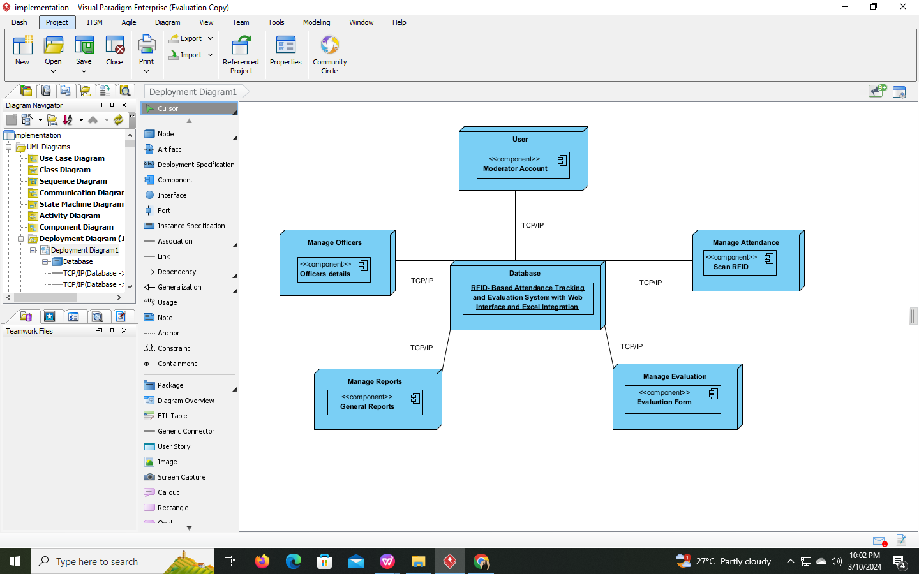
Figure 3.45: Deployment Diagram of RFID-Based Attendance Tracking and Evaluation System with Web Interface and Excel Integration (AttendEX).

Implementation Budget/Cost Specification
BENEFITS | 2023 | 2024 | 2025 | 2026 | 2027 | TOTAL
Production Materials |  | 8,000 | 8,000 | 8,000 | 8,000 | 32,000
Paper |  | 3,000 | 3,000 | 3,000 | 3,000 | 12,000
Salary / Labor |  | 25,000 | 25,000 | 25,000 | 25,000 | 100,000
TOTAL BENEFITS |  | 36,000 | 36,000 | 36,000 | 36,000 | 144,000
DEVELOPMENT COST
Hardware Qualification | 5,000 |  |  |  |  | 5,000
Supplies Expense | 3,000 |  |  |  |  | 3,000
Transportation Expense | 2,000 |  |  |  |  | 2,000
Electricity Expense | 2,000 |  |  |  |  | 2,000
Research Expense | 5,000 |  |  |  |  | 5,000
Training Expense | 3,000 |  |  |  |  | 3,000
Project and Salaries/ Wages Cost | 25,000 |  |  |  |  | 25,000
Others | 2,000 |  |  |  |  | 2,000
Total Development Cost | 47,000 |  |  |  |  | 47,000
Operational Cost
Telecommunication Expense |  | 5,000 | 5,000 | 5,000 | 5,000
Total Operational Cost |  | 5,000 | 5,000 | 5,000 | 5,000 | 20,000
Total Cost (TD+TD) | 47,000 | 4,656.25 | 4,656.25 | 4,656.25 | 4,656.25 | 65,625
Total Benefit–Total Cost – Total Operational Cost | -47,000 | 65,625 | 65,625 | 65,625 | 65,625 | 195,500
Cumulative Net Cash Flow | -47,000 | 13,500 | 74,000 | 134,500 | 195,500
Return of Investment (Roi) | 536.06
Break Even Point | 1.34015 | Cost is fully recovered within 1 year and 8 months

Figure 3.46: Implementation Budget/Cost of RFID-Based Attendance Tracking and Evaluation System with Web Interface and Excel Integration (AttendEX).

Development/ Construction/ Build Phase

Technology Stack

DATABASE
MySQL
PHP
Programming Language
APACHE
Web Server
WINDOWS
Operating System
Other Tools

Figure 3.47: Technology Stack of AttendEX.

- SOFTWARE SPECIFICATION
Language: PHP
Technology: No specific framework
Database: MySQL
IDE: Visual Studio Code
Operating System: Windows 11
HARDWARE SPECIFICATION
Processor: 11th Gen Intel® Core™ i3-1115G4
RAM: 8GB
Storage: 475 GB
Other Hardware
RFID Reader: RFID-RC522
Wi-Fi Access Point: Globe At Home Prepaid Wifi
GPRS Shield: SIMCom SIM900
Program Specification
Language: PHP
Database: MySQL
IDE: Visual Studio Code

Human Resource Specification
Admin- must have the basic knowledge about technology such as opening and managing documents, typing, scanning or printing. He/She must also know basic how to use computing devices, must know basic file manage techniques, how to explore applications, and must know the background of this system including the attendance process using RFID card and reader to be used.
Employee- must be familiar with technologies such as RFID cards, a reader that scans for attendance, and desktop computers or laptops.

Risk Management Plan/ Framework

Risk Management Process
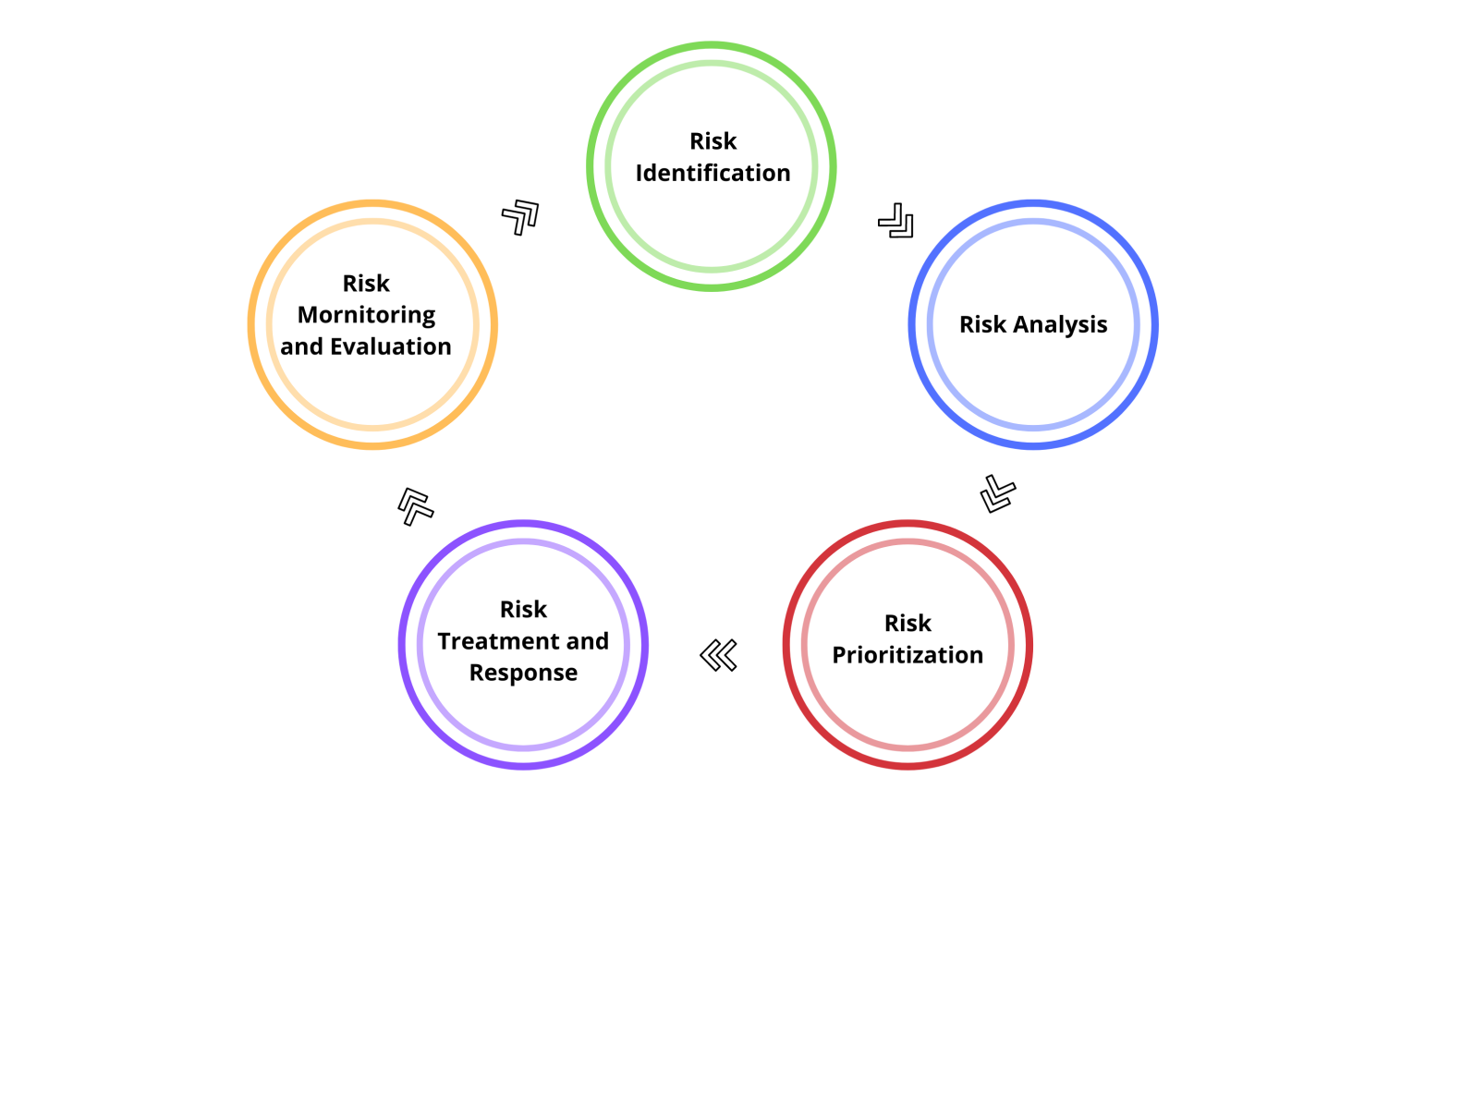
Figure 3.48: Risk Management Process Cycle of RFID-Based Attendance Tracking and Evaluation System with Web Interface and Excel Integration (AttendEX).

STEP 1: Risk Identification
During Risk identification, the project team will have an obligation to recognize and categorize risk sources. The project team and developers are responsible for detecting and troubleshooting any risks, including faults or possible problems, that might impact the system's structure and output. The hacker, who is part of the development team, will attempt to take control of the system to identify particular spots of vulnerability.

Step 3: Risk Prioritization
Prioritizing risks is the process of figuring out which ones require your immediate attention. This ought to be determined by the possibility of risk and the potential consequences. Prioritizing risks can be accomplished by comparing them to the project and determining which are more likely to materialize and which will have a greater impact.
Step 4: Risk Treatment an Response
The risk response planning lessen or eliminate project dangers as well as how to maximize their impact. The goal of project managers should be to get rid of threats before they happen. In addition, the project manager has to raise the probability and importance of opportunities while lowering the probability and impact of risk.
Step 5: Risk Monitoring and Evaluation
In a risk evaluation, estimated threats are compared to per-established risk criteria inside the organization. Risk factors may include related expenses and advantages, regulatory obligations, and system failures.

User-Guide
The Admin/User will be guided through the RFID-Based Attendance Tracking System and Evaluation with Web-Interface and Excel Integration.
1.0 System Login - The Admin will be required to enter his/her given username and password.
1.1 Officer Management - The Admin will be able to register officer’s RFID-cards and information such as: Personal Information, Position, course, and School ID number.
1.2 Officer Attendance - The Admin will be able to view the attendance and click the export button to export the data into Excel.
1.3 Evaluation - The Admin will review the the evaluations by officers to monitor their performance.
1.4 Reports - The Admin will see a bar graph showing the Officer’s performance over the month.
1.5 Dashboard - The dashboard will display the total officers and provides real-time total count of officers who attended on the current date.
1.6 The Attendance Frame will be connected to RFID-Card reader that will be used by officers to tap their RFID cards when logging in and logging out.
1.7 Evaluation Form - The user/Officer will be able to evaluate their co-officers and submit the form.

Installation Guide
Here are the following steps in installing AttendEx to your desktop/Laptop devices:
The installation process has 3 stages:
- 1. Installation of Required Software
- 2. Database Installation
- 3. System Installation
- Install XAMPP for Windows:
- Visit the official XAMPP website: https://www.apachefriends.org/download.html
- Download the XAMPP installer for Windows.
- Run the installer and follow the on-screen instructions to complete the installation.
2.Start Apache and MySQL:
- Open the XAMPP Control Panel after installation.
- Start the Apache server by clicking the "Start" button next to "Apache."
- Start the MySQL server by clicking the "Start" button next to "MySQL."
3.Access MySQL Admin Panel:
- Open your web browser.
- Go to http://localhost/phpmyadmin/ to access the MySQL administration panel or click the “Admin” next to “Start” button.
- Obtain AttendEx Zip File:
- Obtain the AttendEx application zip files containing the system files.
- Extract AttendEx Files:
- Extract the system files to a directory within the XAMPP htdocs folder (typically located at C:\xampp\htdocs\).
- Access AttendEx:
- Run AttendEx by accessing it through your web browser.
- The link to access the system: http://localhost/Attendex/signin.html

CHAPTER IV
Summary
The study found that AttendEx, RFID-Based Attendance Tracking and Evaluation System with Web Interface and Excel Integration created for the Supreme Student Council of South East Asian Institute of Technology (SEAIT), efficiently record the student body attendance and evaluation. AttendEx improves communication and performance capabilities by including user-friendly features like automated attendance, peer assistment evaluation, and SMS alerting systems for the moderator. Testing verifies AttendEx’s functioning, accuracy, and acceptance, with users strongly agreeing that it improves accuracy and security. The approach successfully addresses issues such as inefficient communication during an event, difficulty in monitoring attendance, performance rating, and obstacles encountered in decision making. AttendEx emerges as a dependable solution for the different monitoring needs of SEAIT Supreme Student Council, creating confidence among student body and fighting disinformation among the organizations.
Conclusion
In conclusion, “AttendEx, RFID-Based Attendance Tracking and Evaluation System with Web Interface and Excel Integration" is an important step in improving the accuracy and efficiency of the Supreme Student Council of South East Asian Institute of Technology (SEAIT). The research effectively identifies and tackles significant issues with attendance communication, performance, and student body obstacles at events. AttendEx is built using the Agile technique, with straightforward features and thorough testing to assure operation, accuracy, and acceptance. The findings highlight AttendEx's success in reducing inconsistent records and inaccuracy concerns, building trust with organizations, and countering misinformation and misunderstanding in the student body. AttendEx emerges as a dependable solution, offering SSC SEAIT with easily accessible and real-time records, ensuring an accountable and more efficient environment. Moving forward, the deployment and ongoing refinement of AttendEx provide prospective options for improving SSC managing attendance and performance at SEAIT and other organizational institutions confronting comparable difficulties.
Recommendation
The “AttendEx, RFID-Based Attendance Tracking and Evaluation System with Web Interface and Excel Integration” offers a transformative solution to streamline attendance monitoring and recording processes at the Supreme Student Council. Several recommendations are put forth to maximize its potential impact and ensure its seamless integration into daily operations. As a recommendation, AttendEx should make further improvements, such as optimizing the system to handle many simultaneous users and RFID scans by implementing load balancing, implementing algorithms to detect anomalies in attendance data, and integrating an advanced offline recording of attendance and evaluation system for accurate demand forecasting and resource allocation. Implementing these recommendations will elevate user satisfaction and position itself for sustained success and growth.

REFERENCES

References
Alrikabi, H. Th. S., Alaidi, A. H. M., & Abed, F. T. (2018, June 10). Attendance System Design and implementation based on Radio Frequency Identification (RFID) and Arduino.
https://www.researchgate.net/publication/328051941_Attendance_System_Design_and_implementation_based_on_Radio_Frequency_Identification_RFID_and_Arduino
Amora, E. N. O., Romero, V. K., Amoguis, R. C., Olandria, J. E., Olandria, E. N. & Bernales, A. M. J. (2020, December). Web-based attendance monitoring system.
https://www.ioer-imrj.com/wp-content/uploads/2020/12/Web-%E2%80%93-Based-Attendance-Monitoring-System.pdf
Bharathy, Ms, et al. (2021, June). International Journal of Advances in Engineering and Management (IJAEM) Smart Attendance Monitoring System Using IoT and RFID. Vol. 9001, 2008, p. 1307,
ijaem.net/issue_dcp/Smart%20Attendance%20Monitoring%20System%20using%20IoT%20and%20%20RFID.pdf, https://doi.org/10.35629/5252-030613071313.
Calo, A. M. V. M., Barbosa, J. B., & Llevado, J. C. (2021, December 22). In-Classroom Faculty Attendance Monitoring System based on Ultra High Frequency (UHF) Radio Frequency Identification (RFID) with Captured Image Cross-verification Mechanism.
https://doi.org/10.17485/ijst/v14i45.1782
Dultiao, J. A. L. & Duldulao, A. V. (2019). IT CENTER ATTENDANCE MONITORING SYSTEM USING RFID.
https://ejournals.ph/article.php?id=17045
Joshi, A., Saxena, A., Ahmad, A., & Juneja, P. (2021, January 1). RFID Based Attendance System.
https://doi.org/10.46501/ijmtst0701009
Qureshi, M. R. J. (2020, May). The Proposed Implementation of RFID based Attendance System.
https://doi.org/10.2139/ssrn.3635316
Rjeib, H. D., Ali, N. santaS., Farawn, A. A., Al-Sadawi, B., & Alsharqi, H. (2018, January 1). Attendance and Information System using RFID and Web-Based Application for Academic Sector.

https://doi.org/10.14569/ijacsa.2018.090137

Mrabet, H. E., & Moussa, A. A. (2020). IoT-School Attendance System Using RFID Technology. In www.learntechlib.org. International Association of Online Engineering.

https://www.learntechlib.org/p/217817/
Nivetha, R., Kavipriya, M., Pavithra, R., Jeyanthi, C., & Lakshmi, V. S. (2020, October). Student Attendance System Using RFID.
https://journal.ijresm.com/index.php/ijresm/article/view/327/302
Santander , J. R. B. (2018). iNotify&Monitor System with Data Analytics using RFID and Mobile Broadband Technology. researchgate.net.
https://www.researchgate.net/publication/323595239_iNotifyMonitor_System_with_Data_Analytics_using_RFID_and_Mobile_Broadband_Technology
Ula, Pratama, Asbar, Fuadi, Fajri, & Hardi. (2021). A New Model of The Student Attendance Monitoring System Using RFID Technology. Journal of Physics: Conference Series. Retrieved September 15, 2023, from
https://iopscience.iop.org/article/10.1088/1742-6596/1807/1/012026

CURRICULUM VITAE

APPENDIX D
(Map of Research Environment)

MAP OF RESEARCH ENVIRONMENT
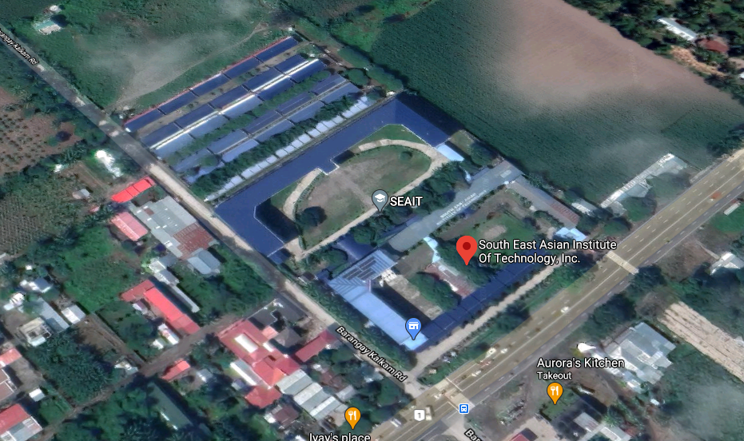

Supreme Student Council, South East Asian Institute of Technology, Incorporated,
National Highway, Tupi, South Cotabato, 9505

APPENDIX E
(Project Documentation)

