1. Router Forwarding Table:  
   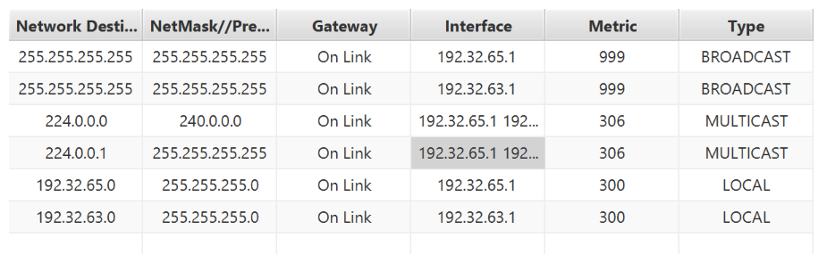

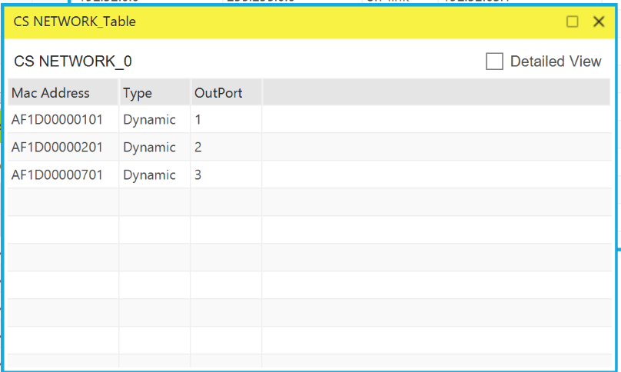

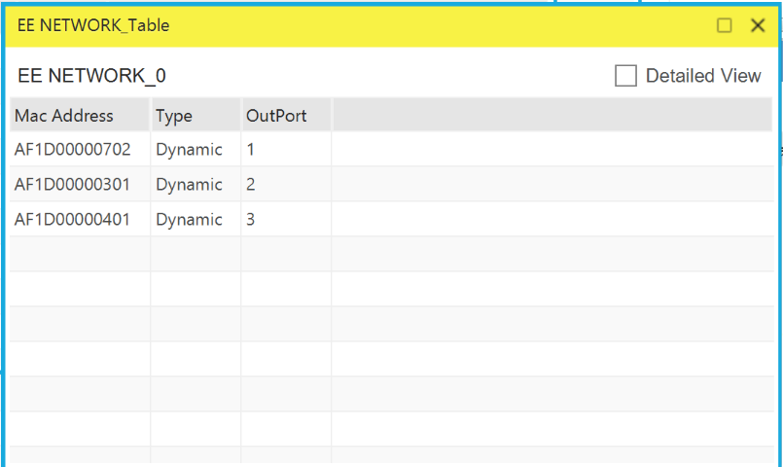

1. (A) Default Gateway . . . . . . . . . : 10.2.0.1

(B) arp -a

Output:   
Internet Address Physical Address Type

10.2.0.1 00-00-0c-9f-f0-d3 dynamic

10.2.0.2 70-7d-b9-63-ff-27 dynamic

10.2.0.138 3a-ec-47-ad-8b-64 dynamic

10.2.0.152 0a-c7-82-4f-47-21 dynamic

10.2.0.154 ea-b6-18-6e-8e-7a dynamic

