- Router Forwarding Table:
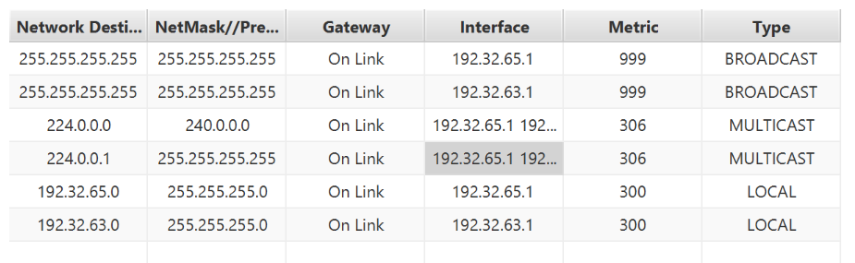

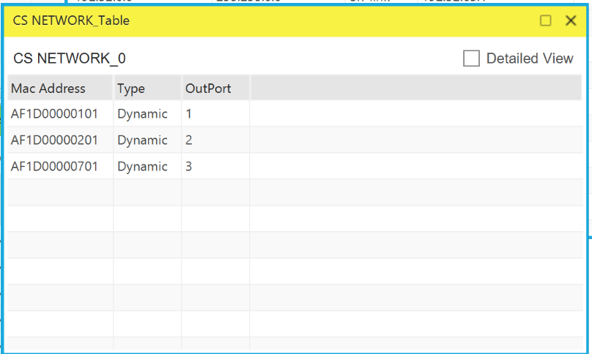
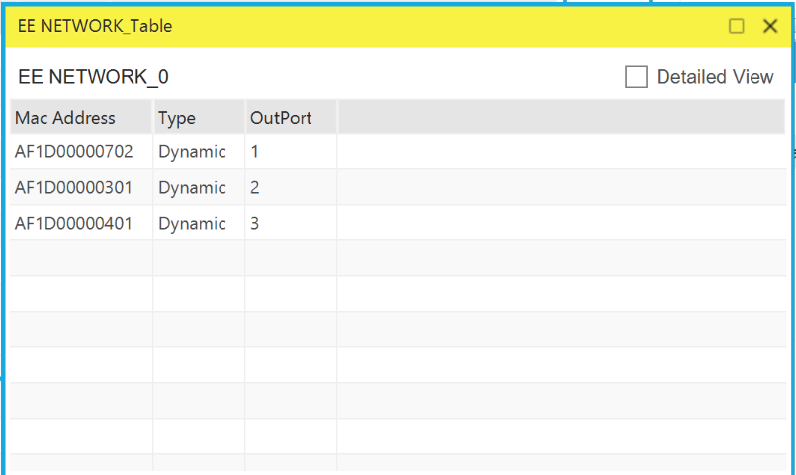

- (A) Default Gateway . . . . . . . . . : 10.2.0.1
(B) arp -a
Output:
Internet Address Physical Address Type
10.2.0.1 00-00-0c-9f-f0-d3 dynamic
10.2.0.2 70-7d-b9-63-ff-27 dynamic
10.2.0.138 3a-ec-47-ad-8b-64 dynamic
10.2.0.152 0a-c7-82-4f-47-21 dynamic
10.2.0.154 ea-b6-18-6e-8e-7a dynamic

