Red Hat Tower 3.8.4:

Ansible Tower Upgrades Engagement Journey

For Hong Kong Jockey Club

# Preface

## Confidentiality, Copyright, and Disclaimer

This is a Customer-facing document between Red Hat, Inc. and Hong Kong Jockey Club (“HKJC”).

Copyright ©2019 Red Hat, Inc. All Rights Reserved. No part of the work covered by the copyright herein may be reproduced or used in any form or by any means – graphic, electronic, or mechanical, including photocopying, recording, taping, or information storage and retrieval systems without permission in writing from Red Hat except as is required to share this information as provided with the aforementioned confidential parties.

This document is not a quote and does not include any binding commitments by Red Hat. If acceptable, a formal quote can be issued upon request, which will include the scope of work, cost, and any customer requirements as necessary.

## Trademarks

Trademarked names may appear throughout this document. Rather than list the names and entities that own the trademarks or insert a trademark symbol with each mention of the trademarked name, the names are used only for editorial purposes and to the benefit of the trademark owner with no intention of infringing upon that trademark.

## Audience

This document is intended for Client technical staff responsible for the environment.

## Additional Background and Related Documents

This document does not contain step by step details of installation or other tasks, as they are covered in the relevant documentation on <http://access.redhat.com/>.

Links to the appropriate documents will be made when required.

## Scripts and playbooks

Any scripts provided are being provided as-is, without any form of support or warranty.

All provided scripts can be modified by the customer at will.

# 

# Version history

| **Version** | **Date** | **Contributor** | **Role** | **Description** |
| --- | --- | --- | --- | --- |
| 1.0 | 2021-11-29 | Andes Chau | Red Hat Consultant | **First Version of the document** |
|  |  |  |  |  |
|  |  |  |  |  |
|  |  |  |  |  |
|  |  |  |  |  |
|  |  |  |  |  |
|  |  |  |  |  |
|  |  |  |  |  |
|  |  |  |  |  |

Table of Contents

**Preface** **2**

Confidentiality, Copyright, and Disclaimer 2

Trademarks 2

Audience 2

Additional Background and Related Documents 2

Scripts and playbooks 2

**Version history** **3**

**1. Introduction** **5**

1.1. Purpose 5

1.2. Staffing 5

1.3. Terms and acronyms 6

**2. UPGRADES PROCEDURE** **7**

2.1 Pre-Upgrades Steps 7

2.2. Run backup before upgrades (if no offline VM snapshot taken) 8

2.3 Run Ansible Tower Upgrades 8

2.4 Create and Apply New Ansible Tower License Manifest 9

# 1. Introduction

## 1.1. Purpose

The purpose of this document is to provide the engagement Journey of the upgrades of Red Hat Ansible Tower, from version 3.7.3 to 3.8.4, for HKJC.

## 1.2. Staffing

*Customer project team*

| Name | Function | E-mail address | Phone number |
| --- | --- | --- | --- |
| Alex Wong | Infrastructure administrator | alex.cs.wong@hkjc.org.hk | +852 9722 09193 |
|  |  |  |  |
|  |  |  |  |
|  |  |  |  |
|  |  |  |  |
|  |  |  |  |

*Red Hat project team*

| Name | Function | E-mail address | Phone number |
| --- | --- | --- | --- |
| Andes Chau | Consultant | andeschau@redhat.com | +852 9873 9634 |
|  |  |  |  |
|  |  |  |  |
|  |  |  |  |
|  |  |  |  |
|  |  |  |  |

## 

## 1.3. Terms and acronyms

The table below provides a glossary of the terms and acronyms used within this document.

| Acronym | Description |
| --- | --- |
| HKJC | Hong Kong Jockey Club |
| RH | Red Hat, Inc |
| RHAT | Red Hat Ansible Tower |
| RHEL | Red Hat Enterprise Linux |
| AD | Active Directory |
| API | Application Programming Interface |
| CA | Certificate Authority |
| DC | Data Centre |
| DNS | Domain Name System |
| DHCP | Dynamic Host Configuration Protocol |
| FQDN | Fully Qualified Domain Name |
| Guest | Also see “VM”. This is virtual machine running on a Host. |
| HA | High-Availability or Highly-Available |
| Host | The physical hardware or the logical OS which runs virtualisation technology allowing one or more Guest OS’s to run on the hardware owned by the Host |
| L2 | Layer 2, part of the TCI/IP Network Stack |
| L3 | Layer 3, part of the TCI/IP Network Stack |
| NAT | Network Address Translation |
| NIC | Network Interface Card. References a virtual or a physical port allowing network access and interface to a Host or Guest VM. |
| NTP | Network Time Protocol |
| OS | Operating System |
| QA | Quality Assurance |
| SAN | Storage Area Network |
| SSL | Secure Sockets Layer |
| TLS | Transport Layer Security |
| VLAN | Virtual LAN is a networking virtualisation technology |
| VM | Virtual machine, in VMware terms, synonymous with “Guest” or “ VM Guest” |

# 

# 2. UPGRADES PROCEDURE

## 2.1 Pre-Upgrades Steps

1. Upload the ***ansible-tower-setup-bundle-latest.tar.gz*** to Ansible Tower.
2. Login Ansible Tower, as root user.
3. Set umask to 0022.

| # umask 0022 |
| --- |

1. Extract the setup bundle to /opt/ansible.

(Please make sure / has enough spaces.)

| # cd /opt/ansible  # tar zxvf <path of setup bundle>/ansible-tower-setup-bundle-latest.tar.gz |
| --- |

1. Backup the original inventory file.

| # cd ansible-tower-setup-bundle-3.8.4-1/  # cp inventory inventory.org |
| --- |

1. Copy the Ansible Tower 3.7.3 inventory file to 3.8.4 folder.

| # cp ../ansible-tower-setup-bundle-3.7.3-1/inventory . |
| --- |

1. Edit the inventory file, as follows:

(Also make sure the admin password and PostgreSQL password are set.)

| # vi inventory  …  …  …  …  [all:vars]  ## Upgrades Tower with upgrade Ansible engine  upgrade_ansible_with_tower=true  ….  …. |
| --- |

1. Check if Ansible Tower’s License is still in compliance/valid.

| Login into Ansible Tower WebUI, as **admin** user  **Settings** -> **License**  See if it is still in valid license and check expires on date. Upload the valid license before running upgrades. |
| --- |

## 2.2. Run backup before upgrades (if no offline VM snapshot taken)

1. Change the backup destination folder, to avoid out of space on / volume.

| # cd /opt/ansible/ansible-tower-setup-bundle-3.7.3-1  # vi /opt/ansible/ansible-tower-setup-bundle-3.7.3-1/roles/backup/defaults/main.yml  ---  backup_dir: /var/backups/tower/  #backup_dest: "{{ playbook_dir }}/"  backup_dest: /var/backups/ |
| --- |

1. Run Ansible Tower backup.

| # /opt/ansible/ansible-tower-setup-bundle-3.7.3-1/setup.sh -b |
| --- |

## 

## 2.3 Run Ansible Tower Upgrades

1. Run Ansible Tower upgrades.

| # /opt/ansible/ansible-tower-setup-bundle-3.8.3-1/setup.sh |
| --- |

1. After Ansible Tower upgrades successfully, please restart the services once.

| # ansible-tower-service restart |
| --- |

1. Check Ansible tower services.

| # ansible-tower-service status |
| --- |

1. Go to Ansible Tower API ping page to see the status:

| Go to Ansible Tower API ping page:  https://<ip address>/api/v2/ping  Tower and Isolated node should be shown in the page. |
| --- |

## 2.4 Create and Apply New Ansible Tower License Manifest

1. Open the browser, and go to <http://access.redhat.com>.
2. Login with “Manage Subscription” permission user.
3. Click to **Subscriptions** on Top right corner:

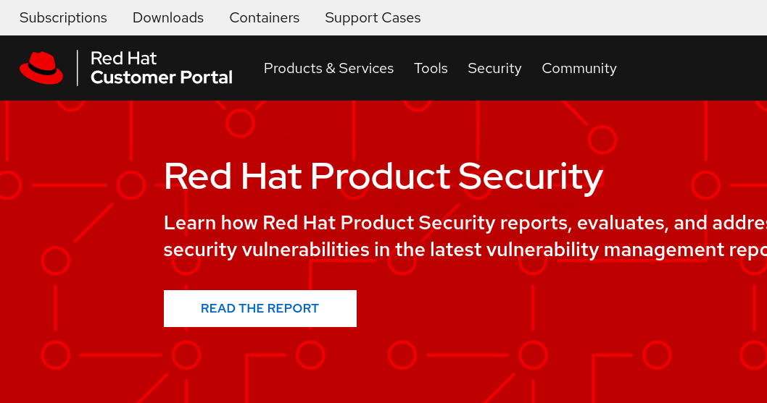

1. Click on the **Subscription Allocations** tab, then create the new allocation (choose the type as Satellite 6.10)

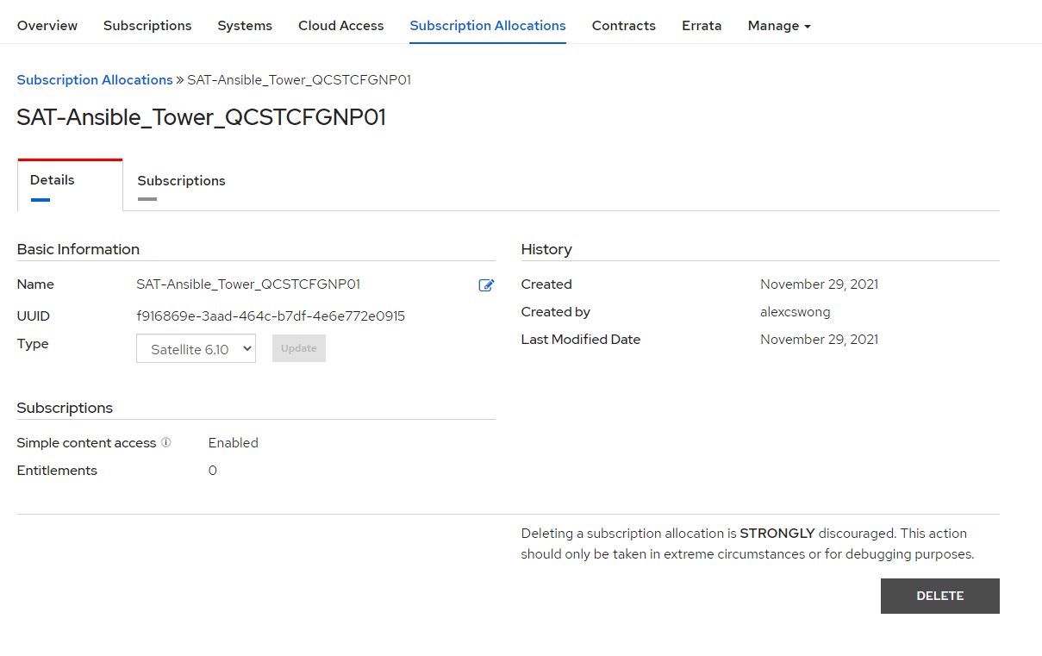

1. Add the **Ansible Automation Platform (Manged Nodes) Subscription**, and allocate the quantity.

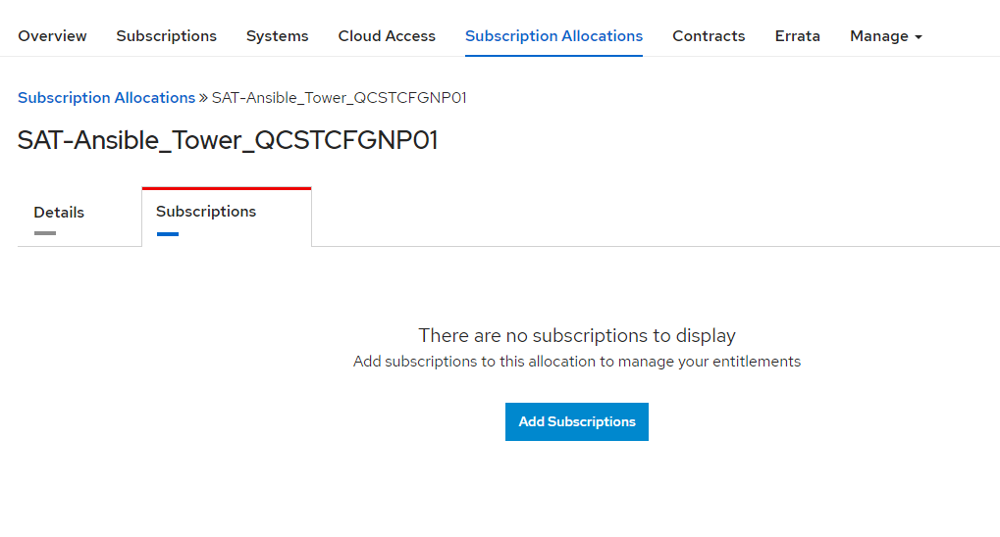

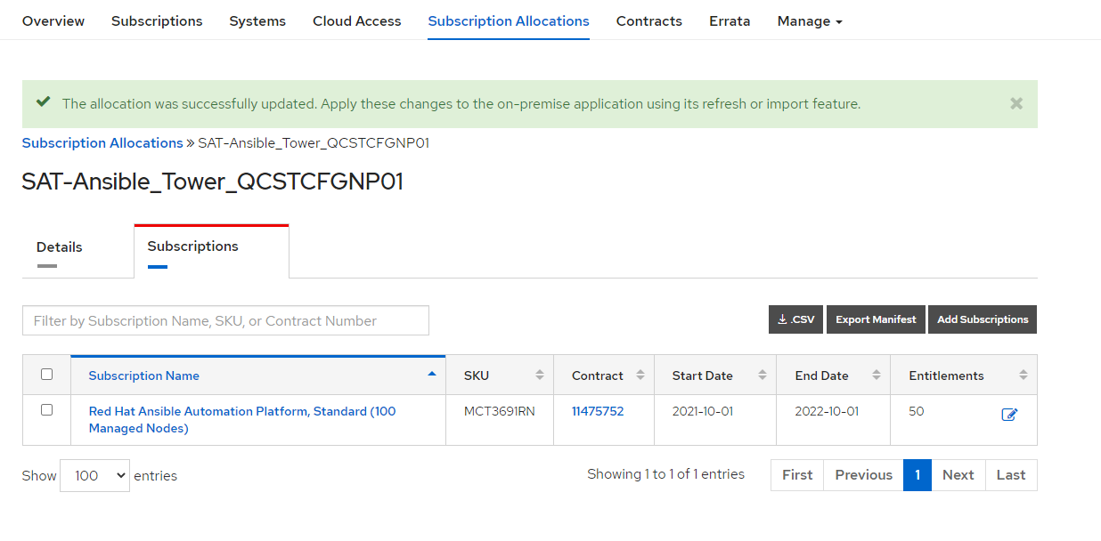

Click **Export Manifest** to download the manifest zip file to the local PC.

1. Login to Ansible Tower WebUI, and upload the Manifest zip file.

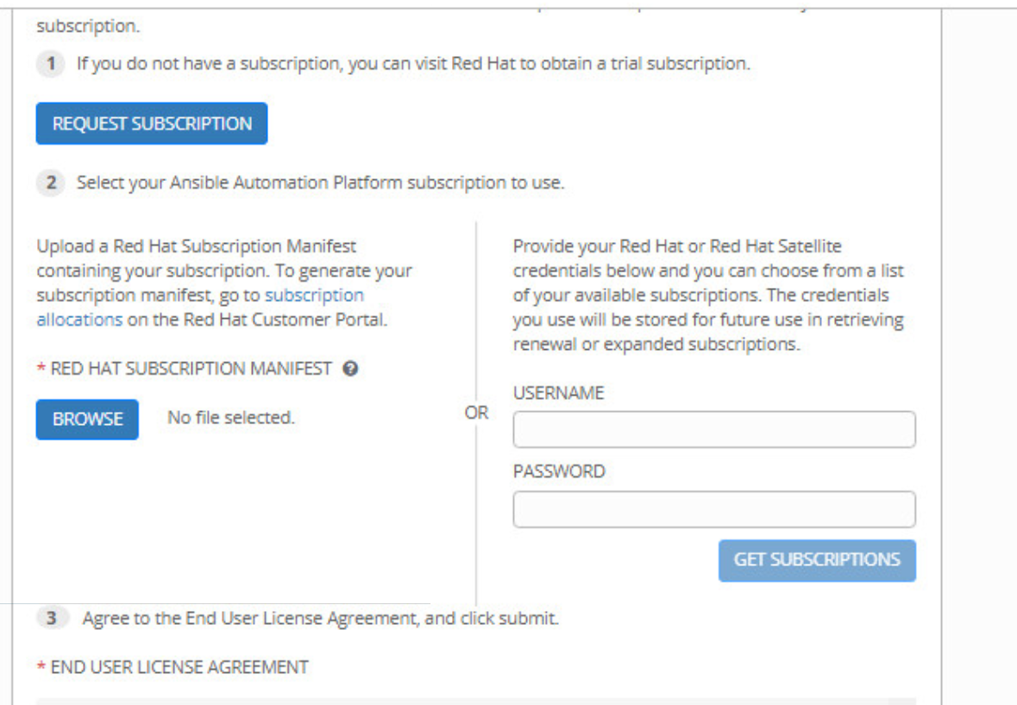

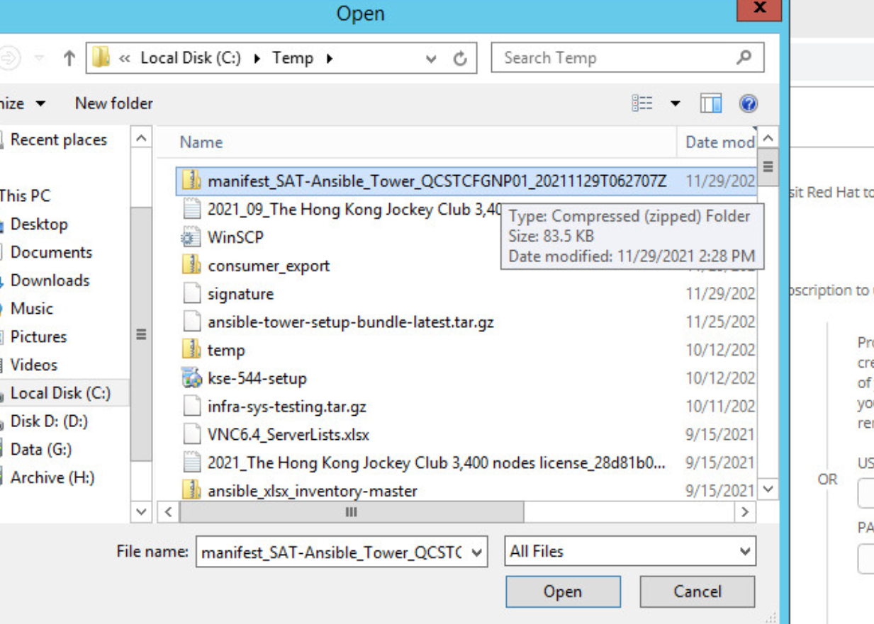

1. Tick to agree to the agreement, and then OK to apply the License Manifest.
2. Ansible Tower Dashboard should be now shown.
3. Click on the **i** button on the Top right to check the Ansible Tower and Ansible Version.

