Alexander Truong

Project #2

Due 5/10/2018

Banker’s Algorithm

Dataset 1

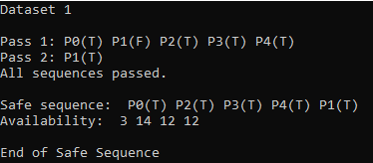

Dataset 2

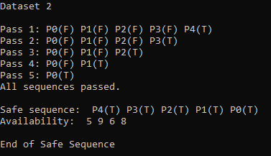

Dataset 3

