Book Catalogue Application Evidence
Git and GitHub assignment | 21 October 2026
This document records evidence from a local run of the Java Book Catalogue application. The screenshots show the live interface and a successful create action; the startup excerpt is copied from the application output.

Running application
The catalogue opened at http://localhost:8080 and displayed the three sample books loaded at startup.
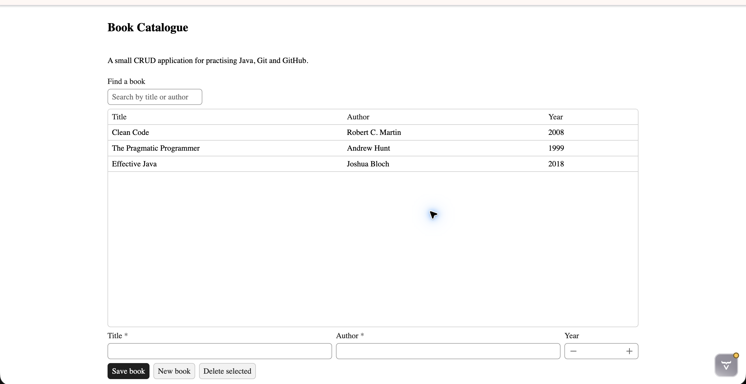
Figure 1. Book Catalogue running with its sample records.

Create action
A temporary example book was added through the interface. The new row and the “Book saved.” confirmation appeared; the temporary row was then removed.
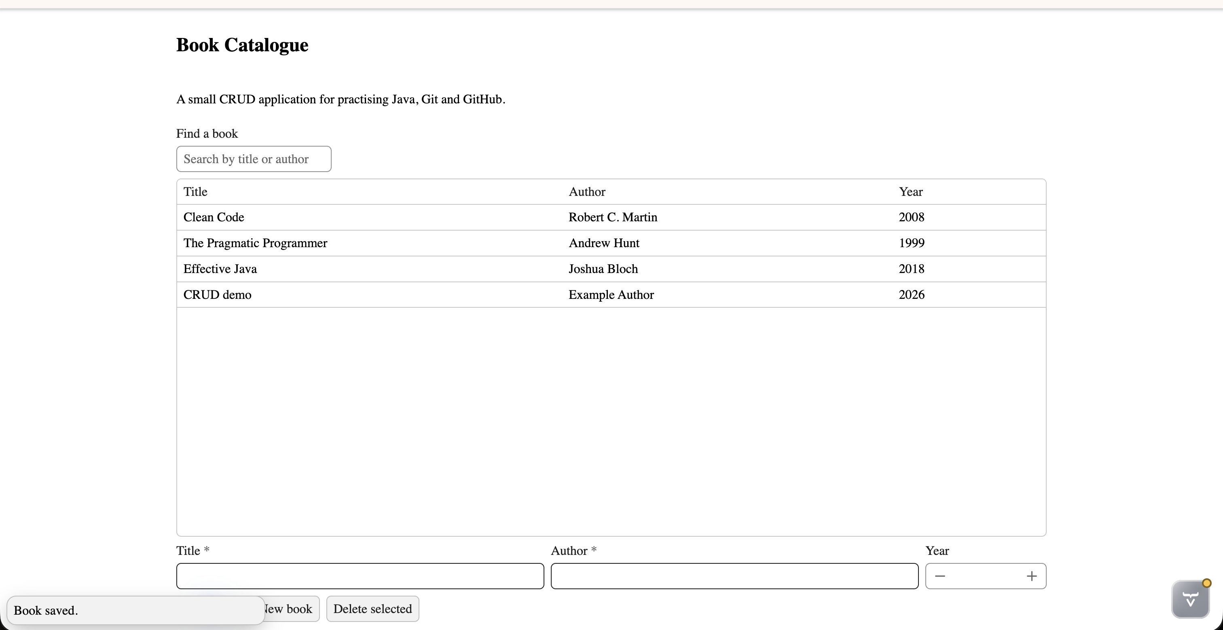
Figure 2. Added example record and the save confirmation.

Successful startup output
2026-10-21T22:55:21.279+02:00 INFO 15250 --- [student-crud-app] [ main] o.s.boot.tomcat.TomcatWebServer : Tomcat started on port 8080 (http) with context path '/'
2026-10-21T22:55:21.281+02:00 INFO 15250 --- [student-crud-app] [ main] p.v.s.crud.StudentCrudAppApplication : Started StudentCrudAppApplication in 3.1 seconds (process running for 3.26)
2026-10-21T22:55:21.515+02:00 INFO 15250 --- [student-crud-app] [ main] c.v.b.d.DevModeHandlerManagerImpl : Application running at http://localhost:8080/
The project compiled with JDK 21. Create, edit, and delete actions were checked in the browser. The included interface image documents the create action; this document does not include a separate screenshot of the console or of each other action.

