|  |
| --- |
| Team 5 |
| Calendar Application |
| Kirill Knyazev, Fei Yang |

|  |
| --- |
|  |

**Project Description**

Our team will attempt to implement an application that keeps track of users’ events, displays them in a calendar view and sends notifications to the user, at a time the user chooses. Any user can register and use the full functionality of the application.

Technologies we will use:

* Microsoft .NET WPF, XAML, C#
* Microsoft Entra id
* Http Client & <https://holidayapi.com/>
* Material design
* NUnit
* System.Net.Mail - SMTP

**Main Features**

* Events: a user can C.R.U.D. his events
* Notifications: a user can choose to create a notification for any event and set the time when the notification will be sent to him by “email???”
* Calendar View: a calendar view displaying days, weeks, and months with respective events for each date. a user can switch between viewing the calendar month by month, week by week or day by day.

**Special Features**

* Holiday API: when a user views a specific day, the application checks if that day has a holiday and displays which holiday that day is.
* Recurring events: An event can be set to repeat by intervals of days weeks or months. These recurring events have an end date/ or amount after which they no longer repeat.
* Categories: Events can be added to categories, which can be treated as separate calendars, so that a user can filter events by category and the calendar will only show events of that category. An event can have multiple categories.

**Database**

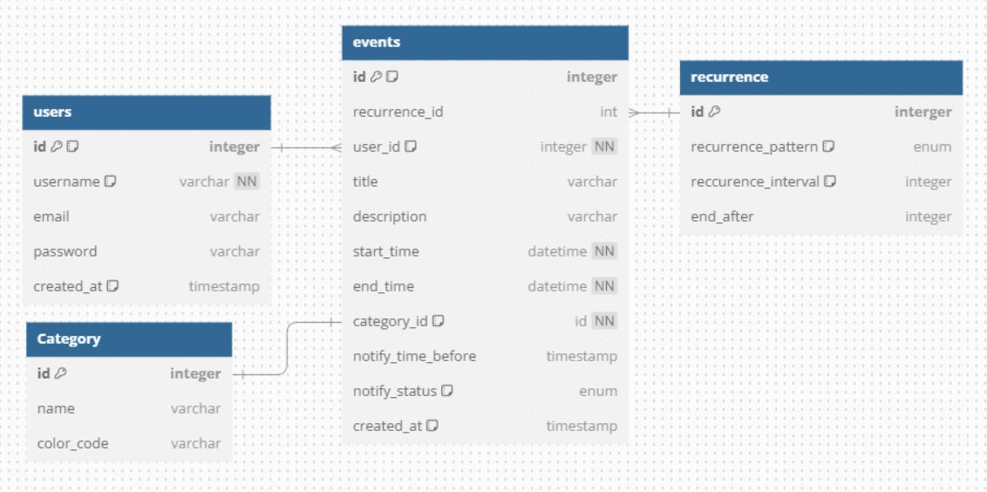

**UML**

https://plantuml.com/use-case-diagram

**Content**

