**12** **Многопользовательское приложение**

Задание 1. Автоматизация учета сотрудников

Листинг задачи:

public class EmployeeViewModel : INotifyPropertyChanged

{

private readonly EmployeeService _employeeService;

private ObservableCollection<EmployeeModel> _employees;

private List<DepartmentModel> _departments;

private EmployeeModel _selectedEmployee;

private string _filterDepartment = "Все";

private bool _isLoading;

private int _progressValue;

public event PropertyChangedEventHandler PropertyChanged;

public ObservableCollection<EmployeeModel> Employees

{

get => _employees;

set

{

_employees = value;

OnPropertyChanged(nameof(Employees));

EmployeesView = CollectionViewSource.GetDefaultView(_employees);

EmployeesView.Filter = FilterEmployees;

}

}

public ICollectionView EmployeesView { get; private set; }

public List<DepartmentModel> Departments

{

get => _departments;

set

{

_departments = value;

OnPropertyChanged(nameof(Departments));

}

}

public EmployeeModel SelectedEmployee

{

get => _selectedEmployee;

set

{

_selectedEmployee = value;

OnPropertyChanged(nameof(SelectedEmployee));

CommandManager.InvalidateRequerySuggested();

}

}

public string FilterDepartment

{

get => _filterDepartment;

set

{

if (_filterDepartment != value)

{

_filterDepartment = value;

OnPropertyChanged(nameof(FilterDepartment));

EmployeesView?.Refresh();

}

}

}

public bool IsLoading

{

get => _isLoading;

set

{

_isLoading = value;

OnPropertyChanged(nameof(IsLoading));

}

}

public int ProgressValue

{

get => _progressValue;

set

{

_progressValue = value;

OnPropertyChanged(nameof(ProgressValue));

}

}

Таблица 1.1 – Входные и выходные данные

|  |  |
| --- | --- |
| Входные данные | Выходные данные |
| ФИО, Должность, Отдел | Добавление сотрудника. Сообщение об ошибке |

Анализ результатов:

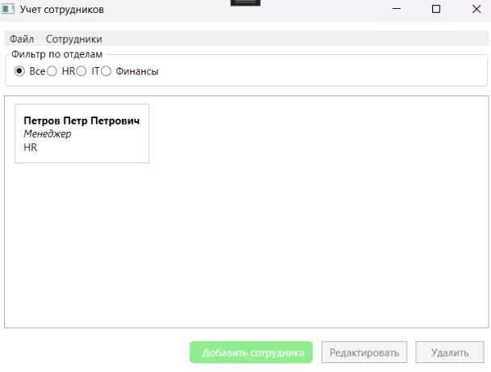

Рисунок 1.1 – Результат работы программы