**12** **Многопользовательское приложение**

Задание 1. Автоматизация учета сотрудников

Листинг задачи:

public class ChatClient : IDisposable

{

private readonly string _pipeName;

private NamedPipeClientStream _pipe;

private StreamReader _reader;

private StreamWriter _writer;

private bool _isConnected;

public event EventHandler<string> MessageReceived;

public ChatClient(string pipeName)

{

_pipeName = pipeName;

}

public async Task ConnectAsync()

{

_pipe = new NamedPipeClientStream(

".",

_pipeName,

PipeDirection.InOut,

PipeOptions.Asynchronous);

await _pipe.ConnectAsync(5000);

_reader = new StreamReader(_pipe);

_writer = new StreamWriter(_pipe) { AutoFlush = true };

_isConnected = true;

_ = Task.Run(ReceiveMessagesAsync);

}

private async Task ReceiveMessagesAsync()

{

while (_isConnected)

{

try

{

var message = await _reader.ReadLineAsync();

if (message != null)

{

MessageReceived?.Invoke(this, message);

}

}

catch

{

Disconnect();

}

}

}

public async Task SendAsync(string message)

{

if (_isConnected)

{

await _writer.WriteLineAsync(message);

}

}

private void Disconnect()

{

_isConnected = false;

Dispose();

}

public void Dispose()

{

_reader?.Dispose();

_writer?.Dispose();

_pipe?.Dispose();

GC.SuppressFinalize(this);

}

}

Таблица 1.1 – Входные и выходные данные

|  |  |
| --- | --- |
| Входные данные | Выходные данные |
| Сообщение | Вывод сообщения |

Анализ результатов:

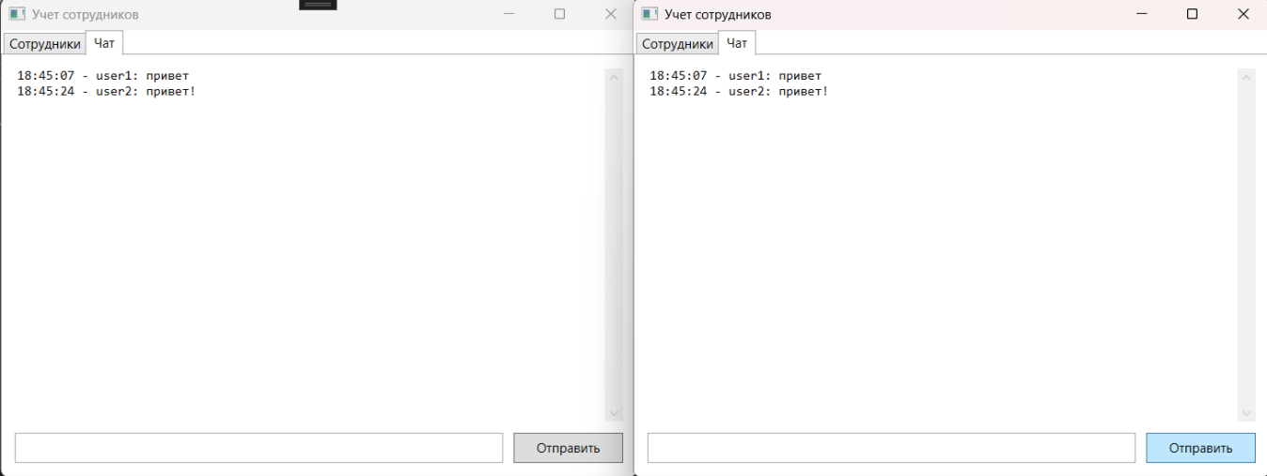

Рисунок 1.1 – Результат работы программы