# Logical Scheme

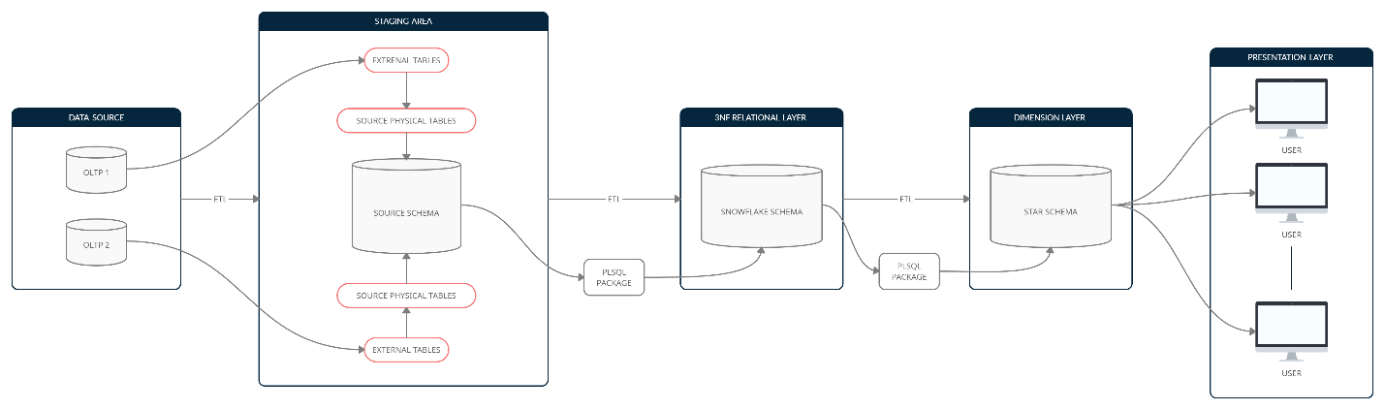

There are two OLTP data sources which provides DWH with the transactional data. The overall process of data load routine is the following:

1. Each OLTP base provides with the flat files of .csv format for each particular business entity. A separate user should be created for each corresponding external source.
2. External tables are created for each flat file from OLTP establishing this way a robust connection DWH and external sources. These tables are assigned to corresponding users (OLTP systems) spaces.
3. Physical tables are created for each external in relation 1:1, forming this way physical source schema with all the necessary data, cleaned and processed with the help of ETL tools.
4. From source schema table space, data flows to 3NF Snowflake Schema. It can be done by using PLSQL Oracle functionality and ETL toolkit.
5. After obtaining a fully developed and populated 3NF model, data is transported to Dimensional Star Schema fully denormalized. It can be done by using PLSQL Oracle functionality and ETL toolkit. This model represents final representative layer which can be accessed and used by 3rd party users for any analytical purposes.

# Data Flow

**Fact table**

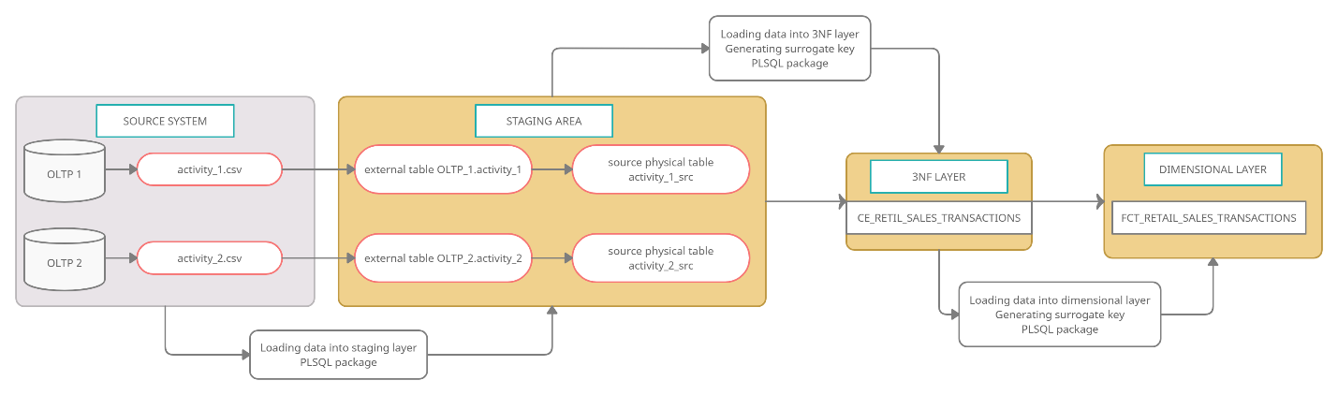

Transactional records come from two separate OLTP systems and are processed by the routine described in *LOGICAL SCHEME* section. Here comes one flat file from each external system and then extraction procedure is applied to each of them as well as migration sequence from source physical schema up to dimensional layer.

**Products**

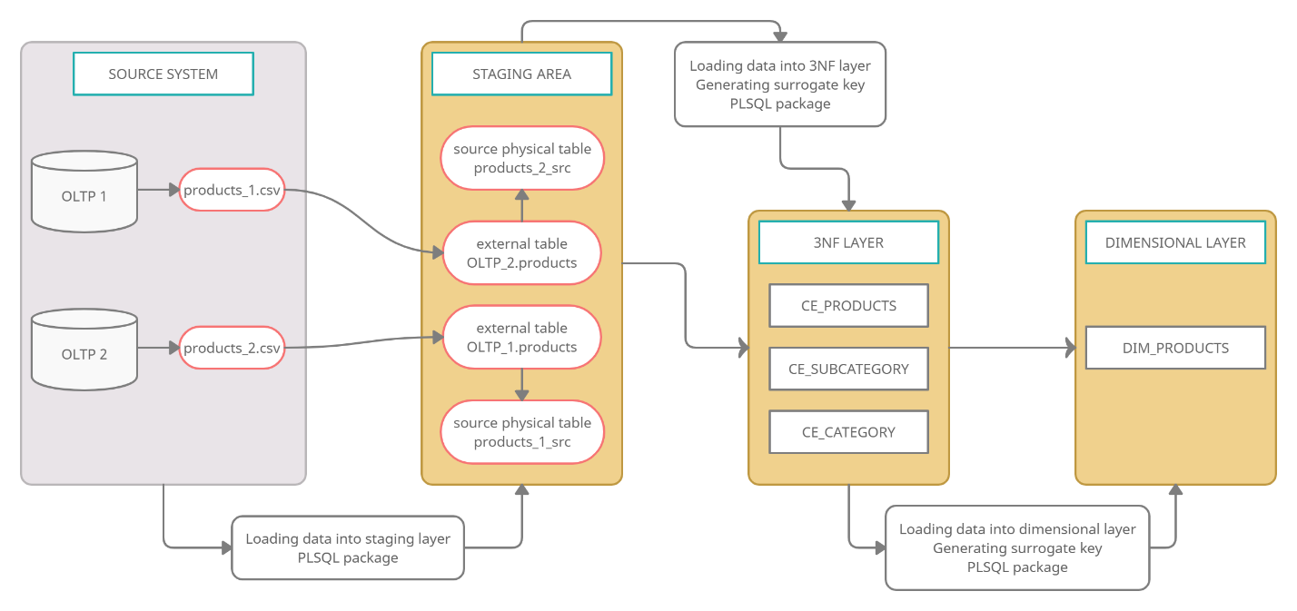

Information about products come from two separate OLTP systems and is processed by the routine described in *LOGICAL SCHEME* section. Here comes one flat file from each external system and then extraction procedure is applied to each of them as well as migration sequence from source physical schema up to dimensional layer. It worth noting that this is the business entity which will experience changes with time (SCD Type 2 table in both 3NF and dimensional layers) so logic here applies frequent flat file updating (by OLTP) and this is the part were external tables play crucial role in establishing robust connections between systems.

**Customers**

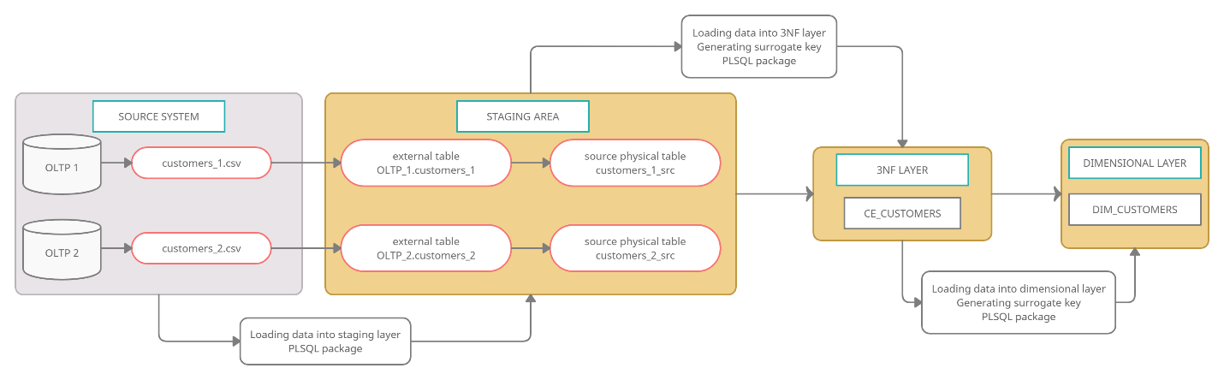

Information about customers come from two separate OLTP systems and is processed by the routine described in *LOGICAL SCHEME* section. Here comes one flat file from each external system and then extraction procedure is applied to each of them as well as migration sequence from source physical schema up to dimensional layer.

**Employees**

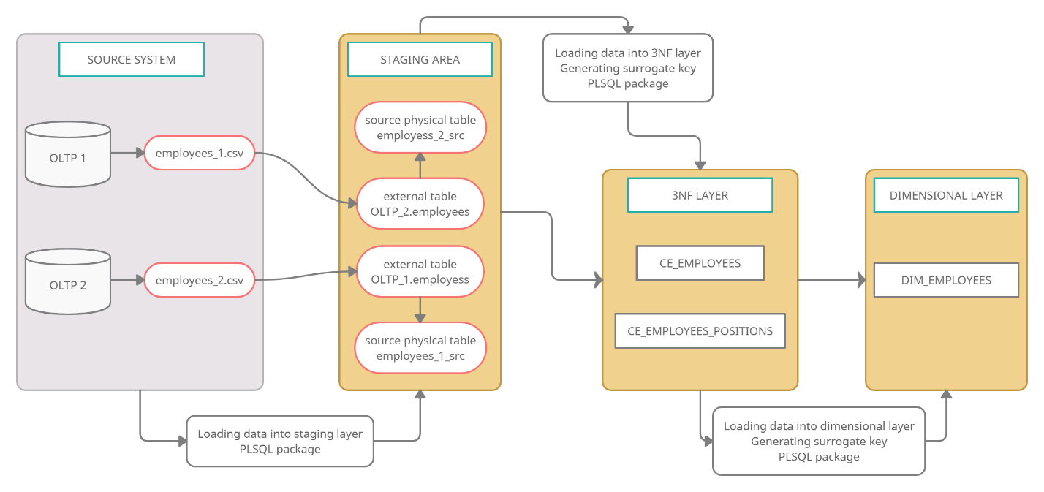

Information about employees come from two separate OLTP systems and is processed by the routine described in *LOGICAL SCHEME* section. Here comes one flat file from each external system and then extraction procedure is applied to each of them as well as migration sequence from source physical schema up to dimensional layer.

**Stores**

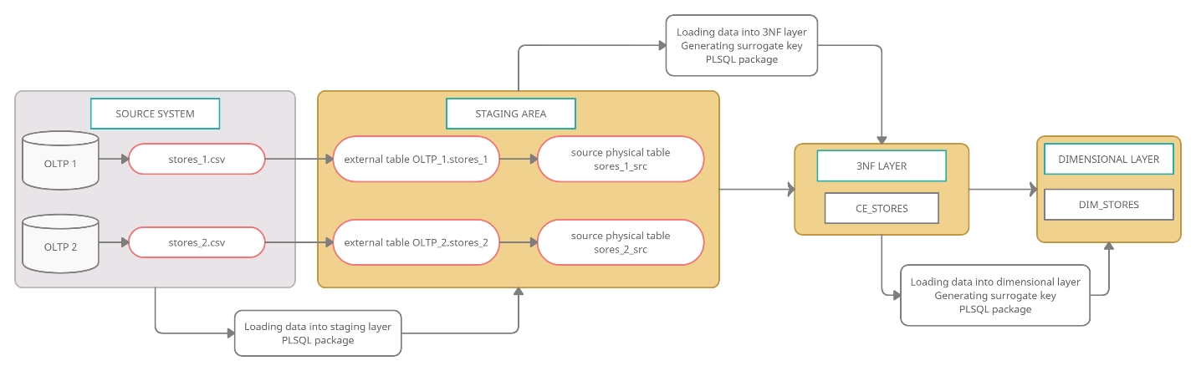

Information about stores come from two separate OLTP systems and is processed by the routine described in *LOGICAL SCHEME* section. Here comes one flat file from each external system and then extraction procedure is applied to each of them as well as migration sequence from source physical schema up to dimensional layer.

**Locations**

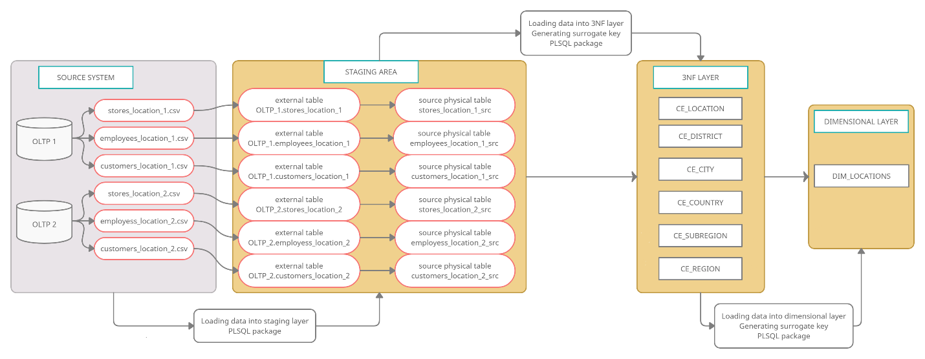

Here, information for locations is obtained the following way: two separate OLTP systems provides with a corresponding flat file with locations for each business inspected entity (each system generates it’s own set of such files) and then this set of files is processed by the routine described in *LOGICAL SCHEME* section. Extraction procedure is applied to each element of this set as well as migration sequence from source physical schema up to dimensional layer.

**Channels**

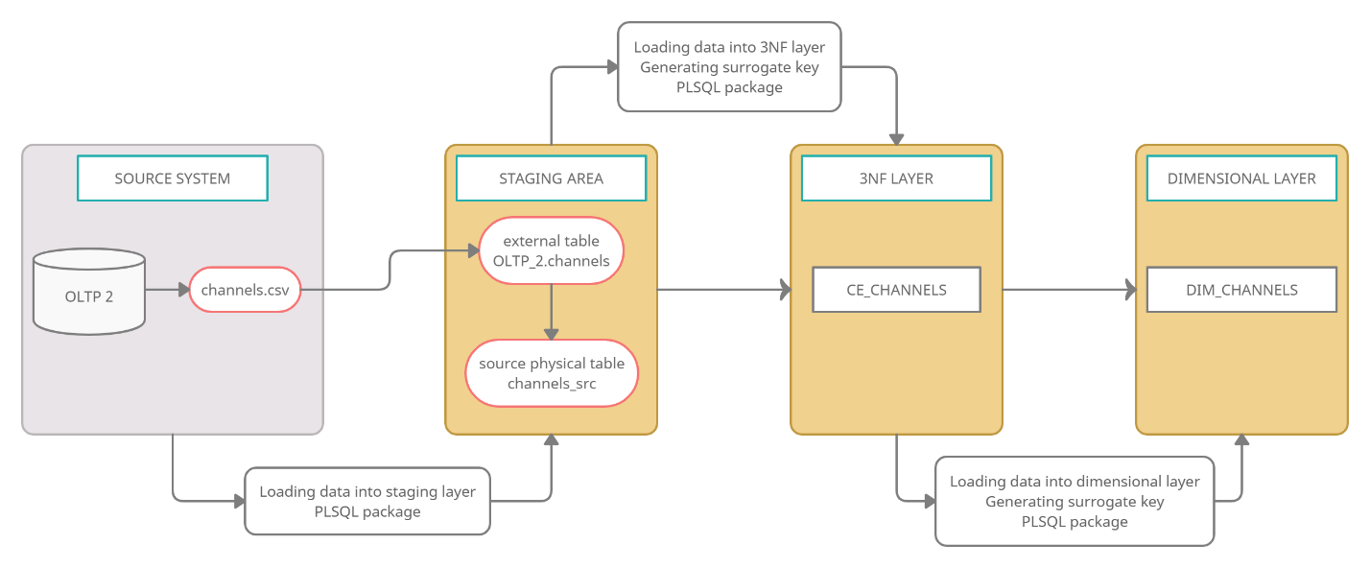

Channels – is a small table which describes each trading channel through which transactions are conducted, come from one OLTP system and is processed by the routine described in *LOGICAL SCHEME* section. Here comes one flat file from one external system and then extraction procedure is applied to it as well as migration sequence from source physical schema up to dimensional layer.

**Events**

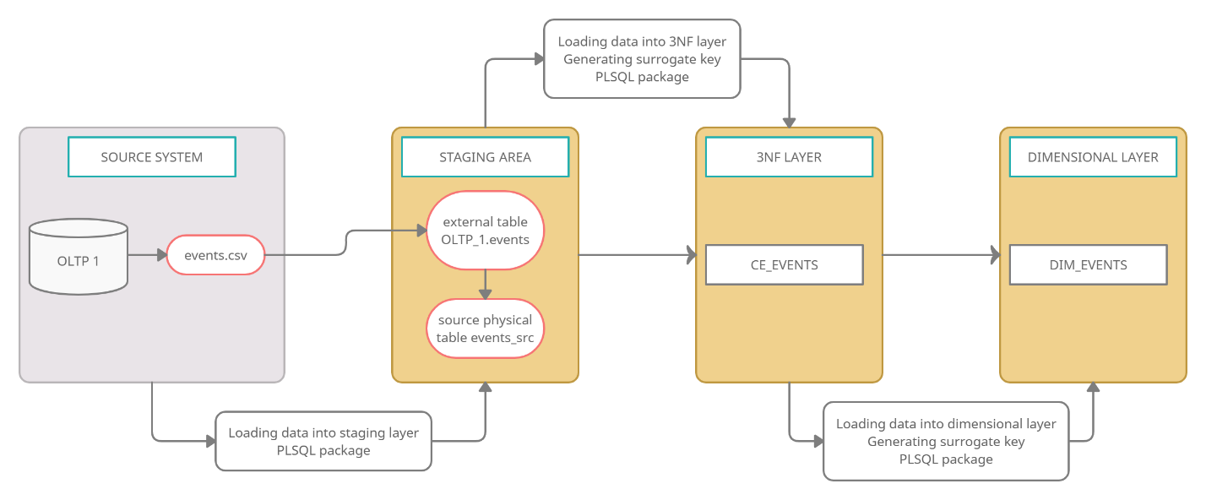

Events – is a small table which describes each possible event which can be registered and classified, come from one OLTP system and is processed by the routine described in *LOGICAL SCHEME* section. Here comes one flat file from one external system and then extraction procedure is applied to it as well as migration sequence from source physical schema up to dimensional layer.